# 第十二章 项目实战

本章学习目标：

* 了解SDL2库和其相关的辅助库
* 掌握构建SDL2的开发环境
* 掌握SDL2基本绘图方法
* 掌握SDL2事件监控实现方法
* 掌握SDL2简单的游戏编程
* 掌握一般C语言程序的设计思路
* 掌握程序的调试方法

## 12.1 实践题

**一、SDL2环境的搭建**

**实验目的**

1. 掌握SDL2环境搭建
2. 测试是否搭建成功

**实验步骤**

步骤1：下载SDL2-devel-2.0.3-VC.zip开发包，下载地址为<http://www.libsdl.org/release/SDL2-devel-2.0.3-VC.zip>,解压下载包。

步骤2：建立解决方案和项目

打开visual studio 2012,新建win32控制台应用程序，解决方案名称为SDL2Demo1，名称为SDL2Demo1,点击确定，点击下一步，此处选择“空项目”选项，如图点击完成。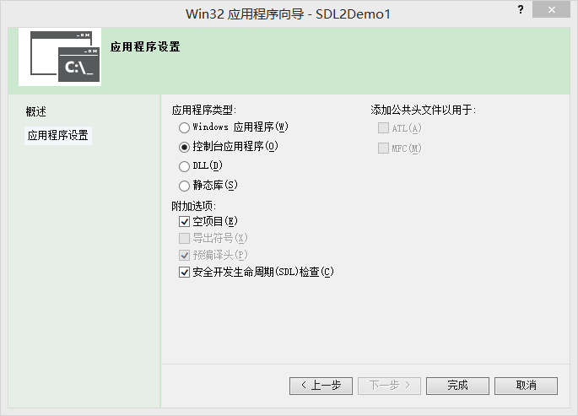

步骤3：在解决方案路径下新建SDL2文件夹，并将SDL2-devel-2.0.3-VC解压包下的include和lib文件夹拷贝到SDL2文件夹下。  
选择SDL2Demo1项目右击选择属性，导航到VC++目录，选择右侧的包含目录并新建一项，内容为$(SolutionDir)SDL2\include，点击确定。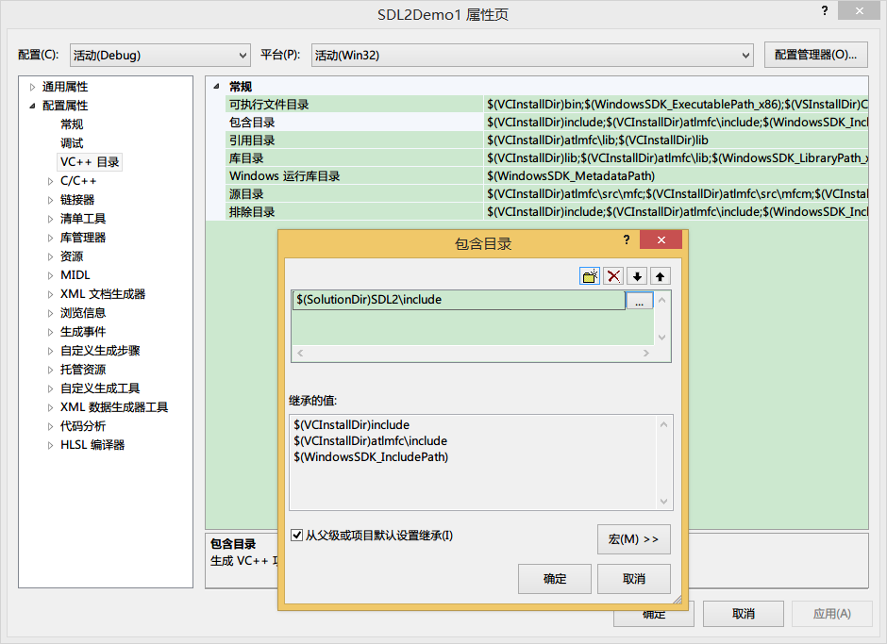  
选择右侧的库目录并新建一项，内容为$(SolutionDir)SDL2\lib\x86，点击确定。  
  
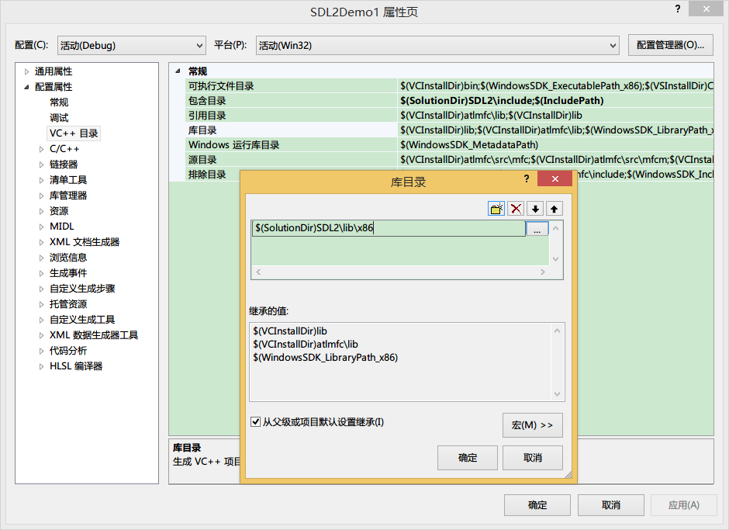导航到C/C++下的代码生成，右侧选择运行库改选项为”多线程 DLL (/MD)”,点击应用。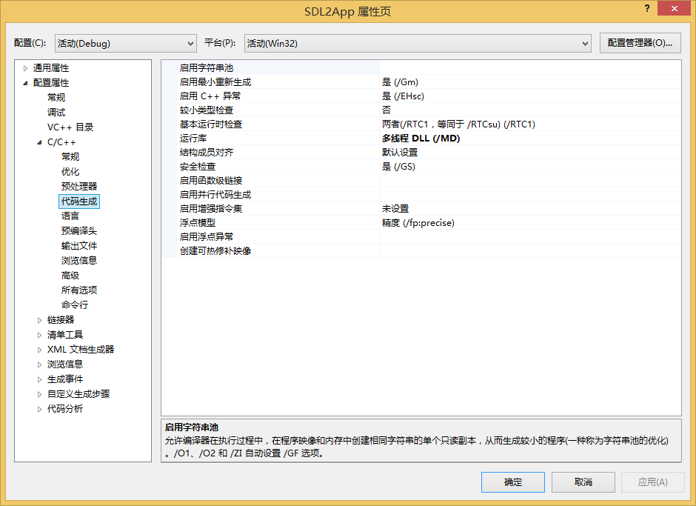  
导航到链接器下的输入选项，右侧选择附加依赖项，添加内容为SDL2.lib、SDL2main.lib，点击确定。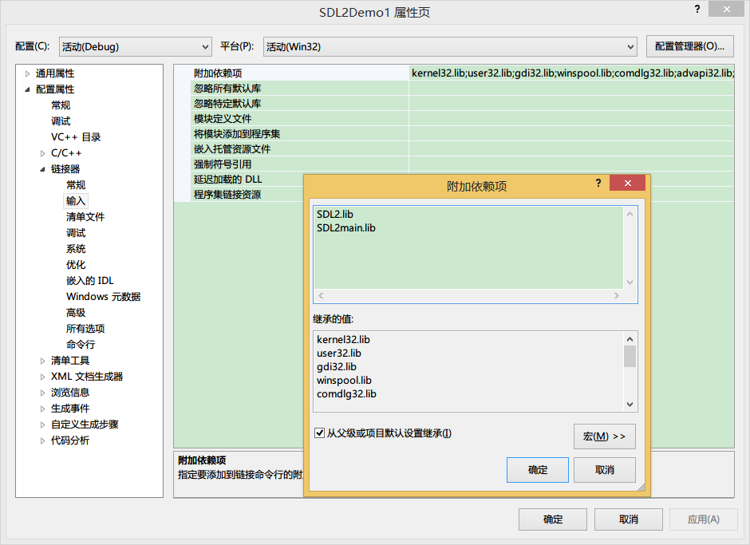

步骤4：在SDL2Demo1项目中选择源文件，右击添加新建项，导航到Visual C++ 下的C++文件(.cpp),名称为main.c,点击添加。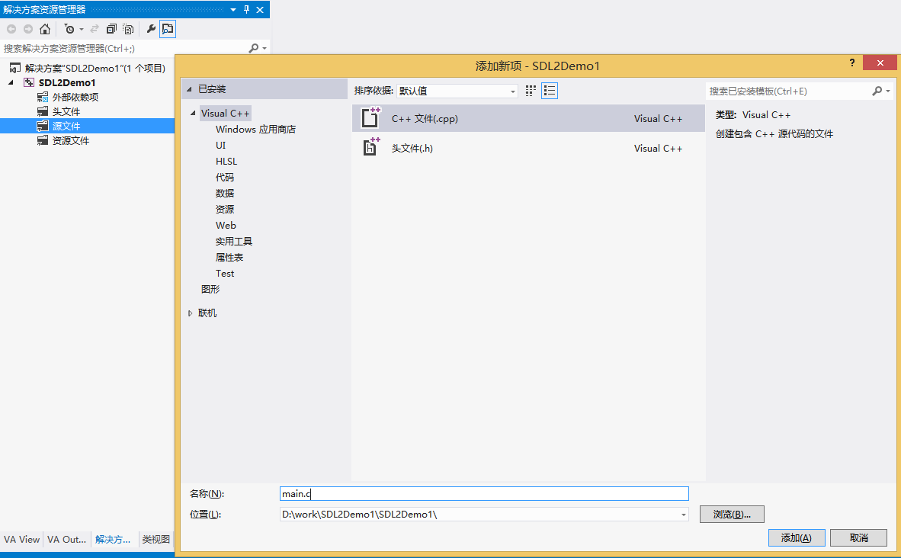  
该文件内容为：  
int main(int argc,char** argv)  
{  
 return 0;  
}  
选择项目生成一下该项目，拷贝解压包SDL2-2.0.3\lib\x86路径下的SDL2.dll到解决方案的Debug目录中。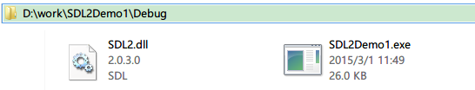

步骤5：编写测试代码，修改main.c文件中的代码  
#include <stdlib.h>  
#include <stdio.h>  
#include "SDL.h"  
  
int main(int argc,char** argv)  
{  
 //初始化SDL各个子系统  
 if((SDL_Init(SDL_INIT_EVERYTHING)==-1)) {  
 //初始化失败，则程序直接退出  
 exit(-1);  
}  
 //关闭SDL各个子系统   
 SDL_Quit();   
 system("pause");   
 return 0;  
}  
编译运行程序，如果程序直接退出表示初始化失败，如果显现如下界面表示程序运行正常。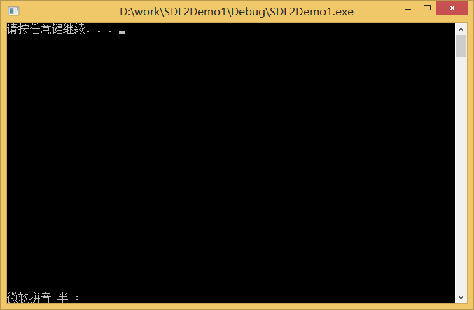

步骤6：删除解决方案目录下Debug文件夹中的SDL2.dll文件，编译项目，发现编译成功。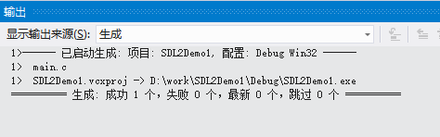  
运行失败。  
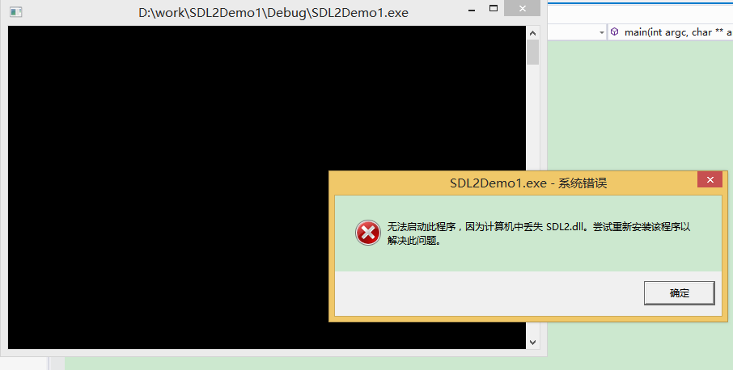

步骤7：选择SDL2Demo1项目的release版本进行编译运行，发现编译失败。

**实验结果/结论**

1. **实验结果**

* 实验步骤6表明程序的执行需要SDL2.dll文件。
* 实验步骤7如果要编译成功需要对release编译环境进行设置。

1. **实验结论**

* SDL2库使用的方法是导入库(lib文件)和动态库(dll文件)配合，导入库只在编译和链接阶段起作用，动态库在运行阶段起作用。
* Debug版本和Release版本都需要分别进行设置才可以编译运行。

**二、SDL2显示bmp图片**

**实验目的**

1. 掌握通过SDL2库显示一副bmp图片的流程
2. 掌握通过SDL2显示图片的一些函数

**实验步骤**

步骤1：按照试验一所示步骤搭建开发环境，建立的项目名称为SDL2App

步骤2：在解决方案目录下新建名称为res的文件夹，将准备的好的图片start.bmp和back.bmp拷贝到该目录下。

步骤3：打开main.c源文件，修改代码内容为：

|  |
| --- |
| #include <stdlib.h>  #include <math.h>  #include <stdio.h>  #include <memory.h>  #include "SDL.h"  #define G_WINDOW_X 50  #define G_WINDOW_Y 50  #define G_WINDOW_W 800  #define G_WINDOW_H 600  typedef struct LoadedPicture {  *SDL_Surface* *surface;  *SDL_Texture* *texture;  const char* name;  } LoadedPicture;  int *main*(int argc, char** argv)  {  *Uint8* num_pictures;  LoadedPicture* pictures;  *SDL_PixelFormat*\* format = *NULL*;  *SDL_Window* *window;  *SDL_Renderer* *renderer;  *Uint32* pixelFormat = 0;  int access = 0;  *SDL_Rect* srcrect;  *SDL_Rect* dstrect;  int i;  int j;  char *game[] = {  "res\\back.bmp",  "res\\start.bmp"  };  *SDL_LogSetPriority*(*SDL_LOG_CATEGORY_APPLICATION*, *SDL_LOG_PRIORITY_INFO*);  if (*SDL_Init*(*SDL_INIT_EVERYTHING*) == -1) {  *SDL_LogError*(*SDL_LOG_CATEGORY_APPLICATION*, "Could not initialize SDL.");  *exit*(-2);  }  num_pictures = 2;  pictures = (LoadedPicture *)*SDL_malloc*(sizeof(LoadedPicture)*num_pictures);  for (i = 0; i < num_pictures; i++)  pictures[i].surface = *NULL*;  for (i = 0; i < num_pictures; i++) {  pictures[i].surface = *SDL_LoadBMP*(game[i]);  pictures[i].name = game[i];  if (pictures[i].surface == *NULL*) {  j = 0;  for (j = 0; j < num_pictures; j++)  *SDL_FreeSurface*(pictures[j].surface);  *SDL_free*(pictures);  *SDL_Quit*();  *SDL_LogError*(*SDL_LOG_CATEGORY_APPLICATION*, "Could not load surface from named bitmap file: %s", game[i]);  *exit*(-3);  }  }  window = *SDL_CreateWindow*("Demo", G_WINDOW_X, G_WINDOW_Y, G_WINDOW_W, G_WINDOW_H, 0);  *SDL_SetWindowPosition*(window, G_WINDOW_X, G_WINDOW_Y);  if (window == *NULL*) {  for (i = 0; i < num_pictures; i++)  *SDL_FreeSurface*(pictures[i].surface);  *SDL_free*(pictures);  *SDL_Quit*();  *SDL_LogError*(*SDL_LOG_CATEGORY_APPLICATION*, "Could not create window for Demo.");  *exit*(-4);  }  renderer = *SDL_CreateRenderer*(window, -1, 0);  if (!renderer) {  *SDL_DestroyWindow*(window);  for (i = 0; i < num_pictures; i++)  *SDL_FreeSurface*(pictures[i].surface);  *SDL_free*(pictures);  *SDL_Quit*();  *SDL_LogError*(*SDL_LOG_CATEGORY_APPLICATION*, "Could not create rendering context for Demo window.");  *exit*(-5);  }  for (i = 0; i < num_pictures; i++)  pictures[i].texture = *NULL*;  for (i = 0; i < num_pictures; i++) {  pictures[i].texture = *SDL_CreateTextureFromSurface*(renderer, pictures[i].surface);  if (pictures[i].texture == *NULL*) {  j = 0;  for (j = 0; j < num_pictures; i++)  if (pictures[i].texture != *NULL*)  *SDL_DestroyTexture*(pictures[i].texture);  for (i = 0; i < num_pictures; i++)  *SDL_FreeSurface*(pictures[i].surface);  *SDL_free*(pictures);  *SDL_DestroyRenderer*(renderer);  *SDL_DestroyWindow*(window);  *SDL_Quit*();  *SDL_LogError*(*SDL_LOG_CATEGORY_APPLICATION*, "Could not create texture for Demo.");  *exit*(-6);  }  }  *SDL_RenderCopy*(renderer, pictures[0].texture, *NULL*, *NULL*);  *SDL_RenderPresent*(renderer);  srcrect.*x* = 10;  srcrect.*y* = 10;  srcrect.*h* = G_WINDOW_H / 2;  srcrect.*w* = G_WINDOW_W / 2;  dstrect.*x* = 10;  dstrect.*y* = 10;  dstrect.*h* = G_WINDOW_H / 2;  dstrect.*w* = G_WINDOW_W / 2;  *SDL_RenderCopy*(renderer, pictures[1].texture, &srcrect, &dstrect);  *SDL_RenderPresent*(renderer);  *SDL_Delay*(2000);  srcrect.*x* = 0;  srcrect.*y* = 0;  srcrect.*h* = G_WINDOW_H;  srcrect.*w* = G_WINDOW_W;  dstrect.*x* = 0;  dstrect.*y* = 0;  dstrect.*h* = G_WINDOW_H;  dstrect.*w* = G_WINDOW_W;  *SDL_RenderClear*(renderer);  *SDL_RenderCopy*(renderer, pictures[0].texture, &srcrect, &dstrect);  *SDL_RenderPresent*(renderer);  srcrect.*x* = 10;  srcrect.*y* = 10;  srcrect.*h* = G_WINDOW_H / 2;  srcrect.*w* = G_WINDOW_W / 2;  dstrect.*x* = 10;  dstrect.*y* = 10;  dstrect.*h* = G_WINDOW_H / 2;  dstrect.*w* = G_WINDOW_W / 2;  *SDL_RenderCopy*(renderer, pictures[1].texture, &srcrect, &dstrect);  *SDL_RenderPresent*(renderer);  *SDL_Delay*(2000);  *system*("pause");  for (i = 0; i < num_pictures; i++)  *SDL_DestroyTexture*(pictures[i].texture);  *SDL_DestroyRenderer*(renderer);  *SDL_DestroyWindow*(window);  for (i = 0; i < num_pictures; i++)  *SDL_FreeSurface*(pictures[i].surface);  *SDL_free*(pictures);  *SDL_Quit*();  return 0;  } |

**实验结果/结论**

1. **实验结果**

* 程序运行后显示界面为  
  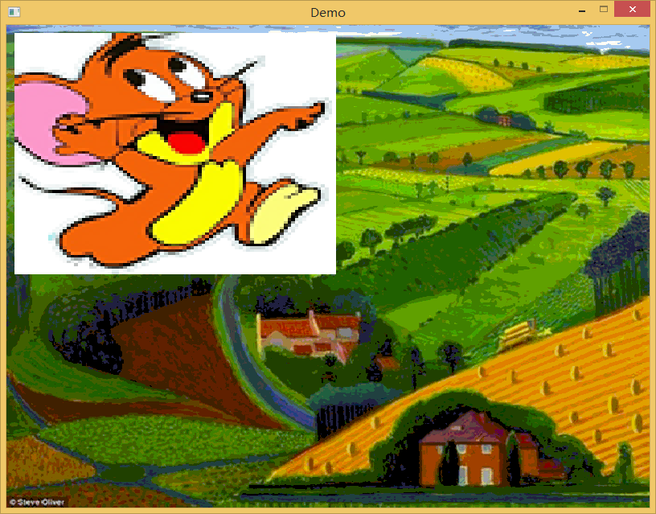  
  延迟2秒后显示  
  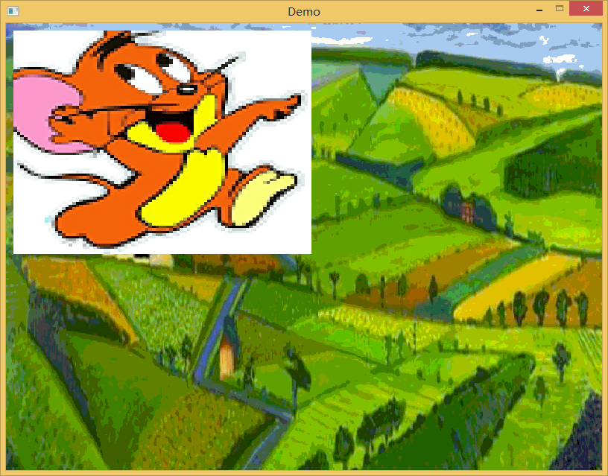  
  back.bmp原始图片为  
  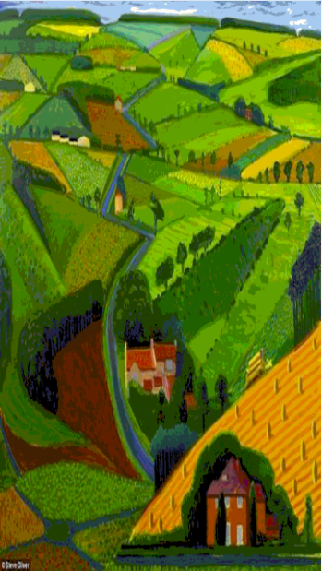  
  start.bmp的原始图片为  
  

1. **实验结论**

* 通过SDL2显示图片的主要流程为首先加载图片数据到SDL_Surface然后通过SDL_CreateTextureFromSurface创建SDL_Texture，通过SDL_RenderCopy和SDL_RenderPresent显示图片，SDL使用SDL_Surface和SDL_Texture这2种结构绘图到屏幕。
* SDL_RenderCopy函数，源矩形用于指定要拷贝到目标图像的源图像起始位置及宽高参数，即可以只拷贝源图像的某一部分到目标图像。  
  目标矩形用于指定要拷贝到目标图像中的起始位置及宽高参数，即可以通过指定不同的目标矩形位置，让源图像拷贝到目标图像的不同位置。且目标矩形的宽高不用和源矩形一致，这可用于缩小或放大图像。x,y为矩形的开始位置；w,h为矩形的宽高。  
  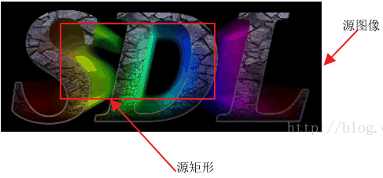  
  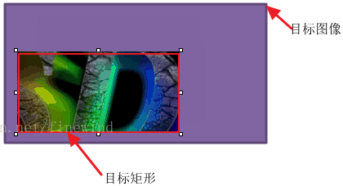
* 程序启动后会显示SDL的日志窗口，便于程序开发和调试。

**三、SDL2监控键盘和鼠标事件**

**实验目的**

1. 掌握SDL2如何监控鼠标的点击事件和监控鼠标的坐标
2. 掌握SDL2如何监控键盘按键事件

**实验步骤**

步骤1：按照试验一所示步骤搭建开发环境，建立的项目名称为SDL2CtrlApp

步骤2：打开main.c源文件，修改代码内容为：

|  |
| --- |
| #include <stdlib.h>  #include <stdio.h>  #include "SDL.h"  #define G_WINDOW_X 50  #define G_WINDOW_Y 50  #define G_WINDOW_W 750  #define G_WINDOW_H 550  int *main*(int argc, char** argv)  {  *SDL_PixelFormat*\* format = *NULL*;  *SDL_Window* *window;  *SDL_Event* event;  int event_pending = 0;  int should_exit = 0;  int button_down;  int cx;  int cy;  *SDL_LogSetPriority*(*SDL_LOG_CATEGORY_APPLICATION*, *SDL_LOG_PRIORITY_INFO*);  if (*SDL_Init*(*SDL_INIT_EVERYTHING*) == -1) {  *SDL_LogError*(*SDL_LOG_CATEGORY_APPLICATION*, "Could not initialize SDL");  *exit*(-2);  }  window = *SDL_CreateWindow*("Event", G_WINDOW_X, G_WINDOW_Y, G_WINDOW_W, G_WINDOW_H, 0);  *SDL_SetWindowPosition*(window, G_WINDOW_X, G_WINDOW_Y);  event_pending = 0;  should_exit = 0;  event_pending = *SDL_PollEvent*(&event);  while (should_exit == 0) {  event_pending = *SDL_PollEvent*(&event);  if (event_pending == 1) {  if (event.*type* == *SDL_KEYDOWN*){  button_down = 1;  if (event.*key*.*keysym*.*sym* == *SDLK_ESCAPE*) {  should_exit = 1;  break;  }  }  if (event.*type* == *SDL_MOUSEBUTTONDOWN*){  cx = event.*button*.*x*;  cy = event.*button*.*y*;  *SDL_LogInfo*(*SDL_LOG_CATEGORY_APPLICATION*, " CX:%d CY:%d ",cx, cy);  }  if (event.*type* == *SDL_QUIT*)  should_exit = 1;  event_pending = 0;  }  }  *SDL_DestroyWindow*(window);  *SDL_Quit*();  return 0;  } |

**实验结果/结论**

1. **实验结果**

* 运行程序会启动程序的主窗口和日志窗口，在主窗口中单击鼠标会在日志窗口中提示鼠标的坐标值，这个坐标值是相对于主窗口的。  
  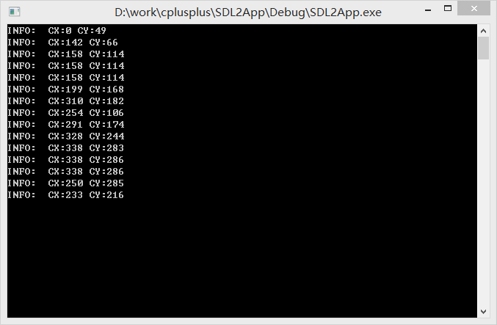  
  坐标通过SDL_MouseButtonEvent结构体变量button获得。
* 将窗体控制焦点给主窗口，点击键盘的ESC键，整个程序将退出。我们通过查看SDLK_ESCAPE的宏定义可以发现SDL_keycode.h文件，该文件中有很多键的定义。我们程序中使用event.key.keysym.sym == SDLK_ESCAPE进行按键的判断。

1. **实验结论**

* SDL2中事件有专门的类型SDL_Event类型，SDL_Event是一个联合体，其定义如下：

|  |
| --- |
| typedef union SDL_Event  {  Uint32 type; /**< Event type, shared with all events */  SDL_CommonEvent common; /**< Common event data */  SDL_WindowEvent window; /**< Window event data */  SDL_KeyboardEvent key; /**< Keyboard event data */  SDL_TextEditingEvent edit; /**< Text editing event data */  SDL_TextInputEvent text; /**< Text input event data */  SDL_MouseMotionEvent motion; /**< Mouse motion event data */  SDL_MouseButtonEvent button; /**< Mouse button event data */  SDL_MouseWheelEvent wheel; /**< Mouse wheel event data */  SDL_JoyAxisEvent jaxis; /**< Joystick axis event data */  SDL_JoyBallEvent jball; /**< Joystick ball event data */  SDL_JoyHatEvent jhat; /**< Joystick hat event data */  SDL_JoyButtonEvent jbutton; /**< Joystick button event data */  SDL_JoyDeviceEvent jdevice; /**< Joystick device change event data */  SDL_ControllerAxisEvent caxis; /**< Game Controller axis event data */  SDL_ControllerButtonEvent cbutton; /**< Game Controller button event data */  SDL_ControllerDeviceEvent cdevice; /**< Game Controller device event data */  SDL_QuitEvent quit; /**< Quit request event data */  SDL_UserEvent user; /**< Custom event data */  SDL_SysWMEvent syswm; /**< System dependent window event data */  SDL_TouchFingerEvent tfinger; /**< Touch finger event data */  SDL_MultiGestureEvent mgesture; /**< Gesture event data */  SDL_DollarGestureEvent dgesture; /**< Gesture event data */  SDL_DropEvent drop; /**< Drag and drop event data */  /* This is necessary for ABI compatibility between Visual C++ and GCC  Visual C++ will respect the push pack pragma and use 52 bytes for  this structure, and GCC will use the alignment of the largest datatype  within the union, which is 8 bytes.  So... we'll add padding to force the size to be 56 bytes for both.  */  Uint8 padding[56];  } SDL_Event; |

其中type字段决定了是那种事件，是一个枚举类型，其定义为：

|  |
| --- |
| typedef enum  {  SDL_FIRSTEVENT = 0, /**< Unused (do not remove) */  /* Application events */  SDL_QUIT = 0x100, /**< User-requested quit */  /* These application events have special meaning on iOS, see README-ios.txt for details */  SDL_APP_TERMINATING, /**< The application is being terminated by the OS  Called on iOS in applicationWillTerminate()  Called on Android in onDestroy()  */  SDL_APP_LOWMEMORY, /**< The application is low on memory, free memory if possible.  Called on iOS in applicationDidReceiveMemoryWarning()  Called on Android in onLowMemory()  */  SDL_APP_WILLENTERBACKGROUND, /**< The application is about to enter the background  Called on iOS in applicationWillResignActive()  Called on Android in onPause()  */  SDL_APP_DIDENTERBACKGROUND, /**< The application did enter the background and may not get CPU for some time  Called on iOS in applicationDidEnterBackground()  Called on Android in onPause()  */  SDL_APP_WILLENTERFOREGROUND, /**< The application is about to enter the foreground  Called on iOS in applicationWillEnterForeground()  Called on Android in onResume()  */  SDL_APP_DIDENTERFOREGROUND, /**< The application is now interactive  Called on iOS in applicationDidBecomeActive()  Called on Android in onResume()  */  /* Window events */  SDL_WINDOWEVENT = 0x200, /**< Window state change */  SDL_SYSWMEVENT, /**< System specific event */  /* Keyboard events */  SDL_KEYDOWN = 0x300, /**< Key pressed */  SDL_KEYUP, /**< Key released */  SDL_TEXTEDITING, /**< Keyboard text editing (composition) */  SDL_TEXTINPUT, /**< Keyboard text input */  /* Mouse events */  SDL_MOUSEMOTION = 0x400, /**< Mouse moved */  SDL_MOUSEBUTTONDOWN, /**< Mouse button pressed */  SDL_MOUSEBUTTONUP, /**< Mouse button released */  SDL_MOUSEWHEEL, /**< Mouse wheel motion */  /* Joystick events */  SDL_JOYAXISMOTION = 0x600, /**< Joystick axis motion */  SDL_JOYBALLMOTION, /**< Joystick trackball motion */  SDL_JOYHATMOTION, /**< Joystick hat position change */  SDL_JOYBUTTONDOWN, /**< Joystick button pressed */  SDL_JOYBUTTONUP, /**< Joystick button released */  SDL_JOYDEVICEADDED, /**< A new joystick has been inserted into the system */  SDL_JOYDEVICEREMOVED, /**< An opened joystick has been removed */  /* Game controller events */  SDL_CONTROLLERAXISMOTION = 0x650, /**< Game controller axis motion */  SDL_CONTROLLERBUTTONDOWN, /**< Game controller button pressed */  SDL_CONTROLLERBUTTONUP, /**< Game controller button released */  SDL_CONTROLLERDEVICEADDED, /**< A new Game controller has been inserted into the system */  SDL_CONTROLLERDEVICEREMOVED, /**< An opened Game controller has been removed */  SDL_CONTROLLERDEVICEREMAPPED, /**< The controller mapping was updated */  /* Touch events */  SDL_FINGERDOWN = 0x700,  SDL_FINGERUP,  SDL_FINGERMOTION,  /* Gesture events */  SDL_DOLLARGESTURE = 0x800,  SDL_DOLLARRECORD,  SDL_MULTIGESTURE,  /* Clipboard events */  SDL_CLIPBOARDUPDATE = 0x900, /**< The clipboard changed */  /* Drag and drop events */  SDL_DROPFILE = 0x1000, /**< The system requests a file open */  /* Render events */  SDL_RENDER_TARGETS_RESET = 0x2000, /**< The render targets have been reset */  /** Events ::SDL_USEREVENT through ::SDL_LASTEVENT are for your use,  * and should be allocated with SDL_RegisterEvents()  */  SDL_USEREVENT = 0x8000,  /**  * This last event is only for bounding internal arrays  */  SDL_LASTEVENT = 0xFFFF  } *SDL_EventType*; |

SDL_KEYDOWN表示按下某键， SDL_KEYUP, 表示松开某键，SDL_MOUSEMOTION,表示鼠标移动，SDL_MOUSEBUTTONDOWN, 表示鼠标键按下, SDL_MOUSEBUTTONUP, 表示鼠标键松开。

* event.button保存的是鼠标相关的值，该结构体定义为

|  |
| --- |
| typedef struct *SDL_MouseButtonEvent*  {  *Uint32* type; /**< ::SDL_MOUSEBUTTONDOWN or ::SDL_MOUSEBUTTONUP */  *Uint32* timestamp;  *Uint32* windowID; /**< The window with mouse focus, if any */  *Uint32* which; /**< The mouse instance id, or SDL_TOUCH_MOUSEID */  *Uint8* button; /**< The mouse button index */  *Uint8* state; /**< ::SDL_PRESSED or ::SDL_RELEASED */  *Uint8* *clicks*; /**< 1 for single-click, 2 for double-click, etc. */  *Uint8* padding1;  *Sint32* x; /**< X coordinate, relative to window */  *Sint32* y; /**< Y coordinate, relative to window */  } *SDL_MouseButtonEvent*; |

其中x, y分别为鼠标的坐标值。

**四、SDL2实现打地鼠游戏**

**实验目的**

1. 掌握SDL2图像库扩展库的使用
2. 掌握使用SDL2进行小型游戏的开发

**实验步骤**

步骤1：按照试验一所示步骤搭建开发环境，建立的项目名称为WhacAMole

步骤2：将预先准备好的png图片素材拷贝到项目的路径下，下载SDL2的image库<http://www.libsdl.org/projects/SDL_image/release/SDL2_image-devel-2.0.0-VC.zip>并按照试验一整合到开发环境之中。

步骤3：程序的逻辑为随机的在田野中出现3只鼠，使用鼠标点击鼠，如果检测到锤子和鼠有碰撞则显示出锤子，添加main.c编写如下代码

|  |
| --- |
| #include <stdlib.h>  #include <math.h>  #include <stdio.h>  #include <memory.h>  #include <time.h>  #include "SDL.h"  #include "SDL_image.h"  #define G_WINDOW_X 10  #define G_WINDOW_Y 10  #define G_WINDOW_W 600  #define G_WINDOW_H 500  #define G_MOUSE_W 90  #define G_MOUSE_H 120  #define G_CUT_W 90  #define G_CUT_H 120  typedef struct LoadedPicture {  *SDL_Surface* *surface;  *SDL_Texture* *texture;  const char* name;  } LoadedPicture;  void render(*SDL_Renderer* *renderer, *SDL_Texture* *texture, *SDL_Rect* texture_dimensions)  {  *SDL_RenderCopy*(renderer, texture, &texture_dimensions, &texture_dimensions);  *SDL_RenderPresent*(renderer);  }  void renderTexture(*SDL_Renderer* *renderer, *SDL_Texture* *texture, int x, int y) {  *SDL_Rect* dst;  dst.x = x;  dst.y = y;  *SDL_QueryTexture*(texture, *NULL*, *NULL*, &dst.*w*, &dst.*h*);  *SDL_RenderCopy*(renderer, texture, &dst, &dst);  *SDL_RenderPresent*(renderer);  }  int *main*(int argc, char** argv)  {  *Uint8* num_pictures;  LoadedPicture* pictures;  *SDL_PixelFormat*\* format = *NULL*;  *SDL_Window* *window;  *SDL_Renderer* *renderer;  *SDL_Color* black = { 0, 0, 0, 0xff };  *SDL_Event* event;  int event_pending = 0;  int should_exit = 0;  unsigned int current_picture;  int button_down;  *Uint32* pixelFormat = 0;  int access = 0;  *SDL_Rect* texture_dimensions;  int mx;  int my;  int cx;  int cy;  int kn;  int mxx;  int myy;  int i;  int j;  int mxy[3][2];  *time_t* start_time;  *time_t* end_time;  double elapsed_time;  char *game[] = {  "back.png",  "mouse.png",  "cut.png",  "start.png",  "jerry.png"  };  mx = 0;  my = 0;  cx = 0;  cy = 0;  kn = 0;  *srand*((unsigned)*time*(*NULL*));  *SDL_GL_SetAttribute*(*SDL_GL_CONTEXT_PROFILE_MASK*, *SDL_GL_CONTEXT_PROFILE_ES*);  *SDL_GL_SetAttribute*(*SDL_GL_CONTEXT_MAJOR_VERSION*, 2);  *SDL_GL_SetAttribute*(*SDL_GL_CONTEXT_MINOR_VERSION*, 0);  *SDL_LogSetPriority*(*SDL_LOG_CATEGORY_APPLICATION*, *SDL_LOG_PRIORITY_INFO*);  if (*SDL_Init*(*SDL_INIT_EVERYTHING*) == -1) {  *SDL_LogError*(*SDL_LOG_CATEGORY_APPLICATION*, "Could not initialize SDL.");  *exit*(-2);  }  if (*IMG_Init*(*IMG_INIT_PNG*) == -1)  {  *SDL_LogError*(*SDL_LOG_CATEGORY_APPLICATION*, "Could not initialize SDL IMG.");  *exit*(-2);  }  num_pictures = 5;  pictures = (LoadedPicture *)*SDL_malloc*(sizeof(LoadedPicture)*num_pictures);  for (i = 0; i < num_pictures; i++)  pictures[i].surface = *NULL*;  for (i = 0; i < num_pictures; i++) {  //pictures[i].surface = SDL_LoadBMP(game[i]);  pictures[i].surface = *IMG_Load*(game[i]);  pictures[i].name = game[i];  if (pictures[i].surface == *NULL*) {  j = 0;  for (j = 0; j < num_pictures; j++)  *SDL_FreeSurface*(pictures[j].surface);  *SDL_free*(pictures);  *SDL_Quit*();  *SDL_LogError*(*SDL_LOG_CATEGORY_APPLICATION*, "Could not load surface from named file: %s", game[i]);  *exit*(-3);  }  }  window = *SDL_CreateWindow*("Demo", G_WINDOW_X, G_WINDOW_Y, G_WINDOW_W, G_WINDOW_H, 0);  //window = SDL_CreateWindow("Whac-A-Mole",SDL_WINDOWPOS_UNDEFINED, SDL_WINDOWPOS_UNDEFINED,G_WINDOW_W,G_WINDOW_H,SDL_WINDOW_FULLSCREEN);  //window = SDL_CreateWindow("Whac-A-Mole", SDL_WINDOWPOS_UNDEFINED, SDL_WINDOWPOS_UNDEFINED, SDL_WINDOWPOS_UNDEFINED, SDL_WINDOWPOS_UNDEFINED, SDL_WINDOW_FULLSCREEN);  if (window == *NULL*) {  for (i = 0; i < num_pictures; i++)  *SDL_FreeSurface*(pictures[i].surface);  *SDL_free*(pictures);  *SDL_Quit*();  *SDL_LogError*(*SDL_LOG_CATEGORY_APPLICATION*, "Could not create window for SDL_GAME.");  *exit*(-4);  }  renderer = *SDL_CreateRenderer*(window, -1, 0);  if (!renderer) {  *SDL_DestroyWindow*(window);  for (i = 0; i < num_pictures; i++)  *SDL_FreeSurface*(pictures[i].surface);  *SDL_free*(pictures);  *SDL_Quit*();  *SDL_LogError*(*SDL_LOG_CATEGORY_APPLICATION*, "Could not create rendering context for SDL_GAME window.");  *exit*(-5);  }  for (i = 0; i < num_pictures; i++)  pictures[i].texture = *NULL*;  for (i = 0; i < num_pictures; i++) {  pictures[i].texture = *SDL_CreateTextureFromSurface*(renderer, pictures[i].surface);  if (pictures[i].texture == *NULL*) {  j = 0;  for (j = 0; j < num_pictures; i++)  if (pictures[i].texture != *NULL*)  *SDL_DestroyTexture*(pictures[i].texture);  for (i = 0; i < num_pictures; i++)  *SDL_FreeSurface*(pictures[i].surface);  *SDL_free*(pictures);  *SDL_DestroyRenderer*(renderer);  *SDL_DestroyWindow*(window);  *SDL_Quit*();  *SDL_LogError*(*SDL_LOG_CATEGORY_APPLICATION*, "Could not create texture for SDL_shape.");  *exit*(-6);  }  }  event_pending = 0;  should_exit = 0;  event_pending = *SDL_PollEvent*(&event);  current_picture = 0;  button_down = 0;  texture_dimensions.*h* = 0;  texture_dimensions.*w* = 0;  texture_dimensions.x = 0;  texture_dimensions.y = 0;  *SDL_QueryTexture*(pictures[3].texture, (*Uint32* *)&pixelFormat, (int *)&access, &texture_dimensions.*w*, &texture_dimensions.*h*);  render(renderer, pictures[3].texture, texture_dimensions);  *SDL_RenderClear*(renderer);  *SDL_RenderCopy*(renderer, pictures[3].texture, &texture_dimensions, &texture_dimensions);  *SDL_Delay*(2 * 1000);  *SDL_QueryTexture*(pictures[current_picture].texture, (*Uint32* *)&pixelFormat, (int *)&access, &texture_dimensions.*w*, &texture_dimensions.*h*);  *SDL_RenderClear*(renderer);  *SDL_RenderCopy*(renderer, pictures[current_picture].texture, &texture_dimensions, &texture_dimensions);  *time*(&start_time);  while (should_exit == 0) {  *time*(&end_time);  elapsed_time = *difftime*(end_time, start_time);  if (elapsed_time > 2)  {  *time*(&start_time);  texture_dimensions.*h* = G_WINDOW_H;  texture_dimensions.*w* = G_WINDOW_W;  texture_dimensions.x = 0;  texture_dimensions.y = 0;  *SDL_RenderClear*(renderer);  *SDL_QueryTexture*(pictures[0].texture, (*Uint32* *)&pixelFormat, (int *)&access, &texture_dimensions.*w*, &texture_dimensions.*h*);  texture_dimensions.x = 0;  texture_dimensions.y = 0;  *SDL_RenderCopy*(renderer, pictures[0].texture, &texture_dimensions, &texture_dimensions);  for (i = 0; i < 3; i++)  {  mx = *rand*() % (G_WINDOW_W - G_MOUSE_W);  my = *rand*() % (G_WINDOW_H - G_MOUSE_H);  texture_dimensions.*h* = G_MOUSE_H;  texture_dimensions.*w* = G_MOUSE_W;  texture_dimensions.x = mx;  texture_dimensions.y = my;  if (i == 1)  {  *SDL_RenderCopy*(renderer, pictures[4].texture, *NULL*, &texture_dimensions);  }  else{  *SDL_RenderCopy*(renderer, pictures[1].texture, *NULL*, &texture_dimensions);  }  mxy[i][0] = mx;  mxy[i][1] = my;  }  *SDL_RenderPresent*(renderer);  }  event_pending = *SDL_PollEvent*(&event);  if (event_pending == 1) {  if (event.*type* == *SDL_KEYDOWN*){  button_down = 1;  if (event.*key*.*keysym*.*sym* == *SDLK_ESCAPE* || event.*key*.*keysym*.*sym* == *SDLK_KP_BACKSPACE*) {  should_exit = 1;  break;  }  }  if (button_down && event.*type* == *SDL_KEYUP*) {  *SDL_LogInfo*(*SDL_LOG_CATEGORY_APPLICATION*, "Changing to shaped bmp: %s", pictures[current_picture].name);  }  if (event.*type* == *SDL_MOUSEBUTTONDOWN*){  cx = event.*button*.x;  cy = event.*button*.y;  for (i = 0; i < 3; i++)  {  mx = mxy[i][0];  my = mxy[i][1];  mxx = mx + G_MOUSE_W / 2;  myy = my + G_MOUSE_H / 2;  *SDL_LogInfo*(*SDL_LOG_CATEGORY_APPLICATION*, "MX: %d CX:%d MY: %d CY:%d abs(X):%d abs(Y):%d", mx, cx, my, cy, *abs*(mx - cx), *abs*(my - cy));  if ((*abs*(cx - mxx) < (G_MOUSE_W + G_CUT_W) / 2) && (*abs*(cy - myy) < (G_MOUSE_H + G_CUT_H) / 2))  {  *SDL_LogInfo*(*SDL_LOG_CATEGORY_APPLICATION*, "MOUSE IS KILLED");  *SDL_RenderClear*(renderer);  *SDL_QueryTexture*(pictures[0].texture, (*Uint32* *)&pixelFormat, (int *)&access, &texture_dimensions.*w*, &texture_dimensions.*h*);  texture_dimensions.x = 0;  texture_dimensions.y = 0;  *SDL_RenderCopy*(renderer, pictures[0].texture, &texture_dimensions, &texture_dimensions);  for (j = 0; j < 3; j++)  {  texture_dimensions.*h* = G_MOUSE_H;  texture_dimensions.*w* = G_MOUSE_W;  texture_dimensions.x = mxy[j][0];  texture_dimensions.y = mxy[j][1];  if (j == 1)  {  *SDL_RenderCopy*(renderer, pictures[4].texture, *NULL*, &texture_dimensions);  }  else{  *SDL_RenderCopy*(renderer, pictures[1].texture, *NULL*, &texture_dimensions);  }  }  texture_dimensions.*h* = G_CUT_H;  texture_dimensions.*w* = G_CUT_W;  texture_dimensions.x = cx - G_CUT_W / 2;  texture_dimensions.y = cy - G_CUT_H / 2;  *SDL_RenderCopy*(renderer, pictures[2].texture, *NULL*, &texture_dimensions);  *SDL_RenderPresent*(renderer);  }  }  }  if (event.*type* == *SDL_QUIT*)  should_exit = 1;  event_pending = 0;  }  }  for (i = 0; i < num_pictures; i++)  *SDL_DestroyTexture*(pictures[i].texture);  *SDL_DestroyRenderer*(renderer);  *SDL_DestroyWindow*(window);  for (i = 0; i < num_pictures; i++)  *SDL_FreeSurface*(pictures[i].surface);  *SDL_free*(pictures);  *IMG_Quit*();  *SDL_Quit*();  return 0;  } |

**实验结果/结论**

1. **实验结果**

* 运行程序，程序进入全屏显示，先显示一张打地鼠的欢迎图片，然后切换为一片田野，有2只地鼠和一只老鼠随机的在田野中出现。点击任何一只鼠，则会出现锤子。  
  游戏界面  
  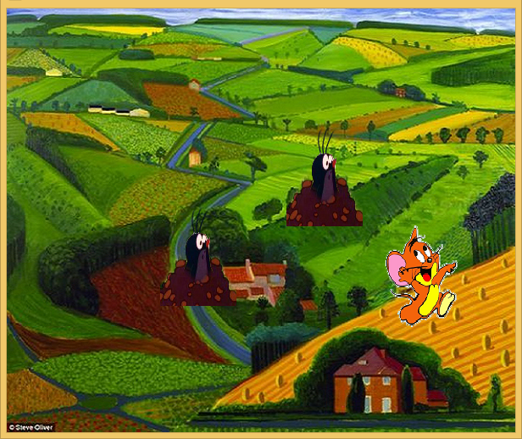  
  击中鼠之后的界面  
  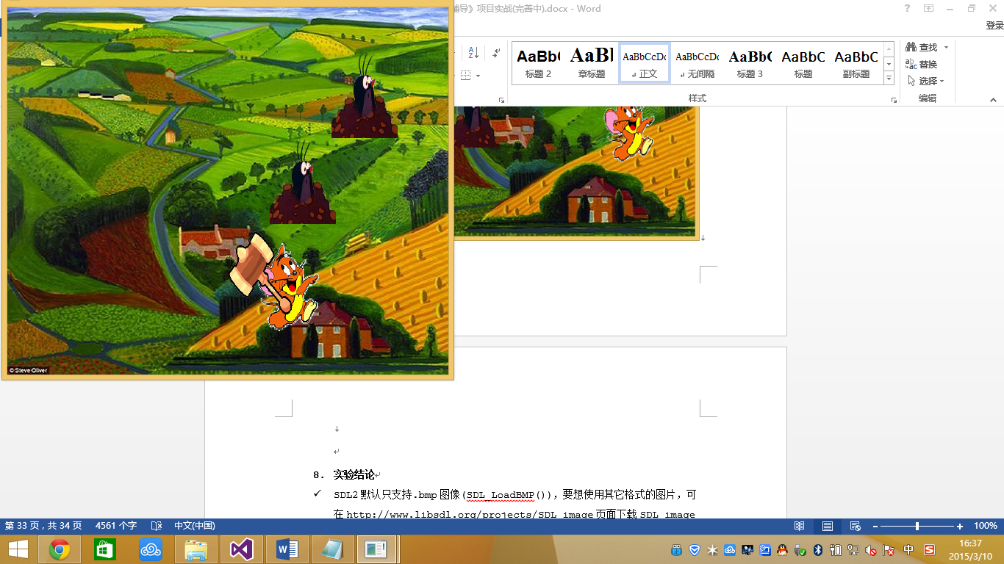

1. **实验结论**

* SDL2默认只支持.bmp图像(SDL_LoadBMP())，要想使用其它格式的图片，可在http://www.libsdl.org/projects/SDL_image页面下载SDL_image扩展组件，它支持BMP,GIF,JPEG,LBM,PCX,PNG,PNM,TGA,TIFF,WEBP,XCF,XPM,XV格式。  
  SDL_image扩展组件的一般使用流程为首先进行初始化

|  |
| --- |
| if (*IMG_Init*(*IMG_INIT_PNG*) == -1)  {  *SDL_LogError*(*SDL_LOG_CATEGORY_APPLICATION*, "Could not initialize SDL IMG.");  *exit*(-2);  } |

然后加载图像文件IMG_Load，使用完毕执行IMG_Quit()。