# **Travel website strategy**

## Goals

The website will have a travel theme and its aim is to bring altogether everything a user needs in order to book a holiday. Because everyone feels better when paying a low price for a good holiday, the website will have articles referring to last minute bookings and all sorts of other promotions.

Our team of developers will be in contact with small and medium resorts in order to promote them properly. They will have access to the website in order to post articles with promotions for our users.

There are lots of websites out there doing almost the same thing we do, for example: Booking, Trip Advisor, Trivago etc.

What is different from us and them is that we are targeting small and medium resorts whilst they are targeting hotels and big resorts. So we are trying to promote small businesses in order to make much more personal and unforgettable holidays.

S – the specific area for improvement is having an opportunity to visit the world at cheap prices

M – comparing to last years prices using the Travel platform, how will our prices be? Smaller?

A – the achievable goal is to get more than 1000 visitors a day

R – 1000 visitors a day is a realistically achievable goal with appropriate advertising on social media

T – judging from previous experiences, these results can be achieved in approximatively 3 months

## Content

Our content will be made of promotions, sales, popular events at discounted prices, videos and a fresh out-of-the-box travel platform. We will talk more about these on specific pages where are placed already in the wireframes.

The homepage starts with the navigation at the top as follows.

Screen%20Shot%202016-03-20%20at%2014.28.34.png

Each button in the navigation will link to our 5 main categories.

As a colour scheme we will use the following one for the buttons but for other sections as we’ll see further down in the report.

Screen%20Shot%202016-03-20%20at%2013.45.27.pngScreen%20Shot%202016-03-20%20at%2013.45.16.png

The events category will have the green (#23BD3C) as a background colour and a white (#ffffff) text colour for the text in the buttons. Font size will be 20pt and the border of the buttons and navigation will be white with a solid stroke of 2px.



Following the navigation, with a gap between elements of 25px, a bigger logo will be displayed, followed by an interesting quote about travelling that will be renewed automatically each day.

The quote will be placed between two <hr> - HTML elements to separate it from the rest of the content.

Font size for the quote will be 36pt and the colour will be lightgray, sometimes with coloured quotes matching one of the colours above.

Following the logo and quotes, the main page will have two big articles to advertise, one being the most popular article and the other one the most recent article. This strategy will be used throughout the website as it helps the user to get to the most popuar article in the least amount of time, but in the same time it keeps the user up to date with the most recent added articles.

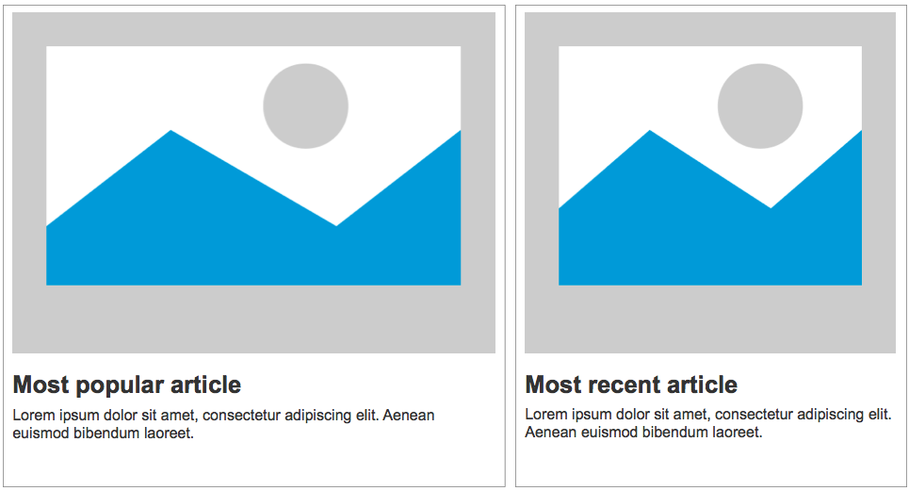

Both articles will consist of an image, heading and teaser text. The headlines will have a font size of 32pt, teaser font size will be 20pt, both coloured black and both with a character limit of 150.

The image can be both PNG or GIF for having transparency effects with PNG or active content given by GIF animations.

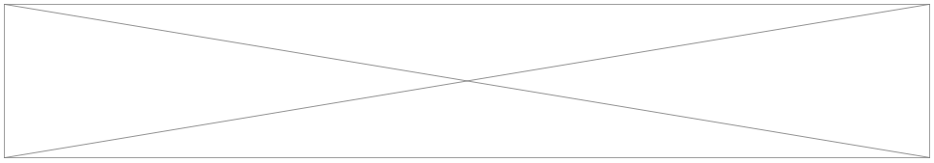

The articles will be followed by this banner which will link to one of our partner websites. Our team will make contact with local car hire businesses and exchange banners with them in order to get promotions.

This will help our website and their business grow in popularity together.

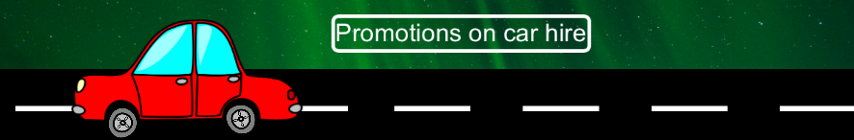

Following the banner will be our trending articles: for example, there is a great opportunity to go to Mallorca with £20 flight return for a 2 days getaway, go to Cork during week times for a starting price of £15 return flight etc.

Because it is a homepage it is best to have the trending articles here, to make sure the users get the best content in the shortest amount of time.

On the right hand side of the articles will be two hotspots and an extra banner. The first hotspot will have a demo on how the travel platform works. For example: there will be a GIF showing how to use it by dragging and dropping icons on the workspace and getting the desired results.

The second hotspot will have a GIF on how the locations page works and how to find the most suitable article in the least amount of time.

Lastly, below the second hotspot will be placed an interactive banner which will be related to the weather forecast as there is no feeling worse than having to stay indoors when you expect to go sunbath on the beach.

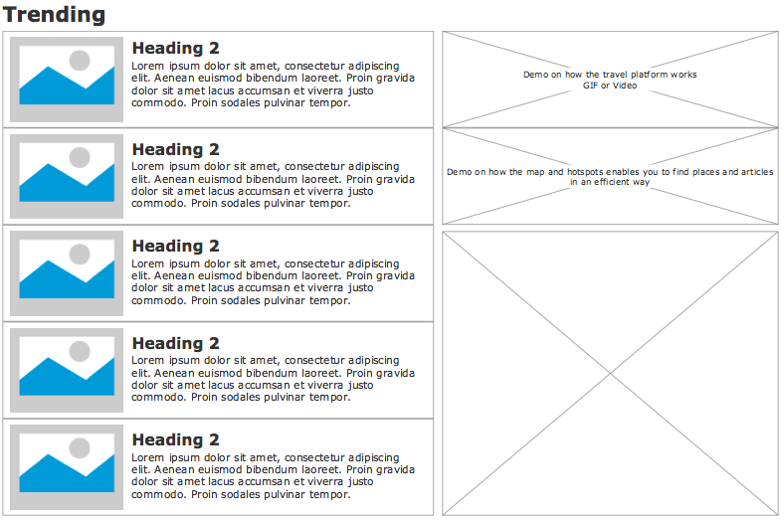

The Trending title will have a font size of 32pt, headings for the articles will be of 24pt size and the teaser text will be of 16pt.

The font throughout the website will be Verdana, a sans-serif font best used for the web, available on 99% of Macs, 99% Windows machines and 67% Linux machines. (statistics according to <http://www.apaddedcell.com>, <http://www.64notes.com> and <http://web.mit.edu/jmorzins/www/fonts.html)>

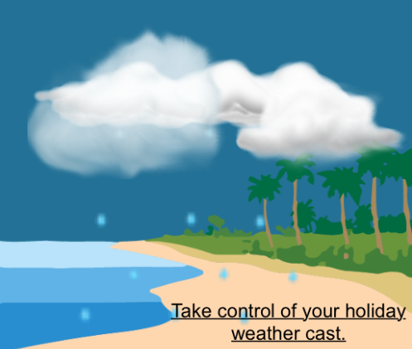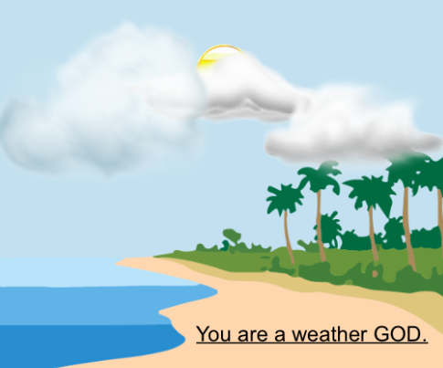

(user has not hovered the banner) (user has hovered the banner)

On click it will open the <http://www.accuweather.com> webpage for guiding the users of when is the best time to book a holiday.

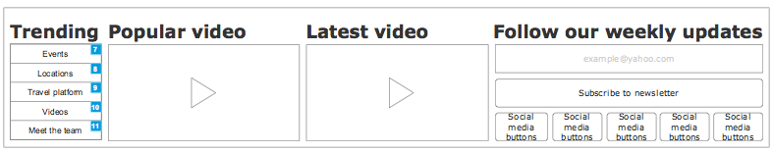

At the end of each page it will be placed a footer that will hold the following:

* A trending list of pages which is the same list in the navigation, the only difference being the last link, having Meet the team instead of About page.
* A popular video will be placed there as the users should be connected to the most interesting events all the time.
* The latest video comes should be advertised as well, being just a matter of time to becoming the most popular video.
* The last section of the footer consists of a subscription opportunity and buttons for a couple of our social medias where we will be active and will post about opportunities, promotions and events so that the users can stay connected to us all the time.

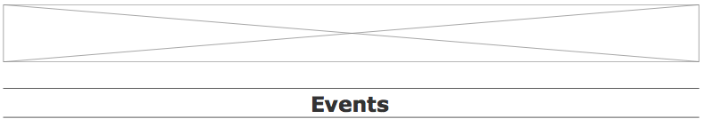

The following page in the navigation is named: Events.

This is closest to the homepage because the users are driven out from under their roof by amazing events such as: Tomorrowland, WeAreFSTVL, RockWerchter etc.

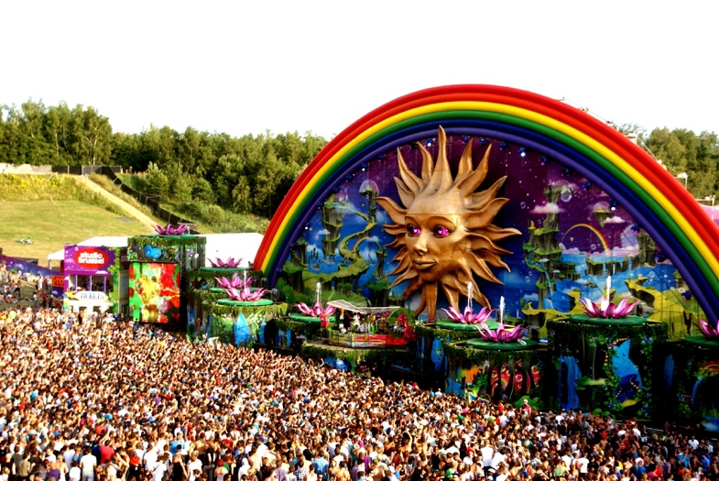

Festivals are where people gather to have fun. There is only one problem: they are expensive.

That is why we have a full category dedicated to that, where we can add promotions about them.

However, it is not the only subject covered in that category. All kinds of interesting events will be added there, so that visiting the world can be much more fun and with people getting the whole experience out of it.

There will be a banner at the top of the page advertising famous cities around the world, so that the users can get excited about their holiday, knowing that wherever they go, it is one of the most visited locations.

This banner will link to <https://www.airbnb.com> as they are one of the companies backing us, having the same target, promoting small and medium sized businesses in accommodation across the world, so that the our users can have a better and enjoyable holiday and cheaper prices.

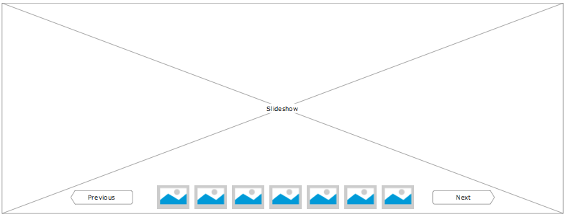

The main content of the page will start with a slideshow to make the users excited about the destination they are about to chose in order to spend days of freedom and relaxation.

Our articles will be sorted in descending order so that the users can find easily the most recent promotions and opportunities to get away from the city.

On the right hand side it will be placed a hotspot advertising our Videos category by having a GIF with some frames of a fun, interesting or popular part of one of our videos.

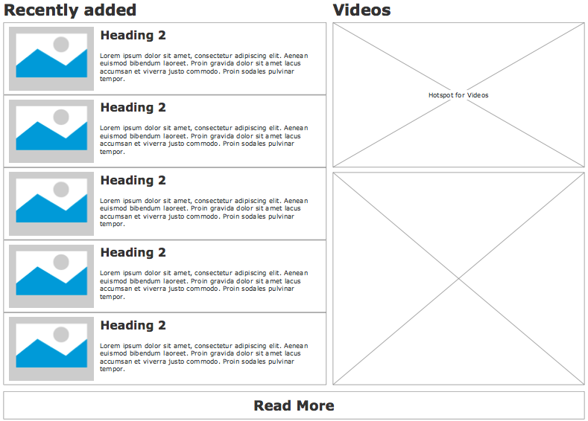

The Location page has articles sorted firstly on location, by showing them on the map.

However, the user has a filtering system so the location will not be the only filter the user can use when searching for great locations to visit.

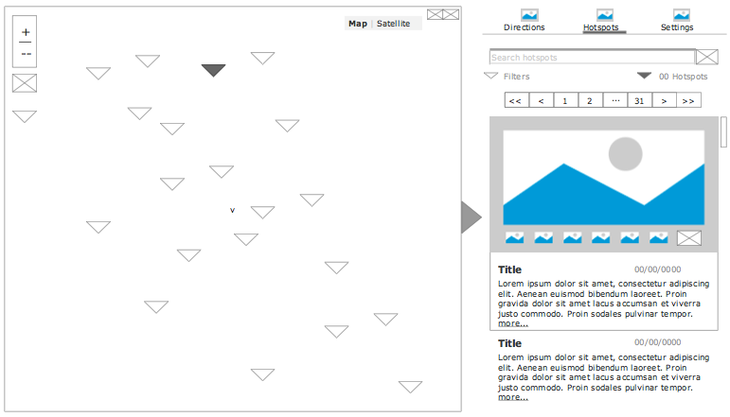

This is an extension that can be used in Joomla CMS named: Hotspots.

It works by selecting a pin on the map, it will scroll automatically on the right hand side selecting the article that corresponds to the location on the map. It can also filter on keywords or the user can just scroll through articles and when selecting one, it automatically centres its location on the map.

On this page and on the Travel platform it is placed the same AirBnb banner at the top.

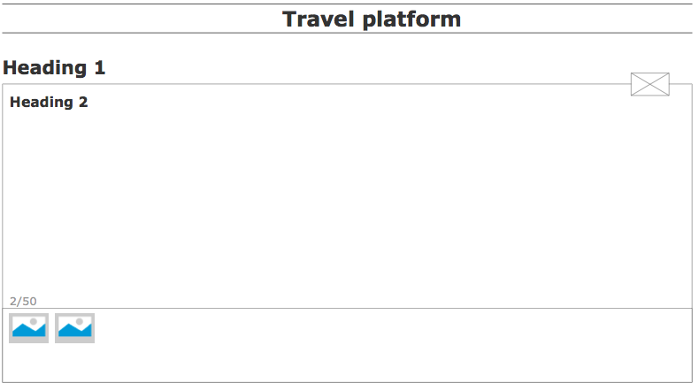

The Travel platform consists on a widget our team will create in Adobe Edge. This widget is aiming to get the prices that someone should expect when booking a holiday. At the bottom of the widget will be icons representing: accommodation, car hire, nights sleeping, number of beds, internet and others.

By dragging and dropping elements on the play area, it will create a range of prices to expect when booking flights and accommodation. We are measuring them based on previous years activity as in: September is a good month to go on a holiday in Greece. Cheap prices everywhere with lovely temperatures. During mid summer would be much more expensive with an unbearable temperature outside during the day.

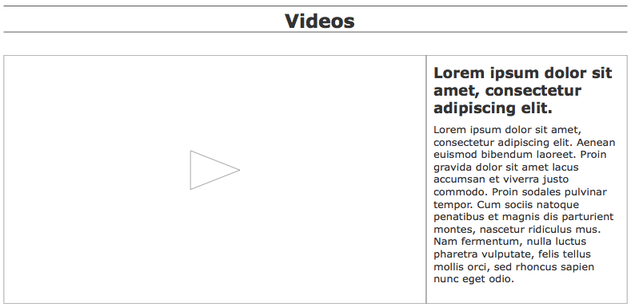

The videos page will have a most popular video at the top and lots of videos below it, where the user can scroll through and play them. The videos will have a heading (28pt) and a teaser description (20pt) to make the user understand what is it about.

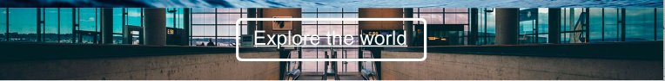

The banner on this page will link to one of our pages: Locations. This banner shows interesting images from big cities just to create a compelling image in our users’ mind about how is it like to explore the world.

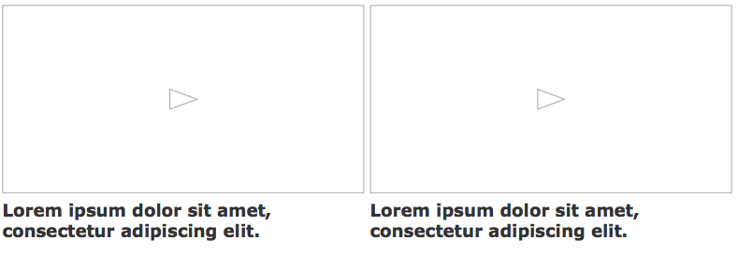

More videos after the banner by splitting the page in half with a distance between them of 10px. The page ends with a View more button that can release more videos to our users.

Besides the reused AirBnb banner at the top the About page will have a slideshow that will continuously slide to the left pictures with the team, what we went through creating the website, interesting pictures from our fans and clients etc.

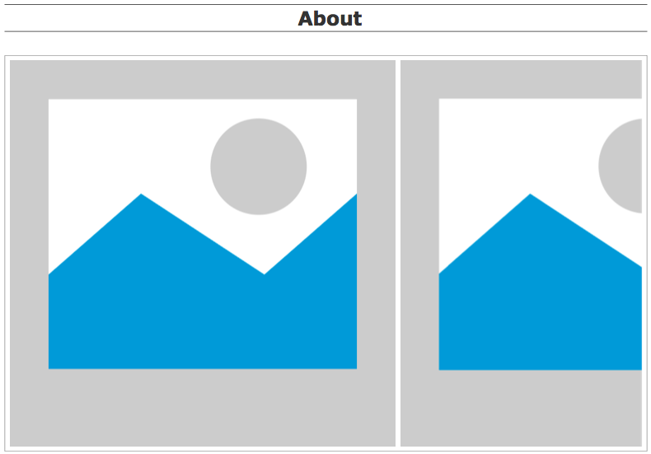

This image slideshow will be created in Adobe Edge and it will slide images to the left continuously.

Below it will be placed a short description of the team and a photo of all of us during a fancy dress party.

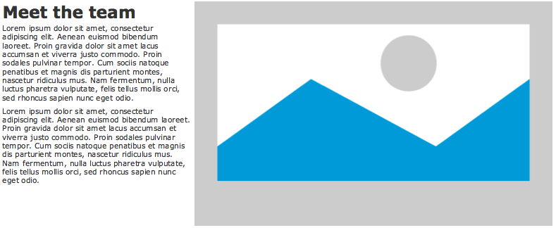

At the bottom of the About page it will be a Contact us form so that all users can give us feedback and ask questions or support.

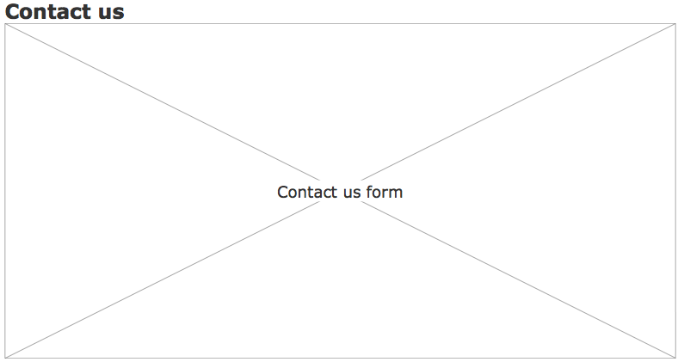

As you have seen above, the content is engaging having both interactive banners but also interactive content. The GIF hotspots and the Video gallery should bring the website to life.

The platform will support comments and sharing to social media, so that our members can share opinions and promotions to and with their friends.

## Screen%20Shot%202016-03-20%20at%2019.22.03.png

The site map with the page architecture is the one above. All the categories are on the same level. There are pages for each event and location, but the pages cannot be accessed through the menu. Only the landing pages are available from the menu. The user can click on an article’s title and go to its page.

## Users

The users targeted for our community are all people already aged 18 looking for holidays at a convenient price. Children can also go on holidays with parents that book holidays through our platform.

In order to have the website advertised our team will have paid advertisement on Facebook with £15 a month until we get started and we have around 1000 visits a day.

Our collaboration with AirBnb should also get users on our websites. Besides this, advertising small and medium resorts works both ways, as they will register on our platform to create promotions, so they will have to advertise our website as well.

Because most of the are looking for cheaper opportunities for holidays, we believe that our product combined with a couple of months of paid advertisement will cover all earned, paid and owned media.

Having promotions that expire will make the users come back to our website often.

The users don’t have to be proficient in technical skills as the website will be intuitive. The website should be responsive and can be accessed on all devices.

The users can develop an idea about how much they should pay on a holiday using our travel platform, so helping them save money will make them loyal to our platform.

There will be users to add articles and comments, but all of them should be published by someone in our team to make sure there are no issues of profanity.

The content placed on the website will be owned by our company as we are the ones hosting it.

## Resources

On a short term, the company will have to pay for advertisement until the website will be visited for at least 1000 views a day. After that, it should be self sustained with the collaborations and advertisement we already have with AirBnb and others.

After this period, on a long term, we should only work on approving articles and comments.

Once the website is up and going, self sustained on visitors, the team should start earning money on having adds and interactive banners in place of the ones we already have now.

With every article we add on the website, we are going to publish a new post on each social media that we will use: Facebook, Twitter, Instagram, YouTube, etc. Being active on the social media we can target young people and give them opportunities to visit the world at cheap prices.