Formal Modeling of ShopAdvizor in VDM++

Report



Integrated Master in Informatics and Computing Engineering

Formal Methods in Software Engineering

Class 3 - Group 3:
Daniel Filipe Santos Marques, up201503822@fe.up.pt
Maria Eduarda Santos Cunha, up201506524@fe.up.pt

Porto, 7th January 2019
Table of Contents
1 Informal System Description and List of Requirements 3
1.1 Informal System Description 3
1.2 List of Requirements 3
2 Visual UML Model 3
2.1 Use Case Model 3
2.2 Class Model 4
3 Formal VDM++ Model 6
3.1 Class Activity 6
3.2 Class Brand 7
3.3 Class Competition 8
3.4 Class Product 8
3.5 Class Retailer 10
3.6 Class ShopAdvizor 11
3.7 Class User 18
4 Model Validation 18
4.1 Class ShopAdvizorTest 18
5 Model Verification 23
5.1 Example of Domain Verification 23
5.2 Example of Invariant Verification 23
6 Code Generation 24
7 Conclusions 24
8 References 24

1 Informal System Description and List of Requirements

1.1 Informal System Description

Our system consists of an app where users can review products and consult reviews done by others. Furthermore, users may also participate in activities started by a brand in order to attempt to win a monetary prize set out for each particular activity.
In addition to this, users may also see listings of different system information, such as existing products, brands, retailers and competitions.

1.2 List of Requirements

The following table states all the system’s requirements, which can directly translate into use cases.
Note that a user may be of type Normal, Retailer, Brand or Admin. There is also the concept of a guest user, which would be an unauthenticated visitor.
Requirements R1 to R5 are common to all users. Admin users have permission to do everything the other users can do.

Id | Priority | Description
R1 | Mandatory | A user may see all products in the system.
R2 | Optional | A user may see all brands in the system.
R3 | Optional | A user may see all retailers in the system.
R4 | Mandatory | A user may see all competitions in the system.
R5 | Mandatory | A user may see a product’s reviews.
R6 | Mandatory | A normal user may see the reviews they have made.
R7 | Mandatory | A normal user may see the competitions they are in.
R8 | Mandatory | A normal user may add a review to a product.
R9 | Optional | A normal user may remove a review they have made.
R10 | Mandatory | A normal user may join a competition.
R11 | Mandatory | A retailer user may add themselves as a retailer.
R12 | Mandatory | A retailer user may add a product to their corresponding retailer.
R13 | Mandatory | A brand user may add themselves as a brand.
R14 | Mandatory | A brand user may add a product under their brand.
R15 | Mandatory | A brand user may add an activity.
R16 | Mandatory | A brand user may initiate an activity.
R17 | Mandatory | A brand user may close an activity.
R18 | Mandatory | A brand user may choose a winner in a competition.

2 Visual UML Model

2.1 Use Case Model

The original image can be found in /generated/useCases.png.

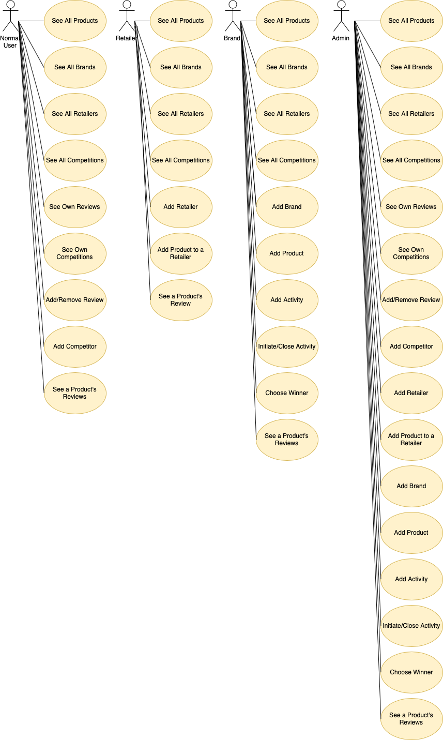

Scenario | See all products
Description | Normal scenario for a user who wants a listing of all products.
Pre-conditions | (unspecified)
Post-conditions | (unspecified)
Steps
Exception

Scenario | See all brands
Description | Normal scenario for a user who wants a listing of all brands.
Pre-conditions | (unspecified)
Post-conditions | (unspecified)
Steps
Exception

Scenario | See all retailers
Description | Normal scenario for a user who wants a listing of all retailers.
Pre-conditions | (unspecified)
Post-conditions | (unspecified)
Steps
Exception

Scenario | See all competitions
Description | Normal scenario for a user who wants a listing of all competitions.
Pre-conditions | (unspecified)
Post-conditions | (unspecified)
Steps
Exception

Scenario | See a product’s reviews
Description | Normal scenario for a user who wants a listing of all reviews of a product.
Pre-conditions | (unspecified)
Post-conditions | (unspecified)
Steps
Exception

Scenario | See own competitions
Description | Normal scenario for a user who wants a listing of the competitions they are in.
Pre-conditions | 1. User must be normal.
Post-conditions | (unspecified)
Steps
Exception

Scenario | See own reviews
Description | Normal scenario for a user who wants a listing of the reviews they have made.
Pre-conditions | 1. User must be normal.
Post-conditions | (unspecified)
Steps
Exception

Scenario | Add review
Description | Normal scenario for a user who wants to add a review to a product.
Pre-conditions | 1. User must be normal.  2. Product (and brand combination) is in the system.  3. User has no review on that product.
Post-conditions | 1. Review is under that product.
Steps
Exception

Scenario | Remove review
Description | Normal scenario for a user who wants to remove a review they have made on a product.
Pre-conditions | 1. User must be normal.  2. User must have a review on that product.
Post-conditions | 1. Review is no lunger under that product.
Steps
Exception

Scenario | Add competitor
Description | Normal scenario for a user who wants to join a competition.
Pre-conditions | 1. User must be normal.  2. User is not in that competition.  3. Competition has not started.
Post-conditions | 1. User is in competition.
Steps
Exception

Scenario | Add retailer
Description | Normal scenario for a user who wants to add a retailer to the system.
Pre-conditions | 1. User must be a retailer.  2. Retailer is not in the system.
Post-conditions | 1. Retailer is in the system.
Steps
Exception

Scenario | Add product to a retailer
Description | Normal scenario for a user who wants to add a product to a certain retailer.
Pre-conditions | 1. User must be a brand.  2. Product (and brand combination) is not registered under that retailer.
Post-conditions | 1. Product is under that retailer.
Steps
Exception

Scenario | Add brand
Description | Normal scenario for a user who wants to add a brand to the system.
Pre-conditions | 1. User must be a brand.  2. Brand is not in the system.
Post-conditions | 1. Brand is in the system.
Steps
Exception

Scenario | Add product
Description | Normal scenario for a user who wants to add a product to the system.
Pre-conditions | 1. User must be a brand.  2. Product (and brand combination) is not in the system.
Post-conditions | 1. Product is in the system.
Steps
Exception

Scenario | Add activity
Description | Normal scenario for a user who wants to add an activity to the system.
Pre-conditions | 1. User must be a brand.  2. Activity is not in the system.
Post-conditions | 1. Activity is in the system.
Steps
Exception

Scenario | Initiate activity
Description | Normal scenario for a user who wants to initiate an activity.
Pre-conditions | 1. User must be a brand.  2. Activity has not started.
Post-conditions | 1. Activity has started.
Steps
Exception

Scenario | Close activity
Description | Normal scenario for a user who wants to close an activity.
Pre-conditions | 1. User must be a brand.  2. Activity has not ended.  3. Activity has started.
Post-conditions | 1. Activity has ended.
Steps
Exception

Scenario | Choose winner
Description | Normal scenario for a user who wants to choose a winner in a competition.
Pre-conditions | 1. User must be a brand.  2. Competition has started and ended.  3. Winner has not be chosen yet.  4. User to be chosen is in competition.
Post-conditions | 1. User is that competition’s winner.  2. Winner is in competition.
Steps
Exception

2.2 Class Model

The following class diagram represents all the implemented classes in VDM++, their attributes and operations and the associations between them. This class diagram was generated by Overture. The original image can be found in /generated/classDiagram.png.

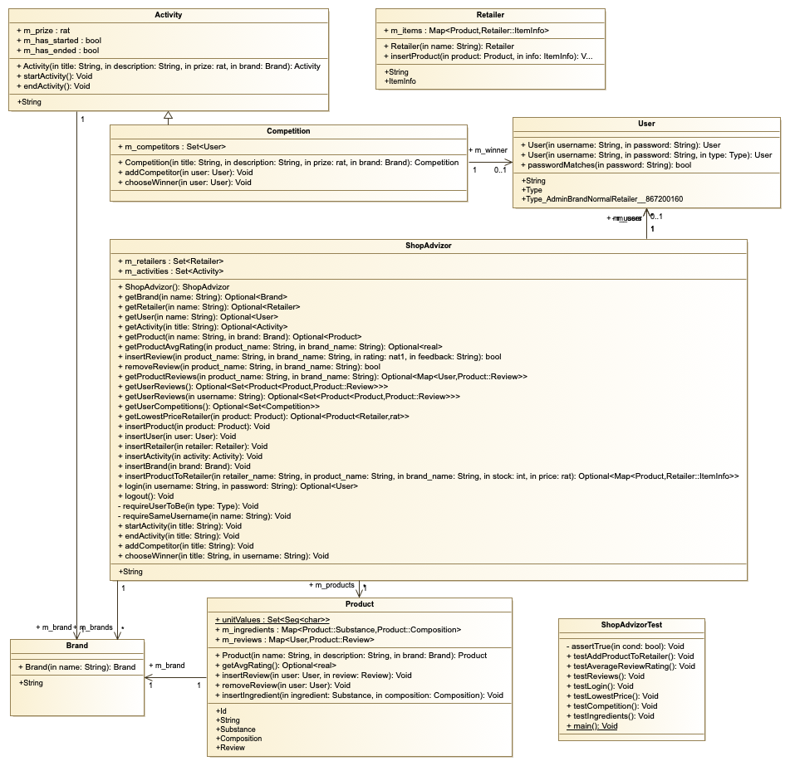

Class | Description
Activity | Defines an activity with a begin and end date. It is created by a brand user and has a description which defines its objective and rules. Each activity has an associated monetary prize.
Brand | Defines a brand which is attributed to a product. A brand can also create activities.
Competition | Subclass of Activity; Defines a competition by adding users to compete and a winner once the activity is finished.
Product | Defines a product in the system. Products can have user reviews composed by a rating and a review. It also stores its nutritional composition (ingredients) and its quantity.
Retailer | Defines a retailer responsible for the sale of products. Each retailer has information regarding stock and price of its products.
ShopAdvizor | Main class; Defines the system where all elements are initialized, added, modified, removed or queued.
ShopAdvizorTest | Class where all tests are implemented. This class tests all the system requirements with perfect coverage.
User | Defines a user who may view products’ reviews, manage their own reviews and partake in competitions.

3 Formal VDM++ Model

3.1 Class Activity

class Activity
/*
Defines an activity composed of a begin and end date, a description which explains
what is consists of and a prize.
Daniel Marques & Eduarda Cunha, FEUP, MFES, 2018/19.
*/

types
public String = seq1 of char;

instance variables
public m_title : String;
public m_description : String;
public m_prize: rat;
public m_brand : Brand;
public m_has_started : bool := false;
public m_has_ended : bool := false;

inv m_has_ended => m_has_started;
inv m_prize >= 0.0;

operations
-- Activity constructor
public Activity : String * String * rat * Brand ==> Activity
Activity(title, description, prize, brand) ==
(
m_title := title;
m_description := description;
m_prize := prize;
m_brand := brand;
m_has_started := false;
m_has_ended := false;
return self;
);

-- Start the activity
public startActivity : () ==> ()
startActivity() ==
(
m_has_started := true;
)
pre not m_has_started
post m_has_started = true;

-- End the activity
public endActivity : () ==> ()
endActivity() ==
(
m_has_ended := true;
)
pre not m_has_ended and m_has_started
post m_has_ended = true;

end Activity

3.2 Class Brand

class Brand
/*
Defines a brand which can manufacture a product.
Daniel Marques & Eduarda Cunha, FEUP, MFES, 2018/19.
*/

types
public String = seq1 of char;

instance variables
public m_name: String;

operations
-- Brand constructor
public Brand : String ==> Brand
Brand(name) ==
(
m_name := name;
return self;
);

end Brand

3.3 Class Competition

class Competition is subclass of Activity
/*
Defines a competition which is an activity with users as competitors
and a winner once the activity is completed.
Daniel Marques & Eduarda Cunha, FEUP, MFES, 2018/19.
*/

instance variables
public m_competitors : set of User;
public m_winner : [User];

inv forall u1, u2 in set m_competitors & u1 <> u2 => u1.m_username <> u2.m_username;
inv m_winner = nil or (m_has_ended and m_winner in set m_competitors); -- Winner must be a competitor

operations
-- Competition constructor
public Competition : String * String * rat * Brand ==> Competition
Competition(title, description, prize, brand) ==
(
m_competitors := {};
m_winner := nil;
Activity(title, description, prize, brand);
);

-- Add a competitor
public addCompetitor : User ==> ()
addCompetitor(user) ==
(
m_competitors := m_competitors union {user}
)
pre user not in set m_competitors and not m_has_started
post m_competitors = m_competitors~ union {user};

-- Choose winner
public chooseWinner : User ==> ()
chooseWinner(user) ==
(
m_winner := user;
)
pre m_has_started and m_has_ended and m_winner = nil and user in set m_competitors
post m_winner = user and m_winner in set m_competitors;

end Competition

3.4 Class Product

class Product
/*
Defines a product to be reviewed.
Since a product is composed of substances in certain proportions
the units in which they are measured are also defined.
Daniel Marques & Eduarda Cunha, FEUP, MFES, 2018/19.
*/

types
public Id = nat1;
public String = seq1 of char;
public Substance = seq1 of char;
public Composition :: quantity: real
unit: seq1 of char
inv c == c.unit in set unitValues;
public Review :: rating: nat1
feedback: seq1 of char
inv review == review.rating >= 1 and review.rating <= 5;

values
public unitValues : set of seq1 of char = {"Kg", "g", "l", "ml", "%", "units"};

instance variables
public m_id: Id;
private static m_next_id : Id := 1;
public m_name: String;
public m_description: String;
public m_brand: Brand;
public m_ingredients: map Substance to Composition;
public m_reviews: map User to Review;

operations
-- Product constructor
public Product : String * String * Brand ==> Product
Product(name, description, brand) ==
(
m_id := m_next_id;
m_next_id := m_next_id + 1;
m_name := name;
m_description := description;
m_brand := brand;
m_ingredients := { |-> };
m_reviews := { |-> };
return self;
);

-- Returns the average review rating
public getAvgRating : () ==> [real]
getAvgRating() ==
(
dcl sum : int := 0;
dcl num_reviews : int := card rng m_reviews;

if num_reviews = 0
then return nil;

for all review in set rng m_reviews do sum := sum + review.rating;
return sum / num_reviews;
);

--Adds a review and the user who did it to reviews map
public insertReview : User * Review ==> ()
insertReview(user, review) ==
(
m_reviews := m_reviews ++ {user |-> review}
)
pre user not in set dom m_reviews
post m_reviews = m_reviews~ ++ {user |-> review};

--Removes a review from the reviews map
public removeReview : User ==> ()
removeReview(user) ==
(
m_reviews := {user} <-: m_reviews
)
pre user in set dom m_reviews
post {user} <: m_reviews = {|->};

--Adds an igredient and its quantity and unit to ingredients map
public insertIngredient : Substance * Composition ==> ()
insertIngredient(ingredient, composition) ==
(
m_ingredients := m_ingredients ++ {ingredient |-> composition}
)
pre ingredient not in set dom m_ingredients
post m_ingredients = m_ingredients~ ++ {ingredient |-> composition};

end Product

3.5 Class Retailer

class Retailer
/*
Defines a retailer which can sell a product.
Daniel Marques & Eduarda Cunha, FEUP, MFES, 2018/19.
*/

types
public String = seq1 of char;
public ItemInfo :: stock: int
price: rat;

instance variables
public m_name: String;
public m_items: map Product to ItemInfo := { |-> };

operations
-- Retailer constructor
public Retailer : String ==> Retailer
Retailer(name) ==
(
m_name := name;
return self;
);

--Adds a product and its info (stock and price) to items map
public insertProduct : Product * ItemInfo ==> ()
insertProduct(product, info) ==
(
m_items := m_items ++ {product |-> info}
)
pre product not in set dom m_items
post m_items = m_items~ ++ {product |-> info};

end Retailer

3.6 Class ShopAdvizor

class ShopAdvizor
/*
Contains the core model of the ShopAdvizor app.
Defines the state variables and operations available to the users.
Daniel Marques & Eduarda Cunha, FEUP, MFES, 2018/19.
*/

types
public String = seq1 of char;

instance variables
public m_products: set of Product;
public m_users: set of User;
public m_retailers: set of Retailer;
public m_brands: set of Brand;
public m_activities: set of Activity;
private m_user: [User];

inv forall b1, b2 in set m_brands & b1 <> b2 => b1.m_name <> b2.m_name;
inv forall r1, r2 in set m_retailers & r1 <> r2 => r1.m_name <> r2.m_name;
inv forall u1, u2 in set m_users & u1 <> u2 => u1.m_username <> u2.m_username;
inv forall p1, p2 in set m_products & p1 <> p2 => p1.m_name <> p2.m_name or p1.m_brand <> p2.m_brand;
inv forall a1, a2 in set m_activities & a1 <> a2 => a1.m_title <> a2.m_title;
inv m_user = nil or m_user in set m_users;

operations
-- ShopAdvizor constructor
public ShopAdvizor : () ==> ShopAdvizor
ShopAdvizor() ==
(
m_products := {};
m_users := {};
m_retailers := {};
m_brands := {};
m_activities := {};
m_user := nil;
return self;
);

-- Get brand by name
public getBrand : String ==> [Brand]
getBrand(name) ==
(
dcl brand : Brand;
if exists1 b in set m_brands & b.m_name = name
then (
brand := iota b in set m_brands & b.m_name = name;
return brand;
)
else return nil;
);

-- Get retailer by name
public getRetailer : String ==> [Retailer]
getRetailer(name) ==
(
dcl retailer : Retailer;
if exists1 r in set m_retailers & r.m_name = name
then (
retailer := iota r in set m_retailers & r.m_name = name;
return retailer;
)
else return nil;
);

-- Get user by name
public getUser : String ==> [User]
getUser(name) ==
(
dcl user : User;
if exists1 u in set m_users & u.m_username = name
then (
user := iota u in set m_users & u.m_username = name;
return user;
)
else return nil;
);

-- Get activity by title
public getActivity : String ==> [Activity]
getActivity(title) ==
(
dcl activity : Activity;
if exists1 a in set m_activities & a.m_title = title
then (
activity := iota a in set m_activities & a.m_title = title;
return activity;
)
else return nil;
);

-- Get product by name and brand
public getProduct : String * Brand ==> [Product]
getProduct(name, brand) ==
(
dcl product : Product;
if exists1 p in set m_products & p.m_name = name and p.m_brand = brand
then (
product := iota p in set m_products & p.m_name = name and p.m_brand = brand;
return product;
)
else return nil;
);

-- Gets the average rating of a product
public getProductAvgRating : String * String ==> [real]
getProductAvgRating(product_name, brand_name) ==
(
dcl brand : [Brand] := getBrand(brand_name);
dcl product : [Product];
if brand = nil then return nil;
product := getProduct(product_name, brand);
if product = nil then return nil
else return product.getAvgRating();
);

-- Insert a user review on a product
public insertReview : String * String * nat1 * String ==> bool
insertReview(product_name, brand_name, rating, feedback) ==
(
dcl brand : [Brand] := getBrand(brand_name);
dcl product : [Product];
requireUserToBe(<Normal>);
if brand = nil then return false;
product := getProduct(product_name, brand);
if product = nil then return false
else (
product.insertReview(m_user, mk_Product`Review(rating, feedback));
return true;
)
);

-- Remove a user review on a product
public removeReview : String * String ==> bool
removeReview(product_name, brand_name) ==
(
dcl brand : [Brand] := getBrand(brand_name);
dcl product : [Product];
requireUserToBe(<Normal>);
if brand = nil then return false;
product := getProduct(product_name, brand);
if product = nil then return false
else (
product.removeReview(m_user);
return true;
)
);

-- Gets all reviews of a product
public getProductReviews : String * String ==> [map User to Product`Review]
getProductReviews(product_name, brand_name) ==
(
dcl brand : [Brand] := getBrand(brand_name);
dcl product : [Product];
if brand = nil then return nil;
product := getProduct(product_name, brand);
if product = nil then return nil
else return product.m_reviews
);

-- Gets all reviews given by the logged in user
public getUserReviews : () ==> [set of (Product * Product`Review)]
getUserReviews() ==
(
return getUserReviews(m_user.m_username);
)
pre m_user <> nil;

-- Gets all reviews given by a user
public getUserReviews : String ==> [set of (Product * Product`Review)]
getUserReviews(username) ==
(
dcl user : [User] := getUser(username);
dcl reviews : set of (Product * Product`Review);
if user = nil
then return nil
else (
reviews := dunion { { mk_(r, r.m_reviews(user)) | u in set dom r.m_reviews & u = user} | r in set m_products};
return reviews;
)
);

-- Gets the competitions the user is competing on
public getUserCompetitions : () ==> [set of Competition]
getUserCompetitions() ==
(
dcl competitions : set of Competition;
requireUserToBe(<Normal>);
competitions := { c | c in set m_activities & isofclass(Competition,c) and m_user in set narrow_(c,Competition).m_competitors};
return competitions;
);

-- Gets the retailer with the lowest price on a product
public getLowestPriceRetailer : Product ==> [Retailer * rat]
getLowestPriceRetailer(product) ==
(
dcl retailer : Retailer * rat; -- Retailer that sells for the lowest price
dcl retailers : set of (Retailer * rat); -- Retailers that sell the product
if product not in set m_products
then return nil
else (
retailers := { mk_(r, r.m_items(product).price) | r in set m_retailers & product in set dom r.m_items };
if exists r1 in set retailers & (forall r2 in set retailers & r1.#2 <= r2.#2)
then (
retailer := iota r1 in set retailers & (forall r2 in set retailers & r1.#2 <= r2.#2);
return retailer;
)
else return nil;
)
);

--Adds a product to products set
public insertProduct : Product ==> ()
insertProduct(product) ==
(
requireUserToBe(<Brand>);
requireSameUsername(product.m_brand.m_name);
m_products := m_products union {product}
)
pre product not in set m_products and product.m_brand in set m_brands
post m_products = m_products~ union {product};

--Adds a user to users set
public insertUser : User ==> ()
insertUser(user) ==
(
m_users := m_users union {user}
)
pre user not in set m_users
post m_users = m_users~ union {user};

--Adds a retailer to retailers set
public insertRetailer : Retailer ==> ()
insertRetailer(retailer) ==
(
requireUserToBe(<Retailer>);
requireSameUsername(retailer.m_name);
m_retailers := m_retailers union {retailer}
)
pre retailer not in set m_retailers
post m_retailers = m_retailers~ union {retailer};

--Adds an activity to activities set
public insertActivity : Activity ==> ()
insertActivity(activity) ==
(
requireUserToBe(<Brand>);
requireSameUsername(activity.m_brand.m_name);
m_activities := m_activities union {activity}
)
pre activity not in set m_activities
post m_activities = m_activities~ union {activity};

--Adds a brand to brands set
public insertBrand : Brand ==> ()
insertBrand(brand) ==
(
requireUserToBe(<Brand>);
requireSameUsername(brand.m_name);
m_brands := m_brands union {brand}
)
pre brand not in set m_brands
post m_brands = m_brands~ union {brand};

-- Adds a product to a retailer
public insertProductToRetailer : String * String * String * int * rat ==> [ map Product to Retailer`ItemInfo]
insertProductToRetailer(retailer_name, product_name, brand_name, stock, price) ==
(
dcl brand : [Brand] := getBrand(brand_name);
dcl retailer: [Retailer] := getRetailer(retailer_name);
dcl product : [Product];
requireUserToBe(<Retailer>);
if brand = nil then return nil;
product := getProduct(product_name, brand);
if product = nil or retailer = nil then return nil
else (
requireSameUsername(retailer.m_name);
retailer.insertProduct(product, mk_Retailer`ItemInfo(stock, price));
return retailer.m_items;
)
);

--Login
public login : String * String ==> [User]
login(username, password) ==
(
if exists1 u in set m_users & u.m_username = username and u.passwordMatches(password)
then (
m_user := iota u in set m_users & u.m_username = username and u.passwordMatches(password);
return m_user;
)
else return nil;
)
pre m_user = nil
post (RESULT <> nil and m_user <> nil) or (RESULT = nil and m_user = nil);

--Logout
public logout : () ==> ()
logout() ==
(
m_user := nil;
)
pre m_user <> nil
post m_user = nil;

-- Enforce user permissions
private requireUserToBe : User`Type ==> ()
requireUserToBe(type) == return
pre m_user <> nil and m_user.m_type = type or m_user.m_type = <Admin>;

-- Enforce same username
private requireSameUsername : String ==> ()
requireSameUsername(name) == return
pre m_user <> nil and m_user.m_username = name or m_user.m_type = <Admin>;

-- Start activity
public startActivity : String ==> ()
startActivity(title) ==
(
dcl activity : [Activity] := getActivity(title);
requireUserToBe(<Brand>);
if activity <> nil
then (
requireSameUsername(activity.m_brand.m_name);
activity.startActivity();
)
);

-- End activity
public endActivity : String ==> ()
endActivity(title) ==
(
dcl activity : [Activity] := getActivity(title);
requireUserToBe(<Brand>);
if activity <> nil
then (
requireSameUsername(activity.m_brand.m_name);
activity.endActivity();
)
);

-- Add competitor to competition
public addCompetitor : String ==> ()
addCompetitor(title) ==
(
dcl activity : [Activity] := getActivity(title);
dcl competition : Competition;
requireUserToBe(<Normal>);
if activity <> nil and isofclass(Competition, activity)
then (
competition := narrow_(activity, Competition);
competition.addCompetitor(m_user)
);
);

-- Choose winner of a competition
public chooseWinner : String * String ==> ()
chooseWinner(title, username) ==
(
dcl activity : [Activity] := getActivity(title);
dcl competition : Competition;
dcl user : [User] := getUser(username);
requireUserToBe(<Brand>);
if user <> nil and activity <> nil and isofclass(Competition, activity)
then (
requireSameUsername(activity.m_brand.m_name);
competition := narrow_(activity, Competition);
competition.chooseWinner(user);
)
);

end ShopAdvizor

3.7 Class User

class User
/*
Defines a user to can use the app.
Since with different permitions are allowed to do different things,
those types are defined here.
Daniel Marques & Eduarda Cunha, FEUP, MFES, 2018/19.
*/

types
public String = seq1 of char;
public Type = <Normal> | <Retailer> | <Brand> | <Admin>

instance variables
public m_username: String;
public m_type: Type;
private m_password: String;

operations
-- User constructor
public User : String * String ==> User
User(username, password) ==
(
m_username := username;
m_password := password;
m_type := <Normal>;
return self;
);

-- User constructor
public User : String * String * Type ==> User
User(username, password, type) ==
(
m_username := username;
m_password := password;
m_type := type;
return self;
);

-- Checks if the password matches
public passwordMatches : String ==> bool
passwordMatches(password) == return m_password = password;

end User

4 Model Validation

4.1 Class ShopAdvizorTest

Our project presently has 100% coverage as can be seen all throughout section 3 Formal VDM++ Model, as all classes have green highlighting to represent the code covered by our tests.
The following class (ShopAdvizorTest) tests all the system requirements.

class ShopAdvizorTest
/*
Contains the test cases for the ShopAdvizor app.
Illustrates a scenario-based testing approach.
The test cases cover all usage scenarios.
Daniel Marques & Eduarda Cunha, FEUP, MFES, 2018/19.
*/

values
private admin : User = new User("admin", "admin", <Admin>);

operations
private assertTrue: bool ==> ()
assertTrue(cond) == return
pre cond;

public testAddProductToRetailer: () ==> ()
testAddProductToRetailer() ==
(
dcl shopAdvizor : ShopAdvizor := new ShopAdvizor();
dcl brand : Brand := new Brand("Chip Mix");
dcl product : Product := new Product("Bolachas", "Bolachas de Chocolate", brand);
dcl info : Retailer`ItemInfo := mk_Retailer`ItemInfo(20, 2.1);
dcl retailer : Retailer := new Retailer("Pingo Doce");
dcl user : User := new User("Pingo Doce", "pingo_doce", <Retailer>);
shopAdvizor.insertUser(admin);
assertTrue(shopAdvizor.login("admin", "admin") = admin);
shopAdvizor.insertUser(user);
shopAdvizor.insertBrand(brand);
shopAdvizor.insertProduct(product);
shopAdvizor.insertRetailer(retailer);
shopAdvizor.logout();
assertTrue(shopAdvizor.login("Pingo Doce", "pingo_doce") = user);
assertTrue(shopAdvizor.insertProductToRetailer("Pingo Azedo", "Bolachas", "Chip Mix", info.stock, info.price) = nil);
assertTrue(shopAdvizor.insertProductToRetailer("Pingo Doce", "Bolachas", "Oreo", info.stock, info.price) = nil);
assertTrue(shopAdvizor.insertProductToRetailer("Pingo Doce", "Detergente da Roupa", "Chip Mix", info.stock, info.price) = nil);
assertTrue(shopAdvizor.insertProductToRetailer("Pingo Doce", "Bolachas", "Chip Mix", info.stock, info.price) = {product |-> info});
);

public testAverageReviewRating : () ==> ()
testAverageReviewRating() ==
(
dcl shopAdvizor : ShopAdvizor := new ShopAdvizor();
dcl brand : Brand := new Brand("Chip Mix");
dcl product : Product := new Product("Bolachas", "Bolachas de Chocolate", brand);
dcl u1 : User := new User("u1", "p1");
dcl u2 : User := new User("u2", "p2");
shopAdvizor.insertUser(admin);
shopAdvizor.insertUser(u1);
shopAdvizor.insertUser(u2);
assertTrue(shopAdvizor.login("admin", "admin") = admin);

assertTrue(shopAdvizor.getProductAvgRating("Bolachas", "Chip Mix") = nil);
shopAdvizor.insertBrand(brand);
assertTrue(shopAdvizor.getProductAvgRating("Bolachas", "Chip Mix") = nil);
shopAdvizor.insertProduct(product);

shopAdvizor.logout();
assertTrue(shopAdvizor.getProductAvgRating("Bolachas", "Chip Mix") = nil);
assertTrue(shopAdvizor.login("u1", "p1") = u1); -- Insert review with user u1
assertTrue(shopAdvizor.insertReview("Bolachas", "Oreos", 1, "mau") = false); -- Oreos does not exist
assertTrue(shopAdvizor.insertReview("Bolachas", "Chip Mix", 1, "mau") = true);
assertTrue(shopAdvizor.getProductAvgRating("Bolachas", "Chip Mix") = 1); -- Average of {1} = 1
shopAdvizor.logout();
assertTrue(shopAdvizor.login("u2", "p2") = u2); -- Insert review with user u2
assertTrue(shopAdvizor.insertReview("Ketchup", "Chip Mix", 1, "mau") = false); -- Chip Mix does not sell Ketchup
assertTrue(shopAdvizor.insertReview("Bolachas", "Chip Mix", 4, "bom") = true);
assertTrue(shopAdvizor.getProductAvgRating("Bolachas", "Chip Mix") = 2.5); -- Average of {1, 4} = 2.5

-- Remove review
assertTrue(shopAdvizor.removeReview("Bolachas", "Oreos") = false); -- Oreos does not exist
assertTrue(shopAdvizor.removeReview("Ketchup", "Chip Mix") = false); -- Chip Mix does not sell Ketchup
assertTrue(shopAdvizor.removeReview("Bolachas", "Chip Mix") = true); -- Remove review of user u2
assertTrue(shopAdvizor.getProductAvgRating("Bolachas", "Chip Mix") = 1); -- Average of {1} = 1
);

public testReviews : () ==> ()
testReviews() ==
(
dcl shopAdvizor : ShopAdvizor := new ShopAdvizor();
dcl b1 : Brand := new Brand("b1");
dcl b2 : Brand := new Brand("b2");
dcl p1 : Product := new Product("p1", "pd1", b1);
dcl p2 : Product := new Product("p2", "pd2", b2);
dcl u1 : User := new User("n1", "np1");
dcl u2 : User := new User("n2", "np2");
shopAdvizor.insertUser(admin);
assertTrue(shopAdvizor.login("admin", "admin") = admin);
shopAdvizor.insertBrand(b1);
shopAdvizor.insertBrand(b2);
shopAdvizor.insertProduct(p1);
shopAdvizor.insertProduct(p2);
shopAdvizor.insertUser(u1);
shopAdvizor.insertUser(u2);

assertTrue(shopAdvizor.getUserReviews("n3") = nil); -- User n3 is not in the system
assertTrue(shopAdvizor.getUserReviews("n1") = {}); -- User n1 does not have any reviews
assertTrue(shopAdvizor.getProductReviews("p3", "b1") = nil); -- Product p3 does not exist
assertTrue(shopAdvizor.getProductReviews("p1", "b3") = nil); -- Brand b3 does not exist
assertTrue(shopAdvizor.getProductReviews("p1", "b1") = {|->}); -- Product p3 of brand b3 has no reviews

p1.insertReview(u1, mk_Product`Review(1, "fb1")); -- User1 has a review on Product1
assertTrue(shopAdvizor.getUserReviews("n1") = { mk_(p1, mk_Product`Review(1, "fb1")) });
assertTrue(shopAdvizor.getProductReviews("p1", "b1") = { u1 |-> mk_Product`Review(1, "fb1") });
p1.insertReview(u2, mk_Product`Review(2, "fb2")); -- User2 has a review on Product1
assertTrue(shopAdvizor.getUserReviews("n2") = { mk_(p1, mk_Product`Review(2, "fb2")) });
assertTrue(shopAdvizor.getProductReviews("p1", "b1") = { u1 |-> mk_Product`Review(1, "fb1"), u2 |-> mk_Product`Review(2, "fb2") });
p2.insertReview(u1, mk_Product`Review(5, "fb1")); -- User1 has a review on Product1 and Product2
assertTrue(shopAdvizor.getUserReviews("n1") = { mk_(p1, mk_Product`Review(1, "fb1")), mk_(p2, mk_Product`Review(5, "fb1")) });
assertTrue(shopAdvizor.getProductReviews("p2", "b2") = { u1 |-> mk_Product`Review(5, "fb1") });
p2.removeReview(u1);
assertTrue(shopAdvizor.getProductReviews("p2", "b2") = {|->});

shopAdvizor.logout();
assertTrue(shopAdvizor.login("n1","np1") = u1);
assertTrue(shopAdvizor.getUserReviews() = shopAdvizor.getUserReviews("n1"));
);

public testLogin : () ==> ()
testLogin() ==
(
dcl shopAdvizor : ShopAdvizor := new ShopAdvizor();
dcl u1 : User := new User("user", "pass");
shopAdvizor.insertUser(u1);
assertTrue(shopAdvizor.login("user", "123") = nil);
assertTrue(shopAdvizor.login("123", "pass") = nil);
assertTrue(shopAdvizor.login("user", "pass") = u1);
shopAdvizor.logout();
);

public testLowestPrice : () ==> ()
testLowestPrice() ==
(
dcl shopAdvizor : ShopAdvizor := new ShopAdvizor();
dcl b1 : Brand := new Brand("b1");
dcl b2 : Brand := new Brand("b2");
dcl p1 : Product := new Product("p1", "pd1", b1);
dcl p2 : Product := new Product("p2", "pd2", b1);
dcl p3 : Product := new Product("p1", "pd3", b2);
dcl p4 : Product := new Product("p2", "pd4", b2);
dcl r1 : Retailer := new Retailer("r1");
dcl r2 : Retailer := new Retailer("r2");
shopAdvizor.insertUser(admin);
assertTrue(shopAdvizor.login("admin", "admin") = admin);
shopAdvizor.insertBrand(b1);
shopAdvizor.insertBrand(b2);
shopAdvizor.insertProduct(p1);
shopAdvizor.insertProduct(p2);
shopAdvizor.insertProduct(p3);
shopAdvizor.insertRetailer(r1);
shopAdvizor.insertRetailer(r2);
r1.insertProduct(p1, mk_Retailer`ItemInfo(25, 2.5)); -- R1 sells P1 for 2.5
r1.insertProduct(p2, mk_Retailer`ItemInfo(30, 1.5)); -- R1 sells P2 for 1.5
r2.insertProduct(p1, mk_Retailer`ItemInfo(25, 2.0)); -- R2 sells P1 for 2.0
assertTrue(shopAdvizor.getLowestPriceRetailer(p1) = mk_(r2, 2.0));
assertTrue(shopAdvizor.getLowestPriceRetailer(p2) = mk_(r1, 1.5));
assertTrue(shopAdvizor.getLowestPriceRetailer(p3) = nil); -- Not sold by any retailer
assertTrue(shopAdvizor.getLowestPriceRetailer(p4) = nil); -- Not in the system
);

public testCompetition : () ==> ()
testCompetition() ==
(
dcl shopAdvizor : ShopAdvizor := new ShopAdvizor();
dcl u1 : User := new User("u1", "p1");
dcl u2 : User := new User("u2", "p2");
dcl u3 : User := new User("u3", "p3");
dcl bu : User := new User("Oreo", "oreo_pass", <Brand>);
dcl b : Brand := new Brand("Oreo");
dcl b2 : Brand := new Brand("ChipMix");
dcl c : Competition := new Competition("Competitive eating", "Eat as much cookies as possible", 20.0, b);
dcl c2 : Competition := new Competition("Biggest buyer", "Buy the biggest ammount of cookies", 100.0, b2);
assertTrue(shopAdvizor.getActivity("Competitive eating") = nil);
shopAdvizor.insertUser(admin);
shopAdvizor.insertUser(bu); -- Oreo brand user
assertTrue(shopAdvizor.login("admin", "admin") = admin); -- Admin has all permissions
shopAdvizor.insertBrand(b);
shopAdvizor.insertBrand(b2);
shopAdvizor.insertUser(u1);
shopAdvizor.insertUser(u2);
shopAdvizor.insertUser(u3);
shopAdvizor.insertActivity(c);
shopAdvizor.insertActivity(c2);

-- Users can only enter themselves in the competition
shopAdvizor.logout();
assertTrue(shopAdvizor.login("u1","p1") = u1);
shopAdvizor.addCompetitor("Competitive eating");
shopAdvizor.addCompetitor("Biggest buyer");
assertTrue(shopAdvizor.getUserCompetitions() = {c,c2});
shopAdvizor.logout();
assertTrue(shopAdvizor.login("u2","p2") = u2);
shopAdvizor.addCompetitor("Competitive eating");
shopAdvizor.logout();
assertTrue(shopAdvizor.login("u3","p3") = u3);
shopAdvizor.addCompetitor("Competitive eating");
assertTrue(c.m_competitors = {u1, u2, u3});

-- The brand user can start, end and choose the winner of a competition
shopAdvizor.logout();
assertTrue(shopAdvizor.login("Oreo","oreo_pass") = bu);
shopAdvizor.startActivity("Competitive eating");
shopAdvizor.endActivity("Competitive eating");
shopAdvizor.chooseWinner("Competitive eating", "u1");
assertTrue(c.m_winner = u1);
);

public testIngredients : () ==> ()
testIngredients() ==
(
dcl shopAdvizor : ShopAdvizor := new ShopAdvizor();
dcl b : Brand := new Brand("Oreo");
dcl p : Product := new Product("Cookies", "Chocolate cookies", b);
p.insertIngredient("milk", mk_Product`Composition(20.0, "ml"));
p.insertIngredient("chocolate", mk_Product`Composition(50.0, "g"));
p.insertIngredient("sugar", mk_Product`Composition(5.0, "g"));
shopAdvizor.insertUser(admin);
assertTrue(shopAdvizor.login("admin", "admin") = admin);
shopAdvizor.insertBrand(b);
shopAdvizor.insertProduct(p);
);

public static main: () ==> ()
main() ==
(
dcl test : ShopAdvizorTest := new ShopAdvizorTest();
test.testAddProductToRetailer();
test.testAverageReviewRating();
test.testReviews();
test.testLogin();
test.testLowestPrice();
test.testCompetition();
test.testIngredients();
);

end ShopAdvizorTest

5 Model Verification

5.1 Example of Domain Verification

Aaaaa

5.2 Example of Invariant Verification

aaaaa

6 Code Generation

The Java code was generated from our VDM++ model using the option offered by Overture as suggested. Essentially, in Overture, we selected the project folder and chose Code Generation → Generate Java (Launch Configuration Based). After following these steps, we noticed that some code elements such as pre/post conditions and invariants were not transcribed into the Java code resulting in code with very poor error and consistency checking. Also, the enumerations were converted with an invalid naming convention so the group fixed the naming of those manually.
In addition, we also implemented a console interface so that a user may use the developed app and test it out. The entry point for the console interface is in the class MenuFactory.java.

7 Conclusions

The model we developed not only covers all the requirements set in the provided guideline but also accommodates additional features we created with the purpose of adding complexity to the project and allowing us to explore VDM++ in more depth.
Although we are pleased with the end result, in the future we believe we could add even more features as to fully explore all of VDM++'s potential. Considering the deadline of the project, we could have worked on this but decided not to since we already had more code pages than intended for a group of two students.
This project took approximately 30 hours to develop spread out over a 10-day period with all operations, tests and java code generation included. Each group member worked equally on this project.

8 References
1. Overture tool web site, http://overturetool.org
2. VDM-10 Language Manual, Peter Gorm Larsen et al, Overture Technical Report Series No. TR-001, March 2014
3. Class slides on VDM++

