Assignment 2

A Guide on How to Use the Application

Student: Modreanu Eduard

Group: 30431
Table of Contents

- Requirements

  - Server Install

  - Java Install

- Login

- Admin

  - Employee

  - Book

  - Report Generation

- User

  - Book Selling

- Logout
1. Requirement

1.1 Server Installation
- Open ​https://tomcat.apache.org/download80.cgi
- Under binary distribution look for core and click download

- A file called apachetomcatversion.zip is downloaded.

- Extract the content of the file above in C:\
Extras​

- Go to Advanced System Setting on your computer

- Click on Environment Variables

- Under System Variables click New

- Complete as follows:

○ 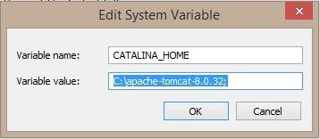 ● Click OK
1.2 Java Install

Instructions may be found at

https://docs.oracle.com/javase/8/docs/technotes/guides/install/windows_jdk_install.html
- Login

  - Go to ​http://localhost:8091/Books/

  - Enter your credentials in the given fields
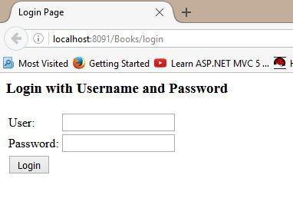

- After you have entered your credentials, click the login button

- If your credentials are bad, an error message will appear and you will have to enter them again
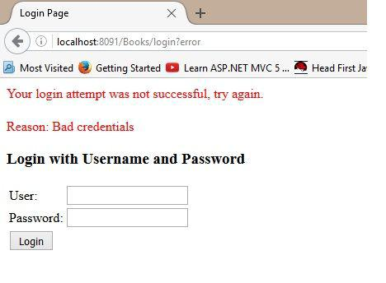

- If your credentials are verified, you will be redirected to the appropriate page, according to the credentials, which is covered in the next chapter
3. Admin

If you are an admin, and entered the correct login credentials, you will be redirected to the admin page

From here, you are presented with four options
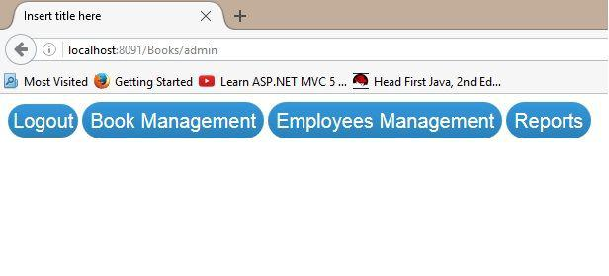

- The Logout option will log you out of the application

- The Book Management will take you to the admin book management page

- The Employees Management will take you to the employee management page

- Reports Will redirect you to the report generation page
3.1 Employee

Here you are presented with an interface from which you can perform operations on employee informations
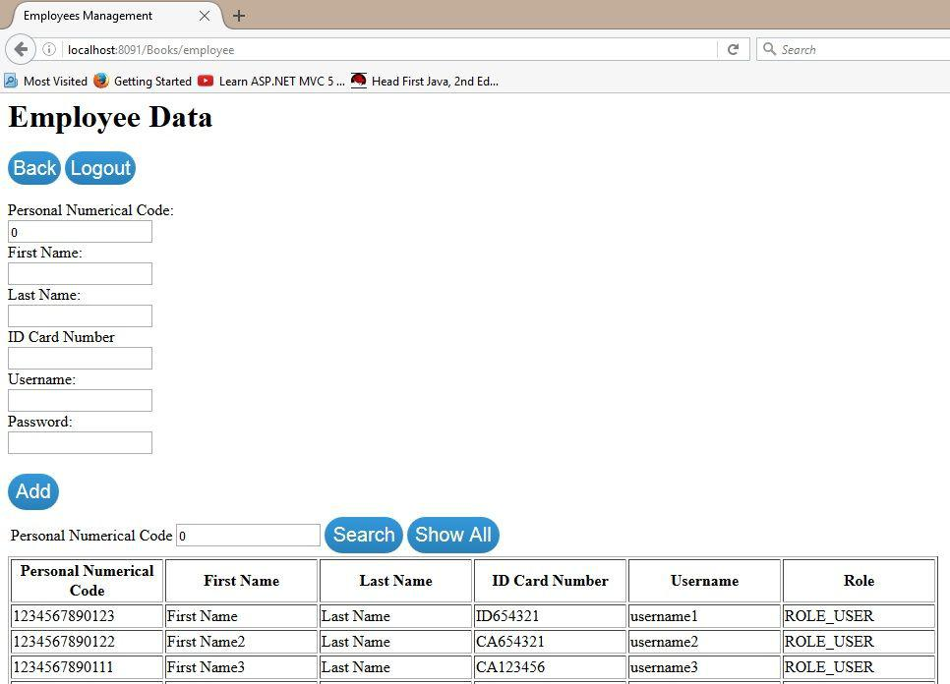

If you wish to add an employee, you must provide the employee information, in their respective fields, and press the Add button
If you want to edit an employee, you must first search for the employee using his personal numerical code and press the search button. If the employee is not found, a message will announce you. If the employee is found, you should see the following, instead of the table:

From here you can either edit or delete the employee, assuming that the information you enter is Valid. Otherwise, an error message indicating the problem will be displayed
3.2 Book

The book user interface is similar with the employee user interface, with the addition that you can search for a book, using the title, author and genre. The input is checked, and an error message will appear if it is not correct.
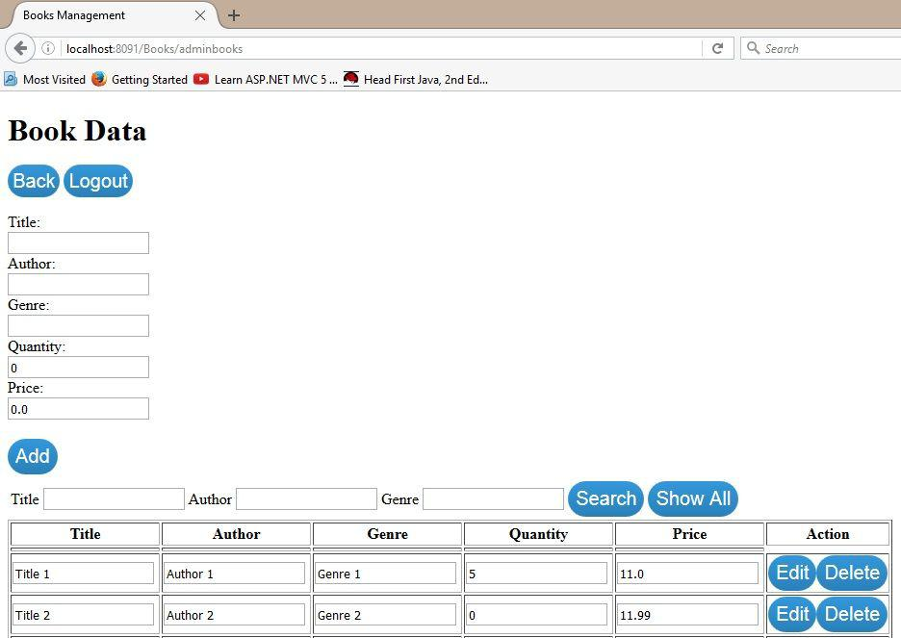
3.3 Report Generation

Here you can download 2 types of reports of the books that are out of stock, one in the PDF format and the other in CSV format.
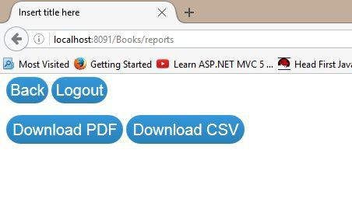

4. Employee

In the employee page, two main actions can be performed: Search by title,author and genre, and sell an amount of books:
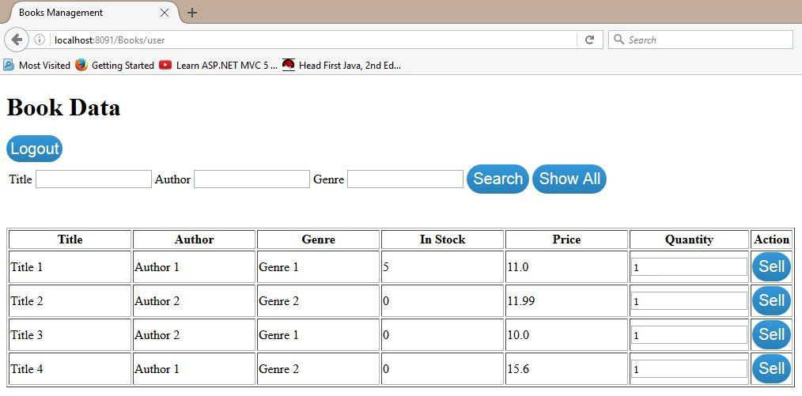

The quantity that must be inserted, must be greater than 0, otherwise, an error message will appear, and the sale will not be executed.
5. Logout

On every page, except for the login page, there is a logout button, which will log the current user out, and he will no longer be able to access pages other than the login page.

The back button on the admin pages will take you back to the main admin page.


