Table of Contents

Docker installation 2

Mac 2

Windows 2

Install Redis 2

Front End Setup 5

Install node 5

# Docker installation

## Mac

Follow the following instructions to install Docker: <https://docs.docker.com/desktop/setup/install/mac-install/>

## Windows

Follow the following instructions to install Docker: <https://docs.docker.com/desktop/setup/install/windows-install/>

# Install Redis

1. Download Redis latest docker image using this command in the terminal: docker pull redis
2. Create a new container from the image you download above, using Docker Desktop:
   1. Go to images (1) and click run (2):

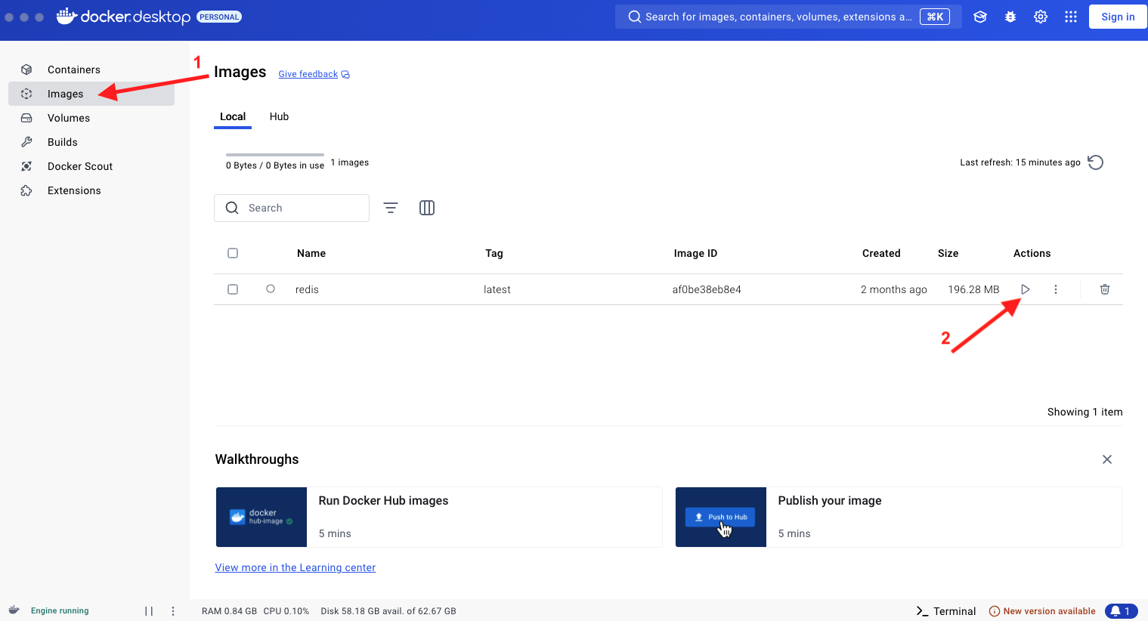

* 1. Click on optional settings and input the following, then click run:

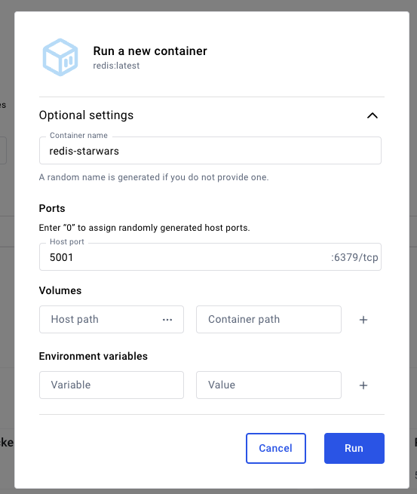

* 1. Validate that your Redis is initialized in your container logs:

# Front End Setup

## Install node and NPM

Ensure Node.js is installed on your system:

* Node:<https://nodejs.org/en/download/prebuilt-installer>
* NPM: run the following command after installing node: npm install -g npm
  + If you have permission issues on a Mac, check this article: <https://elvisciotti.medium.com/mac-osx-fix-npm-eacces-permission-denied-7ed4b5368460>

## Download source code

Download code from the following repository:

## Start app locally

Open your code using VS Code Run the following commands in the terminal:

* npm install
* npm start