# ­Part 1

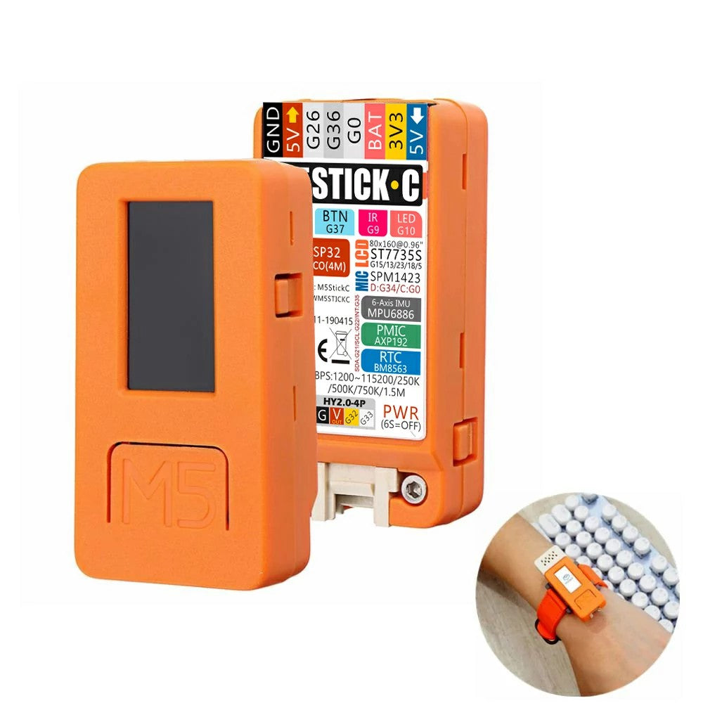

Y

X

Z

# Introduction

This lab was designed to help us learn to use the M5StickC’s IMU and interpret its data. First, we loaded an example to display the acceleration data from the device’s IMU. Then, we used this data to identify and label the axes of the M5StickC. This helped us learn what the IMU did and what it measured. We then created a program that showed the maximum acceleration magnitude. Finally, we updated the program to blink when it detected a drop of at least 10 cm. This helped us test our knowledge of the M5StickC’s IMU.

# Implementation

## Bill of Materials

* M5StickC: <https://www.electromaker.io/shop/product/m5stickc-development-kit-with-hat>. This is the device we are controlling.
* Wristband (This was included with the M5StickC).

## Video

<https://youtube.com/shorts/1hNALXMrKc4>

## Pictures

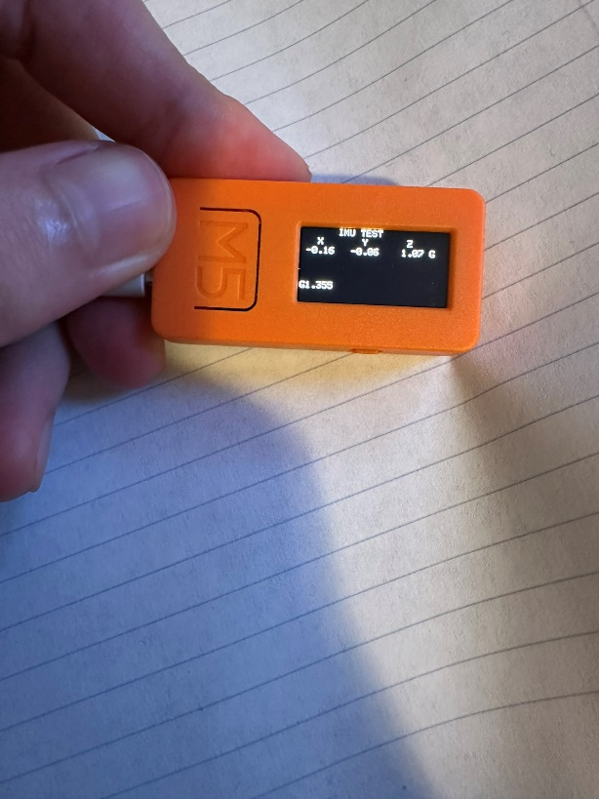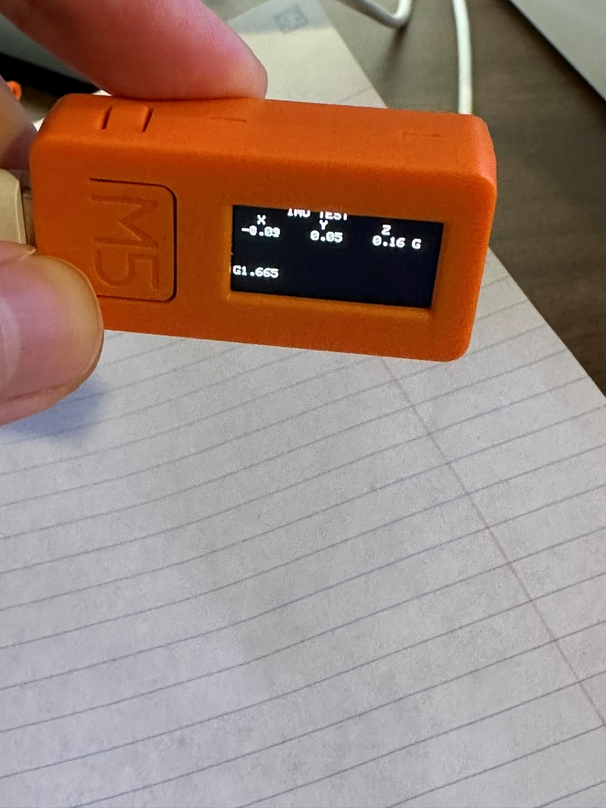

## Source Code



## Explanation

I divided the program into the setup and the loop. In the setup, I set the LCD’s rotation, printed a title, and printed a label for each of the coordinates. I also initialized the pin mode so we could make the LED blink. Finally, I turned the LED off just in case it was on.

In the loop, we updated the variables for the square of the acceleration for each axis. Second, I set the acceleration magnitude to help us measure the total acceleration. Third, I made the LED blink if the acceleration’s magnitude was greater than a certain amount. This allowed the LED to blink if I dropped the M5StickC from 10 cm or more. Finally, we updated the variable for the maximum acceleration magnitude, printed the accelerations for each axis, and printed the maximum acceleration.

## Calculations

* We calculated the squares of each axis’ acceleration. Then, we found the sum of these squares. Finally, we used this information to calculate the acceleration’s magnitude.
* In our for loop, we incremented a variable by 1 on each iteration of the loop.

# References

* https://shop.m5stack.com/cdn/shop/products/04_1200x1200.jpg?v=1587104224