Model
Package in package ''

Model
Version Phase 1.0 Proposed
saidy created on 28/01/2023. Last modified 28/01/2023

interfaz de usuario
Package in package 'Model'

interfaz de usuario
Version 1.0 Phase 1.0 Proposed
saidy created on 28/01/2023. Last modified 28/01/2023

login
Package in package 'interfaz de usuario'

login
Version 1.0 Phase 1.0 Proposed
saidy created on 28/01/2023. Last modified 28/01/2023

Simple User Interface login diagram
Simple User Interface diagram in package 'login'

Simple User Interface login
Version 1.0
saidy created on 28/01/2023. Last modified 28/01/2023

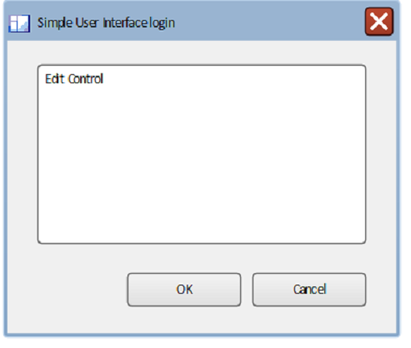

- Simple User Interface login

Simple User Interface login
Screen «simpleDialog» in package 'login'

Simple User Interface login
Version 1.0 Phase 1.0 Proposed
saidy created on 28/01/2023. Last modified 28/01/2023
Extends

Cancel
GUIElement «simpleButton» owned by 'Simple User Interface login', in package 'login'

Cancel
Version 1.0 Phase 1.0 Proposed
saidy created on 28/01/2023. Last modified 28/01/2023
Extends

Edit Control
GUIElement «simpleEdit» owned by 'Simple User Interface login', in package 'login'

Edit Control
Version 1.0 Phase 1.0 Proposed
saidy created on 28/01/2023. Last modified 28/01/2023
Extends

Vertical Scrollbar
GUIElement «simpleScrollBarV» owned by 'Edit Control', in package 'login'

Vertical Scrollbar
Version 1.0 Phase 1.0 Proposed
saidy created on 28/01/2023. Last modified 28/01/2023
Extends

OK
GUIElement «simpleButton» owned by 'Simple User Interface login', in package 'login'

OK
Version 1.0 Phase 1.0 Proposed
saidy created on 28/01/2023. Last modified 28/01/2023
Extends

reportes
Package in package 'interfaz de usuario'

reportes
Version 1.0 Phase 1.0 Proposed
saidy created on 28/01/2023. Last modified 28/01/2023

Simple User Interface reportes diagram
Simple User Interface diagram in package 'reportes'

Simple User Interface reportes
Version 1.0
saidy created on 28/01/2023. Last modified 28/01/2023

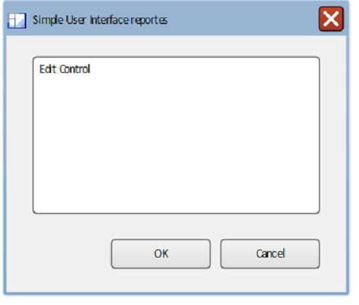

- Simple User Interface reportes

Simple User Interface reportes
Screen «simpleDialog» in package 'reportes'

Simple User Interface reportes
Version 1.0 Phase 1.0 Proposed
saidy created on 28/01/2023. Last modified 28/01/2023
Extends

Cancel
GUIElement «simpleButton» owned by 'Simple User Interface reportes', in package 'reportes'

Cancel
Version 1.0 Phase 1.0 Proposed
saidy created on 28/01/2023. Last modified 28/01/2023
Extends

Edit Control
GUIElement «simpleEdit» owned by 'Simple User Interface reportes', in package 'reportes'

Edit Control
Version 1.0 Phase 1.0 Proposed
saidy created on 28/01/2023. Last modified 28/01/2023
Extends

Vertical Scrollbar
GUIElement «simpleScrollBarV» owned by 'Edit Control', in package 'reportes'

Vertical Scrollbar
Version 1.0 Phase 1.0 Proposed
saidy created on 28/01/2023. Last modified 28/01/2023
Extends

OK
GUIElement «simpleButton» owned by 'Simple User Interface reportes', in package 'reportes'

OK
Version 1.0 Phase 1.0 Proposed
saidy created on 28/01/2023. Last modified 28/01/2023
Extends

Basic Use Case Model
Package in package 'Model'

Basic Use Case Model
Version 1.0 Phase 1.0 Proposed
saidy created on 28/01/2023. Last modified 07/02/2018

modelos de casos de uso diagram
Use Case diagram in package 'Basic Use Case Model'

modelos de casos de uso
Version 1.0
saidy created on 28/01/2023. Last modified 28/01/2023

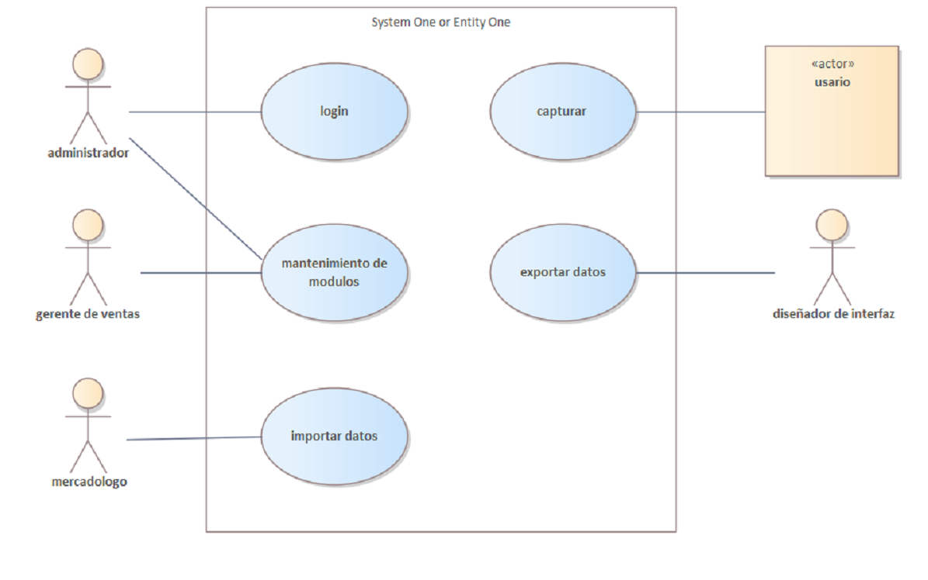

- modelos de casos de uso

System One or Entity One
Boundary in package 'Basic Use Case Model'

[Description of the System]

System One or Entity One
Version 1.0 Phase 1.0 Proposed
saidy created on 28/01/2023. Last modified 28/01/2023
Extends

administrador
Actor in package 'Actors'

administrador
Version 1.0 Phase 1.0 Proposed
saidy created on 28/01/2023. Last modified 28/01/2023

ASSOCIATIONS
Association (direction: Unspecified)

Source: Public (Actor) administrador | Target: Public (UseCase) login
Association (direction: Unspecified)

Source: Public (Actor) administrador | Target: Public (UseCase) mantenimiento de modulos

gerente de ventas
Actor in package 'Actors'

gerente de ventas
Version 1.0 Phase 1.0 Proposed
saidy created on 28/01/2023. Last modified 28/01/2023

ASSOCIATIONS
Association (direction: Unspecified)

Source: Public (Actor) gerente de ventas | Target: Public (UseCase) mantenimiento de modulos

diseñador de interfaz
Actor in package 'Actors'

diseñador de interfaz
Version 1.0 Phase 1.0 Proposed
saidy created on 28/01/2023. Last modified 28/01/2023

ASSOCIATIONS
Association (direction: Unspecified)

Source: Public (UseCase) exportar datos | Target: Public (Actor) diseñador de interfaz

mercadologo
Actor in package 'Actors'

mercadologo
Version 1.0 Phase 1.0 Proposed
saidy created on 28/01/2023. Last modified 28/01/2023

ASSOCIATIONS
Association (direction: Unspecified)

Source: Public (Actor) mercadologo | Target: Public (UseCase) importar datos

usario
Actor in package 'Actors'

usario
Version 1.0 Phase 1.0 Proposed
saidy created on 28/01/2023. Last modified 28/01/2023

ASSOCIATIONS
Association (direction: Unspecified)

Source: Public (Actor) usario | Target: Public (UseCase) capturar

login
UseCase in package 'Use Cases'

login
Version 1.0 Phase 1.0 Proposed
saidy created on 28/01/2023. Last modified 28/01/2023

SCENARIOS
Basic Path. Basic Path

1. User Step One
2. System Step One
3. User Step Two
4. System Step Two

CONSTRAINTS
Invariant. Invariant A
[ Approved, Weight is 0. ]

Pre-condition. Pre-condition A
[ Approved, Weight is 1. ]

Post-condition. Post-condition A
[ Approved, Weight is 2. ]

ASSOCIATIONS
Association (direction: Unspecified)

Source: Public (Actor) administrador | Target: Public (UseCase) login

mantenimiento de modulos
UseCase in package 'Use Cases'

mantenimiento de modulos
Version 1.0 Phase 1.0 Proposed
saidy created on 28/01/2023. Last modified 28/01/2023

ASSOCIATIONS
Association (direction: Unspecified)

Source: Public (Actor) administrador | Target: Public (UseCase) mantenimiento de modulos
Association (direction: Unspecified)

Source: Public (Actor) gerente de ventas | Target: Public (UseCase) mantenimiento de modulos

exportar datos
UseCase in package 'Use Cases'

exportar datos
Version 1.0 Phase 1.0 Proposed
saidy created on 28/01/2023. Last modified 28/01/2023

ASSOCIATIONS
Association (direction: Unspecified)

Source: Public (UseCase) exportar datos | Target: Public (Actor) diseñador de interfaz

capturar
UseCase in package 'Use Cases'

capturar
Version 1.0 Phase 1.0 Proposed
saidy created on 28/01/2023. Last modified 28/01/2023

ASSOCIATIONS
Association (direction: Unspecified)

Source: Public (Actor) usario | Target: Public (UseCase) capturar

importar datos
UseCase in package 'Use Cases'

importar datos
Version 1.0 Phase 1.0 Proposed
saidy created on 28/01/2023. Last modified 28/01/2023

ASSOCIATIONS
Association (direction: Unspecified)

Source: Public (Actor) mercadologo | Target: Public (UseCase) importar datos

Actors
Package in package 'Basic Use Case Model'

Contiene Actores que representan los roles que juegan los usuarios con respecto al sistema.

Actors
Version 1.0 Phase 1.0 Proposed
saidy created on 28/01/2023. Last modified 28/01/2023

administrador
Actor in package 'Actors'

administrador
Version 1.0 Phase 1.0 Proposed
saidy created on 28/01/2023. Last modified 28/01/2023

ASSOCIATIONS
Association (direction: Unspecified)

Source: Public (Actor) administrador | Target: Public (UseCase) login
Association (direction: Unspecified)

Source: Public (Actor) administrador | Target: Public (UseCase) mantenimiento de modulos

gerente de ventas
Actor in package 'Actors'

gerente de ventas
Version 1.0 Phase 1.0 Proposed
saidy created on 28/01/2023. Last modified 28/01/2023

ASSOCIATIONS
Association (direction: Unspecified)

Source: Public (Actor) gerente de ventas | Target: Public (UseCase) mantenimiento de modulos

diseñador de interfaz
Actor in package 'Actors'

diseñador de interfaz
Version 1.0 Phase 1.0 Proposed
saidy created on 28/01/2023. Last modified 28/01/2023

ASSOCIATIONS
Association (direction: Unspecified)

Source: Public (UseCase) exportar datos | Target: Public (Actor) diseñador de interfaz

mercadologo
Actor in package 'Actors'

mercadologo
Version 1.0 Phase 1.0 Proposed
saidy created on 28/01/2023. Last modified 28/01/2023

ASSOCIATIONS
Association (direction: Unspecified)

Source: Public (Actor) mercadologo | Target: Public (UseCase) importar datos

usario
Actor in package 'Actors'

usario
Version 1.0 Phase 1.0 Proposed
saidy created on 28/01/2023. Last modified 28/01/2023

ASSOCIATIONS
Association (direction: Unspecified)

Source: Public (Actor) usario | Target: Public (UseCase) capturar

Use Cases
Package in package 'Basic Use Case Model'

Contiene Casos de Uso que representan el valor o meta que los Actores desean alcanzar.

Use Cases
Version 1.0 Phase 1.0 Proposed
saidy created on 28/01/2023. Last modified 28/01/2023

login
UseCase in package 'Use Cases'

login
Version 1.0 Phase 1.0 Proposed
saidy created on 28/01/2023. Last modified 28/01/2023

SCENARIOS
Basic Path. Basic Path

1. User Step One
2. System Step One
3. User Step Two
4. System Step Two

CONSTRAINTS
Invariant. Invariant A
[ Approved, Weight is 0. ]

Pre-condition. Pre-condition A
[ Approved, Weight is 1. ]

Post-condition. Post-condition A
[ Approved, Weight is 2. ]

ASSOCIATIONS
Association (direction: Unspecified)

Source: Public (Actor) administrador | Target: Public (UseCase) login

mantenimiento de modulos
UseCase in package 'Use Cases'

mantenimiento de modulos
Version 1.0 Phase 1.0 Proposed
saidy created on 28/01/2023. Last modified 28/01/2023

ASSOCIATIONS
Association (direction: Unspecified)

Source: Public (Actor) administrador | Target: Public (UseCase) mantenimiento de modulos
Association (direction: Unspecified)

Source: Public (Actor) gerente de ventas | Target: Public (UseCase) mantenimiento de modulos

exportar datos
UseCase in package 'Use Cases'

exportar datos
Version 1.0 Phase 1.0 Proposed
saidy created on 28/01/2023. Last modified 28/01/2023

ASSOCIATIONS
Association (direction: Unspecified)

Source: Public (UseCase) exportar datos | Target: Public (Actor) diseñador de interfaz

capturar
UseCase in package 'Use Cases'

capturar
Version 1.0 Phase 1.0 Proposed
saidy created on 28/01/2023. Last modified 28/01/2023

ASSOCIATIONS
Association (direction: Unspecified)

Source: Public (Actor) usario | Target: Public (UseCase) capturar

importar datos
UseCase in package 'Use Cases'

importar datos
Version 1.0 Phase 1.0 Proposed
saidy created on 28/01/2023. Last modified 28/01/2023

ASSOCIATIONS
Association (direction: Unspecified)

Source: Public (Actor) mercadologo | Target: Public (UseCase) importar datos

Functional Requirements Analysis
Package in package 'Model'

Functional requirements analysis examines the requirements for a solution that describe the capabilities that a solution must have in terms of the behaviour and information that the solution will manage. BABOK® Guide v3

Functional Requirements Analysis
Version 1.0 Phase 1.0 Proposed
saidy created on 28/01/2023. Last modified 29/08/2016

Functional Requirements Hierarchy diagram
Custom diagram in package 'Functional Requirements Analysis'

This BABOK Requirements diagram shows three requirements that form a hierarchy showing how requirements can be broken down to any number of levels. Requirements can also be nested under each other in the Project Browser showing their hierarchy.

Functional Requirements Hierarchy
Version 1.0
saidy created on 28/01/2023. Last modified 28/01/2023

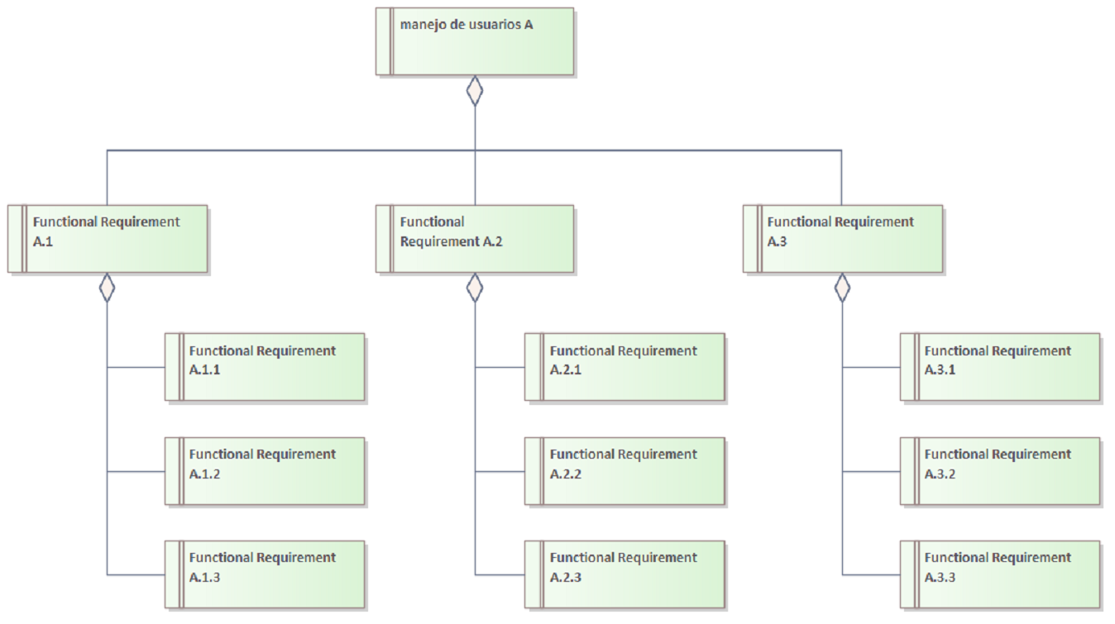

- Functional Requirements Hierarchy

Functional Requirement A.2
Functional Requirement «functional requirement» in package 'Functional Requirements Analysis'

Functional Requirement A.2
Version 1.0 Phase 1.0 Validated
saidy created on 28/01/2023. Last modified 28/01/2023

ELEMENTS OWNED BY Functional Requirement A.2
Functional Requirement A.2.1 : Functional Requirement «functional requirement»

Functional Requirement A.2.2 : Functional Requirement «functional requirement»

Functional Requirement A.2.3 : Functional Requirement «functional requirement»

OUTGOING STRUCTURAL RELATIONSHIPS
Aggregation from «functional requirement» Functional Requirement A.2 to «functional requirement» manejo de usuarios A
[ Direction is 'Source -> Destination'. ]

INCOMING STRUCTURAL RELATIONSHIPS
Aggregation from «functional requirement» Functional Requirement A.2.1 to «functional requirement» Functional Requirement A.2
[ Direction is 'Source -> Destination'. ]

Aggregation from «functional requirement» Functional Requirement A.2.3 to «functional requirement» Functional Requirement A.2
[ Direction is 'Source -> Destination'. ]

Aggregation from «functional requirement» Functional Requirement A.2.2 to «functional requirement» Functional Requirement A.2
[ Direction is 'Source -> Destination'. ]

Functional Requirement A.2.1
Functional Requirement «functional requirement» owned by 'Functional Requirement A.2', in package 'Functional Requirements Analysis'

Functional Requirement A.2.1
Version 1.0 Phase 1.0 Validated
saidy created on 28/01/2023. Last modified 28/01/2023

OUTGOING STRUCTURAL RELATIONSHIPS
Aggregation from «functional requirement» Functional Requirement A.2.1 to «functional requirement» Functional Requirement A.2
[ Direction is 'Source -> Destination'. ]

Functional Requirement A.2.2
Functional Requirement «functional requirement» owned by 'Functional Requirement A.2', in package 'Functional Requirements Analysis'

Functional Requirement A.2.2
Version 1.0 Phase 1.0 Validated
saidy created on 28/01/2023. Last modified 28/01/2023

OUTGOING STRUCTURAL RELATIONSHIPS
Aggregation from «functional requirement» Functional Requirement A.2.2 to «functional requirement» Functional Requirement A.2
[ Direction is 'Source -> Destination'. ]

Functional Requirement A.2.3
Functional Requirement «functional requirement» owned by 'Functional Requirement A.2', in package 'Functional Requirements Analysis'

Functional Requirement A.2.3
Version 1.0 Phase 1.0 Validated
saidy created on 28/01/2023. Last modified 28/01/2023

OUTGOING STRUCTURAL RELATIONSHIPS
Aggregation from «functional requirement» Functional Requirement A.2.3 to «functional requirement» Functional Requirement A.2
[ Direction is 'Source -> Destination'. ]

Functional Requirement A.3
Functional Requirement «functional requirement» in package 'Functional Requirements Analysis'

Functional Requirement A.3
Version 1.0 Phase 1.0 Proposed
saidy created on 28/01/2023. Last modified 28/01/2023

ELEMENTS OWNED BY Functional Requirement A.3
Functional Requirement A.3.1 : Functional Requirement «functional requirement»

Functional Requirement A.3.2 : Functional Requirement «functional requirement»

Functional Requirement A.3.3 : Functional Requirement «functional requirement»

OUTGOING STRUCTURAL RELATIONSHIPS
Aggregation from «functional requirement» Functional Requirement A.3 to «functional requirement» manejo de usuarios A
[ Direction is 'Source -> Destination'. ]

INCOMING STRUCTURAL RELATIONSHIPS
Aggregation from «functional requirement» Functional Requirement A.3.3 to «functional requirement» Functional Requirement A.3
[ Direction is 'Source -> Destination'. ]

Aggregation from «functional requirement» Functional Requirement A.3.1 to «functional requirement» Functional Requirement A.3
[ Direction is 'Source -> Destination'. ]

Aggregation from «functional requirement» Functional Requirement A.3.2 to «functional requirement» Functional Requirement A.3
[ Direction is 'Source -> Destination'. ]

Functional Requirement A.3.1
Functional Requirement «functional requirement» owned by 'Functional Requirement A.3', in package 'Functional Requirements Analysis'

Functional Requirement A.3.1
Version 1.0 Phase 1.0 Proposed
saidy created on 28/01/2023. Last modified 28/01/2023

OUTGOING STRUCTURAL RELATIONSHIPS
Aggregation from «functional requirement» Functional Requirement A.3.1 to «functional requirement» Functional Requirement A.3
[ Direction is 'Source -> Destination'. ]

Functional Requirement A.3.2
Functional Requirement «functional requirement» owned by 'Functional Requirement A.3', in package 'Functional Requirements Analysis'

Functional Requirement A.3.2
Version 1.0 Phase 1.0 Proposed
saidy created on 28/01/2023. Last modified 28/01/2023

OUTGOING STRUCTURAL RELATIONSHIPS
Aggregation from «functional requirement» Functional Requirement A.3.2 to «functional requirement» Functional Requirement A.3
[ Direction is 'Source -> Destination'. ]

Functional Requirement A.3.3
Functional Requirement «functional requirement» owned by 'Functional Requirement A.3', in package 'Functional Requirements Analysis'

Functional Requirement A.3.3
Version 1.0 Phase 1.0 Proposed
saidy created on 28/01/2023. Last modified 28/01/2023

OUTGOING STRUCTURAL RELATIONSHIPS
Aggregation from «functional requirement» Functional Requirement A.3.3 to «functional requirement» Functional Requirement A.3
[ Direction is 'Source -> Destination'. ]

manejo de usuarios A
Functional Requirement «functional requirement» in package 'Functional Requirements Analysis'

manejo de usuarios A
Version 1.0 Phase 1.0 Approved
saidy created on 28/01/2023. Last modified 28/01/2023
Alias roles
Keywords id, password, sha512

ELEMENTS OWNED BY manejo de usuarios A
Functional Requirement A.1 : Functional Requirement «functional requirement»

Functional Requirement A.1.2 : Functional Requirement «functional requirement»

Functional Requirement A.1.3 : Functional Requirement «functional requirement»

INCOMING STRUCTURAL RELATIONSHIPS
Aggregation from «functional requirement» Functional Requirement A.2 to «functional requirement» manejo de usuarios A
[ Direction is 'Source -> Destination'. ]

Aggregation from «functional requirement» Functional Requirement A.3 to «functional requirement» manejo de usuarios A
[ Direction is 'Source -> Destination'. ]

Aggregation from «functional requirement» Functional Requirement A.1 to «functional requirement» manejo de usuarios A
[ Direction is 'Source -> Destination'. ]

Functional Requirement A.1
Functional Requirement «functional requirement» owned by 'manejo de usuarios A', in package 'Functional Requirements Analysis'

Functional Requirement A.1
Version 1.0 Phase 1.0 Proposed
saidy created on 28/01/2023. Last modified 28/01/2023

ELEMENTS OWNED BY Functional Requirement A.1
Functional Requirement A.1.1 : Functional Requirement «functional requirement»

OUTGOING STRUCTURAL RELATIONSHIPS
Aggregation from «functional requirement» Functional Requirement A.1 to «functional requirement» manejo de usuarios A
[ Direction is 'Source -> Destination'. ]

INCOMING STRUCTURAL RELATIONSHIPS
Aggregation from «functional requirement» Functional Requirement A.1.3 to «functional requirement» Functional Requirement A.1
[ Direction is 'Source -> Destination'. ]

Aggregation from «functional requirement» Functional Requirement A.1.1 to «functional requirement» Functional Requirement A.1
[ Direction is 'Source -> Destination'. ]

Aggregation from «functional requirement» Functional Requirement A.1.2 to «functional requirement» Functional Requirement A.1
[ Direction is 'Source -> Destination'. ]

Functional Requirement A.1.1
Functional Requirement «functional requirement» owned by 'Functional Requirement A.1', in package 'Functional Requirements Analysis'

Functional Requirement A.1.1
Version 1.0 Phase 1.0 Proposed
saidy created on 28/01/2023. Last modified 28/01/2023

OUTGOING STRUCTURAL RELATIONSHIPS
Aggregation from «functional requirement» Functional Requirement A.1.1 to «functional requirement» Functional Requirement A.1
[ Direction is 'Source -> Destination'. ]

Functional Requirement A.1.2
Functional Requirement «functional requirement» owned by 'manejo de usuarios A', in package 'Functional Requirements Analysis'

Functional Requirement A.1.2
Version 1.0 Phase 1.0 Proposed
saidy created on 28/01/2023. Last modified 28/01/2023

OUTGOING STRUCTURAL RELATIONSHIPS
Aggregation from «functional requirement» Functional Requirement A.1.2 to «functional requirement» Functional Requirement A.1
[ Direction is 'Source -> Destination'. ]

Functional Requirement A.1.3
Functional Requirement «functional requirement» owned by 'manejo de usuarios A', in package 'Functional Requirements Analysis'

Functional Requirement A.1.3
Version 1.0 Phase 1.0 Proposed
saidy created on 28/01/2023. Last modified 28/01/2023

OUTGOING STRUCTURAL RELATIONSHIPS
Aggregation from «functional requirement» Functional Requirement A.1.3 to «functional requirement» Functional Requirement A.1
[ Direction is 'Source -> Destination'. ]

no funcional A plataform
Package in package 'Model'

Non-functional requirements analysis examines the requirements for a solution that define how well the functional requirements must perform. It specifies criteria that can be used to judge the operation of a system rather than specific behaviours (which are referred to as the functional requirements). BABOK® Guide v3

no funcional A plataform
Version 1.0 Phase 1.0 Proposed
saidy created on 28/01/2023. Last modified 28/01/2023

DBMS diagram
Custom diagram in package 'no funcional A plataform'

This Package diagram contains the packages that collect the non-functional requirements into groups. Other packages can be added as they are completed. It provides a convenient overview of the non-Functional Requirements and their groups. The Requirements can be removed from this diagram.

DBMS
Version 1.0
saidy created on 28/01/2023. Last modified 28/01/2023

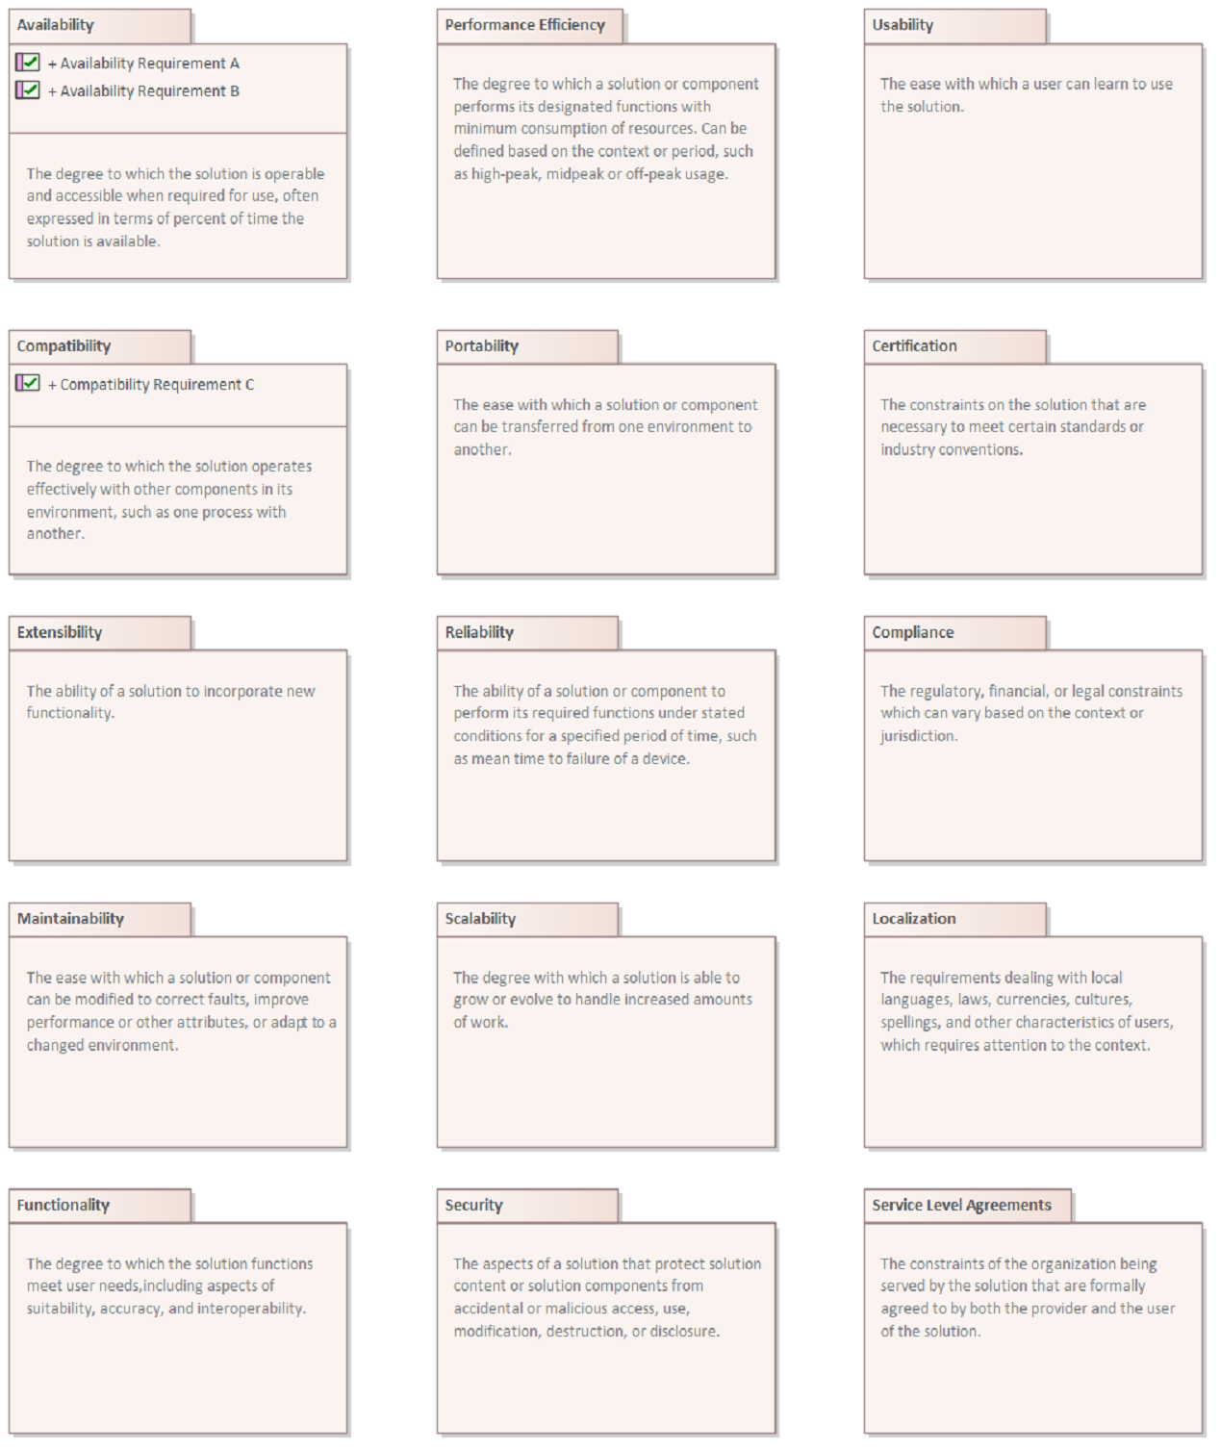

- DBMS

Availability
Package in package 'no funcional A plataform'

The degree to which the solution is operable and accessible when required for use, often expressed in terms of percent of time the solution is available.

Availability
Version 1.0 Phase 1.0 Proposed
saidy created on 28/01/2023. Last modified 28/01/2023

Compatibility
Package in package 'no funcional A plataform'

The degree to which the solution operates effectively with other components in its environment, such as one process with another.

Compatibility
Version 1.0 Phase 1.0 Proposed
saidy created on 28/01/2023. Last modified 28/01/2023

Extensibility
Package in package 'no funcional A plataform'

The ability of a solution to incorporate new functionality.

Extensibility
Version 1.0 Phase 1.0 Proposed
saidy created on 28/01/2023. Last modified 28/01/2023

Maintainability
Package in package 'no funcional A plataform'

The ease with which a solution or component can be modified to correct faults, improve performance or other attributes, or adapt to a changed environment.

Maintainability
Version 1.0 Phase 1.0 Proposed
saidy created on 28/01/2023. Last modified 28/01/2023

Functionality
Package in package 'no funcional A plataform'

The degree to which the solution functions meet user needs,including aspects of suitability, accuracy, and interoperability.

Functionality
Version 1.0 Phase 1.0 Proposed
saidy created on 28/01/2023. Last modified 28/01/2023

Performance Efficiency
Package in package 'no funcional A plataform'

The degree to which a solution or component performs its designated functions with minimum consumption of resources. Can be defined based on the context or period, such as high-peak, midpeak or off-peak usage.

Performance Efficiency
Version 1.0 Phase 1.0 Proposed
saidy created on 28/01/2023. Last modified 28/01/2023

Portability
Package in package 'no funcional A plataform'

The ease with which a solution or component can be transferred from one environment to another.

Portability
Version 1.0 Phase 1.0 Proposed
saidy created on 28/01/2023. Last modified 28/01/2023

Reliability
Package in package 'no funcional A plataform'

The ability of a solution or component to perform its required functions under stated conditions for a specified period of time, such as mean time to failure of a device.

Reliability
Version 1.0 Phase 1.0 Proposed
saidy created on 28/01/2023. Last modified 28/01/2023

Scalability
Package in package 'no funcional A plataform'

The degree with which a solution is able to grow or evolve to handle increased amounts of work.

Scalability
Version 1.0 Phase 1.0 Proposed
saidy created on 28/01/2023. Last modified 28/01/2023

Security
Package in package 'no funcional A plataform'

The aspects of a solution that protect solution content or solution components from accidental or malicious access, use, modification, destruction, or disclosure.

Security
Version 1.0 Phase 1.0 Proposed
saidy created on 28/01/2023. Last modified 28/01/2023

Usability
Package in package 'no funcional A plataform'

The ease with which a user can learn to use the solution.

Usability
Version 1.0 Phase 1.0 Proposed
saidy created on 28/01/2023. Last modified 28/01/2023

Certification
Package in package 'no funcional A plataform'

The constraints on the solution that are necessary to meet certain standards or industry conventions.

Certification
Version 1.0 Phase 1.0 Proposed
saidy created on 28/01/2023. Last modified 28/01/2023

Compliance
Package in package 'no funcional A plataform'

The regulatory, financial, or legal constraints which can vary based on the context or jurisdiction.

Compliance
Version 1.0 Phase 1.0 Proposed
saidy created on 28/01/2023. Last modified 28/01/2023

Localization
Package in package 'no funcional A plataform'

The requirements dealing with local languages, laws, currencies, cultures, spellings, and other characteristics of users, which requires attention to the context.

Localization
Version 1.0 Phase 1.0 Proposed
saidy created on 28/01/2023. Last modified 28/01/2023

Service Level Agreements
Package in package 'no funcional A plataform'

The constraints of the organization being served by the solution that are formally agreed to by both the provider and the user of the solution.

Service Level Agreements
Version 1.0 Phase 1.0 Proposed
saidy created on 28/01/2023. Last modified 28/01/2023

sistema operativo diagram
Custom diagram in package 'no funcional A plataform'

This Package diagram contains the packages that collect the non-functional requirements into groups. Other packages can be added as they are completed. It provides a convenient overview of the non-Functional Requirements and their groups. The Requirements can be removed from this diagram.

sistema operativo
Version 1.0
saidy created on 28/01/2023. Last modified 28/01/2023

- sistema operativo

Availability
Package in package 'no funcional A plataform'

The degree to which the solution is operable and accessible when required for use, often expressed in terms of percent of time the solution is available.

Availability
Version 1.0 Phase 1.0 Proposed
saidy created on 28/01/2023. Last modified 28/01/2023

Compatibility
Package in package 'no funcional A plataform'

The degree to which the solution operates effectively with other components in its environment, such as one process with another.

Compatibility
Version 1.0 Phase 1.0 Proposed
saidy created on 28/01/2023. Last modified 28/01/2023

Extensibility
Package in package 'no funcional A plataform'

The ability of a solution to incorporate new functionality.

Extensibility
Version 1.0 Phase 1.0 Proposed
saidy created on 28/01/2023. Last modified 28/01/2023

Maintainability
Package in package 'no funcional A plataform'

The ease with which a solution or component can be modified to correct faults, improve performance or other attributes, or adapt to a changed environment.

Maintainability
Version 1.0 Phase 1.0 Proposed
saidy created on 28/01/2023. Last modified 28/01/2023

Functionality
Package in package 'no funcional A plataform'

The degree to which the solution functions meet user needs,including aspects of suitability, accuracy, and interoperability.

Functionality
Version 1.0 Phase 1.0 Proposed
saidy created on 28/01/2023. Last modified 28/01/2023

Performance Efficiency
Package in package 'no funcional A plataform'

The degree to which a solution or component performs its designated functions with minimum consumption of resources. Can be defined based on the context or period, such as high-peak, midpeak or off-peak usage.

Performance Efficiency
Version 1.0 Phase 1.0 Proposed
saidy created on 28/01/2023. Last modified 28/01/2023

Portability
Package in package 'no funcional A plataform'

The ease with which a solution or component can be transferred from one environment to another.

Portability
Version 1.0 Phase 1.0 Proposed
saidy created on 28/01/2023. Last modified 28/01/2023

Reliability
Package in package 'no funcional A plataform'

The ability of a solution or component to perform its required functions under stated conditions for a specified period of time, such as mean time to failure of a device.

Reliability
Version 1.0 Phase 1.0 Proposed
saidy created on 28/01/2023. Last modified 28/01/2023

Scalability
Package in package 'no funcional A plataform'

The degree with which a solution is able to grow or evolve to handle increased amounts of work.

Scalability
Version 1.0 Phase 1.0 Proposed
saidy created on 28/01/2023. Last modified 28/01/2023

Security
Package in package 'no funcional A plataform'

The aspects of a solution that protect solution content or solution components from accidental or malicious access, use, modification, destruction, or disclosure.

Security
Version 1.0 Phase 1.0 Proposed
saidy created on 28/01/2023. Last modified 28/01/2023

Usability
Package in package 'no funcional A plataform'

The ease with which a user can learn to use the solution.

Usability
Version 1.0 Phase 1.0 Proposed
saidy created on 28/01/2023. Last modified 28/01/2023

Certification
Package in package 'no funcional A plataform'

The constraints on the solution that are necessary to meet certain standards or industry conventions.

Certification
Version 1.0 Phase 1.0 Proposed
saidy created on 28/01/2023. Last modified 28/01/2023

Compliance
Package in package 'no funcional A plataform'

The regulatory, financial, or legal constraints which can vary based on the context or jurisdiction.

Compliance
Version 1.0 Phase 1.0 Proposed
saidy created on 28/01/2023. Last modified 28/01/2023

Localization
Package in package 'no funcional A plataform'

The requirements dealing with local languages, laws, currencies, cultures, spellings, and other characteristics of users, which requires attention to the context.

Localization
Version 1.0 Phase 1.0 Proposed
saidy created on 28/01/2023. Last modified 28/01/2023

Service Level Agreements
Package in package 'no funcional A plataform'

The constraints of the organization being served by the solution that are formally agreed to by both the provider and the user of the solution.

Service Level Agreements
Version 1.0 Phase 1.0 Proposed
saidy created on 28/01/2023. Last modified 28/01/2023

Availability
Package in package 'no funcional A plataform'

The degree to which the solution is operable and accessible when required for use, often expressed in terms of percent of time the solution is available.

Availability
Version 1.0 Phase 1.0 Proposed
saidy created on 28/01/2023. Last modified 28/01/2023

Availability Requirement A
NonfunctionalRequirement «NonfunctionalRequirement» in package 'Availability'

Availability Requirement A
Version 1.0 Phase 1.0 Proposed
saidy created on 28/01/2023. Last modified 28/01/2023

Availability Requirement B
NonfunctionalRequirement «NonfunctionalRequirement» in package 'Availability'

Availability Requirement B
Version 1.0 Phase 1.0 Proposed
saidy created on 28/01/2023. Last modified 28/01/2023

Compatibility
Package in package 'no funcional A plataform'

The degree to which the solution operates effectively with other components in its environment, such as one process with another.

Compatibility
Version 1.0 Phase 1.0 Proposed
saidy created on 28/01/2023. Last modified 28/01/2023

Compatibility Requirement C
NonfunctionalRequirement «NonfunctionalRequirement» in package 'Compatibility'

Compatibility Requirement C
Version 1.0 Phase 1.0 Proposed
saidy created on 28/01/2023. Last modified 28/01/2023

Extensibility
Package in package 'no funcional A plataform'

The ability of a solution to incorporate new functionality.

Extensibility
Version 1.0 Phase 1.0 Proposed
saidy created on 28/01/2023. Last modified 28/01/2023

Maintainability
Package in package 'no funcional A plataform'

The ease with which a solution or component can be modified to correct faults, improve performance or other attributes, or adapt to a changed environment.

Maintainability
Version 1.0 Phase 1.0 Proposed
saidy created on 28/01/2023. Last modified 28/01/2023

Functionality
Package in package 'no funcional A plataform'

The degree to which the solution functions meet user needs,including aspects of suitability, accuracy, and interoperability.

Functionality
Version 1.0 Phase 1.0 Proposed
saidy created on 28/01/2023. Last modified 28/01/2023

Performance Efficiency
Package in package 'no funcional A plataform'

The degree to which a solution or component performs its designated functions with minimum consumption of resources. Can be defined based on the context or period, such as high-peak, midpeak or off-peak usage.

Performance Efficiency
Version 1.0 Phase 1.0 Proposed
saidy created on 28/01/2023. Last modified 28/01/2023

Portability
Package in package 'no funcional A plataform'

The ease with which a solution or component can be transferred from one environment to another.

Portability
Version 1.0 Phase 1.0 Proposed
saidy created on 28/01/2023. Last modified 28/01/2023

Reliability
Package in package 'no funcional A plataform'

The ability of a solution or component to perform its required functions under stated conditions for a specified period of time, such as mean time to failure of a device.

Reliability
Version 1.0 Phase 1.0 Proposed
saidy created on 28/01/2023. Last modified 28/01/2023

Scalability
Package in package 'no funcional A plataform'

The degree with which a solution is able to grow or evolve to handle increased amounts of work.

Scalability
Version 1.0 Phase 1.0 Proposed
saidy created on 28/01/2023. Last modified 28/01/2023

Security
Package in package 'no funcional A plataform'

The aspects of a solution that protect solution content or solution components from accidental or malicious access, use, modification, destruction, or disclosure.

Security
Version 1.0 Phase 1.0 Proposed
saidy created on 28/01/2023. Last modified 28/01/2023

Usability
Package in package 'no funcional A plataform'

The ease with which a user can learn to use the solution.

Usability
Version 1.0 Phase 1.0 Proposed
saidy created on 28/01/2023. Last modified 28/01/2023

Certification
Package in package 'no funcional A plataform'

The constraints on the solution that are necessary to meet certain standards or industry conventions.

Certification
Version 1.0 Phase 1.0 Proposed
saidy created on 28/01/2023. Last modified 28/01/2023

Compliance
Package in package 'no funcional A plataform'

The regulatory, financial, or legal constraints which can vary based on the context or jurisdiction.

Compliance
Version 1.0 Phase 1.0 Proposed
saidy created on 28/01/2023. Last modified 28/01/2023

Localization
Package in package 'no funcional A plataform'

The requirements dealing with local languages, laws, currencies, cultures, spellings, and other characteristics of users, which requires attention to the context.

Localization
Version 1.0 Phase 1.0 Proposed
saidy created on 28/01/2023. Last modified 28/01/2023

Service Level Agreements
Package in package 'no funcional A plataform'

The constraints of the organization being served by the solution that are formally agreed to by both the provider and the user of the solution.

Service Level Agreements
Version 1.0 Phase 1.0 Proposed
saidy created on 28/01/2023. Last modified 28/01/2023

Non-Functional - Fluidez
Package in package 'Model'

Non-functional requirements analysis examines the requirements for a solution that define how well the functional requirements must perform. It specifies criteria that can be used to judge the operation of a system rather than specific behaviours (which are referred to as the functional requirements). BABOK® Guide v3

Non-Functional - Fluidez
Version 1.0 Phase 1.0 Proposed
saidy created on 28/01/2023. Last modified 28/01/2023

Non-Functional Requirements Analysis diagram
Custom diagram in package 'Non-Functional - Fluidez'

This Package diagram contains the packages that collect the non-functional requirements into groups. Other packages can be added as they are completed. It provides a convenient overview of the non-Functional Requirements and their groups. The Requirements can be removed from this diagram.

Non-Functional Requirements Analysis
Version 1.0
saidy created on 28/01/2023. Last modified 28/01/2023

- Non-Functional Requirements Analysis

Availability
Package in package 'Non-Functional - Fluidez'

The degree to which the solution is operable and accessible when required for use, often expressed in terms of percent of time the solution is available.

Availability
Version 1.0 Phase 1.0 Proposed
saidy created on 28/01/2023. Last modified 28/01/2023

Compatibility
Package in package 'Non-Functional - Fluidez'

The degree to which the solution operates effectively with other components in its environment, such as one process with another.

Compatibility
Version 1.0 Phase 1.0 Proposed
saidy created on 28/01/2023. Last modified 28/01/2023

Extensibility
Package in package 'Non-Functional - Fluidez'

The ability of a solution to incorporate new functionality.

Extensibility
Version 1.0 Phase 1.0 Proposed
saidy created on 28/01/2023. Last modified 28/01/2023

Maintainability
Package in package 'Non-Functional - Fluidez'

The ease with which a solution or component can be modified to correct faults, improve performance or other attributes, or adapt to a changed environment.

Maintainability
Version 1.0 Phase 1.0 Proposed
saidy created on 28/01/2023. Last modified 28/01/2023

Functionality
Package in package 'Non-Functional - Fluidez'

The degree to which the solution functions meet user needs,including aspects of suitability, accuracy, and interoperability.

Functionality
Version 1.0 Phase 1.0 Proposed
saidy created on 28/01/2023. Last modified 28/01/2023

Performance Efficiency
Package in package 'Non-Functional - Fluidez'

The degree to which a solution or component performs its designated functions with minimum consumption of resources. Can be defined based on the context or period, such as high-peak, midpeak or off-peak usage.

Performance Efficiency
Version 1.0 Phase 1.0 Proposed
saidy created on 28/01/2023. Last modified 28/01/2023

Portability
Package in package 'Non-Functional - Fluidez'

The ease with which a solution or component can be transferred from one environment to another.

Portability
Version 1.0 Phase 1.0 Proposed
saidy created on 28/01/2023. Last modified 28/01/2023

Reliability
Package in package 'Non-Functional - Fluidez'

The ability of a solution or component to perform its required functions under stated conditions for a specified period of time, such as mean time to failure of a device.

Reliability
Version 1.0 Phase 1.0 Proposed
saidy created on 28/01/2023. Last modified 28/01/2023

Scalability
Package in package 'Non-Functional - Fluidez'

The degree with which a solution is able to grow or evolve to handle increased amounts of work.

Scalability
Version 1.0 Phase 1.0 Proposed
saidy created on 28/01/2023. Last modified 28/01/2023

Security
Package in package 'Non-Functional - Fluidez'

The aspects of a solution that protect solution content or solution components from accidental or malicious access, use, modification, destruction, or disclosure.

Security
Version 1.0 Phase 1.0 Proposed
saidy created on 28/01/2023. Last modified 28/01/2023

Usability
Package in package 'Non-Functional - Fluidez'

The ease with which a user can learn to use the solution.

Usability
Version 1.0 Phase 1.0 Proposed
saidy created on 28/01/2023. Last modified 28/01/2023

Certification
Package in package 'Non-Functional - Fluidez'

The constraints on the solution that are necessary to meet certain standards or industry conventions.

Certification
Version 1.0 Phase 1.0 Proposed
saidy created on 28/01/2023. Last modified 28/01/2023

Compliance
Package in package 'Non-Functional - Fluidez'

The regulatory, financial, or legal constraints which can vary based on the context or jurisdiction.

Compliance
Version 1.0 Phase 1.0 Proposed
saidy created on 28/01/2023. Last modified 28/01/2023

Localization
Package in package 'Non-Functional - Fluidez'

The requirements dealing with local languages, laws, currencies, cultures, spellings, and other characteristics of users, which requires attention to the context.

Localization
Version 1.0 Phase 1.0 Proposed
saidy created on 28/01/2023. Last modified 28/01/2023

Service Level Agreements
Package in package 'Non-Functional - Fluidez'

The constraints of the organization being served by the solution that are formally agreed to by both the provider and the user of the solution.

Service Level Agreements
Version 1.0 Phase 1.0 Proposed
saidy created on 28/01/2023. Last modified 28/01/2023

Availability
Package in package 'Non-Functional - Fluidez'

The degree to which the solution is operable and accessible when required for use, often expressed in terms of percent of time the solution is available.

Availability
Version 1.0 Phase 1.0 Proposed
saidy created on 28/01/2023. Last modified 28/01/2023

Availability Requirement A
NonfunctionalRequirement «NonfunctionalRequirement» in package 'Availability'

Availability Requirement A
Version 1.0 Phase 1.0 Proposed
saidy created on 28/01/2023. Last modified 28/01/2023

Availability Requirement B
NonfunctionalRequirement «NonfunctionalRequirement» in package 'Availability'

Availability Requirement B
Version 1.0 Phase 1.0 Proposed
saidy created on 28/01/2023. Last modified 28/01/2023

Compatibility
Package in package 'Non-Functional - Fluidez'

The degree to which the solution operates effectively with other components in its environment, such as one process with another.

Compatibility
Version 1.0 Phase 1.0 Proposed
saidy created on 28/01/2023. Last modified 28/01/2023

Compatibility Requirement C
NonfunctionalRequirement «NonfunctionalRequirement» in package 'Compatibility'

Compatibility Requirement C
Version 1.0 Phase 1.0 Proposed
saidy created on 28/01/2023. Last modified 28/01/2023

Extensibility
Package in package 'Non-Functional - Fluidez'

The ability of a solution to incorporate new functionality.

Extensibility
Version 1.0 Phase 1.0 Proposed
saidy created on 28/01/2023. Last modified 28/01/2023

Maintainability
Package in package 'Non-Functional - Fluidez'

The ease with which a solution or component can be modified to correct faults, improve performance or other attributes, or adapt to a changed environment.

Maintainability
Version 1.0 Phase 1.0 Proposed
saidy created on 28/01/2023. Last modified 28/01/2023

Functionality
Package in package 'Non-Functional - Fluidez'

The degree to which the solution functions meet user needs,including aspects of suitability, accuracy, and interoperability.

Functionality
Version 1.0 Phase 1.0 Proposed
saidy created on 28/01/2023. Last modified 28/01/2023

Performance Efficiency
Package in package 'Non-Functional - Fluidez'

The degree to which a solution or component performs its designated functions with minimum consumption of resources. Can be defined based on the context or period, such as high-peak, midpeak or off-peak usage.

Performance Efficiency
Version 1.0 Phase 1.0 Proposed
saidy created on 28/01/2023. Last modified 28/01/2023

Portability
Package in package 'Non-Functional - Fluidez'

The ease with which a solution or component can be transferred from one environment to another.

Portability
Version 1.0 Phase 1.0 Proposed
saidy created on 28/01/2023. Last modified 28/01/2023

Reliability
Package in package 'Non-Functional - Fluidez'

The ability of a solution or component to perform its required functions under stated conditions for a specified period of time, such as mean time to failure of a device.

Reliability
Version 1.0 Phase 1.0 Proposed
saidy created on 28/01/2023. Last modified 28/01/2023

Scalability
Package in package 'Non-Functional - Fluidez'

The degree with which a solution is able to grow or evolve to handle increased amounts of work.

Scalability
Version 1.0 Phase 1.0 Proposed
saidy created on 28/01/2023. Last modified 28/01/2023

Security
Package in package 'Non-Functional - Fluidez'

The aspects of a solution that protect solution content or solution components from accidental or malicious access, use, modification, destruction, or disclosure.

Security
Version 1.0 Phase 1.0 Proposed
saidy created on 28/01/2023. Last modified 28/01/2023

Usability
Package in package 'Non-Functional - Fluidez'

The ease with which a user can learn to use the solution.

Usability
Version 1.0 Phase 1.0 Proposed
saidy created on 28/01/2023. Last modified 28/01/2023

Certification
Package in package 'Non-Functional - Fluidez'

The constraints on the solution that are necessary to meet certain standards or industry conventions.

Certification
Version 1.0 Phase 1.0 Proposed
saidy created on 28/01/2023. Last modified 28/01/2023

Compliance
Package in package 'Non-Functional - Fluidez'

The regulatory, financial, or legal constraints which can vary based on the context or jurisdiction.

Compliance
Version 1.0 Phase 1.0 Proposed
saidy created on 28/01/2023. Last modified 28/01/2023

Localization
Package in package 'Non-Functional - Fluidez'

The requirements dealing with local languages, laws, currencies, cultures, spellings, and other characteristics of users, which requires attention to the context.

Localization
Version 1.0 Phase 1.0 Proposed
saidy created on 28/01/2023. Last modified 28/01/2023

Service Level Agreements
Package in package 'Non-Functional - Fluidez'

The constraints of the organization being served by the solution that are formally agreed to by both the provider and the user of the solution.

Service Level Agreements
Version 1.0 Phase 1.0 Proposed
saidy created on 28/01/2023. Last modified 28/01/2023

