Eduardo Jesus Ayerve Cruz  AI & Robotics Engineer  eduardo.ayerve@gmail.com  +81 010-9297-2109  Seoul, South Korea  www.linkedin.com/in/eduardoayervecruz  github.com/eduardoayervecruz  eduardoayervecruz.github.io | 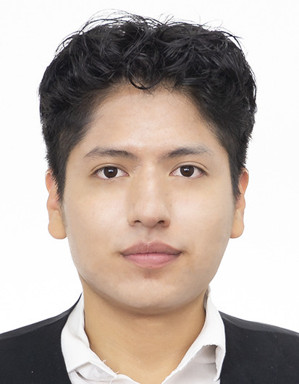

PROFESSIONAL SUMMARY
Engineer deeply interested in Physical and Agentic AI. I build intelligent systems that let robots handle real logistics and industrial work, from AI pipeline design to MLOps and production deployment.
EXPERIENCE
AI & Robotics Engineer — Tommoro Robotics
Mar 2025 – Present | Seoul, South Korea
- Developed a decision tree for Amore Pacific's Osan factory, automating packaging logistics with product picking, placement, and box dispatch operations using humanoid robots — delivered PoC with 90%+ success rate
- Supported Habilis Console, a platform for training, deploying, and testing AI models on robots; tested SmolVLA, Groot, Pi0.5, and ACT models with low-latency inference pipelines
- Built ROS2 pipeline enabling humanoid robots to understand spoken commands and act accordingly (STT → LLM/VLA → TTS), combining rule-based logic with AI inference for real-time visual-motor tasks
- Applied optimization techniques including RTC and LoRA for model fine-tuning on robotic platforms
Research Intern (UROP Awardee) — BioIntelligence Lab, Seoul National University
Jan 2025 – Jun 2025 | Seoul, South Korea
- Selected for UROP (Undergraduate Research Opportunities Program) for the project 'Embodied AI and Vision-Language-Action Models'
- Trained Vision-Language-Action (VLA) models on robotic systems including Mobile Aloha and RB-Y1 using Pi0 and ACT architectures
- Collected and processed training data for real-world manipulation tasks
- Fine-tuned models for robust performance in physical robot deployment scenarios
Research Intern — RUBIS Lab, Seoul National University
Nov 2024 – Mar 2025 | Seoul, South Korea
- Developed AI platform for adolescent mental health support under Prof. Chang-Gun Lee
- Built TTS feature and validated end-to-end pipeline (STT → LLM → TTS → MuseTalk) for real-time human-AI interaction
FEATURED PROJECTS
Amore Pacific Packaging Automation
Decision Orchestrator for factory logistics automation at Osan facility. Manages robot action blocks for picking, placing, and packaging with AI inference and joint stabilization monitoring. Achieved 90%+ success rate in PoC.
Tech: ROS2, VLA, Robot Action Orchestration, Computer Vision
Agentic AI Pipeline for Humanoid Robots
End-to-end ROS2 pipeline enabling humanoid robots to understand spoken commands and execute physical tasks. Hybrid architecture combining rule-based logic with VLA inference for real-time execution.
Tech: ROS2, STT, LLM, VLA, TTS, Real-time AI Inference
The White and Black Rat Duel (eduardoayervecruz.github.io/projects/white_and_black_rat_duel.html)
A 3D platformer game developed from scratch in Unity as a team project for the Principles and Practices of Software Development course. Built using Agile development workflow. Received A+ grade.
Tech: Unity, C#, 3D Game Development, Agile
TECH STACK
Languages: Python, C, C#, Java, JavaScript
Frontend: HTML, CSS, JavaScript, WebGazer.js
Backend: ROS2, Node.js
DevOps & Cloud: Git, GitHub Actions, MLOps (Habilis Console)
Tools: PyTorch, JAX, Vision Models, LLM, VLM, VLA, Unity
EDUCATION
B.S. in Computer Science and Engineering — Seoul National University
Mar 2021 – Aug 2025 | Seoul, South Korea
Global Korea Scholarship recipient (2020–2025). Admitted to SNU, Korea Univ., and Yonsei Univ.
Korean Language Program (GKS) — Dongseo University
Feb 2020 – Feb 2021 | Busan, South Korea
1-year Korean language training as part of Global Korea Scholarship
Studies in Economics (1 year completed) — Pontifical Catholic University of Peru (PUCP)
Mar 2019 – Feb 2020 | Lima, Peru
COAR Excellence Scholarship — awarded to only 2 students nationwide (Aug 2018)
International Baccalaureate Diploma Programme — Colegio Mayor Secundario Presidente del Perú (COAR)
2016 – 2018 | Lima, Peru
IB Score: 37/45 | GPA: 18.78/20.00 — Valedictorian
AWARDS & HONORS
- COAR Excellence Scholarship by PUCP — 1 of only 2 recipients nationwide, selected from Peru's 24 national gifted high schools (Aug 2018)
- Global Korea Scholarship (GKS) — Full scholarship covering Korean language training, undergraduate studies, and living expenses at Seoul National University (2020–2025)
- UROP (Undergraduate Research Opportunities Program) Awardee — Selected for 'Embodied AI and Vision-Language-Action Models' project at SNU BioIntelligence Lab (Jan–Jun 2025)
CERTIFICATIONS
- TOEFL iBT — C1 Level, 100/120 (Aug 2024)
- TOEIC Speaking — 160/200 (Apr 2024)
- TOPIK IBT — Level 5, 383/600 (Feb 2025)
EXTRACURRICULAR ACTIVITIES
Member — ASAPEC (Peru-Korea Academic Association)
Jul 2022 – Present
- Organized '1st Latin American Researchers Gathering in Korea' (Aug 2023)
- Organized 'International Employment & Visa Seminar' (Oct 2023)
Elementary/Middle School Teacher — Seoul National University Global Culture Education Program
May 2023 – Present
- Teaches Peruvian culture to elementary and middle school students in Gangnam-gu as part of SNU's multicultural education initiative
LANGUAGES
Spanish: Mother Tongue
English: Native Proficiency (TOEFL 100/120)
Korean: Upper Intermediate (TOPIK 5)

