- UML diagram(s) of the “Test Manager Module”

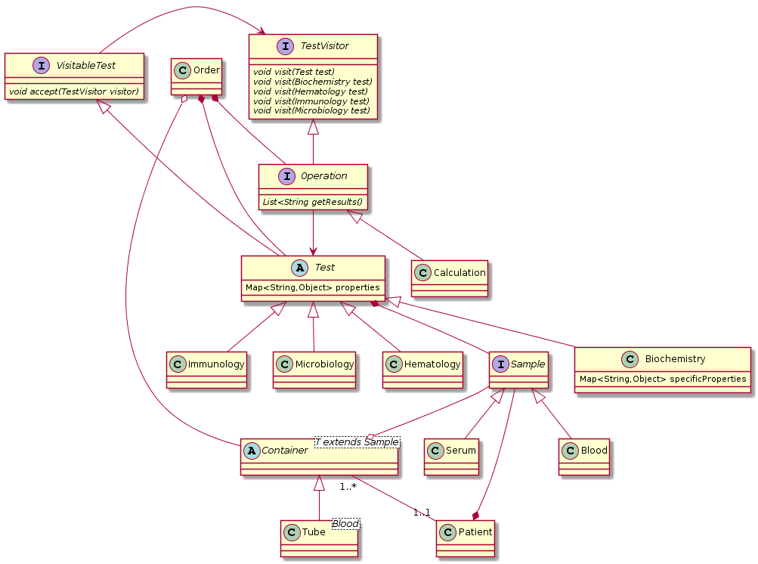
- High level refactoring strategy (e.g. what tasks should be performed before, during and after the refactoring)
  - Cover the code with tests
  - Understand the code
  - Extract methods
  - Add flexibility: SOLID, design patterns, etc
- Rationale of:
  - Proposed project structure.
  - Design patterns used.
    - Visitor Pattern in order to separate Operations algorithm from the Tests itself. It’s a way of keeping the design open for extension but closed for modification.
    - Facade Pattern in order to have only one high-level interface to use as a integration point to legacy systems

- Skeleton of the “Test Manager Module” using your preferred programming language / technology. Source code shall compile and be executed using tests
  - https://github.com/eduardocantu/lis

