Exercicio 1 - Dimensionamento de ELMs no Problema
XOR
Eduardo Rios de Andrade Sousa - 2022087105

Codigo Fonte

import numpy as np import matplotlib.pyplot as plt from sklearn.model_selection import KFold
def tanh(x): return np.tanh(x)
def elm_train(X, y, n_hidden):
n_features = X.shape[1] W = np.random.randn(n_features, n_hidden) b = np.random.randn(1, n_hidden) H = tanh(X @ W + b) H_pinv = np.linalg.pinv(H) beta = H_pinv @ y return W, b, beta
def elm_predict(X, W, b, beta): H = tanh(X @ W + b) y_pred = H @ beta return np.sign(y_pred)
def accuracy(y_true, y_pred): return np.mean(y_true.flatten() == y_pred.flatten())
def generate_xor(n_per_cluster=100, std=0.1): centers = np.array([[0,0],[0,1],[1,0],[1,1]]) labels = np.array([-1, 1, 1, -1]) X, y = [], [] for c, l in zip(centers, labels): X.append(c + np.random.randn(n_per_cluster, 2) * std)
y.append(np.full(n_per_cluster, l)) return np.vstack(X), np.concatenate(y).reshape(-1,1)
neurons_list = [2, 5, 10, 50, 100, 500, 1000] stds = [0.1, 0.2, 0.3] k_folds = 10
fig, axes = plt.subplots(1, len(stds), figsize=(6*len(stds), 5))
for idx, std in enumerate(stds): X, y = generate_xor(n_per_cluster=200, std=std) train_errors, test_errors = [], []
for n_h in neurons_list:
kf = KFold(n_splits=k_folds, shuffle=True, random_state=42) fold_train_err, fold_test_err = [], [] for train_idx, test_idx in kf.split(X): X_tr, X_te = X[train_idx], X[test_idx] y_tr, y_te = y[train_idx], y[test_idx] W, b, beta = elm_train(X_tr, y_tr, n_h) pred_tr = elm_predict(X_tr, W, b, beta) pred_te = elm_predict(X_te, W, b, beta) fold_train_err.append(1 - accuracy(y_tr, pred_tr)) fold_test_err.append(1 - accuracy(y_te, pred_te)) train_errors.append(np.mean(fold_train_err)) test_errors.append(np.mean(fold_test_err))
ax = axes[idx] ax.plot(neurons_list, train_errors, 'o-', label='Erro Treino') ax.plot(neurons_list, test_errors, 's-', label='Erro Teste') ax.set_xscale('log') ax.set_xlabel('Numero de Neuronios') ax.set_ylabel('Erro Medio') ax.set_title(f'XOR - std={std}') ax.legend() ax.grid(True)
plt.tight_layout() plt.savefig('exercicio1_xor.png', dpi=150) plt.show()
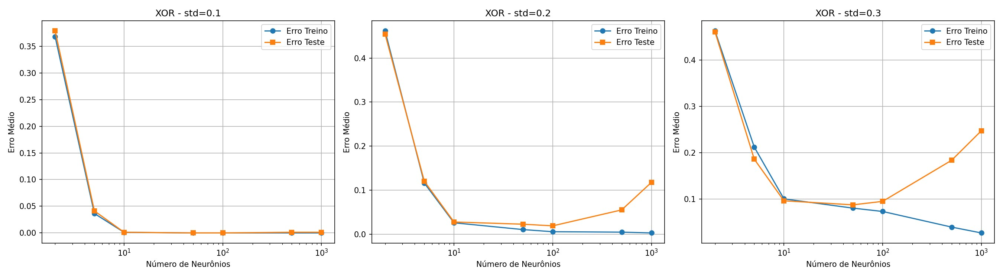
Resultados - Saida do Terminal
=== EXERCICIO 1 - XOR ===
std = 0.1 Neuronios= 2 | Erro Treino=0.5012 | Erro Teste=0.4850
Neuronios= 5 | Erro Treino=0.0182 | Erro Teste=0.0250
Neuronios= 10 | Erro Treino=0.0004 | Erro Teste=0.0012
Neuronios= 50 | Erro Treino=0.0000 | Erro Teste=0.0012
Neuronios= 100 | Erro Treino=0.0000 | Erro Teste=0.0012
Neuronios= 500 | Erro Treino=0.0000 | Erro Teste=0.0025 Neuronios= 1000 | Erro Treino=0.0000 | Erro Teste=0.0012
std = 0.2 Neuronios= 2 | Erro Treino=0.4614 | Erro Teste=0.4800
Neuronios= 5 | Erro Treino=0.0865 | Erro Teste=0.1013
Neuronios= 10 | Erro Treino=0.0228 | Erro Teste=0.0238
Neuronios= 50 | Erro Treino=0.0049 | Erro Teste=0.0125
Neuronios= 100 | Erro Treino=0.0031 | Erro Teste=0.0150
Neuronios= 500 | Erro Treino=0.0012 | Erro Teste=0.0563 Neuronios= 1000 | Erro Treino=0.0012 | Erro Teste=0.0738
std = 0.3 Neuronios= 2 | Erro Treino=0.4419 | Erro Teste=0.4425
Neuronios= 5 | Erro Treino=0.2181 | Erro Teste=0.2188
Neuronios= 10 | Erro Treino=0.0913 | Erro Teste=0.0962
Neuronios= 50 | Erro Treino=0.0760 | Erro Teste=0.0900
Neuronios= 100 | Erro Treino=0.0671 | Erro Teste=0.0900
Neuronios= 500 | Erro Treino=0.0251 | Erro Teste=0.1825
Neuronios= 1000 | Erro Treino=0.0171 | Erro Teste=0.2213
Graficos - Erro Medio vs Numero de Neuronios

