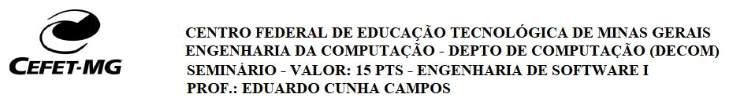

- seminário consistirá na apresentação de um artigo (do inglês, paper) da área de Engenharia de Software. Os alunos serão divididos em 10 grupos, sendo: 9 grupos de 3 pessoas e 1 dupla. Cada grupo irá apresentar um único artigo. Abaixo, segue a relação dos artigos que foram definidos pelo professor. A duração de cada seminário é de no máximo 25 minutos. A data limite para a definição dos grupos é dia 31/10/19.

Paper 1:

"Why Good Developers Write Bad Code: An Observational Case Study of the

Impacts of Organizational Factors on Software Quality"

Mathieu Lavallee and Pierre N. Robillard

Link: WhyGoodDevelopersWriteBadCode.pdf

Paper 2:

"A Large Scale Study of Programming Languages and Code Quality in Github"

Baishakhi Ray, Daryl Posnett, Vladimir Filkov, Premkumar Devanbu

Link: CodeQualityInGitHub.pdf

Paper 3:

"Hipikat: Recommending Pertinent Software Development Artifacts"

Davor Cubranic, Gail C. Murphy

Link: Hipikat.pdf

Paper 4:

"Mining Version Histories to Guide Software Changes"

Thomas Zimmerman, Peter Weisgerber, Stephan Diehl and Andreas Zeller

Link: MiningVersionHistories.pdf

Paper 5:

"Who Should Fix This Bug?"

John Anvik, Lyndon Hiew and Gail C. Murphy

Link: WhoShouldFixThisBug.pdf

Paper 6:

"Trade-Offs in Continuous Integration: Assurance, Security, and Flexibility" Michael Hilton, Nicholas Nelson, Timothy Tunnell, Darko Marinov, DannyDig

Link: Trade-Offs-Continuous-Integration.pdf

Paper 7:

"Visualization of Test Information to Assist Fault Localization"

James A. Jones, Mary Jean Harrold, and John Stasko

Link: Visualization-Test-Information.pdf

Paper 8:

"MAPO: Mining and recommending API usage patterns"

Hao Zhong, Tao Xie, Lu Zhang, Jian Pei, Hong Mei

Link: MAPO.pdf

Paper 9:

"Parseweb: a programmer assistant for reusing open source code on the web"

Suresh Thummalapenta, Tao Xie

Link: PARSEWeb.pdf

Paper 10:

"Taming Android Fragmentation: Characterizing and Detecting Compatibility Issues for Android Apps" Lili Wei, Yepang Liu, and Shing-Chi Cheung
Link: Taming-Android-Fragmentation.pdf

