**Analises referentes a incidência por 100000 habitantes.**

***Descritiva da sazonalidade***

Aqui estão os box-plot das taxas de incidência a cada 100000 habitantes. Observem se os valores estão fazendo sentido. Não há rótulos nos gráficos, mas as idades aumentam da esquerda para direita de cima para baixo.

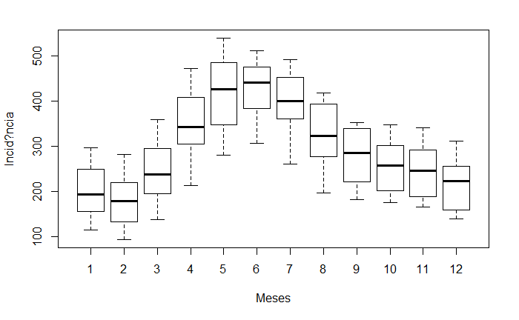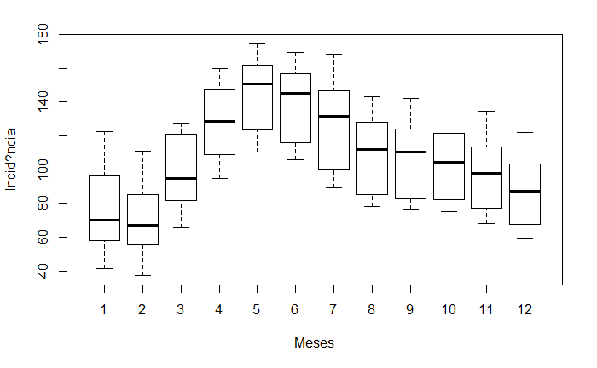

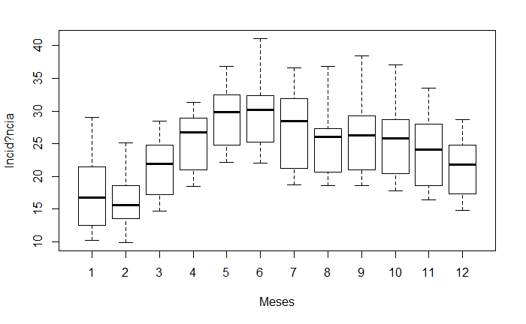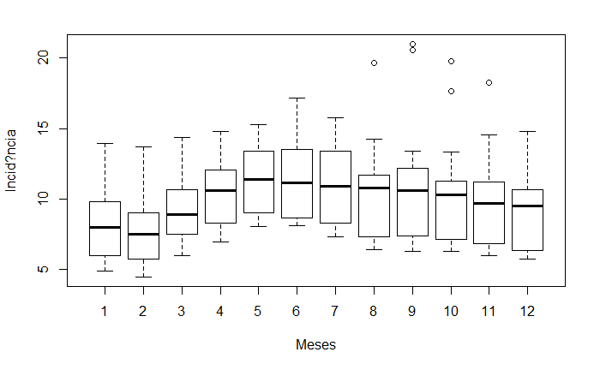

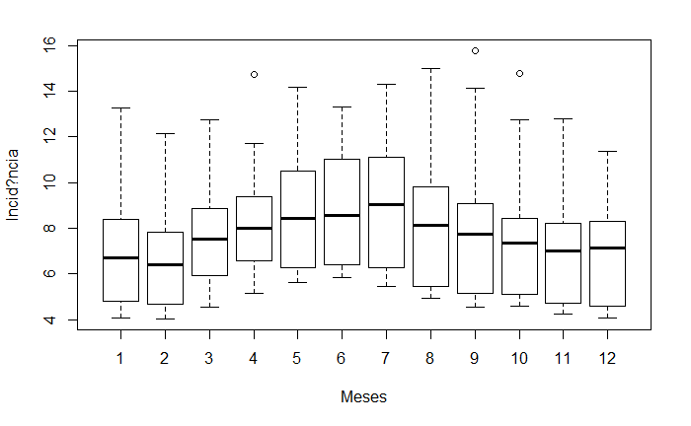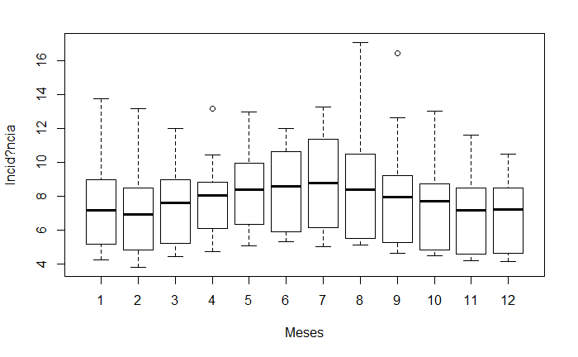

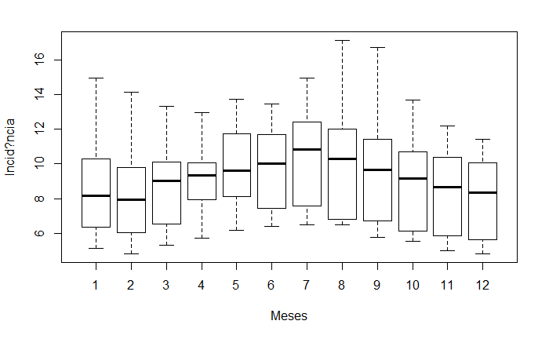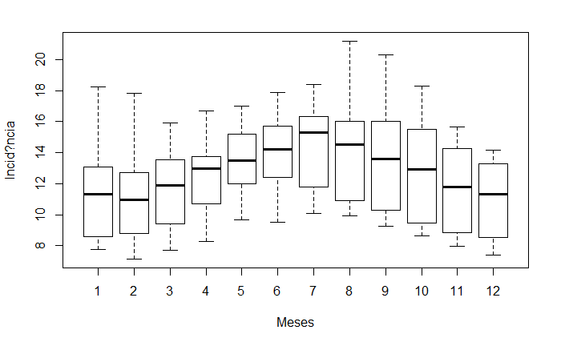

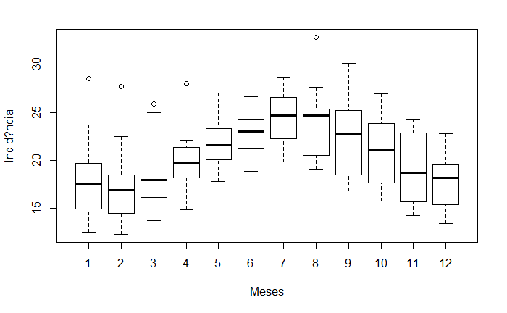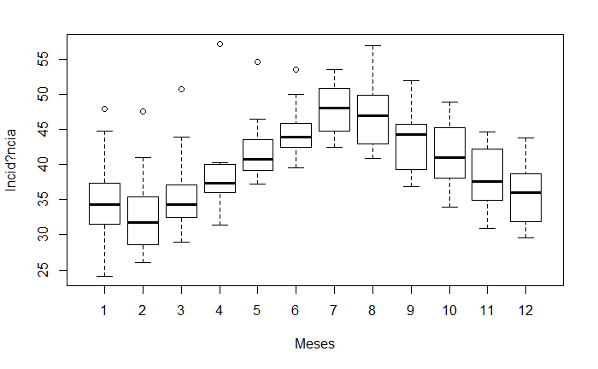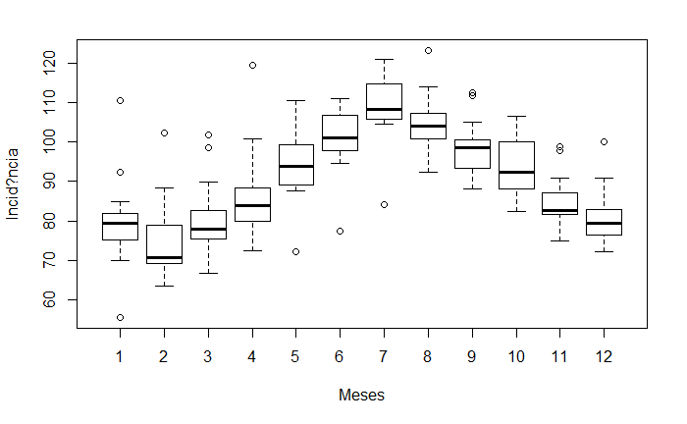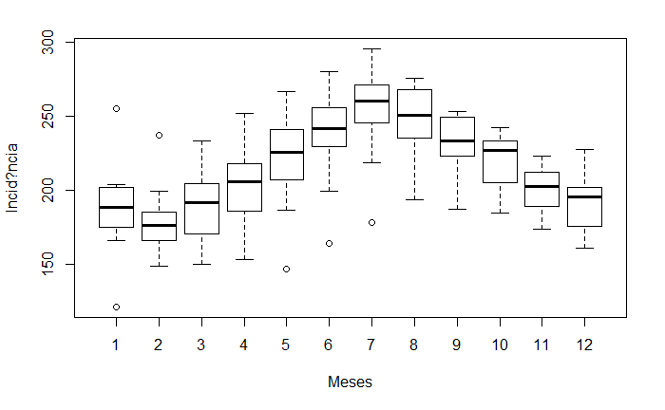

***Descritiva de tendência***

Vamos observar então as séries temporais simples destes dados interpolando uma linha de media movel simples usando12 meses para o calculo.

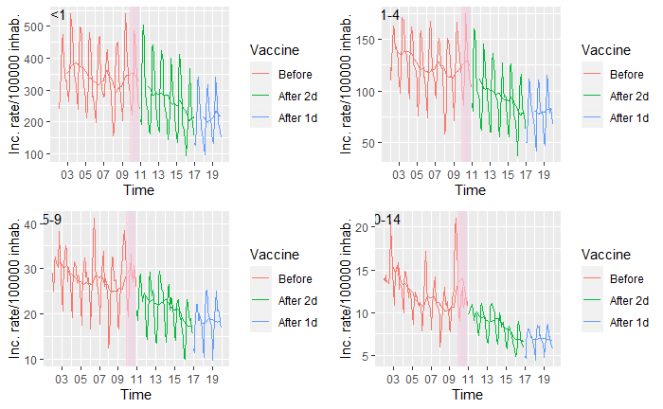 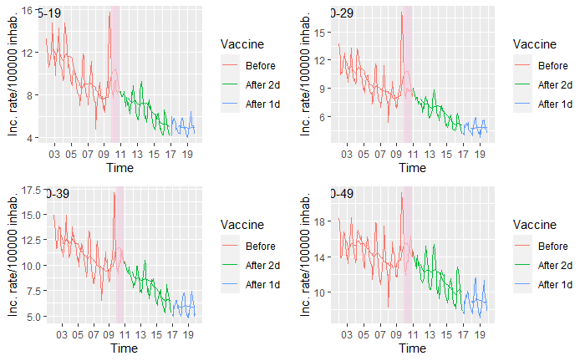

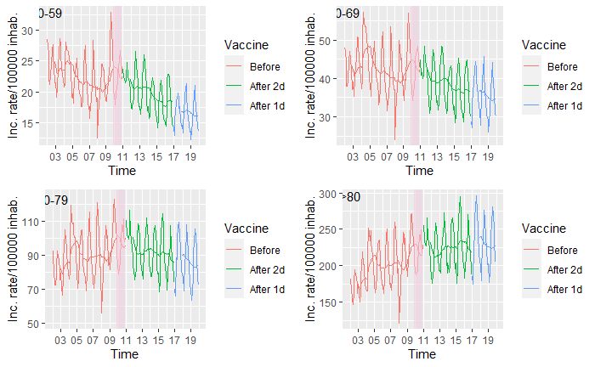

Para algumas séries parece bem clara a mudança nos três ultimos anos, para outras nem tanto. Duas hipóteses me ocorreram:

1 – Há um efeito da alteração do protocolo, mais em algumas idades que em outras;

2 – O fenômeno que estamos vendo não deveria ser modelado de forma linear, visto que ele troca de comportamento no final da série. Se isso for verdadae, então estamos lidando com um modelo bem mais complexo do que estamos abordando até agora.

Em se tratando da primeira hipótese, seria possível agrupar as idades em grupo vacinado e grupo não vacinado? Isso deveria ser baseado nos graficos acima...Em outras palavaras, nossa descritiva deve nos dar indícios de que esse agrupamento faria sentido (e.g., vemos pelos graficos que nas idades x, x e x, ocorreu um aumento na incidencia após 2016. Estas faixas são as faixas de idade vacinadas...). Neste caso, vocês poderiam me indicar as idades vacinadas.

***Modelo de regressão dinâmica (série temporal) Aqui nada mudou***

Aqui podemos ver o que foi dito anteriormente. As tendências não foram estimadas de acordo com as descritivas. Possivelmente pela adição de covariáveis. Há, entretanto uma possibilidade de estarmos presenciando um fenômeno chamado multicolinearidade. Ainda tenho que dar mais umas testadas no modelo pra ver se isso pode ser uma razão.

Observe que, para todas as idades há tendência de aumento na incidência antes da vacina, e que essa tendência vira de decréscimo após a vacinação. Há duas exceções. Idades de 10-14 e 15-19 anos (marcadas em amarelo). Nestes casos, a introdução da vacina não alterou o cenário.

|  |  |  |  |  |
| --- | --- | --- | --- | --- |
|  | Estimate | Std. Error | t value | Pr(>|t|) |
|  | flt01 ~ Full | flt01 ~ Full | flt01 ~ Full | flt01 ~ Full |
| Intercepto | 36.6258074 | 11.25536994 | 3.254074065 | 0.001341011 |
| Fev | -4.901042197 | 4.628897363 | -1.058792583 | 0.291004029 |
| Mar | 11.70528865 | 6.048849434 | 1.93512647 | 0.054421318 |
| Abr | 17.17884235 | 7.965385334 | 2.156686918 | 0.03225403 |
| Mai | 18.07613826 | 9.025528726 | 2.002778874 | 0.046586064 |
| Jun | 9.990663092 | 8.789670888 | 1.136636766 | 0.257085035 |
| Jul | 16.58583709 | 8.333770697 | 1.990195998 | 0.047966335 |
| Ago | 10.5508977 | 7.478663416 | 1.410799913 | 0.159896942 |
| Set | 16.1229401 | 6.480218116 | 2.488024293 | 0.013683875 |
| Out | 12.01678461 | 5.285529888 | 2.273525052 | 0.024084173 |
| Nov | 9.598991711 | 4.760287148 | 2.016473253 | 0.045122297 |
| Dez | -0.532345207 | 4.583988099 | -0.116131455 | 0.907667869 |
| Trend | 0.500909673 | 0.636922568 | 0.786453013 | 0.432556826 |
| Vac | 29.69076317 | 9.487572247 | 3.129437373 | 0.002020277 |
| Confoun | 0.978197407 | 0.064956859 | 15.05918573 | 1.67E-34 |
| L1 | 0.880829106 | 0.056938512 | 15.46983017 | 9.47E-36 |
| L2 | -0.186556317 | 0.047076853 | -3.962803493 | 0.000103867 |
| Lc1 | -0.740171157 | 0.078572572 | -9.420223133 | 1.33E-17 |
| vac*trend | -4.149891637 | 1.066701101 | -3.89039782 | 0.000137255 |
|  | f0104 ~ Full | f0104 ~ Full | f0104 ~ Full | f0104 ~ Full |
| Intercepto | 2.152253863 | 5.806948089 | 0.370634252 | 0.711312267 |
| Fev | 0.587254072 | 1.762810029 | 0.3331352 | 0.739390134 |
| Mar | 15.45928337 | 2.885255648 | 5.358028979 | 2.36E-07 |
| Abr | 16.6201909 | 3.298837355 | 5.038196524 | 1.07E-06 |
| Mai | 12.08002034 | 3.234971981 | 3.73419628 | 0.000247114 |
| Jun | 8.052238483 | 2.754623383 | 2.923172195 | 0.003874593 |
| Jul | 9.07451551 | 2.422842153 | 3.745401036 | 0.000237052 |
| Ago | 5.027162699 | 2.164771191 | 2.322260532 | 0.02125116 |
| Set | 11.27098228 | 1.98234193 | 5.685690299 | 4.70E-08 |
| Out | 7.207835256 | 1.866624998 | 3.861426511 | 0.000153281 |
| Nov | 4.136880361 | 1.807449604 | 2.288794306 | 0.023162989 |
| Dez | 2.416330067 | 1.63746487 | 1.475653072 | 0.141649925 |
| Trend | 1.088124037 | 0.330810149 | 3.289270421 | 0.001191829 |
| vac | 8.857566953 | 2.860488011 | 3.096523012 | 0.002246593 |
| Confoun | 0.775038673 | 0.077966115 | 9.940711714 | 4.26E-19 |
| L1 | 0.911085262 | 0.063171701 | 14.42236388 | 1.44E-32 |
| L2 | -0.271618767 | 0.054818726 | -4.954853697 | 1.57E-06 |
| Lc1 | -0.453571982 | 0.086910555 | -5.218836576 | 4.59E-07 |
| vac*trend | -1.707308582 | 0.343148441 | -4.975422815 | 1.43E-06 |
|  | f0509 ~ Full | f0509 ~ Full | f0509 ~ Full | f0509 ~ Full |
| Intercepto | 0.126681435 | 1.578584493 | 0.080250019 | 0.936120709 |
| Fev | -0.984945495 | 0.574819707 | -1.713485957 | 0.08821237 |
| Mar | 1.798768029 | 0.81856684 | 2.197460173 | 0.029165442 |
| Abr | 2.329773143 | 0.812619854 | 2.866990182 | 0.004599439 |
| Mai | 2.330277209 | 0.813588534 | 2.864196224 | 0.004638527 |
| Jun | 2.367266696 | 0.732876955 | 3.230101153 | 0.001452369 |
| Jul | 1.438111651 | 0.625512089 | 2.299094896 | 0.022559112 |
| Ago | 0.500838919 | 0.621679495 | 0.805622388 | 0.421441904 |
| Set | 3.215858454 | 0.595355359 | 5.401578071 | 1.91E-07 |
| Out | 1.296545449 | 0.602930423 | 2.150406416 | 0.032754051 |
| Nov | 0.958019259 | 0.555657686 | 1.724117715 | 0.086271375 |
| Dez | 0.736941423 | 0.499070371 | 1.47662828 | 0.14138839 |
| Trend | 0.048788007 | 0.0554053 | 0.880565706 | 0.379636904 |
| vac | 0.665022698 | 0.72378758 | 0.918809215 | 0.359330484 |
| Confoun | 0.527726868 | 0.050224695 | 10.50731845 | 9.48E-21 |
| L1 | 0.781844562 | 0.065919877 | 11.86052817 | 8.79E-25 |
| L2 | -0.166055978 | 0.055508453 | -2.991543978 | 0.003134071 |
| Lc1 | -0.289966436 | 0.058082728 | -4.992300567 | 1.32E-06 |
| vac*trend | -0.218103772 | 0.074184746 | -2.940008334 | 0.003678691 |
|  | f1014 ~ Full | f1014 ~ Full | f1014 ~ Full | f1014 ~ Full |
| Intercepto | -0.993455053 | 0.684429688 | -1.451507834 | 0.148245408 |
| Fev | -0.787563621 | 0.240393175 | -3.276148007 | 0.001245544 |
| Mar | -0.509241394 | 0.293978905 | -1.732237875 | 0.084812445 |
| Abr | -0.79652495 | 0.286766203 | -2.777610966 | 0.006010687 |
| Mai | -0.639160405 | 0.291559666 | -2.192211339 | 0.029548087 |
| Jun | -0.784915875 | 0.278586181 | -2.817497521 | 0.005338321 |
| Jul | -0.366841759 | 0.256262246 | -1.431509189 | 0.153885118 |
| Ago | -0.894826688 | 0.256870131 | -3.483576244 | 0.000610832 |
| Set | 0.203403642 | 0.255678556 | 0.795544397 | 0.427264213 |
| Out | -0.695205413 | 0.243966101 | -2.849598413 | 0.004847723 |
| Nov | -0.094014243 | 0.228398909 | -0.411622995 | 0.681067846 |
| Dez | -0.40006709 | 0.217463038 | -1.839701561 | 0.067332295 |
| Trend | -0.009601881 | 0.026077861 | -0.368200463 | 0.713123151 |
| vac | -0.338641395 | 0.345272318 | -0.980795093 | 0.32790908 |
| Confoun | 0.747444028 | 0.050398908 | 14.83055994 | 8.25E-34 |
| L1 | 0.886534483 | 0.062355753 | 14.21736482 | 6.07E-32 |
| L2 | -0.280067853 | 0.045396441 | -6.169379077 | 3.88E-09 |
| Lc1 | -0.368657479 | 0.068003659 | -5.421141797 | 1.74E-07 |
| vac*trend | -0.003990927 | 0.032980971 | -0.121006953 | 0.903810124 |
|  | f1519 ~ Full | f1519 ~ Full | f1519 ~ Full | f1519 ~ Full |
| Intercepto | -1.352660056 | 0.600123641 | -2.253968956 | 0.02531062 |
| Fev | -0.356358336 | 0.17931028 | -1.987383746 | 0.048279514 |
| Mar | -0.166166433 | 0.1966784 | -0.844863662 | 0.399222349 |
| Abr | -0.095361939 | 0.197122686 | -0.483769481 | 0.629092289 |
| Mai | -0.307963082 | 0.199577716 | -1.543073485 | 0.12443421 |
| Jun | 0.001801263 | 0.195893445 | 0.009195117 | 0.992672862 |
| Jul | -0.177841087 | 0.193487479 | -0.919134864 | 0.359160578 |
| Ago | -0.515029106 | 0.1932025 | -2.665747633 | 0.008326033 |
| Set | -0.16042458 | 0.192794698 | -0.832100579 | 0.406370031 |
| Out | -0.264350834 | 0.186077771 | -1.420647041 | 0.157016407 |
| Nov | -0.265587476 | 0.180156985 | -1.474200269 | 0.142040238 |
| Dez | -0.017568459 | 0.176054651 | -0.099789806 | 0.920613717 |
| Trend | -0.03391903 | 0.025041778 | -1.354497682 | 0.177145012 |
| vac | -0.438172298 | 0.285173388 | -1.536511878 | 0.126033868 |
| Confoun | 0.736928472 | 0.053525275 | 13.7678596 | 1.42E-30 |
| L1 | 0.66346992 | 0.071058544 | 9.336947886 | 2.29E-17 |
| L2 | -0.177886638 | 0.048705104 | -3.652320234 | 0.00033387 |
| Lc1 | -0.198493922 | 0.074499027 | -2.664382742 | 0.008358679 |
| vac*trend | 0.007777689 | 0.027301069 | 0.284885894 | 0.776033896 |
|  | f2029 ~ Full | f2029 ~ Full | f2029 ~ Full | f2029 ~ Full |
| Intercepto | -0.832282842 | 0.513037002 | -1.622266696 | 0.106361908 |
| Fev | -0.405152464 | 0.138583918 | -2.923517169 | 0.003870485 |
| Mar | -0.263564409 | 0.144574636 | -1.823033536 | 0.069829629 |
| Abr | -0.161641152 | 0.144548615 | -1.11824767 | 0.264836945 |
| Mai | -0.139422549 | 0.145701242 | -0.956907073 | 0.339799002 |
| Jun | 0.10683351 | 0.145607625 | 0.733708215 | 0.464007807 |
| Jul | 0.04002377 | 0.145605292 | 0.27487854 | 0.78370057 |
| Ago | -0.119456633 | 0.145691397 | -0.819929219 | 0.413257537 |
| Set | -0.08988321 | 0.143743143 | -0.625304328 | 0.532502426 |
| Out | -0.144168996 | 0.14153325 | -1.018622803 | 0.309644197 |
| Nov | -0.232441444 | 0.13913856 | -1.67057531 | 0.096409824 |
| Dez | 0.008747497 | 0.137895044 | 0.063435904 | 0.949484376 |
| Trend | 0.076795452 | 0.026458706 | 2.902464426 | 0.004128626 |
| vac | 0.5765772 | 0.240787669 | 2.394546211 | 0.017587963 |
| Confoun | 0.916243612 | 0.048263428 | 18.98422167 | 3.38E-46 |
| L1 | 0.760727394 | 0.059928342 | 12.6939502 | 2.64E-27 |
| L2 | -0.173289628 | 0.040153025 | -4.315730323 | 2.53E-05 |
| Lc1 | -0.536400751 | 0.070469651 | -7.611798003 | 1.13E-12 |
| vac*trend | -0.101599676 | 0.026002197 | -3.90734961 | 0.000128629 |
|  | f3039 ~ Full | f3039 ~ Full | f3039 ~ Full | f3039 ~ Full |
| Intercepto | -0.088006447 | 0.674632798 | -0.130450888 | 0.896344183 |
| Fev | -0.638413127 | 0.148594065 | -4.29635685 | 2.74E-05 |
| Mar | -0.448761632 | 0.160602069 | -2.794245642 | 0.005721443 |
| Abr | -0.465213582 | 0.155889224 | -2.984257466 | 0.003206292 |
| Mai | -0.258311061 | 0.160472753 | -1.609687972 | 0.109083635 |
| Jun | -0.167959794 | 0.158354766 | -1.06065512 | 0.290158592 |
| Jul | 0.111368399 | 0.161514462 | 0.689525861 | 0.491312112 |
| Ago | -0.245853664 | 0.163057393 | -1.507773797 | 0.133230823 |
| Set | -0.272606272 | 0.15752275 | -1.7305835 | 0.085108041 |
| Out | -0.391589269 | 0.15375668 | -2.546811429 | 0.011643168 |
| Nov | -0.474648364 | 0.14703798 | -3.228066405 | 0.001462206 |
| Dez | -0.40368267 | 0.144334644 | -2.796852224 | 0.005677284 |
| Trend | 0.140805991 | 0.043581108 | 3.230895182 | 0.001448547 |
| vac | 1.244758637 | 0.321814548 | 3.867937744 | 0.000149532 |
| Confoun | 0.902738994 | 0.059981489 | 15.05029316 | 1.77E-34 |
| L1 | 0.842187033 | 0.058726906 | 14.34073563 | 2.55E-32 |
| L2 | -0.227628857 | 0.045559278 | -4.996322787 | 1.30E-06 |
| Lc1 | -0.586998778 | 0.075731119 | -7.751090812 | 4.91E-13 |
| vac*trend | -0.179902169 | 0.037705035 | -4.771303584 | 3.58E-06 |
|  | f4049 ~ Full | f4049 ~ Full | f4049 ~ Full | f4049 ~ Full |
| Intercepto | -1.081409752 | 1.195300748 | -0.904717707 | 0.366731356 |
| Fev | -0.418222725 | 0.200350452 | -2.087455855 | 0.038146367 |
| Mar | -0.224228735 | 0.214838673 | -1.043707502 | 0.29791289 |
| Abr | 0.014700426 | 0.212449581 | 0.069194891 | 0.944905394 |
| Mai | 0.16745234 | 0.220698144 | 0.758739229 | 0.448924677 |
| Jun | 0.350023195 | 0.225462053 | 1.552470537 | 0.122171142 |
| Jul | 0.444789193 | 0.233867456 | 1.9018858 | 0.058660169 |
| Ago | 0.04882065 | 0.233481895 | 0.209098225 | 0.834589832 |
| Set | 0.030631324 | 0.225813884 | 0.135648542 | 0.892239055 |
| Out | -0.079587908 | 0.216273378 | -0.367996785 | 0.713274774 |
| Nov | -0.336843661 | 0.205513416 | -1.639034896 | 0.102818354 |
| Dez | -0.222324159 | 0.199557295 | -1.114086852 | 0.266613225 |
| Trend | 0.319371634 | 0.086357974 | 3.698229831 | 0.000282211 |
| vac | 2.837209097 | 0.607869072 | 4.66746743 | 5.66E-06 |
| Confoun | 0.748271856 | 0.061127514 | 12.24116299 | 6.23E-26 |
| L1 | 0.863368651 | 0.061620749 | 14.01100555 | 2.58E-31 |
| L2 | -0.221500183 | 0.049903754 | -4.438547526 | 1.51E-05 |
| Lc1 | -0.488886615 | 0.073727275 | -6.631014291 | 3.20E-10 |
| vac*trend | -0.359931288 | 0.070517755 | -5.10412293 | 7.86E-07 |
|  | f5059 ~ Full | f5059 ~ Full | f5059 ~ Full | f5059 ~ Full |
| Intercepto | -0.927748502 | 1.996167341 | -0.464764894 | 0.642618361 |
| Fev | -1.131685651 | 0.341159613 | -3.317173568 | 0.001084701 |
| Mar | -0.330392265 | 0.365149893 | -0.904812712 | 0.36668114 |
| Abr | -0.263308989 | 0.375140295 | -0.70189471 | 0.483581729 |
| Mai | 0.305352419 | 0.392025645 | 0.778909296 | 0.436977348 |
| Jun | 0.314620507 | 0.411736998 | 0.764129792 | 0.445713524 |
| Jul | 0.862505364 | 0.427058714 | 2.019641175 | 0.044789305 |
| Ago | -0.441213629 | 0.435867057 | -1.012266519 | 0.312665016 |
| Set | -0.256151004 | 0.402989515 | -0.63562697 | 0.525764822 |
| Out | -0.588652759 | 0.382095298 | -1.540591477 | 0.125037413 |
| Nov | -0.830851083 | 0.35130128 | -2.365067054 | 0.019008536 |
| Dez | -0.840722668 | 0.335330018 | -2.507150042 | 0.012987474 |
| Trend | 0.508440752 | 0.156535054 | 3.248095168 | 0.001368015 |
| vac | 4.768527765 | 1.157830293 | 4.118503198 | 5.63E-05 |
| Confoun | 0.638625726 | 0.05417776 | 11.78759937 | 1.46E-24 |
| L1 | 0.869693892 | 0.061166539 | 14.21845838 | 6.02E-32 |
| L2 | -0.195418715 | 0.051158213 | -3.81988942 | 0.000179382 |
| Lc1 | -0.464764033 | 0.062885832 | -7.390600017 | 4.19E-12 |
| vac*trend | -0.559604879 | 0.131082697 | -4.269098009 | 3.06E-05 |
|  | f6069 ~ Full | f6069 ~ Full | f6069 ~ Full | f6069 ~ Full |
| Intercepto | -1.66819088 | 3.868683167 | -0.431203799 | 0.666796499 |
| Fev | -1.44734587 | 0.542422324 | -2.668300707 | 0.008265276 |
| Mar | 0.742724065 | 0.576045021 | 1.289350724 | 0.198803447 |
| Abr | 0.495472566 | 0.615392715 | 0.805132322 | 0.421723938 |
| Mai | 1.484366567 | 0.637521706 | 2.328338866 | 0.020919192 |
| Jun | 0.917218391 | 0.673923723 | 1.361012174 | 0.175080625 |
| Jul | 2.213223361 | 0.711716564 | 3.109697697 | 0.002153333 |
| Ago | -0.315944454 | 0.730944748 | -0.432241226 | 0.666043699 |
| Set | -0.252302586 | 0.675098702 | -0.37372696 | 0.709013475 |
| Out | -0.558990093 | 0.6428538 | -0.869544667 | 0.385618342 |
| Nov | -0.915202937 | 0.578351088 | -1.582434884 | 0.115170867 |
| Dez | -0.336195917 | 0.546184703 | -0.615535212 | 0.538919059 |
| Trend | 0.903404623 | 0.309780121 | 2.916276945 | 0.003957547 |
| vac | 7.189491147 | 2.235952574 | 3.215404133 | 0.001524824 |
| Confoun | 0.553786661 | 0.041294153 | 13.41077645 | 1.74E-29 |
| L1 | 0.942165683 | 0.058269751 | 16.16903579 | 7.32E-38 |
| L2 | -0.215523236 | 0.049520136 | -4.35223431 | 2.17E-05 |
| Lc1 | -0.435730148 | 0.048394853 | -9.003646544 | 1.98E-16 |
| vac*trend | -0.884347236 | 0.253699422 | -3.485807053 | 0.00060606 |
|  | f7079 ~ Full | f7079 ~ Full | f7079 ~ Full | f7079 ~ Full |
| Intercepto | -12.18197942 | 8.390640967 | -1.451853257 | 0.148149414 |
| Fev | -1.820755576 | 1.246143077 | -1.46111278 | 0.145593961 |
| Mar | 1.105258078 | 1.317002365 | 0.839222546 | 0.402372083 |
| Abr | 2.321325118 | 1.359181057 | 1.707885132 | 0.089249071 |
| Mai | 2.936958715 | 1.443790332 | 2.034200292 | 0.043285674 |
| Jun | 3.584453955 | 1.503026413 | 2.384824327 | 0.018045729 |
| Jul | 4.307453391 | 1.652145271 | 2.607188039 | 0.009834801 |
| Ago | -1.649879336 | 1.675867057 | -0.98449297 | 0.326093122 |
| Set | -1.218258898 | 1.575027443 | -0.773484235 | 0.440172506 |
| Out | -0.926433862 | 1.467580355 | -0.631266192 | 0.528605741 |
| Nov | -3.688082943 | 1.327158202 | -2.778932412 | 0.005987233 |
| Dez | -0.883778675 | 1.270693814 | -0.695508757 | 0.487564546 |
| Trend | 2.727221148 | 0.682717198 | 3.994657165 | 9.18E-05 |
| vac | 20.63366684 | 4.819782357 | 4.281037049 | 2.92E-05 |
| Confoun | 0.683366092 | 0.050014289 | 13.6634172 | 2.96E-30 |
| L1 | 0.837849828 | 0.060350156 | 13.88314271 | 6.33E-31 |
| L2 | -0.116615717 | 0.049940225 | -2.335105949 | 0.020554974 |
| Lc1 | -0.509710397 | 0.059965595 | -8.500047333 | 4.88E-15 |
| vac*trend | -2.427016969 | 0.537942218 | -4.511668514 | 1.11E-05 |
|  | fmm80 ~ Full | fmm80 ~ Full | fmm80 ~ Full | fmm80 ~ Full |
| Intercepto | -30.79313725 | 18.75898404 | -1.641514124 | 0.102302552 |
| Fev | -7.120353188 | 3.078591237 | -2.312860864 | 0.021773627 |
| Mar | 4.0935763 | 3.169363816 | 1.291608202 | 0.198021689 |
| Abr | 1.184292272 | 3.417262976 | 0.346561643 | 0.729294343 |
| Mai | 6.623105545 | 3.512767941 | 1.885437825 | 0.060857746 |
| Jun | 7.925409133 | 3.735135877 | 2.121852965 | 0.035112529 |
| Jul | 6.902268291 | 4.153044141 | 1.661978071 | 0.098123868 |
| Ago | -3.657285453 | 4.135124579 | -0.884443838 | 0.377545877 |
| Set | -4.874047707 | 3.872721877 | -1.258558673 | 0.209694504 |
| Out | -5.131688245 | 3.624893609 | -1.415679686 | 0.158464491 |
| Nov | -8.639027568 | 3.256672406 | -2.652716176 | 0.00864247 |
| Dez | -5.97746445 | 3.088376215 | -1.935471599 | 0.054378695 |
| Trend | 6.626728125 | 1.492948803 | 4.438684107 | 1.51E-05 |
| vac | 40.45295685 | 10.03341052 | 4.031825147 | 7.93E-05 |
| Confoun | 0.918306169 | 0.076441976 | 12.01311391 | 3.05E-25 |
| L1 | 0.829161424 | 0.062977641 | 13.16596506 | 9.69E-29 |
| L2 | -0.11084694 | 0.053827109 | -2.059314367 | 0.040792932 |
| Lc1 | -0.645533141 | 0.089634488 | -7.201838893 | 1.26E-11 |
| vac*trend | -4.828553144 | 1.111759493 | -4.343163406 | 2.26E-05 |