**Analises referentes a incidência por 100000 habitantes.**

***Descritiva da sazonalidade***

Aqui estão os box-plot das taxas de incidência a cada 100000 habitantes com tempo entre 2011 e 2019. Observem se os valores estão fazendo sentido. Não há rótulos nos gráficos, mas as idades aumentam da esquerda para direita de cima para baixo.

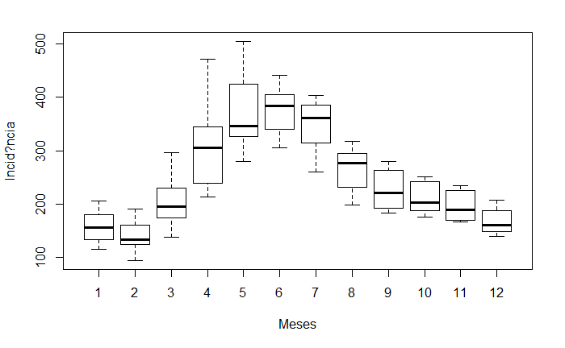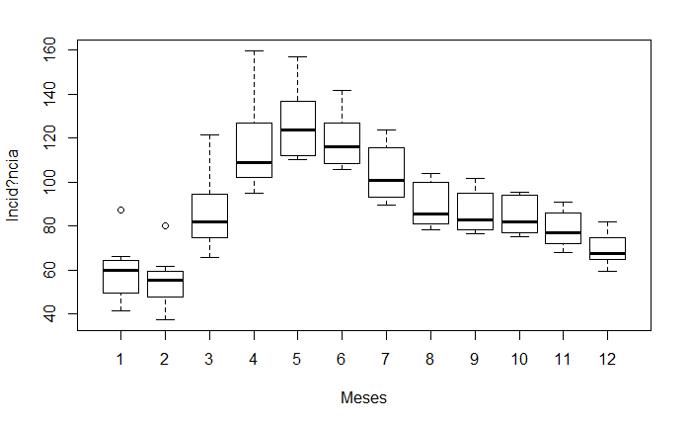

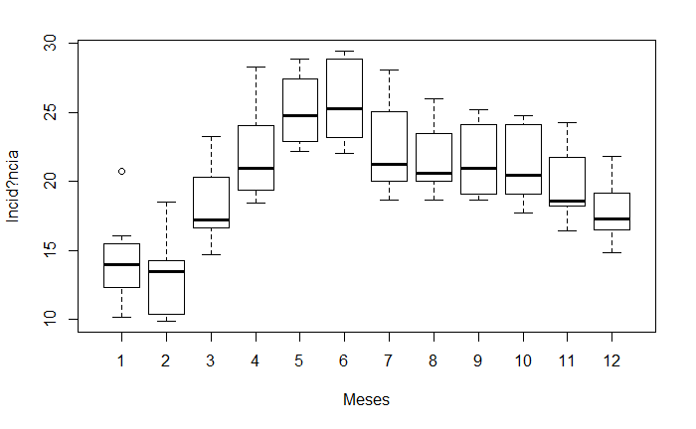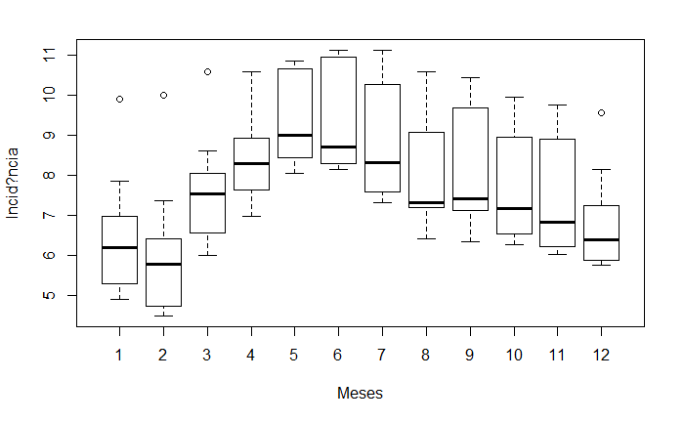

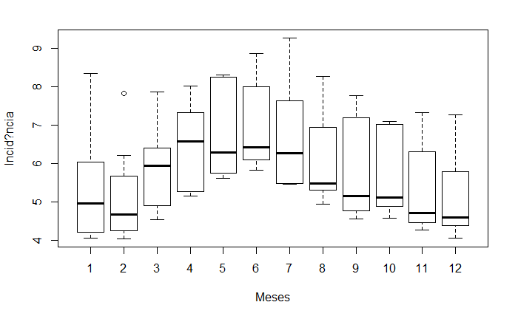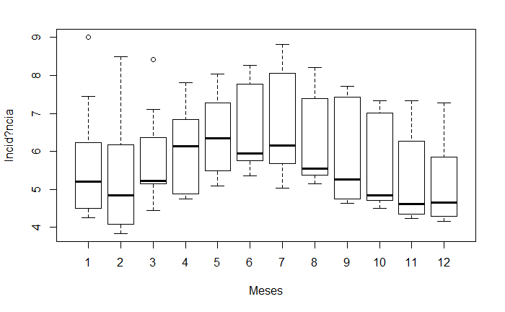

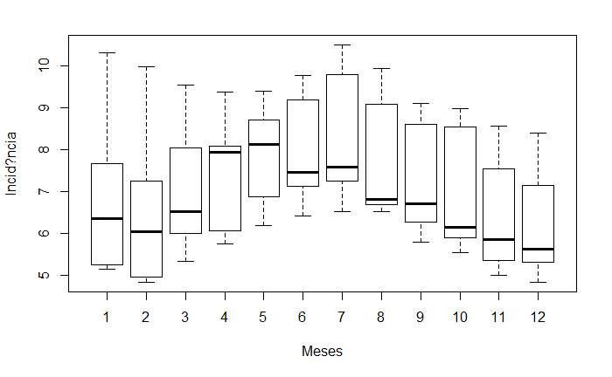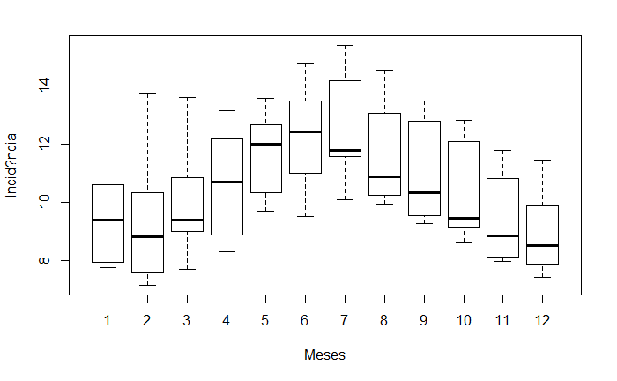

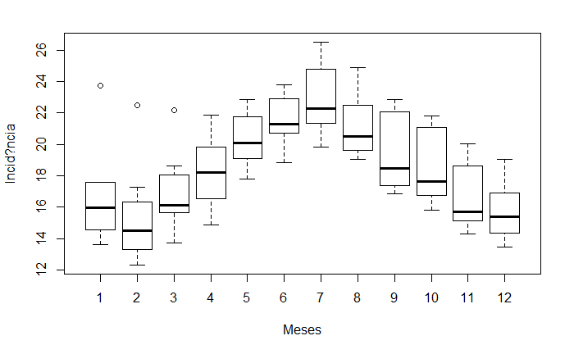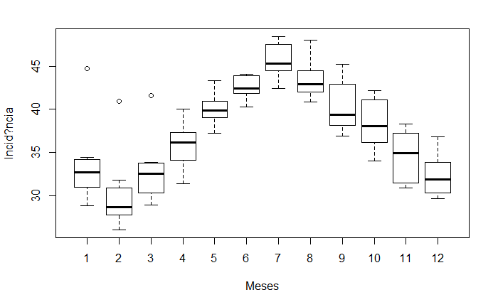

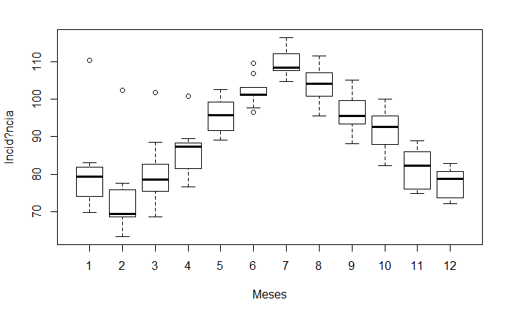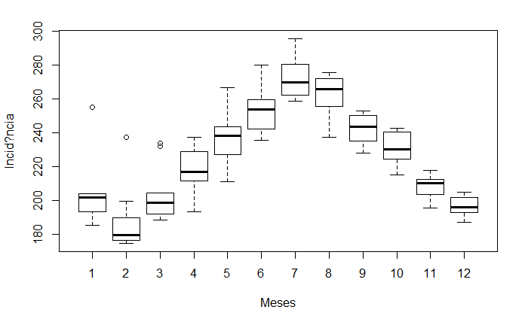

***Descritiva de tendência***

Vamos observar então as séries temporais simples destes dados:

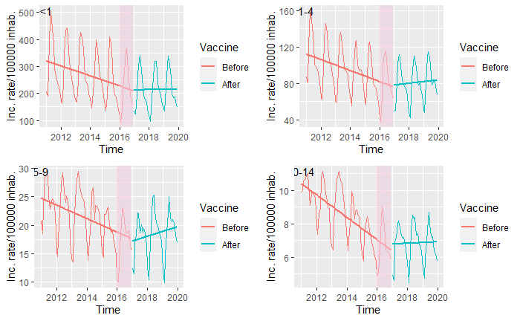

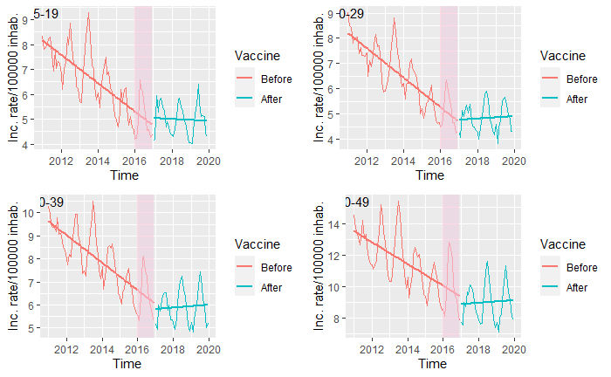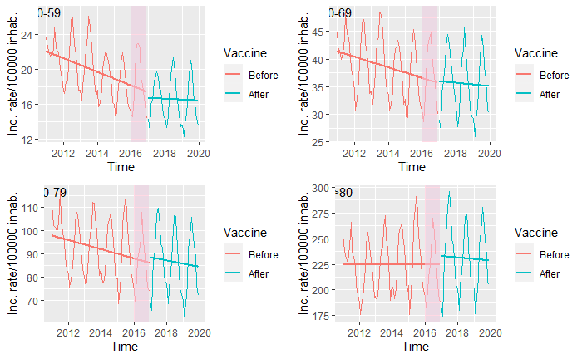

Aqui, vamos ver se os intervalos dos eixos Y estão fazendo sentido. A qualidade da imagem será melhorada se decidirmos usar. Percebam que, as tendências vistas aqui não necessariamente condizem com o que a regressão vai estimar. Isso se deve ao fato de que a regressão tem mais covariáveis no modelo (e.g., sazonalidade, lag, confundidor). De qualquer forma, parece lógico pensar em testar hipóteses de interação entre a tendência e a utilização da vacina.

***Modelo de regressão dinâmica (série temporal)***

Aqui podemos ver o que foi dito anteriormente. As tendências não foram estimadas de acordo com as descritivas. Possivelmente pela adição de covariáveis. Há, entretanto uma possibilidade de estarmos presenciando um fenômeno chamado multicolinearidade. Ainda tenho que dar mais umas testadas no modelo pra ver se isso pode ser uma razão.

Há algo interessante. Para varias idades a tendência é de subida após o choque (i.e., troca de protocolo). Eu marquei em amarelo quando significativo. Há também, em amarelo, as faixas de idade em que o valor p foi marginal. Observe que as idades de 5 a 9 e 10 a 14, bem como todos acima dos 40 anos, não houve diferença.

|  |  |  |  |  |
| --- | --- | --- | --- | --- |
|  | Estimate | Std. Error | t value | Pr(>|t|) |
|  | flt01 ~ Full | flt01 ~ Full | flt01 ~ Full | flt01 ~ Full |
| Intercepto | 47.12965 | 14.35464 | 3.283234 | 0.001479 |
| Fev | -6.97671 | 6.160603 | -1.13247 | 0.260548 |
| Mar | 4.339256 | 8.373807 | 0.518194 | 0.605638 |
| Abr | 0.059928 | 11.26018 | 0.005322 | 0.995766 |
| Mai | -6.25125 | 13.20263 | -0.47348 | 0.637053 |
| Jun | -1.4417 | 13.7047 | -0.1052 | 0.916461 |
| Jul | 9.972587 | 13.40429 | 0.743985 | 0.45889 |
| Ago | 5.650177 | 11.47636 | 0.492332 | 0.623725 |
| Set | 21.17707 | 9.664078 | 2.191318 | 0.031101 |
| Out | 8.11622 | 7.359264 | 1.102857 | 0.27313 |
| Nov | 4.442422 | 6.469425 | 0.68668 | 0.494111 |
| Dez | -1.37132 | 6.064075 | -0.22614 | 0.821624 |
| Trend | -5.29929 | 1.337941 | -3.96078 | 0.000152 |
| vac | -38.2498 | 18.79172 | -2.03546 | 0.044848 |
| Confoun | 1.00128 | 0.093637 | 10.69317 | 1.58E-17 |
| L1 | 0.833055 | 0.08839 | 9.424796 | 6.06E-15 |
| L2 | -0.23103 | 0.065926 | -3.50443 | 0.000725 |
| Lc1 | -0.65024 | 0.125071 | -5.19894 | 1.31E-06 |
| vac*trend | 5.217838 | 2.662566 | 1.959703 | 0.053232 |
|  | f0104 ~ Full | f0104 ~ Full | f0104 ~ Full | f0104 ~ Full |
| Intercepto | -1.10246 | 7.226691 | -0.15255 | 0.879103 |
| Fev | 0.545084 | 2.273213 | 0.239786 | 0.81106 |
| Mar | 13.21675 | 4.179378 | 3.162373 | 0.002155 |
| Abr | 17.20695 | 4.464754 | 3.853952 | 0.000222 |
| Mai | 13.11517 | 4.291089 | 3.056373 | 0.002975 |
| Jun | 11.20536 | 3.795697 | 2.952121 | 0.004056 |
| Jul | 8.21846 | 3.472015 | 2.367058 | 0.020149 |
| Ago | 4.882632 | 3.129774 | 1.560059 | 0.122376 |
| Set | 10.08463 | 2.663159 | 3.786718 | 0.00028 |
| Out | 6.292673 | 2.471258 | 2.546344 | 0.012646 |
| Nov | 3.140324 | 2.283574 | 1.37518 | 0.172607 |
| Dez | 2.447923 | 1.946877 | 1.257359 | 0.211988 |
| Trend | -0.99723 | 0.467925 | -2.13117 | 0.035896 |
| Vac | -14.6709 | 5.768065 | -2.54347 | 0.012743 |
| Confoun | 0.924326 | 0.131967 | 7.004228 | 4.97E-10 |
| L1 | 0.63596 | 0.103386 | 6.151322 | 2.28E-08 |
| L2 | -0.19268 | 0.081607 | -2.36101 | 0.020459 |
| Lc1 | -0.23641 | 0.166678 | -1.41836 | 0.159659 |
| vac*trend | 2.295962 | 0.839179 | 2.735963 | 0.007538 |
|  | f0509 ~ Full | f0509 ~ Full | f0509 ~ Full | f0509 ~ Full |
| Intercepto | -0.59415 | 2.260374 | -0.26286 | 0.793283 |
| Fev | -0.27267 | 0.673827 | -0.40466 | 0.686724 |
| Mar | 3.446029 | 1.032358 | 3.338018 | 0.001243 |
| Abr | 4.349142 | 1.085791 | 4.005505 | 0.00013 |
| Mai | 4.61603 | 0.996286 | 4.633238 | 1.25E-05 |
| Jun | 4.306528 | 0.933201 | 4.614789 | 1.35E-05 |
| Jul | 1.922074 | 0.773487 | 2.484947 | 0.014871 |
| Ago | 2.07776 | 0.794859 | 2.613996 | 0.010545 |
| Set | 3.30109 | 0.702572 | 4.698576 | 9.73E-06 |
| Out | 2.73756 | 0.702806 | 3.895185 | 0.000192 |
| Nov | 1.979726 | 0.664211 | 2.980568 | 0.00373 |
| Dez | 1.572441 | 0.563328 | 2.791342 | 0.006451 |
| Trend | -0.27713 | 0.121369 | -2.2834 | 0.024843 |
| Vac | 0.272134 | 1.828885 | 0.148798 | 0.882058 |
| Confoun | 0.389512 | 0.065806 | 5.91908 | 6.27E-08 |
| L1 | 0.547489 | 0.109237 | 5.011915 | 2.81E-06 |
| L2 | -0.00367 | 0.090238 | -0.04071 | 0.967618 |
| Lc1 | -0.13773 | 0.076425 | -1.80217 | 0.074982 |
| vac*trend | 0.025656 | 0.268478 | 0.095561 | 0.924089 |
|  | f1014 ~ Full | f1014 ~ Full | f1014 ~ Full | f1014 ~ Full |
| Intercepto | 1.583563 | 1.040831 | 1.521441 | 0.131776 |
| Fev | -0.20214 | 0.224427 | -0.90067 | 0.370248 |
| Mar | 1.052171 | 0.323224 | 3.255238 | 0.001615 |
| Abr | 1.069941 | 0.361747 | 2.957703 | 0.00399 |
| Mai | 1.445664 | 0.357913 | 4.039146 | 0.000115 |
| Jun | 1.0327 | 0.352945 | 2.925952 | 0.00438 |
| Jul | 0.725333 | 0.300348 | 2.414978 | 0.01783 |
| Ago | 0.379154 | 0.2927 | 1.295366 | 0.198621 |
| Set | 0.987068 | 0.266219 | 3.707733 | 0.000367 |
| Out | 0.51853 | 0.260083 | 1.993713 | 0.049316 |
| Nov | 0.621127 | 0.236995 | 2.620846 | 0.010351 |
| Dez | 0.310794 | 0.207568 | 1.497314 | 0.137931 |
| Trend | -0.16438 | 0.062585 | -2.62646 | 0.010194 |
| Vac | -0.63324 | 0.6576 | -0.96295 | 0.33824 |
| Confoun | 0.275306 | 0.070611 | 3.898896 | 0.00019 |
| L1 | 0.716135 | 0.101718 | 7.040372 | 4.21E-10 |
| L2 | -0.08117 | 0.094071 | -0.86282 | 0.39061 |
| Lc1 | -0.18369 | 0.073964 | -2.48354 | 0.014926 |
| vac*trend | 0.129565 | 0.098371 | 1.317108 | 0.191261 |
|  | f1519 ~ Full | f1519 ~ Full | f1519 ~ Full | f1519 ~ Full |
| Intercepto | 1.198512 | 1.174682 | 1.020286 | 0.310422 |
| Fev | -0.10871 | 0.182482 | -0.59572 | 0.55291 |
| Mar | 0.358497 | 0.217784 | 1.646113 | 0.103348 |
| Abr | 0.776307 | 0.242903 | 3.195956 | 0.001943 |
| Mai | 0.707111 | 0.257034 | 2.751046 | 0.007227 |
| Jun | 0.892734 | 0.257397 | 3.468314 | 0.000817 |
| Jul | 0.392218 | 0.261774 | 1.498305 | 0.137674 |
| Ago | 0.074512 | 0.261501 | 0.284941 | 0.776367 |
| Set | 0.060633 | 0.237659 | 0.255125 | 0.799229 |
| Out | 0.147508 | 0.218953 | 0.673697 | 0.50229 |
| Nov | -0.01332 | 0.205679 | -0.06476 | 0.948515 |
| Dez | 0.150068 | 0.1878 | 0.799084 | 0.426418 |
| Trend | -0.16887 | 0.061236 | -2.75775 | 0.007092 |
| Vac | -1.01545 | 0.607939 | -1.67031 | 0.098452 |
| Confoun | 0.329544 | 0.09563 | 3.44603 | 0.000878 |
| L1 | 0.447958 | 0.108241 | 4.138536 | 8.05E-05 |
| L2 | 0.104919 | 0.098206 | 1.068361 | 0.288313 |
| Lc1 | -0.14995 | 0.102658 | -1.46071 | 0.147697 |
| vac*trend | 0.184103 | 0.089075 | 2.066826 | 0.041723 |
|  | f2029 ~ Full | f2029 ~ Full | f2029 ~ Full | f2029 ~ Full |
| Intercepto | 1.38506 | 0.866395 | 1.598648 | 0.113524 |
| Fev | -0.4056 | 0.131998 | -3.07275 | 0.002832 |
| Mar | 0.153646 | 0.137957 | 1.113729 | 0.268463 |
| Abr | 0.023668 | 0.152132 | 0.155579 | 0.876726 |
| Mai | 0.320236 | 0.155774 | 2.055778 | 0.042801 |
| Jun | 0.379542 | 0.163644 | 2.319311 | 0.022721 |
| Jul | 0.182802 | 0.165003 | 1.107871 | 0.270971 |
| Ago | -0.06178 | 0.165343 | -0.37363 | 0.709589 |
| Set | -0.06277 | 0.156413 | -0.40134 | 0.689156 |
| Out | -0.13517 | 0.144729 | -0.93396 | 0.352911 |
| Nov | -0.19317 | 0.136992 | -1.41008 | 0.16208 |
| Dez | -0.06285 | 0.132898 | -0.47292 | 0.637453 |
| Trend | -0.11967 | 0.050397 | -2.37458 | 0.019768 |
| Vac | -0.8113 | 0.489612 | -1.65702 | 0.101118 |
| Confoun | 0.460173 | 0.091779 | 5.013938 | 2.78E-06 |
| L1 | 0.771691 | 0.099924 | 7.722806 | 1.80E-11 |
| L2 | -0.09518 | 0.088221 | -1.07888 | 0.283625 |
| Lc1 | -0.34311 | 0.096135 | -3.56907 | 0.000586 |
| vac*trend | 0.137037 | 0.071668 | 1.912109 | 0.059153 |
|  | f3039 ~ Full | f3039 ~ Full | f3039 ~ Full | f3039 ~ Full |
| Intercepto | 2.268657 | 0.979317 | 2.316569 | 0.022877 |
| Fev | -0.38269 | 0.147176 | -2.60022 | 0.010945 |
| Mar | 0.024457 | 0.165534 | 0.147748 | 0.882883 |
| Abr | 0.230109 | 0.16685 | 1.379138 | 0.171387 |
| Mai | 0.405594 | 0.174923 | 2.318695 | 0.022756 |
| Jun | 0.422543 | 0.179849 | 2.349436 | 0.021066 |
| Jul | 0.532163 | 0.188306 | 2.826063 | 0.005845 |
| Ago | 0.028523 | 0.194136 | 0.146923 | 0.883532 |
| Set | -0.02675 | 0.181501 | -0.14738 | 0.883177 |
| Out | -0.17367 | 0.172714 | -1.00551 | 0.317441 |
| Nov | -0.26318 | 0.153342 | -1.71632 | 0.089662 |
| Dez | -0.13399 | 0.144193 | -0.92921 | 0.355349 |
| Trend | -0.14125 | 0.058092 | -2.43149 | 0.017088 |
| Vac | -1.11708 | 0.533378 | -2.09436 | 0.039137 |
| Confoun | 0.576375 | 0.11579 | 4.977764 | 3.22E-06 |
| L1 | 0.720073 | 0.100024 | 7.19903 | 2.04E-10 |
| L2 | -0.05143 | 0.090204 | -0.57012 | 0.570067 |
| Lc1 | -0.49548 | 0.119734 | -4.13823 | 8.06E-05 |
| vac*trend | 0.171556 | 0.076372 | 2.246325 | 0.027215 |
|  | f4049 ~ Full | f4049 ~ Full | f4049 ~ Full | f4049 ~ Full |
| Intercepto | 0.598534 | 1.597739 | 0.374613 | 0.70886 |
| Fev | -0.24311 | 0.219942 | -1.10534 | 0.27206 |
| Mar | 0.012848 | 0.219035 | 0.058655 | 0.953361 |
| Abr | 0.519077 | 0.231605 | 2.241214 | 0.027558 |
| Mai | 0.613054 | 0.243681 | 2.51581 | 0.013712 |
| Jun | 0.685177 | 0.263549 | 2.599809 | 0.010957 |
| Jul | 0.738338 | 0.282168 | 2.616664 | 0.010469 |
| Ago | -0.13415 | 0.291662 | -0.45995 | 0.646697 |
| Set | 0.196524 | 0.275492 | 0.713354 | 0.477536 |
| Out | -0.14197 | 0.245625 | -0.578 | 0.564754 |
| Nov | -0.28014 | 0.227167 | -1.2332 | 0.220821 |
| Dez | -0.04886 | 0.211059 | -0.23152 | 0.817455 |
| Trend | -0.01409 | 0.094038 | -0.14982 | 0.881253 |
| Vac | -0.79305 | 0.735877 | -1.07769 | 0.284149 |
| Confoun | 0.754091 | 0.128769 | 5.856129 | 8.23E-08 |
| L1 | 0.755267 | 0.105932 | 7.129728 | 2.80E-10 |
| L2 | -0.14334 | 0.085065 | -1.68501 | 0.095571 |
| Lc1 | -0.41784 | 0.14169 | -2.94898 | 0.004094 |
| vac*trend | 0.112739 | 0.103918 | 1.084888 | 0.280968 |
|  | f5059 ~ Full | f5059 ~ Full | f5059 ~ Full | f5059 ~ Full |
| Intercepto | 2.629272 | 2.304749 | 1.140806 | 0.257081 |
| Fev | -0.81334 | 0.335236 | -2.42617 | 0.017324 |
| Mar | 0.339998 | 0.33752 | 1.007341 | 0.316564 |
| Abr | 0.547225 | 0.382829 | 1.429423 | 0.156464 |
| Mai | 1.053775 | 0.420137 | 2.508169 | 0.013991 |
| Jun | 1.137673 | 0.464037 | 2.451685 | 0.016218 |
| Jul | 1.545186 | 0.517554 | 2.985555 | 0.003675 |
| Ago | -0.39862 | 0.538576 | -0.74013 | 0.461212 |
| Set | 0.359682 | 0.478184 | 0.752183 | 0.453971 |
| Out | 0.20779 | 0.418146 | 0.496932 | 0.620491 |
| Nov | -0.44188 | 0.36437 | -1.21271 | 0.228523 |
| Dez | -0.05465 | 0.32794 | -0.16665 | 0.868034 |
| Trend | -0.0152 | 0.135995 | -0.11179 | 0.911244 |
| Vac | -0.19983 | 1.023546 | -0.19523 | 0.845665 |
| Confoun | 0.73355 | 0.110696 | 6.626734 | 2.75E-09 |
| L1 | 0.891004 | 0.09223 | 9.660708 | 1.99E-15 |
| L2 | -0.24656 | 0.075998 | -3.24433 | 0.001671 |
| Lc1 | -0.52621 | 0.118482 | -4.44125 | 2.62E-05 |
| vac*trend | 0.013057 | 0.145397 | 0.089806 | 0.928648 |
|  | f6069 ~ Full | f6069 ~ Full | f6069 ~ Full | f6069 ~ Full |
| Intercepto | 4.774547 | 3.561011 | 1.340784 | 0.183481 |
| Fev | -1.91375 | 0.557844 | -3.43062 | 0.000923 |
| Mar | 0.185617 | 0.615668 | 0.301488 | 0.763761 |
| Abr | 1.39095 | 0.673976 | 2.063797 | 0.042016 |
| Mai | 2.506096 | 0.756945 | 3.310804 | 0.001356 |
| Jun | 2.559653 | 0.855135 | 2.993275 | 0.003592 |
| Jul | 3.065283 | 0.998756 | 3.0691 | 0.002863 |
| Ago | 0.698377 | 1.002376 | 0.696722 | 0.487834 |
| Set | 0.69341 | 0.872542 | 0.794701 | 0.42895 |
| Out | 0.214394 | 0.767488 | 0.279345 | 0.780643 |
| Nov | -0.50347 | 0.632382 | -0.79616 | 0.428109 |
| Dez | -0.37435 | 0.547791 | -0.68338 | 0.496184 |
| Trend | 0.188881 | 0.223482 | 0.845173 | 0.400332 |
| Vac | 2.381174 | 1.691985 | 1.407326 | 0.162894 |
| Confoun | 0.755704 | 0.111654 | 6.768284 | 1.45E-09 |
| L1 | 0.751408 | 0.09375 | 8.014987 | 4.61E-12 |
| L2 | -0.14824 | 0.076844 | -1.92914 | 0.056973 |
| Lc1 | -0.5208 | 0.12143 | -4.28886 | 4.63E-05 |
| vac*trend | -0.33212 | 0.244319 | -1.35936 | 0.177545 |
|  | f7079 ~ Full | f7079 ~ Full | f7079 ~ Full | f7079 ~ Full |
| Intercepto | -1.969 | 7.991126 | -0.2464 | 0.805954 |
| Fev | -1.1139 | 1.413655 | -0.78796 | 0.432862 |
| Mar | 3.238128 | 1.365491 | 2.371401 | 0.019928 |
| Abr | 2.689214 | 1.525886 | 1.762396 | 0.081515 |
| Mai | 6.131561 | 1.710635 | 3.584376 | 0.000557 |
| Jun | 6.995782 | 1.949729 | 3.58808 | 0.00055 |
| Jul | 8.182301 | 2.301837 | 3.554683 | 0.000615 |
| Ago | 2.035578 | 2.29941 | 0.885261 | 0.378456 |
| Set | 1.677272 | 1.990354 | 0.8427 | 0.401707 |
| Out | 1.853352 | 1.722509 | 1.075961 | 0.284919 |
| Nov | -2.43281 | 1.484667 | -1.63862 | 0.104903 |
| Dez | 0.686325 | 1.374264 | 0.499413 | 0.618749 |
| Trend | 1.872622 | 0.602235 | 3.109451 | 0.002534 |
| Vac | 6.190503 | 3.93159 | 1.574555 | 0.118989 |
| Confoun | 0.988576 | 0.1233 | 8.017679 | 4.56E-12 |
| L1 | 0.587582 | 0.100082 | 5.871014 | 7.72E-08 |
| L2 | -0.13541 | 0.069789 | -1.9403 | 0.055582 |
| Lc1 | -0.41364 | 0.150465 | -2.7491 | 0.007266 |
| vac*trend | -0.99817 | 0.550957 | -1.81171 | 0.073482 |
|  | fmm80 ~ Full | fmm80 ~ Full | fmm80 ~ Full | fmm80 ~ Full |
| Intercepto | -6.75512 | 17.4092 | -0.38802 | 0.698949 |
| Fev | -4.97933 | 3.259765 | -1.52751 | 0.130261 |
| Mar | 3.068985 | 3.087444 | 0.994021 | 0.322969 |
| Abr | 0.462393 | 3.530447 | 0.130973 | 0.896099 |
| Mai | 9.11972 | 3.77281 | 2.417223 | 0.017727 |
| Jun | 9.034991 | 4.425479 | 2.041585 | 0.044222 |
| Jul | 11.23407 | 5.041168 | 2.228466 | 0.028428 |
| Ago | 0.556598 | 5.059385 | 0.110013 | 0.912652 |
| Set | -1.23921 | 4.386424 | -0.28251 | 0.778223 |
| Out | 1.717239 | 3.83867 | 0.447353 | 0.655732 |
| Nov | -5.95641 | 3.366367 | -1.76939 | 0.080333 |
| Dez | -2.98155 | 3.048239 | -0.97812 | 0.330727 |
| Trend | 5.633639 | 1.556705 | 3.618951 | 0.000496 |
| Vac | 11.04751 | 9.043693 | 1.221571 | 0.22517 |
| Confoun | 1.672351 | 0.168882 | 9.902501 | 6.39E-16 |
| L1 | 0.629157 | 0.096459 | 6.522514 | 4.39E-09 |
| L2 | -0.12855 | 0.065571 | -1.96042 | 0.053147 |
| Lc1 | -0.84083 | 0.218254 | -3.85252 | 0.000223 |
| vac*trend | -1.83261 | 1.244571 | -1.47248 | 0.1445 |