**Analises referentes a letalidade.**

***Descritiva da sazonalidade***

Aqui estão os box-plot daletalidade. Observem se os valores estão fazendo sentido. Não há rótulos nos gráficos, mas as idades aumentam da esquerda para direita de cima para baixo.

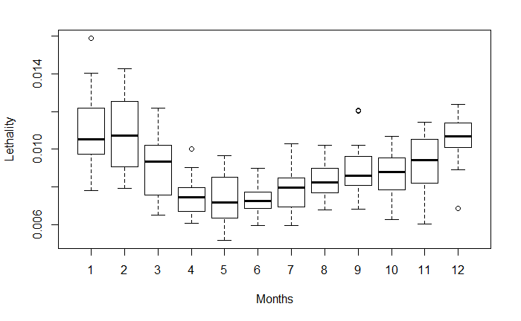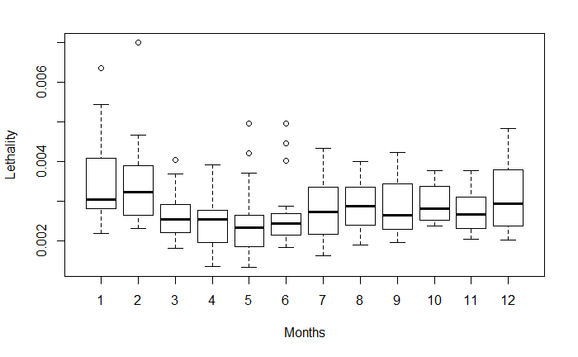

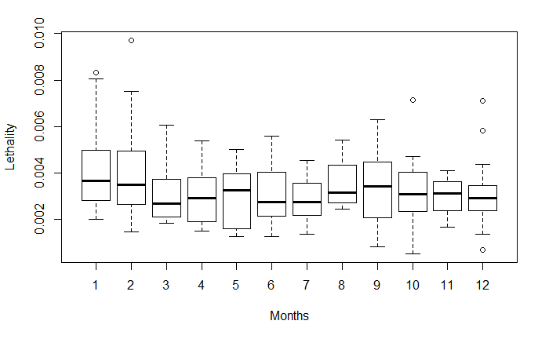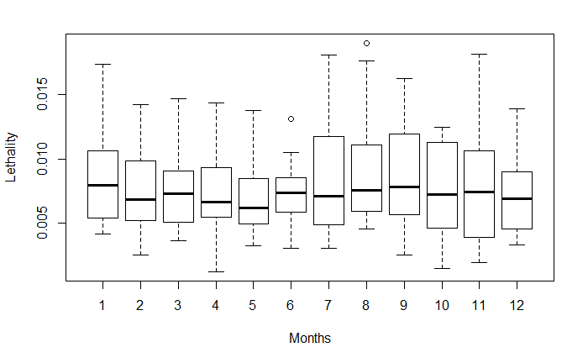

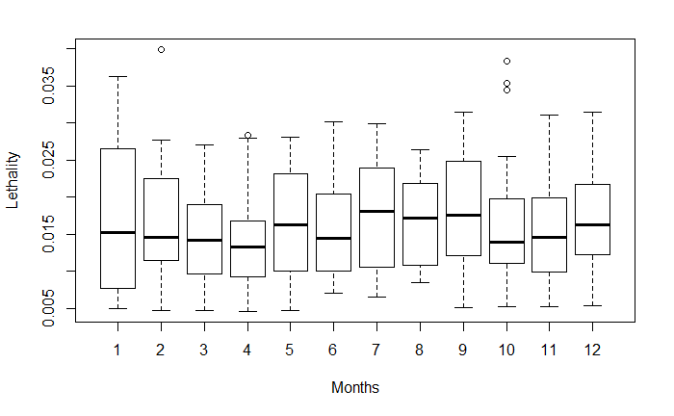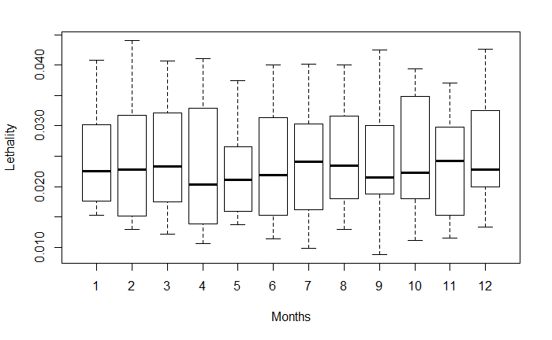

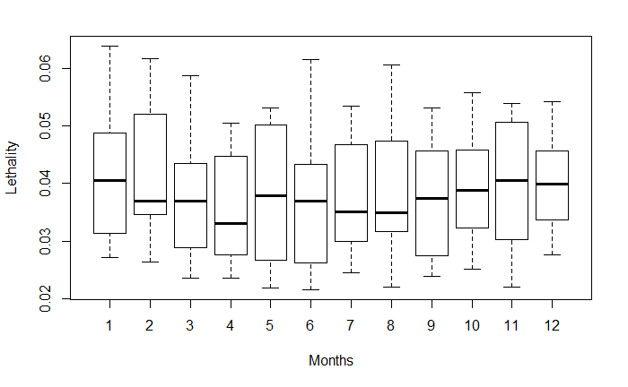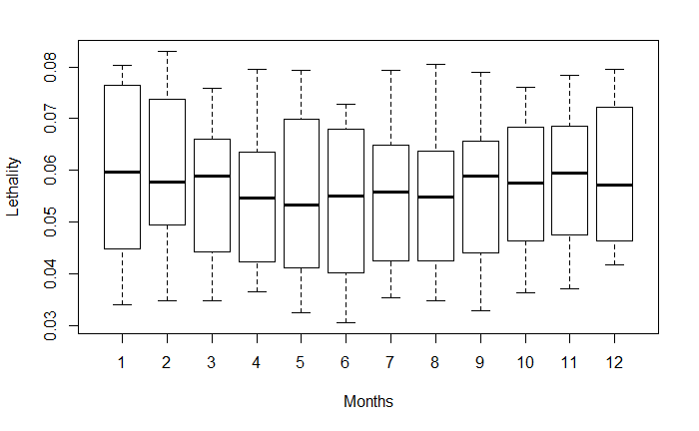

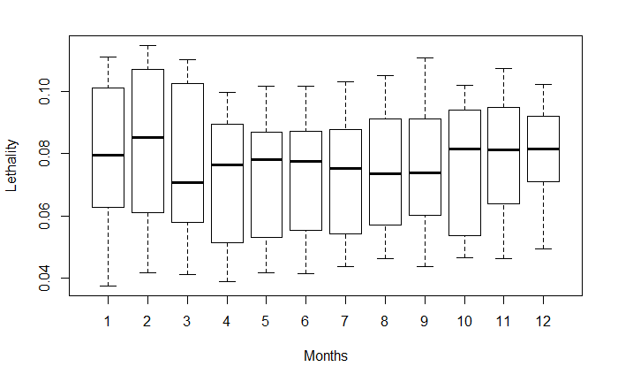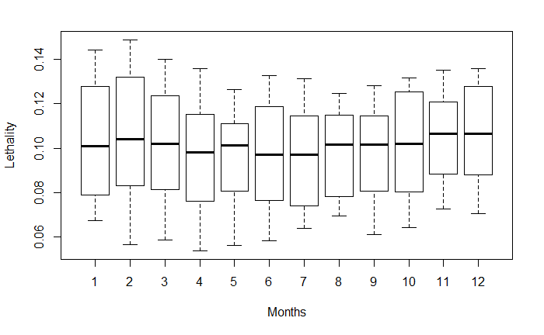

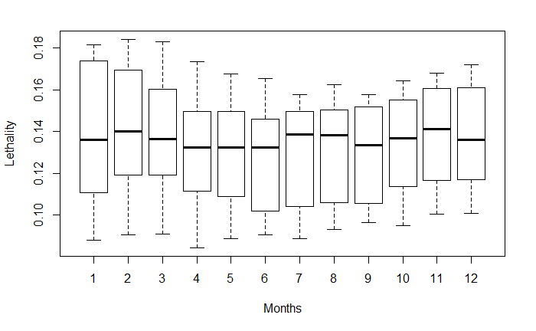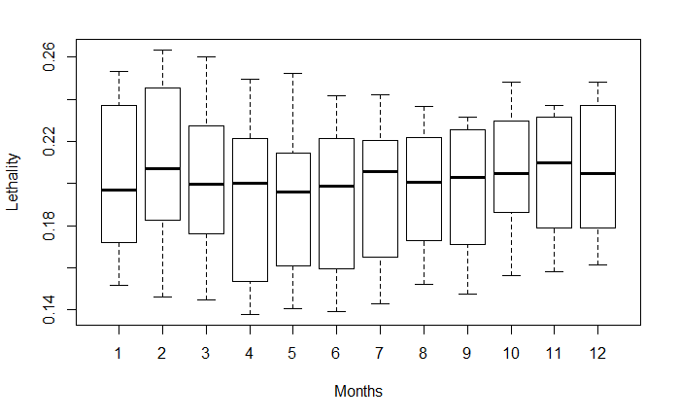

***Descritiva de tendência***

Vamos observar então as séries temporais simples destes dados:

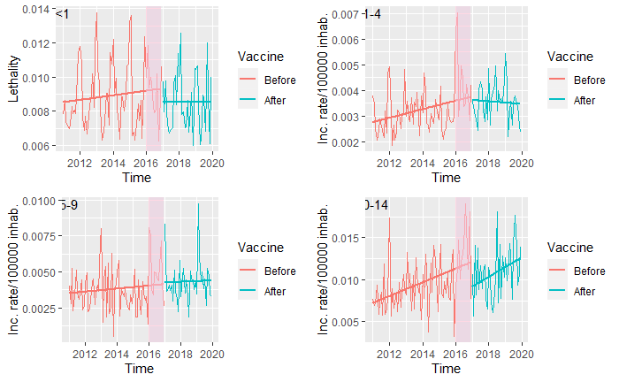

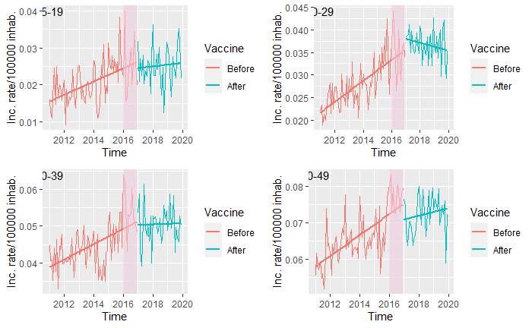

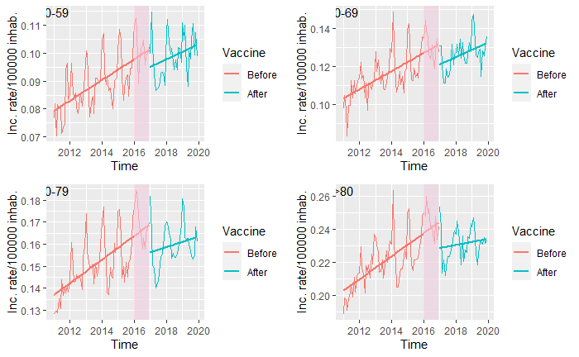

Aqui, vamos ver se os intervalos dos eixos Y estão fazendo sentido. A qualidade da imagem será melhorada se decidirmos usar. Percebam que, as tendências vistas aqui não necessariamente condizem com o que a regressão vai estimar. Isso se deve ao fato de que a regressão tem mais covariáveis no modelo (e.g., sazonalidade, lag, confundidor).

***Modelo de regressão dinâmica (série temporal)***

Aqui podemos ver o que apenas a idade de 20 ate 29 anos foi significativa, tanto para tendência, quanto para interação de tendência e de vacina. Estranho somente esta faixa estar assim. Talvez exista algum confundidor que ainda não foi levado em conta.

|  |  |  |  |  |
| --- | --- | --- | --- | --- |
|  | Estimate | Std. Error | t value | Pr(>|t|) |
|  | flt01 ~ Full | flt01 ~ Full | flt01 ~ Full | flt01 ~ Full |
| Intercepto | 0.010917666 | 0.001911768 | 5.710769867 | 1.47E-07 |
| Fev | -0.00075352 | 0.000665858 | -1.131653286 | 0.260820198 |
| Mar | -0.002727744 | 0.000803367 | -3.395390495 | 0.00102565 |
| Abr | -0.003529733 | 0.000872323 | -4.04635968 | 0.000110606 |
| Mai | -0.004056185 | 0.000943802 | -4.297708789 | 4.40E-05 |
| Jun | -0.003961021 | 0.000994872 | -3.981436214 | 0.000139599 |
| Jul | -0.00322425 | 0.00095958 | -3.360063895 | 0.001149184 |
| Ago | -0.003490838 | 0.000865582 | -4.032937283 | 0.000116081 |
| Set | -0.002145282 | 0.000823705 | -2.60442911 | 0.010783819 |
| Out | -0.003012292 | 0.000766328 | -3.930812689 | 0.000167122 |
| Nov | -0.00255423 | 0.000771363 | -3.311319522 | 0.001342728 |
| Dez | -0.000328997 | 0.000712594 | -0.461689248 | 0.645430687 |
| Trend | 0.000103008 | 9.27E-05 | 1.111108883 | 0.269514178 |
| vac | -0.000595009 | 0.001938537 | -0.306937168 | 0.759608196 |
| Confoun | 0.027008237 | 0.074375636 | 0.363132859 | 0.717366693 |
| L1 | 0.000492886 | 0.104704919 | 0.004707381 | 0.996254603 |
| Lc1 | -0.011193329 | 0.073505125 | -0.152279568 | 0.879311125 |
| vac*trend | -3.50E-05 | 0.000266398 | -0.131402253 | 0.895753694 |
|  | f0104 ~ Full | f0104 ~ Full | f0104 ~ Full | f0104 ~ Full |
| Intercepto | 0.00212249 | 0.000562173 | 3.775508605 | 0.000287719 |
| Fev | -0.000297704 | 0.000382655 | -0.777995953 | 0.438634752 |
| Mar | -0.00130085 | 0.000377554 | -3.445464978 | 0.000871805 |
| Abr | -0.001063146 | 0.000383639 | -2.771216745 | 0.006799303 |
| Mai | -0.000801174 | 0.000391824 | -2.044728201 | 0.043835642 |
| Jun | -0.000712658 | 0.000383761 | -1.85703459 | 0.066613874 |
| Jul | -0.000642874 | 0.000375581 | -1.71167928 | 0.090438609 |
| Ago | -0.000770792 | 0.000377796 | -2.040235201 | 0.044290651 |
| Set | -0.000936746 | 0.000375142 | -2.497044304 | 0.014363264 |
| Out | -0.000880566 | 0.000380388 | -2.314912599 | 0.022918433 |
| Nov | -0.001148846 | 0.000384891 | -2.984861061 | 0.003662583 |
| Dez | -0.000365774 | 0.000384006 | -0.952522236 | 0.343411978 |
| Trend | 0.000127523 | 5.62E-05 | 2.269350509 | 0.02566354 |
| vac | 0.000102366 | 0.001151563 | 0.088893254 | 0.929366473 |
| Confoun | 0.116995389 | 0.104191749 | 1.122885353 | 0.264506185 |
| L1 | 0.137789677 | 0.105232483 | 1.309383495 | 0.19377478 |
| Lc1 | 0.241739885 | 0.104986735 | 2.302575502 | 0.02363489 |
| vac*trend | -7.23E-05 | 0.000158379 | -0.456556119 | 0.649102403 |
|  | f0509 ~ Full | f0509 ~ Full | f0509 ~ Full | f0509 ~ Full |
| Intercepto | 0.005236464 | 0.000936228 | 5.593147797 | 2.42E-07 |
| Fev | 1.48E-05 | 0.000731528 | 0.020266427 | 0.983876205 |
| Mar | -0.001284188 | 0.000725199 | -1.770807821 | 0.080016404 |
| Abr | -0.001787837 | 0.000716133 | -2.496515205 | 0.014383271 |
| Mai | -0.001474159 | 0.000720558 | -2.045857486 | 0.043721911 |
| Jun | -0.001188837 | 0.000726696 | -1.635947519 | 0.105382379 |
| Jul | -0.002222575 | 0.00071557 | -3.106022001 | 0.002544127 |
| Ago | -0.00169161 | 0.000723372 | -2.33850758 | 0.02160145 |
| Set | -0.001248681 | 0.000714615 | -1.747347024 | 0.084026442 |
| Out | -0.001372048 | 0.000734303 | -1.86850478 | 0.064981473 |
| Nov | -0.002453826 | 0.000719826 | -3.408915803 | 0.000981751 |
| Dez | -0.001473644 | 0.000739059 | -1.993945515 | 0.049219138 |
| Trend | 0.000155702 | 0.000103783 | 1.500271084 | 0.137083462 |
| vac | -0.000795247 | 0.002209147 | -0.359979118 | 0.71971558 |
| Confoun | 0.39007204 | 0.2429316 | 1.605686701 | 0.111885345 |
| L1 | -0.109878432 | 0.103924438 | -1.057291562 | 0.293239927 |
| Lc1 | -0.452002877 | 0.246865377 | -1.8309691 | 0.070451421 |
| vac*trend | 8.07E-05 | 0.000304204 | 0.265190573 | 0.791475912 |
|  | f1014 ~ Full | f1014 ~ Full | f1014 ~ Full | f1014 ~ Full |
| Intercepto | 0.008388206 | 0.001687761 | 4.970020486 | 3.22E-06 |
| Fev | -0.001230379 | 0.001520062 | -0.809426946 | 0.420428347 |
| Mar | -0.000384123 | 0.001464408 | -0.262305752 | 0.793691912 |
| Abr | -0.001416812 | 0.001474046 | -0.961172034 | 0.339069789 |
| Mai | -0.0020825 | 0.001458056 | -1.428271475 | 0.156713684 |
| Jun | -0.002011025 | 0.001441739 | -1.39485986 | 0.166529638 |
| Jul | 7.69E-05 | 0.001425421 | 0.053958224 | 0.957089385 |
| Ago | -0.000293078 | 0.001507775 | -0.194377661 | 0.84632318 |
| Set | 0.000498933 | 0.001461403 | 0.341406492 | 0.733602329 |
| Out | -0.001578441 | 0.001517118 | -1.040420644 | 0.30096269 |
| Nov | -0.000407955 | 0.001474548 | -0.276664721 | 0.782679068 |
| Dez | -0.003636847 | 0.001512915 | -2.403866876 | 0.018296603 |
| Trend | 0.000891618 | 0.000236744 | 3.766175302 | 0.00029714 |
| vac | -0.00678448 | 0.004442418 | -1.527204277 | 0.130256447 |
| Confoun | 0.064285329 | 0.178039359 | 0.361073692 | 0.718900042 |
| L1 | -0.103104775 | 0.107790406 | -0.956530164 | 0.34139553 |
| Lc1 | 0.047667013 | 0.175789711 | 0.27115929 | 0.786896448 |
| vac*trend | 0.000536006 | 0.00061485 | 0.871767451 | 0.385680916 |
|  | f1519 ~ Full | f1519 ~ Full | f1519 ~ Full | f1519 ~ Full |
| Intercepto | 0.017624382 | 0.004448179 | 3.962157072 | 0.000149525 |
| Fev | -0.004489921 | 0.002576886 | -1.742382626 | 0.08489585 |
| Mar | -0.008469278 | 0.002552161 | -3.318472685 | 0.001312527 |
| Abr | -0.008649168 | 0.002563362 | -3.374150214 | 0.001098337 |
| Mai | -0.006167217 | 0.002560079 | -2.408995292 | 0.018057407 |
| Jun | -0.00695154 | 0.002555199 | -2.72054702 | 0.007837991 |
| Jul | -0.004590274 | 0.002544287 | -1.804149472 | 0.074590752 |
| Ago | -0.006602673 | 0.002550014 | -2.589269034 | 0.011234686 |
| Set | -0.004077271 | 0.002562304 | -1.591251864 | 0.115098805 |
| Out | -0.004659998 | 0.002561537 | -1.819219346 | 0.072240676 |
| Nov | -0.007020355 | 0.002562624 | -2.739518502 | 0.007433244 |
| Dez | -0.005711071 | 0.002577446 | -2.215786844 | 0.029257142 |
| Trend | 0.00171389 | 0.000421464 | 4.066514521 | 0.000102848 |
| vac | 0.003509253 | 0.007878916 | 0.445397935 | 0.657113706 |
| Confoun | 0.109866341 | 0.183020801 | 0.600294286 | 0.549835642 |
| L1 | -0.013832804 | 0.106768786 | -0.1295585 | 0.897208096 |
| Lc1 | 0.152280726 | 0.182786654 | 0.833106371 | 0.407014922 |
| vac*trend | -0.000832286 | 0.001105663 | -0.752748416 | 0.453587572 |
|  | f2029 ~ Full | f2029 ~ Full | f2029 ~ Full | f2029 ~ Full |
| Intercepto | 0.020784048 | 0.00492233 | 4.222400482 | 5.82E-05 |
| Fev | -0.000461054 | 0.002038319 | -0.226193439 | 0.82156964 |
| Mar | -0.001135071 | 0.001916488 | -0.592266185 | 0.555174072 |
| Abr | -0.001834736 | 0.001969088 | -0.93176955 | 0.353976389 |
| Mai | -0.004323793 | 0.001934248 | -2.235387253 | 0.027894027 |
| Jun | -0.002849627 | 0.001891793 | -1.506310475 | 0.135528684 |
| Jul | -0.000867343 | 0.001889793 | -0.458961629 | 0.64738066 |
| Ago | -0.002655965 | 0.002095585 | -1.267409709 | 0.208314984 |
| Set | -0.000811253 | 0.00201798 | -0.402012336 | 0.688638761 |
| Out | -0.00120227 | 0.002032542 | -0.591510305 | 0.555678031 |
| Nov | -0.002719465 | 0.00189221 | -1.437189621 | 0.154170571 |
| Dez | -0.003023625 | 0.001910625 | -1.582532139 | 0.117075472 |
| Trend | 0.002291482 | 0.000371387 | 6.1700663 | 1.97E-08 |
| vac | 0.019298594 | 0.006046958 | 3.191454725 | 0.001956403 |
| Confoun | 0.000849979 | 0.119970018 | 0.007084932 | 0.994362946 |
| L1 | 0.002049123 | 0.106331887 | 0.019271009 | 0.984668048 |
| Lc1 | 0.106900748 | 0.118515886 | 0.901995095 | 0.369494082 |
| vac*trend | -0.002858006 | 0.000854429 | -3.344931672 | 0.001206268 |
|  | f3039 ~ Full | f3039 ~ Full | f3039 ~ Full | f3039 ~ Full |
| Intercepto | 0.022483796 | 0.008311369 | 2.705185602 | 0.008180319 |
| Fev | 0.00098814 | 0.002630103 | 0.375704118 | 0.708030875 |
| Mar | -0.001120058 | 0.00259766 | -0.431179789 | 0.667380234 |
| Abr | -0.003051006 | 0.002616323 | -1.166142585 | 0.246672276 |
| Mai | 0.001604623 | 0.002714443 | 0.591142648 | 0.555923237 |
| Jun | -0.001138601 | 0.002600307 | -0.43787171 | 0.662540144 |
| Jul | -0.00118553 | 0.002637351 | -0.449515348 | 0.654152773 |
| Ago | -0.002070373 | 0.002616991 | -0.79112723 | 0.430973015 |
| Set | -0.000743234 | 0.002816215 | -0.263912365 | 0.792457568 |
| Out | -0.001573968 | 0.002693785 | -0.58429589 | 0.560499416 |
| Nov | 0.001581726 | 0.002618402 | 0.604080568 | 0.547326843 |
| Dez | -0.002538583 | 0.002636549 | -0.962843055 | 0.338235085 |
| Trend | 0.001638658 | 0.000431691 | 3.795908087 | 0.000268109 |
| vac | 0.005281717 | 0.007813928 | 0.675936222 | 0.500833817 |
| Confoun | 0.39411138 | 0.138909399 | 2.837182961 | 0.005635577 |
| L1 | 0.138012607 | 0.105006647 | 1.314322575 | 0.192114912 |
| Lc1 | -0.108742697 | 0.141280641 | -0.769692833 | 0.443520206 |
| vac*trend | -0.0010341 | 0.001108577 | -0.93281773 | 0.353437843 |
|  | f4049 ~ Full | f4049 ~ Full | f4049 ~ Full | f4049 ~ Full |
| Intercepto | 0.042558792 | 0.01110346 | 3.832930457 | 0.000235729 |
| Fev | -0.003169788 | 0.002684019 | -1.180985485 | 0.240754892 |
| Mar | -0.005688549 | 0.002472104 | -2.301095675 | 0.023722142 |
| Abr | -0.004263359 | 0.002783002 | -1.531927934 | 0.129087229 |
| Mai | -0.00271927 | 0.002516445 | -1.080599873 | 0.28279466 |
| Jun | -0.007842823 | 0.00259028 | -3.027789656 | 0.003222537 |
| Jul | -0.007221804 | 0.002548136 | -2.834152025 | 0.005684765 |
| Ago | -0.006171544 | 0.002833845 | -2.177798475 | 0.032065754 |
| Set | -0.004793686 | 0.0027143 | -1.766085556 | 0.080810594 |
| Out | -0.004362621 | 0.00262465 | -1.662172559 | 0.099996535 |
| Nov | -0.00440721 | 0.002566667 | -1.717094549 | 0.089440046 |
| Dez | -0.002127896 | 0.002624896 | -0.810658912 | 0.419724042 |
| Trend | 0.002012221 | 0.000545198 | 3.69080924 | 0.000384732 |
| vac | 0.002546547 | 0.007485205 | 0.340210763 | 0.734499477 |
| Confoun | 0.096283476 | 0.107621287 | 0.894650851 | 0.373386884 |
| L1 | 0.149511641 | 0.105712589 | 1.414322011 | 0.160756241 |
| Lc1 | 0.080604036 | 0.106615834 | 0.756023123 | 0.451631775 |
| vac*trend | -0.000970608 | 0.001052897 | -0.92184483 | 0.359101739 |
|  | f5059 ~ Full | f5059 ~ Full | f5059 ~ Full | f5059 ~ Full |
| Intercepto | 0.065429272 | 0.014974897 | 4.369263675 | 3.36E-05 |
| Fev | 0.000311676 | 0.00268882 | 0.115915499 | 0.907980659 |
| Mar | -0.009246243 | 0.002849821 | -3.244499694 | 0.001658072 |
| Abr | -0.014547527 | 0.002753838 | -5.282637782 | 8.96E-07 |
| Mai | -0.012831354 | 0.002695009 | -4.761154282 | 7.42E-06 |
| Jun | -0.011787876 | 0.002643653 | -4.458934821 | 2.40E-05 |
| Jul | -0.014330941 | 0.002696552 | -5.314543731 | 7.84E-07 |
| Ago | -0.010659932 | 0.002730457 | -3.904083624 | 0.000183676 |
| Set | -0.012933853 | 0.002672833 | -4.83900594 | 5.45E-06 |
| Out | -0.00907043 | 0.002737094 | -3.313889949 | 0.001331801 |
| Nov | -0.009030368 | 0.002713267 | -3.32822622 | 0.001272374 |
| Dez | -0.011166577 | 0.002575447 | -4.335782255 | 3.82E-05 |
| Trend | 0.00266643 | 0.00061589 | 4.329394186 | 3.91E-05 |
| vac | -0.007433476 | 0.007715601 | -0.963434468 | 0.337939986 |
| Confoun | -0.01073754 | 0.112848216 | -0.095150284 | 0.924409366 |
| L1 | 0.297047853 | 0.097655377 | 3.041797214 | 0.003089902 |
| Lc1 | 0.008482235 | 0.111846146 | 0.075838419 | 0.939717866 |
| vac*trend | 0.000169507 | 0.001064485 | 0.15923818 | 0.873842033 |
|  | f6069 ~ Full | f6069 ~ Full | f6069 ~ Full | f6069 ~ Full |
| Intercepto | 0.047051738 | 0.019702592 | 2.388098914 | 0.019049806 |
| Fev | 0.001670592 | 0.002967199 | 0.563019843 | 0.574837015 |
| Mar | -0.007304768 | 0.003257255 | -2.24261456 | 0.027405635 |
| Abr | -0.011479159 | 0.003115536 | -3.684489834 | 0.000393099 |
| Mai | -0.013918516 | 0.003058563 | -4.55067195 | 1.69E-05 |
| Jun | -0.009100066 | 0.003166944 | -2.873453375 | 0.005076498 |
| Jul | -0.011027464 | 0.003101966 | -3.554991501 | 0.000607773 |
| Ago | -0.013821931 | 0.003149521 | -4.388582211 | 3.13E-05 |
| Set | -0.010010295 | 0.003275813 | -3.05582019 | 0.002962207 |
| Out | -0.007823814 | 0.003433013 | -2.278993377 | 0.025059547 |
| Nov | -0.005404599 | 0.003288047 | -1.643710982 | 0.103764136 |
| Dez | -0.005581789 | 0.00303744 | -1.837662427 | 0.069448792 |
| Trend | 0.002015884 | 0.000923784 | 2.182203602 | 0.03172845 |
| vac | -0.012349087 | 0.009110728 | -1.355444575 | 0.178705831 |
| Confoun | 0.209870246 | 0.13298332 | 1.578169701 | 0.118074513 |
| L1 | 0.203403181 | 0.104070568 | 1.95447363 | 0.053784282 |
| Lc1 | 0.191075774 | 0.134661826 | 1.418930507 | 0.159411927 |
| vac*trend | 0.000623488 | 0.00125109 | 0.49835592 | 0.619462555 |
|  | f7079 ~ Full | f7079 ~ Full | f7079 ~ Full | f7079 ~ Full |
| Intercepto | 0.043496084 | 0.015698937 | 2.770638803 | 0.006810405 |
| Fev | -0.007254393 | 0.002674044 | -2.712892253 | 0.008006912 |
| Mar | -0.01465274 | 0.002705806 | -5.415294884 | 5.14E-07 |
| Abr | -0.017114942 | 0.002739006 | -6.248595405 | 1.39E-08 |
| Mai | -0.018090891 | 0.002725498 | -6.63764719 | 2.43E-09 |
| Jun | -0.018660171 | 0.002934648 | -6.35857201 | 8.53E-09 |
| Jul | -0.016009458 | 0.002927678 | -5.468312003 | 4.12E-07 |
| Ago | -0.015947707 | 0.002886252 | -5.525403249 | 3.23E-07 |
| Set | -0.015728102 | 0.002870494 | -5.479231674 | 3.93E-07 |
| Out | -0.012880906 | 0.002931177 | -4.39444792 | 3.06E-05 |
| Nov | -0.00906858 | 0.002769151 | -3.2748596 | 0.001507054 |
| Dez | -0.008817764 | 0.002762021 | -3.192503966 | 0.001950045 |
| Trend | 0.000471384 | 0.000819975 | 0.574875949 | 0.56682561 |
| vac | -0.006210961 | 0.008051873 | -0.771368537 | 0.442531704 |
| Confoun | 0.261186567 | 0.099265066 | 2.631203287 | 0.010027325 |
| L1 | 0.334827921 | 0.093868585 | 3.566985921 | 0.000583974 |
| Lc1 | 0.21584177 | 0.10170202 | 2.122295802 | 0.036590782 |
| vac*trend | 1.35E-05 | 0.001126237 | 0.01200146 | 0.990451312 |
|  | fmm80 ~ Full | fmm80 ~ Full | fmm80 ~ Full | fmm80 ~ Full |
| Intercepto | 0.104892828 | 0.024545777 | 4.273355325 | 4.82E-05 |
| Fev | 0.002376155 | 0.003711075 | 0.640287694 | 0.523630619 |
| Mar | -0.008830811 | 0.003991393 | -2.212463431 | 0.02949396 |
| Abr | -0.013216432 | 0.003832423 | -3.448583295 | 0.000862983 |
| Mai | -0.016279226 | 0.003946197 | -4.125294606 | 8.31E-05 |
| Jun | -0.009589805 | 0.004136606 | -2.318278489 | 0.022726326 |
| Jul | -0.012952246 | 0.003945306 | -3.282950598 | 0.001469038 |
| Ago | -0.009882447 | 0.004211685 | -2.346435587 | 0.021174221 |
| Set | -0.010992149 | 0.003925228 | -2.80038459 | 0.006260023 |
| Out | -0.006757023 | 0.003949287 | -1.710947473 | 0.090574249 |
| Nov | -0.007764251 | 0.003855732 | -2.013690591 | 0.047062364 |
| Dez | -0.001274859 | 0.004006746 | -0.318178273 | 0.751095113 |
| Trend | 0.00238099 | 0.001246977 | 1.909409353 | 0.059430819 |
| vac | -0.001258972 | 0.011694262 | -0.107657212 | 0.914509936 |
| Confoun | 0.256886507 | 0.104657004 | 2.454556294 | 0.016051708 |
| L1 | 0.325903227 | 0.100475348 | 3.243613816 | 0.001662684 |
| Lc1 | -0.024089565 | 0.104820625 | -0.229817031 | 0.818761318 |
| vac*trend | -0.001197056 | 0.00173208 | -0.691108901 | 0.491295828 |