Final Project
Higher Diploma in Computer Science

Eduardo Kenji Zen Nakashima
Student Number: SB18004

Date : | 06/07/2019

0 INDEX
Table of Contents
0 INDEX 2
1 Project Introduction 3
1.1 Project context 3
1.2 Required knowledge 3
1.3 Summarised Project Plan 4
1.4 Why this is a good project 4
2 Literature Review: 6
2.1 Web-design tools 6
3 System Analysis and Design: 7
3.1 Functional Requirements 7
3.2 Data-flow 7
3.3 Web-design 8
3.4 Database 11
4 Implementation of the system: 13
4.1 Database 13
5 Testing and Evaluation: 14
6 Conclusions: 15
7 Code Listings: 16
8 Appendix B: (other technical or data appendices as required): 17
9 List of References: 18

Project Introduction
The first chapter sets the background and motivation for the project. The problem to be solved is stated, with the project aims and a list of specific objectives.

The handbook SUGGESTS possible contents as follows:
- A brief synopsis of the project context (If your project is based on one of the scenarios that CCT provided, then you need to provide your own synopsis of the brief. If this is your OWN project, then you will need to provide some more detail, but you can use your proposal as a basis for this section)
- General areas of computing that project context covers / requires knowledge of
- Brief summary of your initial proposed plan for addressing the project context (you should update the draft plan that you submitted previously)
- Short section arguing ‘why’ this is a good project – outline Individual’s skills, interests, strengths – they Individual can describe how the project brings together many of the modules they’ve listed
- Novel aspects – a real world business or organisation or taking advantage of new technology.

Project context
Ger’s garage needs a new web system to helps him out on management, booking, and invoice generation processes.
Ger’s businesses consists on selling parts and services to wide range of possible vehicles types.
He divides his booking services in four basic types of maintenance, each one with its own time frame and correlative initial budget cost.
As a small business he has a small number of employees and needs a system to help him with the roster schedule.
As expected from his customers, they should be able to see their relationship records within the garage as also to register their vehicles just once and reuse it later on as required.
The costumer interface should be able to schedule its services on date basis.
The costumer should be able to book just if there is availability on the date.
Dates with no available staff do not be possible to be booked.

Required knowledge
Web design
HTML, CSS, PHP, JavaScript, JSON, hosting, access control, cyber security
Database
SQL, Database integration with website

Summarised Project Plan
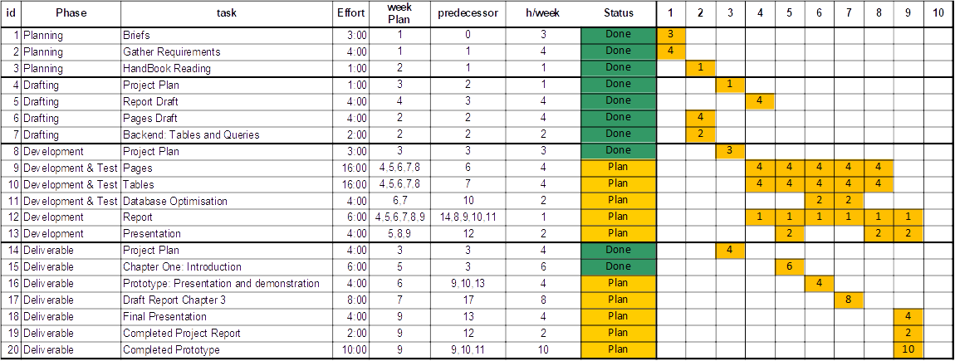

Why this is a good project

This project brings together a lot of all content showed in class and spoke technologies and attention points.
The requirements covers mostly aspects of the viewed content, including but not limited to:
- Algorithms and constructs: They organised way to divide the code following the “KISS” principle (Keep It Stupid Simple) in order to facilitate the understanding of the code for whoever is going to need to maintain it or further developments.
- Database: All aspects of it in order to hold and deal with data from the input, structure, optimisation, queries and outputs.
- Web development: As basis of this particular project as a web system it need all sort of tools saw along the course.
- Cloud systems: The understanding on how the code could be deployed in the cloud platform allows me to better dimensioning the development solutions according with the customer expectations over reliability, confidentiality, security and availability.
- Software Development: The ability to understand the basics of programming language gave me the knowledge to enhance the comprehension of potential new languages, what is key for my further projects, including this one.
- Mobile Development: The practices brought within the course allowed me to understand better new templates and tools and frameworks in order to accelerate the development process and how to make sure the code is working properly through intensive tests along the development for each particular task. The breakdown development and versioning is key to keep the traceability over all working code and work in progress development.
- Strategic Business IT and Professional Practice: Created the foundation ethics around the code and practices, gave me the understanding on how to work in respect of the community and how it helps itself to improve the society even immersed in so many different culture and laws worldwide.
- Operating Systems and Architecture and Networking and Virtualisation: The understanding on the hardware and how it is connected impacts directly over the reliability of the system, the correct dimensioning is fundamental to achieve the target performance against the possible use of it. The amount of data use and traffic will direct impact in the overall performance accordingly to the designed solution. It is important to balance what information should be trafficking and where the processing should be happening for the aimed performance.
My accumulated experience within reports and system tools development helps me to come up with clearer work and data flows. My learned skills during this course allowed me to have a much more structured thinking way on how to build up the system and also points my in the right direction on development time, as the discussions and tools presented and spoke is going to be basis on my future career and projects.
The main idea on the project development plan approach is to breakdown the scope in order to be able to better estimate the required time for each task and plan the deliverables due date.
A good project plan is always a best way to start any project cause it is going to direct and show how the development progress is going on.
The key importance of this project is to give me basis on further developments aiming to be able to generate potentially new businesses all by myself and also to show my skill set to future new employers.

Literature Review:
The aim of this chapter is to present all academic research carried out throughout the project cycle. It is important that learners produce research that defends their justifications for choosing one from of technology or software over another, and other sources of information that have helped inform the individuals thinking, planning and delivery of the project.

Web-design tools
The development of the web styles might take as much time as it available and it still might require future adjustments.
For this project scope, it is key to use some sort of available tool to help improve the its design regarding the visual appeal that its required in order to help to improve the amount customers.
This tool research will be restricted to one hour in order to identify the easiest and fastest tool to cover forms, requiring as minimal as possible dedicated customisations to have it working.
Its result come up with the following resources:
- www.coffeecup.com
- www.mobirise.com‎
- www.phpform.org
It should be enough to develop this system once the php form is very straight forward to generate a basic visual to a web form HTML page with some simple CSS.
While coffecup HTMLEditor application promises to be a powerful tool to develop a wide range of HTML appliances, including, but not restricted to HTML, CSS, JavaScript, PHP.
By the time I spent trying to understand all those tools I felt myself losing the control of my time against the plan. At the same time I remembered that in the first semester we did a simple dynamic web application that will be a good template for start as it has the Login forms, main welcome page, database connection using SQLite3 and all should be working fine.
My research back them required to configure my webserver to be able to work with the SQLite3 by changing the configuration file as clarified by Zeuf (posted: 04/May/2018 - https://stackoverflow.com/ accessed:14/Jul/2019) it is simple four step procedure:
- open “xampp/php/php.ini”,
- locate the line with “;extension=sqlite3” and;
- delete the comment sign “;”,
- save it and close the file and it should work.

Calendar
The development of the web styles might take as much time as it available and it still might require future adjustments.

System Analysis and Design:
The overall aim of this chapter is to answer the questions – exactly what is the application supposed to do? It can include the following, where relevant:
- Functional Requirements:
- Detailed description of the functionality of the proposed system. This should be comprehensive and exact, break up the application into subsystems.
- Diagrams – use Case diagrams, Wire frames, with text descriptions
- Data Requirements – An overview of the entities and data in the system, and what data needs to be stored
- Diagrams – an Entity-Relationship Diagram
- User Interface Design – This should contain an argument as to how this suggested interface supports each of the use cases specified in the analysis
- Diagrams – Screen designs, either pen-and-paper or computer drawn of how the user interface will appear.
- Functional Design – should model both the structure of each software component in the systems, and also how they interact with each other.
- Diagrams – detailed class diagram and an Interaction Diagram to show the interaction between objects in the system
- Data Design – Whether to be implemented as a database or some other central data repository, a detailed design of the data storage components should be presented
- Diagrams – Normalised database tables

Functional Requirements
The costumer briefing as given requires the system to facilitate the booking services to them vehicles regarding some restrictions as the garage working dates (not on Sundays).
This is translated as a register form to the costumers themself, their vehicles and to booking, by interested date, them as it should be able to show them the booking status. Allowing them to check and use their data for future references.
As a small business it the availability of the dates needs to be restrictive, not allowing the costumer to select a date not available.
When Booking the costumer is required to select between at least four different type of Budget services, for each one it has a certain amount of associated time and cost.
The administrator needs to view all the booking for a particular period of time.
They need to be able to add at least 40 different parts and at least 4 services.
The Booking should be monitored by statuses.

Data-flow
The overall project data follows the diagram as following explanation:
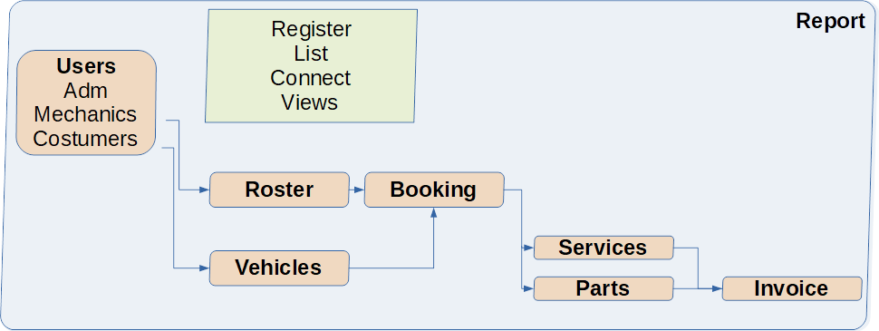
This report should cover all the project.
All data supposed to be registered by the costumer as each costumer might have further developments without requiring new contracts to cover small changes in data, but still working through the same process.
Users might be different types, as administrator, staff or final costumers.
The costumers will be able to register their vehicles regardless it is already register type (motorbikes, car, small van or small bus, the administrator might be able to change those options as the business develops itself), brand (Volvo, Volkswagen etc) or model (Fiesta, Leaf, Up, Polo etc).
The administrator should be able to register the staff and also setup their roster, generating possible date-slots to be booked.
Each date-slot than will be able to hold one booking – same booking should be able to use more than one date-slot as it might require more time regarding its type (Annual Service, Small Repair / Fault or Major Maintenance).
Each booking should be linked to a specific vehicle.
The staff should be able to allocate services and parts for the booking, generating the correspondent invoice and changing the booking status – from Booked, Confirmed, In service, Serviced, Paid, Delivered and Unrepairable – the correspondent date and time for each status change might be kept for future reference.

Web-design
In order to get the websites layouts ready to go as fast as possible, reducing the amount of labour required and consequentially the overall costs to develop the system to the costumer, but yet claim a marketing appeal, the development of the layouts is going to be developed by using consolidated templates with just some customisations for the specifics of this project.
The initial amount of pages required are:
To the administrator:
- Staff register
- Rostering
- Services register
- Parts register
- Bookings Statuses
To the costumer:
- Register
- Login
- Vehicle register
- Booking schedule
- Booking Status
To the staff:
- Booking pick, Add Services And Parts
- Booking Invoice
It brought me to develop the following wire-framing, and given the time and budget it should be the best practice to use just pen and paper to draft out and discuss it with the costumer, once the task to do it by the book could take much more time and end up with higher costs.
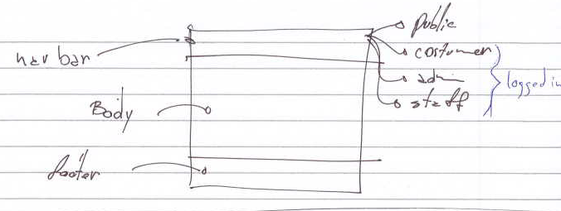
WebDesign img1 – overall layout
It is basically done by generating a simplified development platform while makes it looks good and easy to use.
Three section webpage will have one main navigation bar for each type of user:
Before log in as Public. And after login as Costumer, Staff or Administrator.
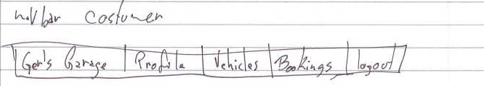
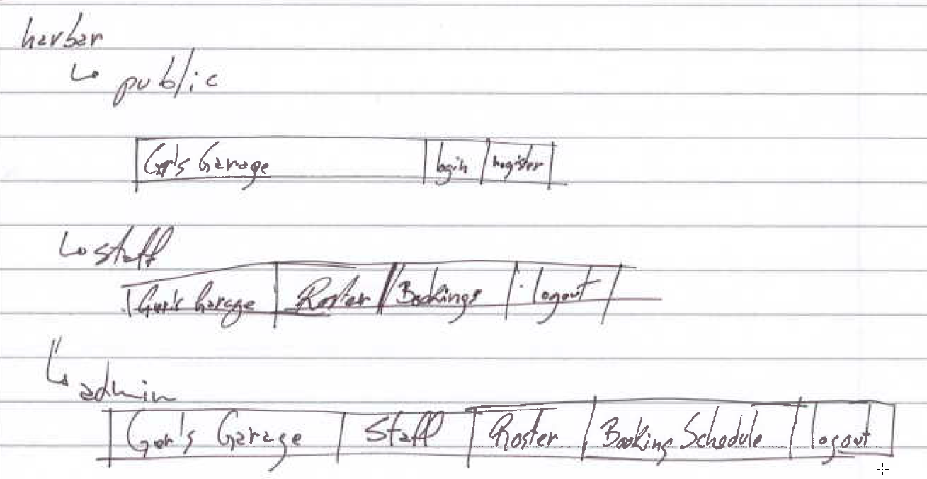
WebDesign img2 - navigation bar
Each feature page has a link in the navigation bars, with particularities on its accessibility accordingly to each type of user.
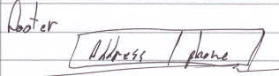
WebDesign img2 - navigation bar
The footer is going to hold basically the basic contact information.
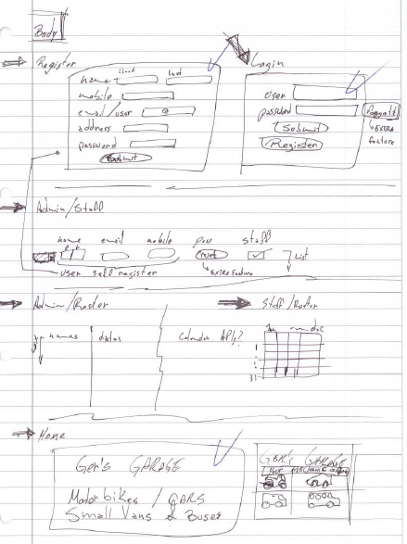
WebDesign img3 - Body section
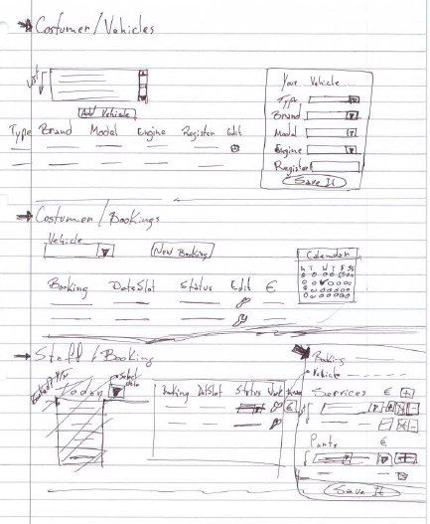
WebDesign img4 - Body section
The body holds on the forms and lists interfaces to self-register, login, vehicle register, booking schedule and its statuses, rostering, invoicing and booking schedules.
The main idea is to develop it in phases as basic version, with the minimum requirements and later on add extra features as parts stock management, staff management and so on.

Database
The database system is going to be develop in SQLite as it is free and portable allowing for later compatibility for possible Cloud servers.
The overall required tables are:
- Users
- Vehicles
- Booking
- Status
- Roster
- Invoice
- Services
- Parts
As required the database should be delivered with normalisation 3NF what will demand a breakdown tables that will be done at development and test phase.
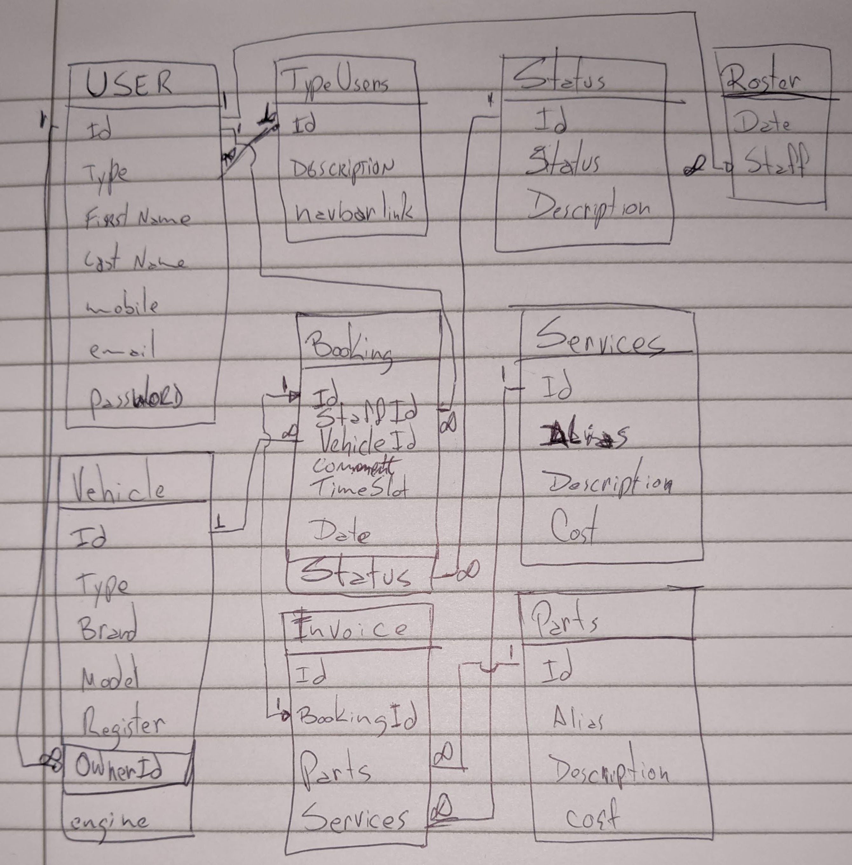
Database Design img5 - ER Diagram
The simplified ER Diagram was generated on the notebook in order to optimise the resources, once the database software – DB Browser for SQLite – used to help manage the SQLite3 database doesn’t have this feature to help on this process and to research another tool it might take more time then available. The decision to stick with it was taken to manage the risk of losing the deadline delivery at this point. Later on, if the time and budget allows it could be something to be worked on in order to improve the appearance and maybe quality of the documentation.

Implementation of the system:
This chapter should detail how the learner implemented a working system based on their design. This should include the technologies used (languages, APIs, frameworks etc.) and how the system was implemented, based on the user and functional requirements identified during the analysis and design phase. This chapter should address any potential problems that could arise in the system and suggested or implemented solutions.
Possible areas for discussion in this chapter are:
- Architecture considerations - e.g. are there specific functional requirements that will influence the software architecture implementation.
- Technologies used - operating systems, databases, computer languages, frameworks, API's etc.
- Implementation of the system - main body of work for the chapter. This will discuss precisely how the system was developed, based on the analysis and design considerations.
- Problems encountered - any issues that may have arisen during the implementation phase, e.g. the project's cross-platform compatibility between different operating systems.

Code editor
The development of the website requires a lot of commenting and debugging for testing and troubleshooting. In order to do it and reduce the researching to find out better tools I’m using Netbeans IDE 8.2, once I’ve been using it during this course and cause the way my developing IDE tools are configured, requiring no further investigations.
I tried use of Visual Studio Code, Brackets and Netbeans, during my level of pressure and lack of concentration over the short night along the development time I identified first the comment button on Netbeans. But it could also be easily done with Brackets, through shortcut Ctrl+\.

Database
The database used was SQLite3, once the template base was developed using it, with the SQL statements been done through PHP variables and validation.

Calendar
In order to facilitate the selection of a date and also protect the system against all sort of date formatting and SQL injection it was researched 5 different possible codes, once the explanation was clear enough for all of them the understanding on how it works and how to implement them was restrict in time the first one that I get working was used, but further developments is possible to make it look better to the user.
Some of the codes researched allows to block the selection of restricted dates, but once my level of learning on PHP and API’s against my level of SQL directs me to develop it through validation against a validation using PHP and SQL to identify possible and not possible dates to be selected.
Within my development I got it to be validated against the bookings, blocking it to be done twice for the same vehicle in the same date. The idea was to further develop this SQL query to validate against the roster, counting how many staff rostered to a particular day and the amount of bookings in order to check the availability of slots to be booked.

Web-design
The main architecture of the system requires to PHP forms to change data between itself, once the PHP code allows to request the values from variables from the “POST” to the recipient page to handle it and generates the SQL queries handles the results and return the required feedback to the main page.
In other words, all the system was developed over the PHP to generates HTML’s to the browser. Each PHP them was calling others PHP’s to assemble the required page as it was also watched by AJAX to partially update the main page.
So it was possible to use the “include” PHP function to build up the page through different parts, witch also reduces the amount of pieces to be looked at when developing or debugging.

Testing and Evaluation:
Details of the learner’s test plans, test results, user evaluations and discussion of these
results in detail and in summary.
Possible entries in this chapter might include:
- Functional correctness
o Set of tasks system should be able to perform – part of requirements
specification of system and include a focus on efficiency
o Set of inputs and correct outputs
o Set of ‘test scripts’
- Objective of test / statement of which part of systems is being
tested
- Input data/situation
- Correct output data / state / behaviour
- Need to show actual results of test – screen shots
- Evaluation - if actual matches correct then working
- Usability
o List of usability requirements
- set of tasks user should be able to perform
- Have a set of tasks for each type of user
- System Response times
- Time for user to complete a task
- Aesthetic
- Acceptable navigation of site and layout
o Set of ‘test scripts’
- Instructions for user
- Observation / measure time / evaluate success of task
- Analyse results to come up with usability result
o Can also measure qualitative usability aspects with questionnaires /
structured interviews etc.
- Commercialisation / marketing
o Requirements – registration on web search engines, direct marketing –
discuss real commercialisation aspects of project
o Evaluation – have set of key words / phrases for targeted websites

Features
All features were tested while it was been developed, with allows to ensure each step of the data-flow works properly before starts to develop the next step.
All systems main functions were mean to be developed and tested for each bit of the code.
It was done for each click and each communication between the PHPs, the database and the AJAX components.
Given the low budget and compact solution to be developed this system wouldn’t use many resources, if it was a bigger project with more resource in time or people it could have a dedicated team to be responsible exclusively for the testing.
All the failure in tests was direct fixed and refactored in developing time reducing the overall response time.

Conclusions:
The Individual needs to review the entire project against their problem context, aims and
objectives, and evaluate project success and results. This may also include a section for
suggestions for further work.
Appendix A: Code Listings
This should be a link to a cloud resource (such as GitHub) where the project code is
maintained. Students should have only included selected code fragments or algorithm
summaries in the main chapters, otherwise the project report can become a monotonous
technical manual rather than a story of what they did and why they did it.

Code Listings:
This should be a link to a cloud resource (such as GitHub) where the project code is maintained. Students should have only included selected code fragments or algorithm summaries in the main chapters, otherwise the project report can become a monotonous technical manual rather than a story of what they did and why they did it.

Appendix B: (other technical or data appendices as required):
If you have additional technical data to showcase it should be included in this appendix,
you can also use this appendix to present the raw data of empirical research carried out
(questionnaires, interviews etc.)

List of References:
All citations used within the report should include their full reference using the Harvard referencing style. A reference list should be included in this section of the report.

Dojo Toolkit. 2019. Adam Peller. [ONLINE] Available at: https://dojotoolkit.org/reference-guide/1.10/dijit/Calendar.html. [Accessed 26 July 2019].

SQLite. 2019. SQLite. [ONLINE] Available at: https://www.sqlite.org/datatype3.html. [Accessed 26 July 2019].

