**CONSULTA 1.**

SELECT DISTINCT nom FROM NENS WHERE poblacio_nen = 'Mataro';

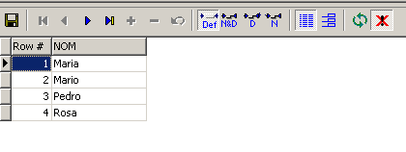

**CONSULTA 2.**

**A)**

SELECT DISTINCT ASSIGNADA.codi_nen, NENS.nom, NENS.data_naixement, ASSIGNADA.any_assignat, ASSIGNADA.nom_joguina, JOGUINES.edat_adequada

FROM ASSIGNADA, NENS, JOGUINES

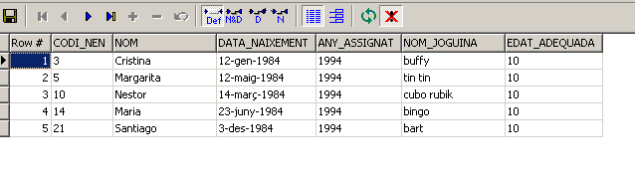WHERE NENS.codi = ASSIGNADA.codi_nen AND JOGUINES.nom = ASSIGNADA.nom_joguina AND JOGUINES.edat_adequada = 10 AND ASSIGNADA.any_assignat = 1994;

**B)**

SELECT DISTINCT ASSIGNADA.codi_nen, NENS.nom, NENS.data_naixement

FROM ASSIGNADA, NENS, JOGUINES

WHERE NENS.codi = ASSIGNADA.codi_nen AND JOGUINES.nom = ASSIGNADA.nom_joguina AND JOGUINES.edat_adequada = 10 AND ASSIGNADA.any_assignat = 1994;

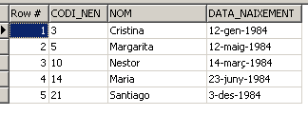

**CONSULTA 3.**

**A)**

SELECT DISTINCT ASSIGNADA.any_assignat, COMPORTAMENT.comportament, JOGUINES.nom, COMPORTAMENT.any_comportament

FROM ASSIGNADA, COMPORTAMENT, JOGUINES

WHERE COMPORTAMENT.codi_nen = ASSIGNADA.codi_nen AND ASSIGNADA.nom_joguina = JOGUINES.nom

AND ASSIGNADA.any_assignat = 1994 AND COMPORTAMENT.any_comportament = 1993 AND COMPORTAMENT.comportament >= 5;

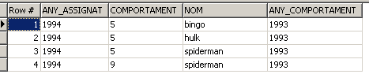

**B)**

SELECT DISTINCT JOGUINES.nom

FROM ASSIGNADA, COMPORTAMENT, JOGUINES

WHERE COMPORTAMENT.codi_nen = ASSIGNADA.codi_nen AND ASSIGNADA.nom_joguina = JOGUINES.nom

AND ASSIGNADA.any_assignat = 1994 AND COMPORTAMENT.any_comportament = 1993 AND COMPORTAMENT.comportament >= 5;

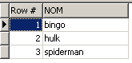

**CONSULTA 4.**

**A)**

SELECT DISTINCT CARTA.codi_nen, NENS.nom

FROM CARTA, NENS

WHERE NENS.codi= CARTA.codi_nen AND CARTA.codi_nen NOT IN (SELECT CARTA.codi_nen FROM CARTA WHERE CARTA.any_carta = 1994);

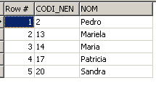

**B)**

SELECT DISTINCT CARTA.codi_nen, NENS.nom, CARTA.any_carta

FROM CARTA, NENS

WHERE NENS.codi= CARTA.codi_nen AND CARTA.codi_nen NOT IN (SELECT CARTA.codi_nen FROM CARTA WHERE CARTA.any_carta = 1994);

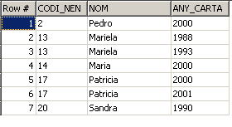

**CONSULTA 5.**

**A)**

SELECT CARTA.codi_nen, NENS.nom

FROM CARTA, NENS

WHERE CARTA.codi_nen=NENS.codi

GROUP BY CARTA.codi_nen, NENS.nom

HAVING COUNT(*) > 3

ORDER BY CARTA.codi_nen;

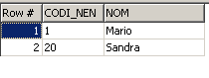

**B)**

SELECT CARTA.codi_nen, NENS.nom, COUNT(*) AS NOMBRE_CARTES

FROM CARTA, NENS

WHERE CARTA.codi_nen=NENS.codi

GROUP BY CARTA.codi_nen, NENS.nom

HAVING COUNT(*) > 3

ORDER BY CARTA.codi_nen;

