

**MySm(art)Home**

**Universidade de Aveiro**

**Licenciatura em Engenharia Informática**

**UC 40384** - **Introdução à Engenharia de Software**

**Docentes:**

Prof. José Luís Oliveira

Prof. Idílio Oliveira

**Trabalho realizado por:**

André Morais -

Diogo Moreira -

Gonçalo Pereira -

Eduardo Santos - 93107

Oscar Sanchez -

**Architecture Notebook** **3**

**Personas** **4**

Jose Alvez 4

Julia Rodes 4

Brendon James 5

Juan Carlos 6

Francisca Miles 6

# Architecture Notebook

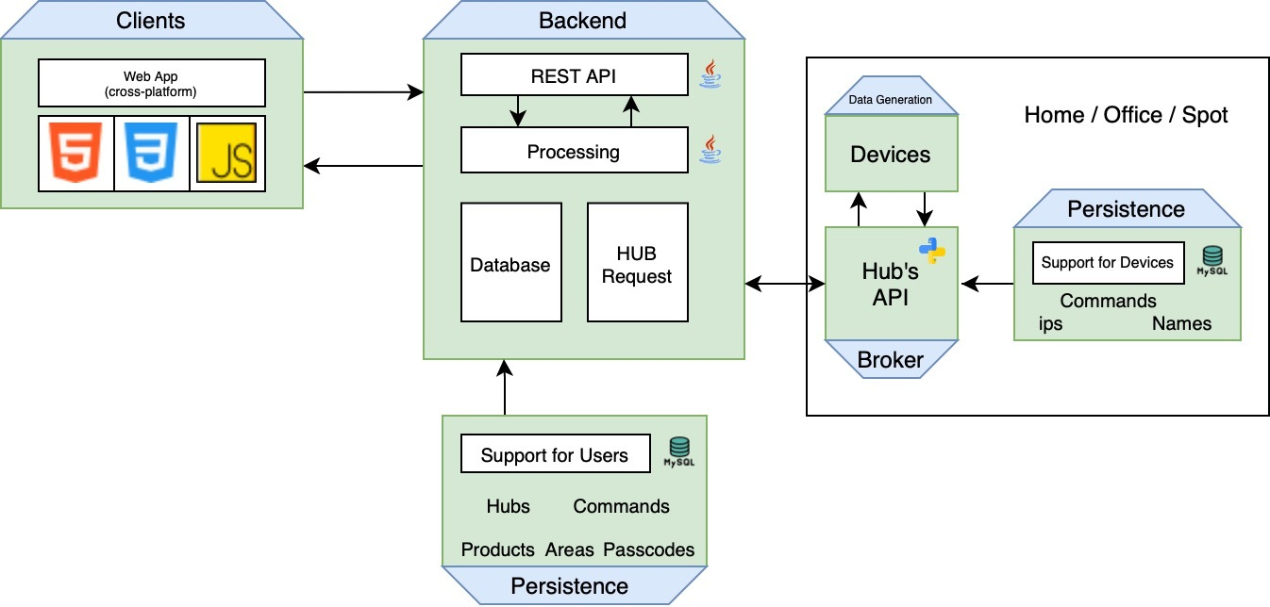

# Personas

## Jose Alvez

Age: 45

Backstory:

Jose is an Alimentar Engineer working in Aveiro. One day his home was robbed and now he wants to install security cameras. On weekends he is a little lazy, he doesn't want to get up from the couch.

Personality:

* Likes to work
* Good in communication
* Friendly
* Calm
* Clever

Scenarios:

* Control shutters while at work
* Watch security cameras while at work
* Turn light on/off while in the soffa, so he can stay laid down Make coffee moments before waking up

## Julia Rodes

Age: 29

Backstory:

Julia is a Social Media Marketing Manager at a big marketing company. She is divorced and has a 13-year-old son, Magnus.

Her job is a stable one, and gives Julia a good income each month, she is financially independent. For the past few years, Julia has been seeing the growth of the smart homes industry, this always aroused her attention. One day, she decided to buy a smart home system, to facilitate her life, as well as give her more information about what happens during her work time, especially when her son gets home from school.

Personality:

* Hard-worker
* Humble
* Friendly
* Stubborn

Scenarios:

* Knowing what's happening in her house while at work.
* Keeping track of what content her son can see on the web.
* Ask the coffee machine to make her a coffee in the morning, while she dresses up. Check the security cameras whenever she pleases.
* Keep track if all smart devices are functioning correctly.

## Brendon James

Age: 16

Backstory:

Brendon is a smart kid, under 16, who is remarkably lazy.

He enjoys playing online videogames and going out with his friends.

On the opposite, Brendon hates to do his chores, especially the ones who he thinks could be done remotely.

As a technology enthusiast, he hopes he can find a way to stop interrupting his games to do basic chores through his phone.

Brendon hopes one day his parents can get a smart home, so he can do exactly that.

Personality:

* Lazy
* Smart
* Selfish
* Absent minded Arrogant

Scenarios:

* Turning on/off the laundry machine.
* Closing the blinds at night.
* Check who's at the door.

## 

## Juan Carlos

Age: 47

Backstory:

Juan is a middle-age man who wants to monitorize the things that happens in his house. When he goes on vacation he wants to control the heating and the blinds of the house, and also see who rings the door ́s bell. When wakes up in the morning, he doesn ́t have much time to prepare for work, so he wants to prepare his coffe at the same time that he takes a shower.

Personality:

* Constant
* Curious
* Protective
* Egocentric
* Ungrateful

Scenarios:

* Grade down the heating
* Check who rings the door’s bell when he’s out
* Prepare a coffee in the kitchen while he is taking a shower
* Turn down the blinds automatically at 22:00
* Turn up the blinds automatically at 08:00 while he’s on a vacation

## Francisca Miles

Age: 65

Backstory:

Francisca grew up in a village and she used to work in a farm all day helping her parents.

She finished highschool and went back to the village to continue farming since that was what she liked to do.

Now she has her own farm where she grows the food she needs to sustain herself and does what she likes which is farming.

Personality:

* Hardworking
* Passionate
* Confident
* Cheerful
* Altruistic

Scenarios:

* She wants an easier way to control the house while she is away from it
* She wants to be able to turn on/off the lights or shut the blinds when she isn't at home
* She wants to be able to watch every spot on the house without needing to go there
* She wants to be able to close the blinds or make coffee without needing too much effort.