TQS: Product specification report

***André Morais [93236], Eduardo Santos [93107], Pedro Bastos [93150], Pedro Santos [93221]***

v2020-05-09

1 Introduction 1

1.1 Overview of the project 1

1.2 Limitations 1

2 Product concept 2

2.1 Vision statement 2

2.2 Personas 2

2.3 Main scenarios 2

2.4 Project epics and priorities 2

3 Domain model 2

4 Architecture notebook 3

4.1 Key requirements and constrains 3

4.2 Architetural view 3

4.3 Deployment architeture 4

5 API for developers 4

6 References and resources 4

[This report should be written as the main source of technical documentation on the project, clarifying the functional scope and architectural choices. Provide concise, but informative content, allowing other software engineers to understand the product and quickly access the related resources.

Tips on the expected content, along the document, are meant to be removed.

You may use English or Portuguese; do not mix.]

# Introduction

## Overview of the project

Our Deliveries Engine is supposed to be a common platform so that any delivery store can use it. Its purpose is to calculate the dynamic matchmaking of orders and riders, manage the riders’ reputation, among other statistics.

T-Tracker is our specific store implementation, that is a delivery service for Covid-19 tests. The idea is to have users request a covid test and receive it in their homes. The T-Tracker will consume the Deliveries Engine API to get the rider’s information of each order.

In the scope of TQS, the project has the objective to implement multiple types of tests, as well as CI/CD pipelines to make sure that a strong SQE practice is used.

## Limitations

 <explain the known limitations/unimplemented (but planned) features>

# Product concept

## Vision statement

(Business Initiative)

This system aims to improve people’s quality of life by providing a platform where they can request a driver to deliver a covid test and, after using the test, its delivery to an analysis laboratory. By using our app, users won’t have to personally travel to the laboratory in order to do quick tests, that way they won’t subject themselves to potentially infected individuals. Users will be able to set their pickup and delivery address (home address), they will also be able to schedule deliveries and rate how the experience was.

(Deliveries Engine)

Riders will be able to register themselves into our system and, at any time, set their status as available or unavailable. Riders will be automatically selected based on their current location and global rating (reputation). This rating will be calculated based on previous job’s ratings made by clients.

Due to it being a platform with the potential to have multiple business partnerships, riders will have the ability to be assigned to jobs from various businesses making it easier for them to get assignments. System administrators will also be able to access statistics such as number of assignments or riders with the best ratings.

## Personas

**Admin:**

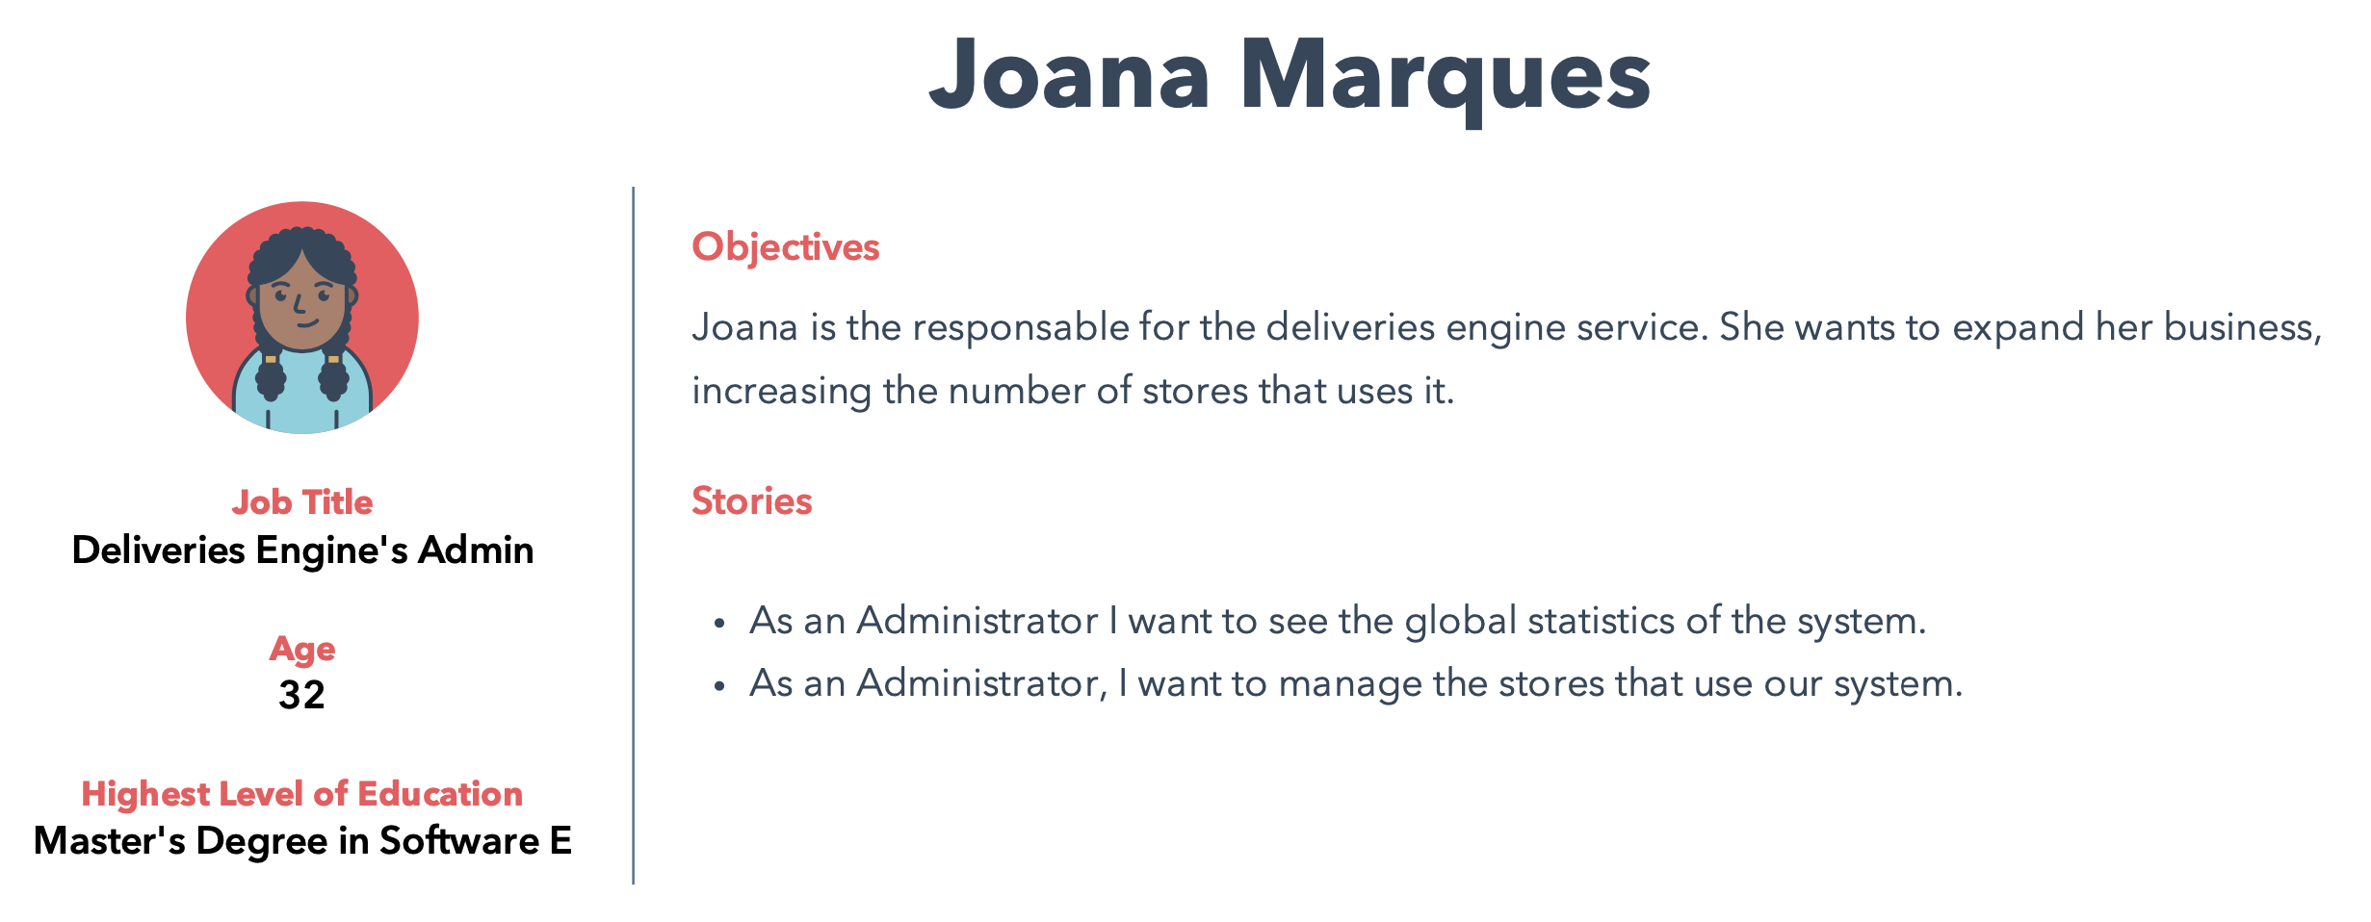

**Rider:**

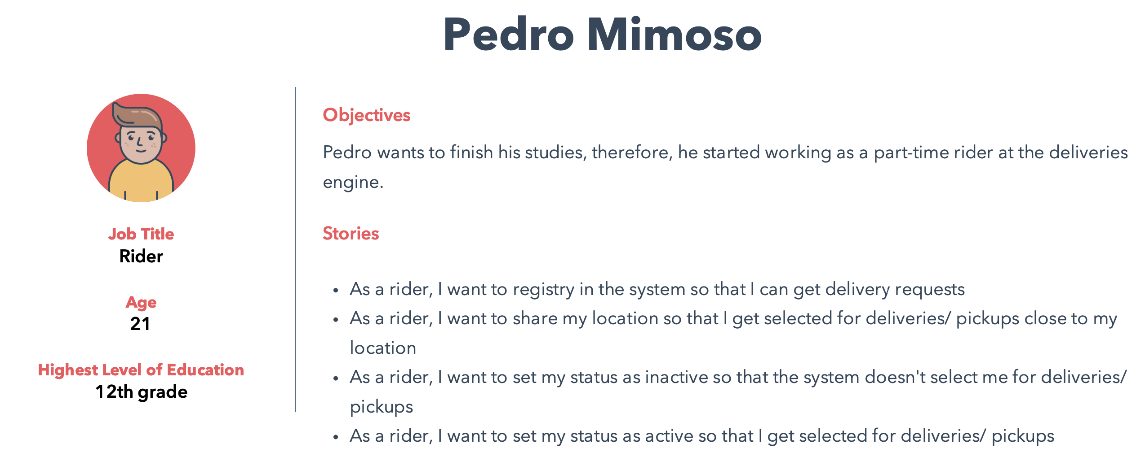

**Owner:**

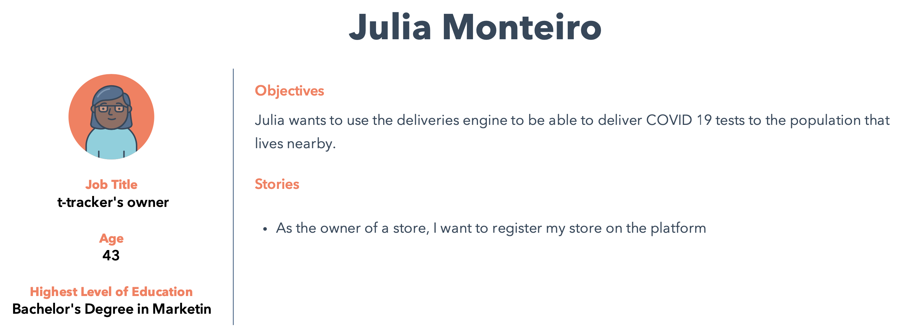

**User:**

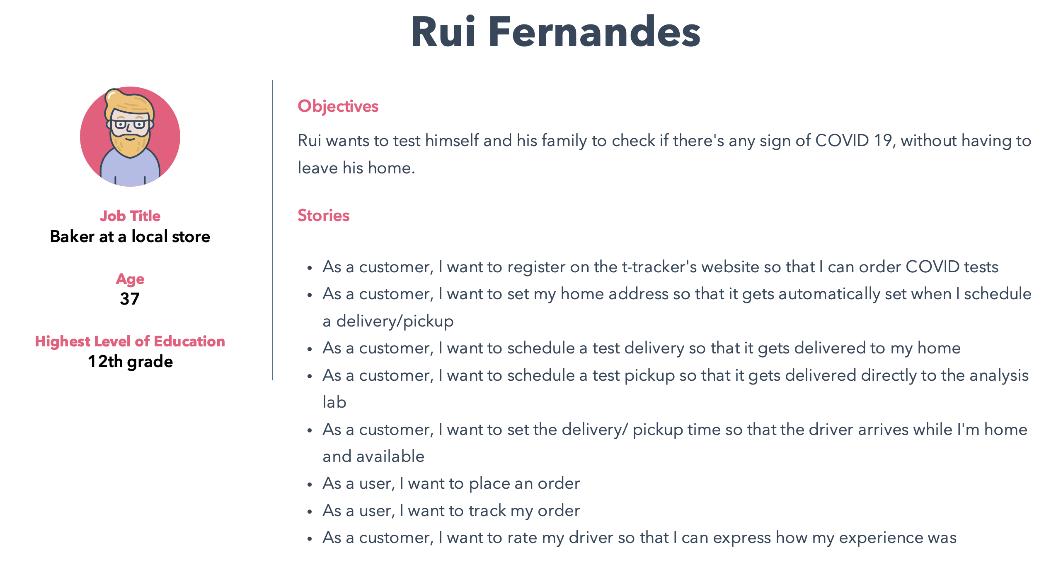

## Main scenarios

These are the main scenarios:

* **Joana Marques checks the global statistics of her system**

Joana, as an **admin**, wants to see the global performance of her system’s riders. She **logs in** and evaluates the global statistics of the system

* **Pedro Mimoso sets his status as active and receives an order request**

**Pedro Mimoso**, as a **rider** for the Deliveries Engine service, has some free time today and wants to make some money. Because he is already registered as a rider in the system, he only needs to set himself as active. He **logs in**, goes to his **profile page** and sets his **status as active**. With this, he is available to be selected to deliver an order. After some minutes, he **receives a request** from the system and **accepts it**. After this, he gets the **store and client’s location** so that he can **pick up the order** on the store and **deliver** it to the client.

* **Julia Monteiro registers her store in the Deliveries Engine service**

**Julia Monteiro**, as an owner of the t-tracker store, wants to i**mprove her store’s capability** and implement a delivery at home system. Yet she can’t afford hiring a software company to produce the system that she wants. Therefore, she wants to find a service that she can use to **manage the pickups** so that she only needs to worry about adapting the store’s website to use it. Thus, she **registers** her store in the Deliveries Engine service so that she can use their services to manage the riders and pickups for her.

* **Rui Fernandes sets his location and places an order**

**Rui Fernandes**, as a general user of the t-tracker application, wants to receive a COVID test at **home** for him and his family so that he doesn’t need to travel to the store. Therefore, he **registers** in the t-tracker application, goes to his **profile**, **sets his location and places the order**. Then, he has a live view of the rider so he can **track** is order.

## Project epics and priorities

|  |  |
| --- | --- |
| Sprint | Epic |
| 1 | * Riders’ registry; * Deliveries Engine’s basic global statistics. |
| 2 | * Each order’s rider being automatically assigned; * User placing an order on t-tracker. |
| 3 | * User placing a pickup order for the COVID tests to the lab; * User being able to track his orders, and rating the riders’ service. |

# Domain model

<which information concepts will be managed in this domain? How are they related?>

<use a logical model (UML classes) to explain the concepts of the domain and their attributes>

# Architecture notebook

## Key requirements and constrains

Our system will be developed from scratch. We’ll develop a robust system, that is able to have multiple services (stores) attached to it.

Our goal is to have two main modules: a deliveries engine, that can be used by any external store, and a specific implementation of a store – t-tracker.

Inside each module, we will have a web app, a business logic module, and a database.

We also expect to implement a mobile app, in case we manage to have all the previous requirements implemented on time.

All the communications between the web apps and the business logic will be through HTTP requests to an API.

The communication between each specific store and the deliveries engine will also be through an API.

Each service will be dockerized, and the entire system will be deployed on a virtual machine.

## Architetural view

→ Discuss architecture planned for the software solution.

→ include a diagram

<detail the specific technologies/frameworks that were used>

→ explain how the identified modules will interact. Use sequence diagrams to clarify the interactions along time, when needed

→ dicuss more advanced app design issues: integration with Internet-based external services, data synchronization strategy, distributed workflows, push notifications mechanism, distribution of updates to distributed devices, etc.>

## Deployment architecture

[Explicar a organização prevista da solução em termos configuração de produção (*deployment*). Modelar num diagrama de *deployment*]

# API for developers

[Explicar a organização da API. Os detalhes detalhes/documentação dos métodos devem ficar numa solução *hosted* de documentação de APIs, como o [Swagger](https://swagger.io), ou <https://apiary.io/> ]

<what services/resources can a developer obtain from your REST-API?>

<document the support endpoints>

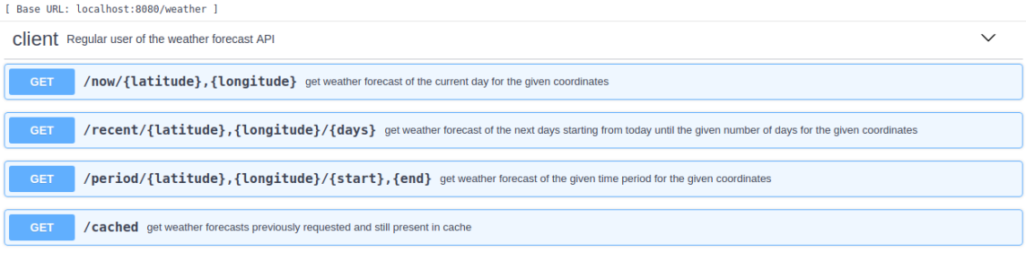

# References and resources

<document the key components (e.g.: libraries, web services) or key references (e.g.: blog post) used that were really helpful and certainly would help other students pursuing a similar work>