REVISED DECISION BRIEF

Keep more than
the photos.
A complete App Store revamp built around the value of Momora itself.
Version 2.0 • 20 September 2026 • Replaces the book-first recommendation
Momora should make sense as a paid app even when a parent never orders a printed book. Lead with photos, stories and saved sound together; make gallery import a practical reason getting started feels easier. Present automatic books as a substantial optional extension, not the outcome that gives the subscription its only purpose.

The new default
The first four images explain the digital experience. Image 5 shows automatic book creation and a separate print purchase. The final two images return to family connection and revisiting memories in the app.

The commercial distinction
The owner states that the app costs $99/year and a printed book costs another $99 plus shipping. These are owner-supplied reference amounts, not verified global prices. The listing must not make the membership feel like an unexplained fee before buying the actual product. [O1]

The decisive review question
Hide the book image and paragraph. Is there still an understandable reason to subscribe and return?
This is the standard for the revised description, screenshot set and agent prompts. It does not establish willingness to pay or predict conversion improvement.
This report updates the previous audit rather than starting a new positioning study. Practitioner findings are retained with their limitations. Current competitor-page structure and core Apple field/screenshot guidance were checked for this revision. No new customer interviews, live Momora analytics, production purchase or print-sample inspection was performed.

01 / WHAT CHANGED

A stronger app story.
Not a weaker book feature.
The earlier recommendation moved too quickly from “printing deserves more visibility” to “printing should define the product.” The new direction separates those decisions. It preserves the new feature's importance without assuming that the digital experience is merely book preparation.
Earlier handoff | Revised default
The finished printed book is the main reason to download. | The app keeps meaningful photos, stories and sound together now.
Three opening images explain a photo-to-book journey. | The opening explains a useful collection, easier import and things photos missed.
Gallery import is chiefly the beginning of book creation. | Import removes the empty-journal problem and creates something useful inside Momora.
Voice, stories and sharing support the print outcome. | These are valuable experiences independently of print.
Book-led title, subtitle, description and challengers. | App-led metadata and digital-value challengers; book-first is deferred.
Printing helps justify membership. | Membership and print each need a clear, separate value explanation.

What remains
Keep the distinctive warmth, real product evidence, readable copy, complete seven-frame production scope, genuine device captures, editable rendering sources and rigorous QA. Keep an accurate book spread and clear automatic-selection/layout benefit. Do not return to six attractive images that omit the new capabilities.

What is not being changed
This assignment does not change the business model, annual price, print price, paywall, onboarding, app identity or product features. It does not conclude that parents will never prefer a book-led proposition. That remains testable with informed expectations and real pricing. [O1]
The v2 handoff replaces strategy, copy, order, variants and acceptance criteria. Good work already done on captures and rendering should be retained after verification—not thrown away.

02 / CUSTOMER EVIDENCE

Remembering is broader
than completing a book.
The supplied synthesis describes parents as having many photographs but missing context, sounds and ordinary details. It distinguishes fear of forgetting from the downstream guilt of an unfinished book, and calls the illustrated keepsake a reward rather than the original felt need. Those are the research's conclusions, not new findings from this revision. [V1 §§1–2]
Its wish language includes light effort, no pressure to write every day, and turning memories into a book later without having to design it. This supports making print easy and available; it does not establish that every preceding app experience is merely preparation. [V1 §3, “The wish”]

Preserve the tension in the evidence
The research also recommends monetizing the artifact rather than access to memories and avoiding subscription-first where possible. That is a proposed business-model implication, not measured willingness to pay for Momora. It should remain visible, not be silently edited out to support the current model. [V1 §8]
This revision therefore establishes a hypothesis: make the paid app's independent value clear, then test whether people understand and value it at the actual offer. Neither “the book is the real product” nor “the app is definitely worth $99/year” is proven.

The app's value before printing
Parent's situation | Experience to demonstrate
The photos are already there. | Suggested memories and draft captions, ready for review.
I want to remember what they said. | A short note or dictation; optional illustration.
I want to hear that sound again. | A kept recording that can actually be played.
I want to enjoy this with my family. | Chosen-family access and genuine interaction.
I want to find my way back to these days. | A useful, readable collection for each child.

Do not turn fear of forgetting into countdowns, shame or sibling comparisons. The synthesis explicitly warns against manufactured guilt and tools that become another obligation. Preserve that distinction in both words and visuals. [V1 §§2, 6–9]

03 / RETAINED PRACTITIONER LESSONS

Test the reason to care,
then make it readable.
These lessons carry forward from the original research. They are not new experiments, independently reproduced results or a forecast for Momora.

Messaging before decoration
Phiture practitioner Andrew Hart's framework crosses features with customer values/segments to generate hypotheses. The useful application is to test app value, an easier camera-roll starting point and saved voice as distinct reasons to care—not begin with a slightly different background color. [P5]

Legibility in the environment where people see it
Vlad Dugnist's X account reported improvement after enlarging screenshot text. The earlier review checked the numerical statement through Apptamin's reproduction because full X access was blocked. Borrow the attention to search-sized readability, not the reported uplift as a benchmark. [P1–P2]
For Momora, readable proof matters as much as headline size. A giant phone frame with a tiny story can be polished at full resolution and still fail to explain the app in a small row.

A meaningful proposition change is not a color test
A developer's Reddit report focused on the first three screenshots and later clarified that the value proposition changed. The public account did not provide enough experimental detail for independent causal validation. Treat it as support for testing a coherent buying reason, not proof that copying the design will work. [P3]

Look past downloads
BetterSleep's operating-team case described concurrent custom-page experiments and attention to trial/subscription economics alongside download rate. The vendor-reported downstream results were distinct from download improvements. Momora should likewise judge understood paid membership and useful repeat behavior, not only installs. [P4]

Avoid the convenient shortcuts
The earlier specialist investigation of screenshot-title indexing found mixed evidence. Meaningful screenshot words should earn their place by helping people understand, not by relying on an assumed OCR ranking loophole. No fixed one-week stopping rule or another app's absolute conversion rate belongs in this plan. [P7]
Apple's own guidance says early screenshots can appear in search and recommends showing the essence of the app. Here, that means the independent digital experience—not a physical outcome that costs extra. [A1]

04 / COMPETITOR CONTEXT

Print can belong inside
a broader app promise.

Tinybeans
Its app page puts remembering above a set of benefits that includes sharing, firsts, family updates, revisiting and printing. Printing is visible in the opening explanation; it is not hidden. The dedicated photobook page then concentrates on choosing memories, automatic photo/caption population, customization and ordering. [C1–C2]
The lesson for this revision is the relationship between the two surfaces: a broad app page explains why the digital service matters, while a product-specific page can sell the book directly. That is an observed architecture, not evidence about which headline converts best.

BackThen
Its homepage explains saving, sorting, sharing and revisiting before presenting automatically created print products. This gives the app an intelligible ongoing role, rather than treating it solely as a prerequisite to ordering. [C3]

What these examples do not establish
Neither company's page proves Momora's annual price, customer motivations or retention model. Their benefits and entitlements are not automatically Momora's. Do not copy claims about unlimited storage, search, email recaps, privacy guarantees, supported platforms or delivery times into this listing.
Automation alone is not a verified unique advantage: both companies describe automatically populated or created print products. Momora may differ in curation, grouping and storytelling, but that difference needs actual output comparison before a superiority claim. [C2–C3]

Decision for this release
Use the app-led seven-frame default. Keep a substantial book frame in slot 5. A later sequence test can move it earlier, and a genuinely book-first concept can be evaluated with explicit owner agreement and a truthful two-purchase offer.
The revised hypothesis is not “parents do not want books.” It is “parents should understand what the membership gives them even if they do not print.”

05 / PRODUCT TRUTH

Make the promise specific.
Keep its boundaries visible.
The prior review inspected detailed feature documents. This revision carries those findings forward as implementation evidence, not a fresh production acceptance test. The coding agent must verify the current checkout and relevant runtime states before final captures. [R1–R8]
Feature | Message to support | Boundary
Gallery | Group accessible photos and draft captions for review. | Not automatic approval, camera-roll cleanup or guaranteed complete cloud-library coverage.
Import output | Save approved photo memories. | Photos do not automatically become illustrations; different media types must not be collapsed into one fictional card.
Stories | Short text/dictation and optional illustration. | No recovery of unknown conversations, dates or first-ever milestones.
Kept sound | Save and replay a recording. | Dictation is a separate flow; no printed audio/QR feature unless verified.
Family | Actual invitations, approvals and roles. | Not every invited member can edit, order or export.
Revisiting | Real collection, timeline or saved-memory views. | No invented search, recap, widget or filter.
Read/export | Saved archive access after lapse; owner export. | No forever-storage promise, free ongoing writes or universal export rights.
Books | Choose scope; curate/arrange; review online; order print. | Separate physical purchase, no fake native editor, no assumed generation/review entitlement.

Privacy and commercial facts are not decoration
The documented import flow uploads small previews for AI before review, while retaining full-resolution originals after approval. “Your camera roll stays as it is” must not become “nothing leaves your phone.” [R1]
A clearly private audience does not imply end-to-end encryption. A subscription qualifier does not imply that saved reading becomes inaccessible when billing stops. Describe the relevant control or restriction rather than a broad security or permanence claim. [R1, R6–R8]
Keep live availability, localized offers, print scope, shipping territories and rights as explicit release gates. No attractive screenshot resolves an unverified product fact.

06 / DESCRIPTION AUDIT

Recognizable situations.
Not a sales script.
The original description correctly notices the little things parents care about, but its guilt-led opening and sales scaffolding obscure the practical product. The first replacement then overcorrected toward printing. Version 2 keeps recognition while giving the digital experience a clear job.
Original or v1 language | Problem | v2 treatment
“Never forget” / “never miss” | An absolute promise; adds pressure. | Name the photos, words and sounds parents can keep.
“And the guilt stings.” | Creates the feeling the product offers to remove. | Recognize missing context without judging the parent.
“Enter Momora” / “everyday magic” | Sounds like a scripted pitch. | Explain grouping, draft captions, short capture and replay.
“Why Parents Love Momora” | Implies unsupported social proof. | Use practical headings and observable benefits.
“Family-centered design” | Describes a design attribute, not an experience. | Per-child memories and chosen-family access.
“Preserved forever” | Unbounded storage promise. | Specific continued reading and owner export, subject to verification.
v1: “A baby book from the photos you already have.” | Makes the separate print product define the membership. | Open with photos and the little things they do not contain.
v1: most benefits lead toward print | Leaves the independent paid app unexplained. | Establish useful digital outcomes; introduce the book later.

The new order
Recognition → a useful app collection → an easier start → short stories/illustrations → saved voice → revisiting/family → optional book → archive and purchase clarity.
The description is not a pasted customer testimonial. The anecdote is illustrative copy. Do not put quotation marks around research fragments and imply a real Momora customer said them. [V1 §§3, 6]
Printing still receives a full practical paragraph, including selection, grouping, layout, online review and delivery through a separate purchase. Less dominance is not the same as less explanation.

07 / CURRENT IMAGE AUDIT

Original images 1–3
Visual references are unchanged originals, not revised screenshots. These observations concern the supplied files, not unseen live-store placement.
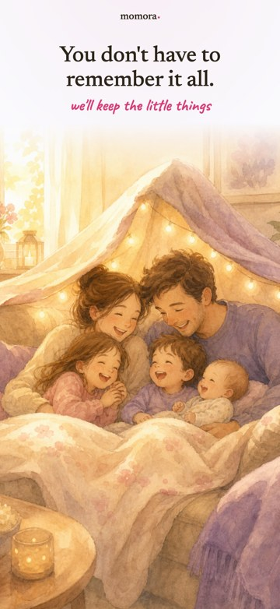 | 1 · You don’t have to remember it all.  KEEP: The warm identity and forgiving intent.  CHANGE: Replace the art-only opening with a real populated Momora collection. Use separate photo/story/sound evidence; do not replace one ambiguous poster with a book advertisement.  WHY: The first frame should establish a useful app before a purchase of print. Apple expects actual use, not just title art. [A2]

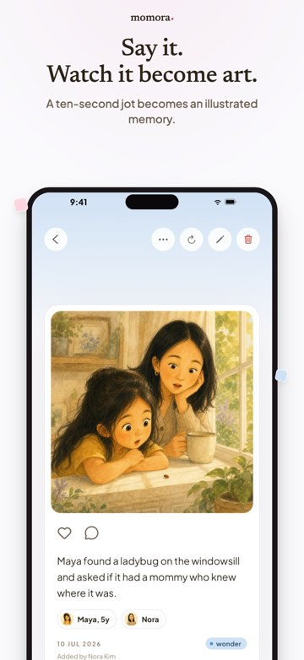 | 2 · Say it. Watch it become art.  KEEP: The specific ladybug story and corresponding expressive illustration.  CHANGE: Move to new slot 3. Add the real short input, enlarge the meaningful result and reduce empty space/control chrome.  WHY: This is a valuable digital feature, but it should not make the whole app look like an image generator. Avoid an unmeasured ten-second end-to-end promise.

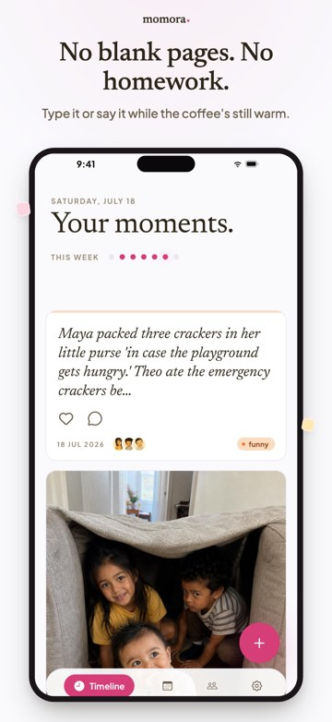 | 3 · No blank pages. No homework.  KEEP: The low-effort idea and ordinary funny story.  CHANGE: Prove easier starting with gallery suggestions in new slot 2; prove short capture in slot 3. Replace truncated demo text with a genuinely shorter complete entry.  WHY: Weekly dots and an unfinished anecdote can suggest the obligation the headline denies. Choose an honest better screen; do not erase real behavior.

07 / CURRENT IMAGE AUDIT

Original images 4–6
Reuse strong source material and brand elements where they fit. New headlines alone do not turn these references into the revised product story.
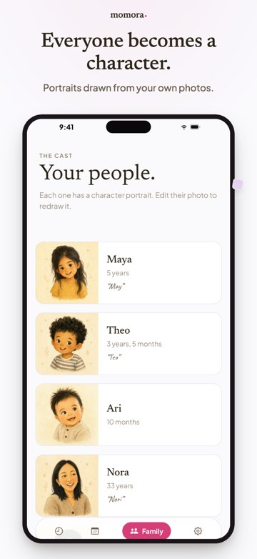 | 4 · Everyone becomes a character.  KEEP: Recognition and Momora’s portrait style.  CHANGE: Use portraits as supporting context. Replace the profile-setup emphasis with actual family sharing in new slot 6 and per-child revisiting in slot 7.  WHY: Setting up characters is not the main outcome. The default no longer needs a second per-child printed-book advertisement either.

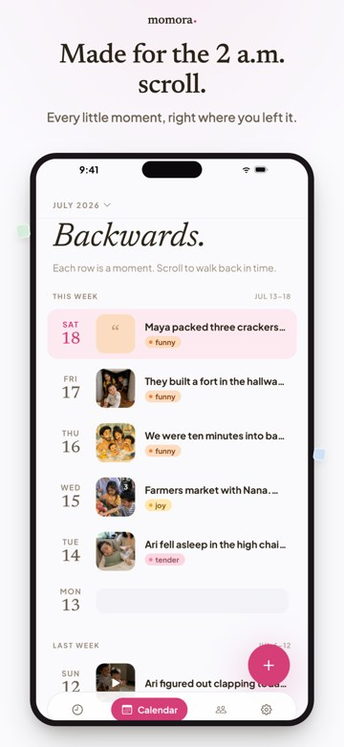 | 5 · Made for the 2 a.m. scroll.  KEEP: The insight that returning to familiar memories is valuable now.  CHANGE: Develop this into new slot 7 with a complete saved memory or genuine child collection. Keep it app-led rather than treating revisiting as secondary to print.  WHY: Truncated calendar rows and an empty day are weak proof of the benefit. Do not invent filled dates, search or recap features.

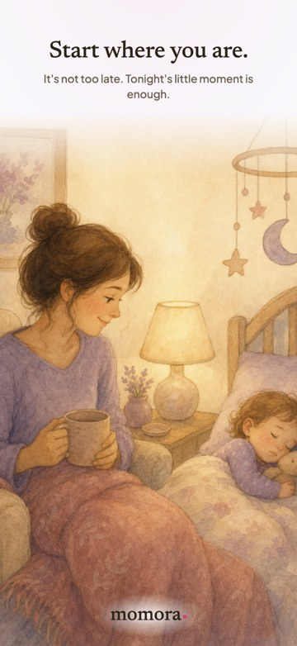 | 6 · Start where you are.  KEEP: The forgiving phrase and calm tone.  CHANGE: Move the practical idea to new slot 2, using older photos becoming suggestions and saved memories. End the set on the actual app experience, not another lifestyle painting.  WHY: Gallery import makes starting from existing material concrete. The revised end point is enjoying the collection—not completing a mandatory book project.

08 / SEVEN-IMAGE ARCHITECTURE

Digital value first.
Print as an extension.
The default has seven images. This is a production choice, not an ASO rule. Each frame stands alone; the early row explains the app without needing the description.
# | Headline | Supporting line
1 | Keep more than the photos. | Their stories, funny words and little voice.
2 | Start with the photos you have. | Moments grouped. Captions drafted. You choose what to keep.
3 | For the things a photo missed. | Say what happened. Add an illustration.
4 | Keep their little voice, too. | Save the recording, not just the words.
5 | And a book to hold, too. | Momora selects the memories and lays out the pages.
6 | For your family. Not a public feed. | Invite only the people you choose.
7 | Here when you want to look back. | Photos, stories and sounds, together for each child.

Two useful tests of the sequence
No-print test: Hide image 5. A visitor should still understand why they would use Momora and return to it.
No-fine-print rescue: The book frame and description should make the physical purchase optional and separate. A tiny disclaimer must not be the only clue that membership excludes a printed copy.

Keep evidence coherent without inventing one workflow
Reuse the same photo event in the suggestion, saved collection, revisit view and optional book. The illustrated story is a separate input/output path; the saved recording is another. Do not imply that gallery import creates illustrated/audio memories or that one unsupported card contains everything. [R1, R4–R5]
The old requirement to make images 1–3 a photo-to-book chain is withdrawn. The new story is a useful app, an easier start, and an example of what photographs miss.

09 / PRODUCTION BRIEFS

Images 1–2: value now
and an easier beginning.

01 · Keep more than the photos.
Supporting line: Their stories, funny words and little voice.
Show a genuine populated timeline/collection, not a blank journal or setup screen. A recognizable photograph and a complete short story should be easy to read. Include a genuine sound card or a clearly identified magnified detail when the actual viewport cannot show all memory types cleanly.
Do not draw a fictional combined photo/audio/illustration card. One substantial app view plus an honest inset is preferable to three tiny phones. Illustrations and portraits can add character without turning the frame into an AI-art demo. No book, order button or arrows ending in print are needed here.
Use the registry’s proportionate subscription qualifier for adding new memories. Do not imply saved reading is gated after lapse. The test is whether a parent recognizes a useful digital collection—not merely storage, a journaling obligation or a future printing workflow.

02 · Start with the photos you have.
Supporting line: Moments grouped. Captions drafted. You choose what to keep.
Make the actual gallery suggestion the hero: a small set of related older photos, a complete draft caption and the current Keep/Set aside controls. Old photos demonstrate backfilling; a wall of microscopic thumbnails does not.
The earlier documented deck is read-only; choosing Keep proceeds to an editable composer. Capture the real state instead of inventing inline editing. The caption must stay grounded in the material, not identify people or infer unknown history as if recovered by AI. [R1]
Use the same event in the saved collection in image 1 or revisit in image 7. The outcome is something worthwhile inside Momora now. Do not label this “step one” of creating a book, imply automatic approval or claim that the camera roll is cleaned up.
Capture request: raw source photos approved for marketing, a real suggestion, the approved saved memory, device/build/locale and a provenance record connecting them.

10 / PRODUCTION BRIEFS

Images 3–4: the stories
and the actual sound.

03 · For the things a photo missed.
Supporting line: Say what happened. Add an illustration.
Show a genuine short composer entry and its matching illustrated memory. Reuse the ladybug example when cleared and available. A demo line can be as simple as “She asked if the ladybug had a mommy looking for it.” It is an example, not a testimonial.
Make the input/result relationship readable using one dominant output and a genuine input crop. Do not present the illustration as a photograph or as proof of an event. This is optional visualization of a saved story, not automatic illustration of imported photos. [R1, R4]
Avoid “ten seconds” as a total process promise unless measured. A short entry itself can demonstrate low effort. The story is already worth revisiting inside the app, whether or not it ever appears in print.

04 · Keep their little voice, too.
Supporting line: Save the recording, not just the words.
Use the real saved sound-memory detail/player with a duration, a short description and a legitimate demo clip. A microphone symbol or transcript alone does not demonstrate the capability. Verify playback when the capture environment permits.
Retained audio and dictation are different choices in the inspected feature documents. Do not imply that all dictated entries keep their recordings or that saved audio can be combined with every other memory type. [R4–R5]
Do not imitate an identifiable child’s voice or reuse private customer recordings. A file in the repository is not automatically cleared for marketing. Never connect this frame to invented audio QR codes or playback in a printed book.
Success criterion: a parent sees a digital outcome worth having now: hearing the actual sound again. No physical product is needed to complete the promise.

11 / PRODUCTION BRIEF

Image 5: a book
to hold, too.
Headline: And a book to hold, too.
Supporting line: Momora selects the memories and lays out the pages.
Disclosure: Printed books sold separately. Shipping extra.

Give the book one strong frame
Use an actual generated cover or open spread, paired with the genuine in-app book entry. Show enough detail to demonstrate useful selection, grouping and story text—not a montage of tiny page thumbnails. The book should feel like a meaningful physical extension of the collection already shown.
Prefer a cleared photograph of a real printed sample. When that is unavailable, use a presentation mockup built from the actual print output with verified geometry. Record internally that it is a mockup. Do not invent lay-flat binding, paper quality, thickness or a delivered specimen.

Show the work removed, not a fictional effortless purchase
The parent chooses a child/time period, reviews generated pages online, makes supported changes and orders a separate printed copy. The visual should make automatic selection/layout clear without implying automatic approval, buying or shipping. The earlier implementation hands off to a website for preview; do not place a fabricated native editor inside the phone. [R2–R3]
Reuse a saved event from images 1/2/7 where feasible. A milestone or “first” must be supported by the source record. AI should not be portrayed as recovering facts no one saved.

Preserve the commercial distinction
The owner states $99/year for the app and another $99 plus shipping for print. The frame should not carry a frozen global price, but it must make the separate physical purchase legible. Verify whether book generation/review is included in membership before claiming it is. [O1; A1]
This is not a token mention buried in a footer. It is a full product-proof frame. Nor is it the compulsory destination of the entire carousel: the following images deliberately return to family connection and enjoying memories inside Momora.
A later sequence test can move this same frame earlier without relabeling the membership as a printing service.

12 / PRODUCTION BRIEFS

Images 6–7: sharing
and returning.

06 · For your family. Not a public feed.
Supporting line: Invite only the people you choose.
Use real family-member/invitation controls with fictional names and actual roles. Where useful, pair them with a separately captured meaningful shared memory. A family interaction demonstrates value better than a generic padlock badge.
Use no active invite token, real email address or private customer data. Respect the documented owner/manager/viewer distinction; do not imply every invited person can edit, export or order. Audience control is not a promise of on-device processing or end-to-end encryption. [R1, R8]

07 · Here when you want to look back.
Supporting line: Photos, stories and sounds, together for each child.
End with a genuine per-child collection or a complete saved-memory view. Revisit a sample already introduced. Show sound only in a supported card/tile/player; do not fabricate a filter or an all-in-one media view.
Choose a short, readable anecdote instead of a screen dominated by chopped-off rows. Do not manufacture filled calendar dates or remove a meaningful product constraint. A real alternative view is preferable to photoshopping away behavior that clashes with the message.
No unshipped Looking Back feature, recap, widget or search capability is needed to make this frame. The already-supported experience of returning to a saved moment is the point.

Ownership reassurance remains important
Keep continued saved reading and family-owner export in the description and evidence checks. An optional, separate image-7 challenger can use “Your memories stay yours” with a real export control and the documented scope. It is not the default ending, a forever-storage promise or a replacement for showing the digital experience. [R6–R7]
The closing test is not “does this persuade someone to buy a book?” It is “does this give them a reason to come back to Momora?”

13 / REPLACEMENT DESCRIPTION

The revised public copy
Proposed en-US listing copy · 2,067 characters · product/release checks still apply
The photos are on your phone. The little things are harder to keep.
The question from the back seat. The word they say their own way. What was happening just before everyone started laughing.
Momora brings your photos, stories and recordings together, so there’s more to look back on than a camera roll.

START WITH THE PHOTOS YOU HAVE
You don’t have to fill an empty journal from scratch. With your permission, Momora looks through your photos, groups them into suggested memories and drafts captions. Keep the ones you like, change a few words, or leave them out. Your camera roll stays as it is.

FOR THE THINGS A PHOTO MISSED
Write a few words or say what happened while it’s still fresh. No need to make it sound special. “He packed crackers in case the playground got hungry” is already worth keeping.
You can turn a story into an AI illustration, too, using your family’s character portraits.

KEEP THEIR LITTLE VOICE
The way they say “banana.” Their laugh. The song they keep making up. Save the recording itself and listen again—not just a transcript of the words.

SOMETHING TO COME BACK TO
Keep memories together for each child. Look back through the photos and stories, play a familiar recording, and invite family members to share in it. You choose who joins your family journal.

AND A BOOK TO HOLD, TOO
When you’d like a printed baby book, choose a child and a time period. Momora selects saved memories, groups related moments and lays out the pages with your photos and stories. Review the book online, make changes and order a printed copy delivered to your door. Printed books are optional and purchased separately, with shipping extra.

YOUR MEMORIES STAY YOURS
Your saved memories remain available to read after your subscription ends. The family owner can export the archive, too.
Start with what you already have. Add the little things when you have a minute.
An active subscription is required to add memories and use AI features. A printed book is not included in the subscription. Book prices and shipping charges are shown at checkout.

14 / METADATA AND OFFER

Name the app experience.
Separate the purchases.
Field | Proposed starting copy | Count
Name | Momora: Family Memories | 23/30
Subtitle | Photos, stories & their voices | 30/30
Promotional text | Start with the photos you have. Keep the stories and little sounds, too. Momora groups photos and drafts captions for you to review. | 132/170
Description | Complete copy on the previous page | 2067/4000

These are literal counts from the supplied UTF-8 exports, not estimates. Name/subtitle/promo/description use character limits; the field-specific keyword reference specifies bytes. [A1, A4]

Keyword candidate, not search-volume research
baby,book,album,journal,milestones,child,parenting,recording,print
66 UTF-8 bytes. Terms are relevant hypotheses, not evidence of demand or ranking. “Book” can remain relevant query vocabulary without defining the hero/title. Preserve other locales and validate against actual acquisition data before a final keyword choice.

Commercial clarity
Public description: subscription needed for new memories/AI; printed books optional and separate; prices/shipping shown at checkout. Book image: separate print purchase and shipping extra. Continued reading/export is a distinct post-lapse scope, not free ongoing creation.
Use the owner's $99/year and $99-plus-shipping figures as internal context until localized offers, tax, scope and entitlements are checked. Apple advises avoiding specific description prices across regions. Do not solve unclear messaging by changing pricing or adding an included book. [O1, A1]

Release notes
The included proposal explains import suggestions first, then optional automatic books. Use it only when those changes belong to the target release. Keep required current legal/support links; do not invent them or put unresolved placeholders into an upload file. [A2, A4]

15 / PRODUCTION STANDARD

Make it real, readable
and reproducible.

Keep the brand; enlarge the proof
Reuse the repository's current fonts/tokens and the original warmth. Headlines should work in a small row; supporting text and UI should show one concrete benefit. Vary composition by purpose instead of placing seven different benefits inside the same oversized phone.
Honest crops or identified magnified details are useful. They must remain excerpts of real screens, not new functionality. Apple permits overlays but expects actual app use and appropriate rights for depicted material. [A2]

A coherent asset pack
Capture a populated collection, an import suggestion and approved memory, a short input and matching illustration, saved-audio playback, family controls, a revisit/child view, an actual generated book and its app/web handoff. Keep owner-export evidence for the description and optional trust variant.
Use cleared media and fictional accounts. Log source IDs, routes, revision, device, locale, approval basis and whether an asset is a native runtime capture, fixture, web view, renderer export or mockup. A local fixture is not live availability evidence. Never execute a demo script before inspecting its side effects and environment target.

Device/export requirements
Verify current device support. The previously inspected app enabled iPad; genuine tablet screenshots remain in scope when supported. Initial accepted portrait targets include 1320×2868 for the 6.9-inch iPhone slot and 2064×2752 or 2048×2732 for the 13-inch iPad slot. Check the current specification before rendering. Do not stretch phone UI or disable support to avoid captures. [A3]
Use opaque RGB PNGs with no alpha. Keep text editable, await fonts/images and implement reproducible render/validate/preview commands. Missing assets must fail clearly, not produce blank “finals.” Do not ship font files or secret/private data in the handoff.

Review artifacts and final gates
Create individual masters, local previews, contact sheets and first-three rows. Inspect every image at full and reduced size, including roughly 390px single-card and 120–140px-per-card diagnostics. Fix and re-render. Review previews are not upload assets.
The complete assignment includes all seven defaults and two opener challengers for required devices. A missing native capture becomes a precise blocker; independent work continues. No new icon or video is a prerequisite. Nothing is published automatically.

16 / VALIDATION AND EXPERIMENTS

Win understood membership.
Not just more installs.

Start with comprehension and the actual offer
Show the default to a small qualitative sample of relevant parents. Ask what the app gives them, whether existing photos can be used, what remains their decision, why they would open it next week, and whether print is included. Use the same verified/localized price context for each concept. A price-free preference poll cannot settle the two-charge concern.
Remove the print frame/paragraph and repeat the value question. This is an understanding check, not proof of representative demand or willingness to pay.

Required first-image challengers
Treatment | Opening message | Isolated change
Default | Keep more than the photos. | Baseline digital collection.
Existing-photo-first | Your camera roll. Their stories. | Frame 1 only; show import-to-saved digital value.
Voice-first | Their little voice. Yours to hear again. | Frame 1 only; real playback plus broader app context.

Keep frames 2–7 byte-identical in these tests; separate manifests and hashes prevent accidental mixed treatments. An ownership ending is a separate slot test. Earlier book prominence is a later sequence test. A true book-first concept is deferred until explicitly chosen, with the same honest two-purchase offer—not presumed wrong or right.

Read results beyond the download
Recommend measuring the first approved useful memory, return to saved content, actual audio replay, relevant family participation, subscription conversion/retention and complaints/refunds about expected benefits or extra charges. Print orders are additional value, not the sole activation event.
Distinguish metric denominators and traffic/storefront mix. Book buyers versus non-buyers are observational groups, not causal evidence. Existing subscribers who bought before printing launched may inform the question but do not prove why they retained.
Do not invent analytics events, per-install PPO treatment joins or description-test controls. Verify account capabilities. Log concurrent changes, uncertainty and a practical decision rule; no fixed seven-day finish or guaranteed uplift. The prior practitioner's download improvement is not Momora's target conversion rate. [P3–P4]

17 / IMPLEMENTATION HANDOFF

Replace the direction.
Reuse good implementation work.
The updated ZIP is the authoritative handoff. Keep its folder named momora-listing-handoff-v2 beside any old folder. Do not overwrite an existing worktree's state by unzipping over it.

Run the reset, then five phases
00 — Rebase: read the new direction, inspect prior work, retain valid captures/tooling and reopen affected gates. On a fresh project this records that no migration was needed.
01 — Evidence: actual workspace, claim/entitlement matrix, asset/device plan and precise blockers.
02 — Text: canonical v2 registry, all metadata files, verified counts, release notes and removal of active old copy.
03 — Captures: real proof for all seven app-led frames with separate photo/story/sound paths and optional print.
04 — Rendering: complete device sets, digital-value openers, editable compositor, previews and visual inspection.
05 — Independent QA: no-print value test, separate-purchase understanding, product/visual/technical truth and a manual upload package.

v1 work that can survive
Keep approved raw media, valid native captures, actual book exports, renderer source, tokens and useful provenance. Recheck build freshness and rights. Move book output/layout material into new slot 5, story material into 3, sound into 4, privacy into 6, and appropriate child/revisit material into 7.
Replace the default title/subtitle/description, scene-order arrays, semantic crop assumptions, challenger definitions, test assertions and upload manifests. Old “complete” fields do not pass v2 acceptance. Preserve history and unrelated edits; do not do destructive global replacement.

The package is not implementation already done
This update supplies revised documents, proposed copy and prompts. It does not create new store images, alter the repository or publish the listing. The coding agent must produce and inspect those outputs in the user's environment. A release candidate still needs actual feature/rights/commercial checks and owner approval.
No paywall, pricing, onboarding, product feature, production data, physical order, paid generation or store submission is authorized by this handoff.

SOURCE REGISTER / PRACTITIONERS AND PLATFORM

Where the recommendations
come from
The prior research findings below are retained as attributed evidence, not re-audited experiments. The revision changes their application. Official field/screenshot rules were checked on 20 September 2026; verify again at implementation.
P1 — Vlad Dugnist, X. Original first-person legibility account; prior full access blocked. Original post
P2 — Apptamin. Reproduction used in the prior report to check the X statement, not a current source for platform rules. Embedded account
P3 — u/aristotenes, Reddit. First-three-screenshot account; proposition changed; incomplete experiment detail. Practitioner discussion
P4 — BetterSleep / SplitMetrics. Operating-team and vendor case; separates download outcomes from downstream economics. Case study
P5 — Andrew Hart, Phiture. Feature/value/segment matrix for messaging hypotheses. Practitioner framework
P7 — ConsultMyApp / APPlyzer. Mixed screenshot-title indexing observations; not a reliable shortcut. Investigation
A1 — Apple, Creating your product page. App name/subtitle, promo text, opening description, screenshot exposure and caution on region-specific prices. Official guidance
A2 — Apple, App Review Guidelines. Accurate paid-feature claims, actual app use, demo rights and appropriate release notes, especially sections 2.3.2, 2.3.3, 2.3.9 and 2.3.12. Guidelines
A3 — Apple, Screenshot specifications. Current accepted device dimensions. Specifications
A4 — Apple, Platform version information. Plain-text description, keyword byte limit and version-note limits. Field reference
No source establishes a transferable conversion multiplier for Momora. Some prior sources are vendor-hosted or self-reported; that limitation is part of their use, not removed by citation.

SOURCE REGISTER / PRODUCT AND CUSTOMER INPUTS

Inputs, ownership
and evidence limits
O1 — Owner clarification in this conversation. $99/year app membership, optional $99 printed book plus shipping, concern about two-purchase expectations, and approval to revise the documents. These figures are not a live checkout inspection.
V1 — Supplied customer synthesis. reference/voice-of-customer.md, “Voice of Customer: Parents of Young Children (0–6) & Memory-Keeping,” July 2026. Most relevant: §§1–2, §3 wish language, §6 terminology and §§7–9 implications/limitations. Preserved unchanged. Its underlying appendix reports were not supplied or independently re-audited here.
S1–S6 — Original images and description. The six supplied PNGs remain unchanged visual references. The source description is the text pasted by the owner. No live placement or store performance was supplied.
C1–C3 — Competitor primary pages. Checked for structure, not conversion evidence: Tinybeans app page, Tinybeans photobooks, BackThen homepage. Do not transfer their features, claims or economics to Momora.

Repository evidence carried forward from the previous review
These links locate the detailed feature documents previously inspected. Their code histories are implementation evidence, not confirmation of current rollout. This revision does not claim a fresh main-branch or production test.
R1 — Gallery import: Feature document
R2 — Book generation and online preview: Feature document
R3 — Book orders and fulfillment: Feature document
R4–R5 — Dictation and retained sound: Voice journaling and Audio memories
R6–R7 — Export and billing gates: Data export and Subscriptions
R8 — Household roles and invitations: Family sharing
Revalidate features, localized prices, print-preparation entitlement, shipping scope, source-media approval, legal links and target device layouts before release. The v2 prompts explicitly carry these gates forward.

