Architetture dei Sistemi di Elaborazione  02GOLOV | Delivery date:  October 18th 2023
Laboratory  1 | Expected delivery of lab_01.zip including:  - program_0.s  - lab_01.pdf (fill and export this file to pdf)

Please, configure the winMIPS64 processor architecture with the Base Configuration provided in the following:
- Integer ALU: 1 clock cycle
- Data memory: 1 clock cycle
- Branch delay slot: 1 clock cycle
- Code address bus: 12
- Data address bus: 12
- Pipelined FP arithmetic unit (latency): 6 stages
- Pipelined FP multiplier unit (latency): 8 stages
- FP divider unit (latency): not pipelined unit, 28 clock cycles
- Forwarding optimization is disabled
- Branch prediction is disabled
- Branch delay slot optimization is disabled.

Use the Configure menu:
- Running the WinMIPS simulator, launching the graphical user interface
(folder_to_simulator)...\winMIPS64\winmips64.exe
- Disable ALL the optimization (a mark appears when they are enabled)
- Browse the Architecture menu (Ctrl-A)
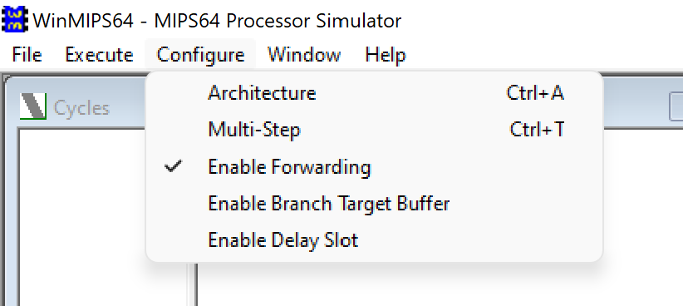

- Modify the defaults Architectural parameters (where needed)
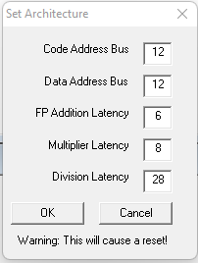

- Verify in the Pipeline window that the configuration is effective (usually in the left bottom window)

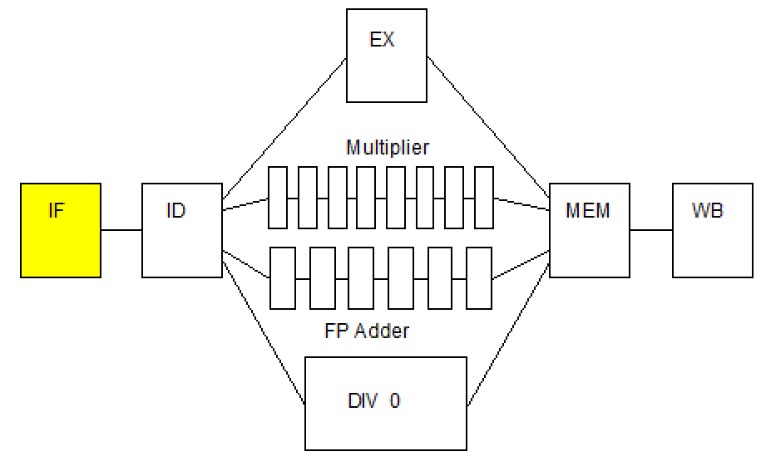
- Exercise your assembly skills.
Write and run an assembly program called program_0.s (to be delivered) for the MIPS64 architecture.

The program must:
- Given three arrays of 15 8-bit integer numbers (v1,v2,v3), check for each one of them if the content corresponds to a palindrome sequence of numbers. If yes, use three 8-bit unsigned variables (flags) to store the results. The variables will be equal to 1 is the sequence is palindrome, 0 otherwise.
- Only for the palindrome arrays, compute the sum element by element and place the result in another array v4 (i.e. v4[i] = v2[i] + v3[i] supposing that only v2 and v3 are palindromes)
Example of a vectors sequence containing only 9 numbers:
v1: . byte 2, 6, -3, 11, 9, 11, -3, 6, 2
v2: . byte 4, 7, -10,3, 11, 9, 7, 6, 4, 7
v3: . byte 9, 22, 5, -1, 9, -1, 5, 22, 9
f1: .space 1
f2: .space 1
f3: .space 1
v4: .space 9

- Use the WinMIPS simulator.
Identify and use the main components of the simulator:
  - Running the WinMIPS simulator
- Launch the graphic interface
...\winMIPS64\winmips64.exe

  - Load your program in the simulator:
    - Load the program from the File→Open menu (CTRL-O). In the case the of errors, you may use the following command in the command line to compile the program and check the errors:
...\winMIPS64\asm program_0.s

  - Run your program step by step (F7), identifying the whole processor behavior in the six simulator windows:
Pipeline, Code, Data, Register, Cycles and Statistics

  - Collect the clock cycles to fill the following table (fill all required data in the table before exporting this file to pdf format to be delivered).

Table 1: Program performance for the specific processor configurations

Program | Clock cycles | Number of Instructions | Clocks per instruction (CPI) | Instructions per Clock (IPC)
program_0 | 432 | 287 | 1.505 | 0.664

- Perform execution and time measurements.
Measure the processor performance by running a benchmark of programs. Change the weights of the programs as indicated in the following to evaluate how these variations may produce different performance results.

Search in the winMIPS64 folder the following benchmark programs:
  - testio.s
  - mult.s
  - series.s
  - program_0.s (your program)

Starting from the basic configuration with no optimizations, compute by simulation the number of cycles required to execute these programs; in this initial scenario, it is assumed that the weight of the programs is the same (25%) for everyone. Assume a processor frequency of 1.75 kHz (a very old technology node).

Then, change processor configuration and vary the programs’ weights as follows. Compute again the performance for every case and fill the table below (fill all required data in the table before exporting this file to pdf format to be delivered).:

- Configuration 1
  - Enable Forwarding
  - Disable branch target buffer
  - Disable Delay Slot
Assume that the weight of all programs is the same (25%).
- Configuration 2
  - Enable Forwarding
  - Enable branch target buffer
  - Disable Delay Slot
Assume that the weight of all programs is the same (25%).

- Configuration 3
Configuration 1, but assume that the weight of the program your program is 43.33%.
- Configuration 4
Configuration 1, but assume that the weight of the program series.s is 60%.

Assuming that TOTAL time is based on the weighted average between the programs

Table 2: Processor performance for different weighted programs
Program | No opt | Conf. 1 | Conf. 2 | Conf. 3 | Conf. 4
testio.s | 750 | 483 | 439 | 483 | 483
mult.s | 1880 | 980 | 922 | 980 | 980
series.s | 550 | 233 | 234 | 233 | 233
program_0.s | 432 | 378 | 365 | 378 | 378
TOTAL Time  (@ 1.75kHz) | 516 ms | 296 ms | 280 ms | 643 ms | 500 ms

Appendix: winMIPS64 Instruction Set

WinMIPS64

The following assembler directives are supported
.data - start of data segment
.text - start of code segment
.code - start of code segment (same as .text)
.org <n> - start address
.space <n> - leave n empty bytes
.asciiz <s> - enters zero terminated ascii string
.ascii <s> - enter ascii string
.align <n> - align to n-byte boundary
.word <n1>,<n2>.. - enters word(s) of data (64-bits)
.byte <n1>,<n2>.. - enter bytes
.word32 <n1>,<n2>.. - enters 32 bit number(s)
.word16 <n1>,<n2>.. - enters 16 bit number(s)
.double <n1>,<n2>.. - enters floating-point number(s)

where <n> denotes a number like 24, <s> denotes a string like "fred", and
<n1>,<n2>.. denotes numbers seperated by commas.

The following instructions are supported
lb - load byte
lbu - load byte unsigned
sb - store byte
lh - load 16-bit half-word
lhu - load 16-bit half word unsigned
sh - store 16-bit half-word
lw - load 32-bit word
lwu - load 32-bit word unsigned
sw - store 32-bit word
ld - load 64-bit double-word
sd - store 64-bit double-word
l.d - load 64-bit floating-point
s.d - store 64-bit floating-point
halt - stops the program

daddi - add immediate
daddui - add immediate unsigned
andi - logical and immediate
ori - logical or immediate
xori - exclusive or immediate
lui - load upper half of register immediate
slti - set if less than or equal immediate
sltiu - set if less than or equal immediate unsigned

beq - branch if pair of registers are equal
bne - branch if pair of registers are not equal
beqz - branch if register is equal to zero
bnez - branch if register is not equal to zero

j - jump to address
jr - jump to address in register
jal - jump and link to address (call subroutine)
jalr - jump and link to address in register (call subroutine)

dsll - shift left logical
dsrl - shift right logical
dsra - shift right arithmetic
dsllv - shift left logical by variable amount
dsrlv - shift right logical by variable amount
dsrav - shift right arithmetic by variable amount
movz - move if register equals zero
movn - move if register not equal to zero
nop - no operation
and - logical and
or - logical or
xor - logical xor
slt - set if less than
sltu - set if less than unsigned
dadd - add integers
daddu - add integers unsigned
dsub - subtract integers
dsubu - subtract integers unsigned

add.d - add floating-point
sub.d - subtract floating-point
mul.d - multiply floating-point
div.d - divide floating-point
mov.d - move floating-point
cvt.d.l - convert 64-bit integer to a double FP format
cvt.l.d - convert double FP to a 64-bit integer format
c.lt.d - set FP flag if less than
c.le.d - set FP flag if less than or equal to
c.eq.d - set FP flag if equal to
bc1f - branch to address if FP flag is FALSE
bc1t - branch to address if FP flag is TRUE
mtc1 - move data from integer register to FP register
mfc1 - move data from FP register to integer register

