|  |  |  |  |
| --- | --- | --- | --- |
| A male skier on a mountain, in motion, under a bright, cloudless sky with mountain scene in background  Test WORD FILE  Event Title, Up to Two Lines Event Description Heading To replace any tip text with your own, just tap it and start typing. To replace the photo or logo with your own, on the Insert tab of the ribbon, just select the option you need. To try out different looks for this flyer, on the Design tab, check out the Themes, Colors, and Fonts galleries.  Logo placeholder | |  | | --- | | Add Key Info About Your Event Here! ____ Don’t Be Shy—Tell Them Why They Can’t Miss This Event! ____ One More Exciting Point Here! ____ Add Another Important Point Here! ____ You Have Room for One More Here! | | Company Name Street Address  City, ST ZIP Code  Telephone  Web Address  Dates and Times | |

###### WINTER LIFT TICKETS

Explore Blue’s 43 trails with a lift ticket priced according to access and age. With special rates for youth, seniors, beginners, night skiers or riders, early birds and more, you are sure to find one that suits you. Save on lift tickets by packaging it with an overnight stay.

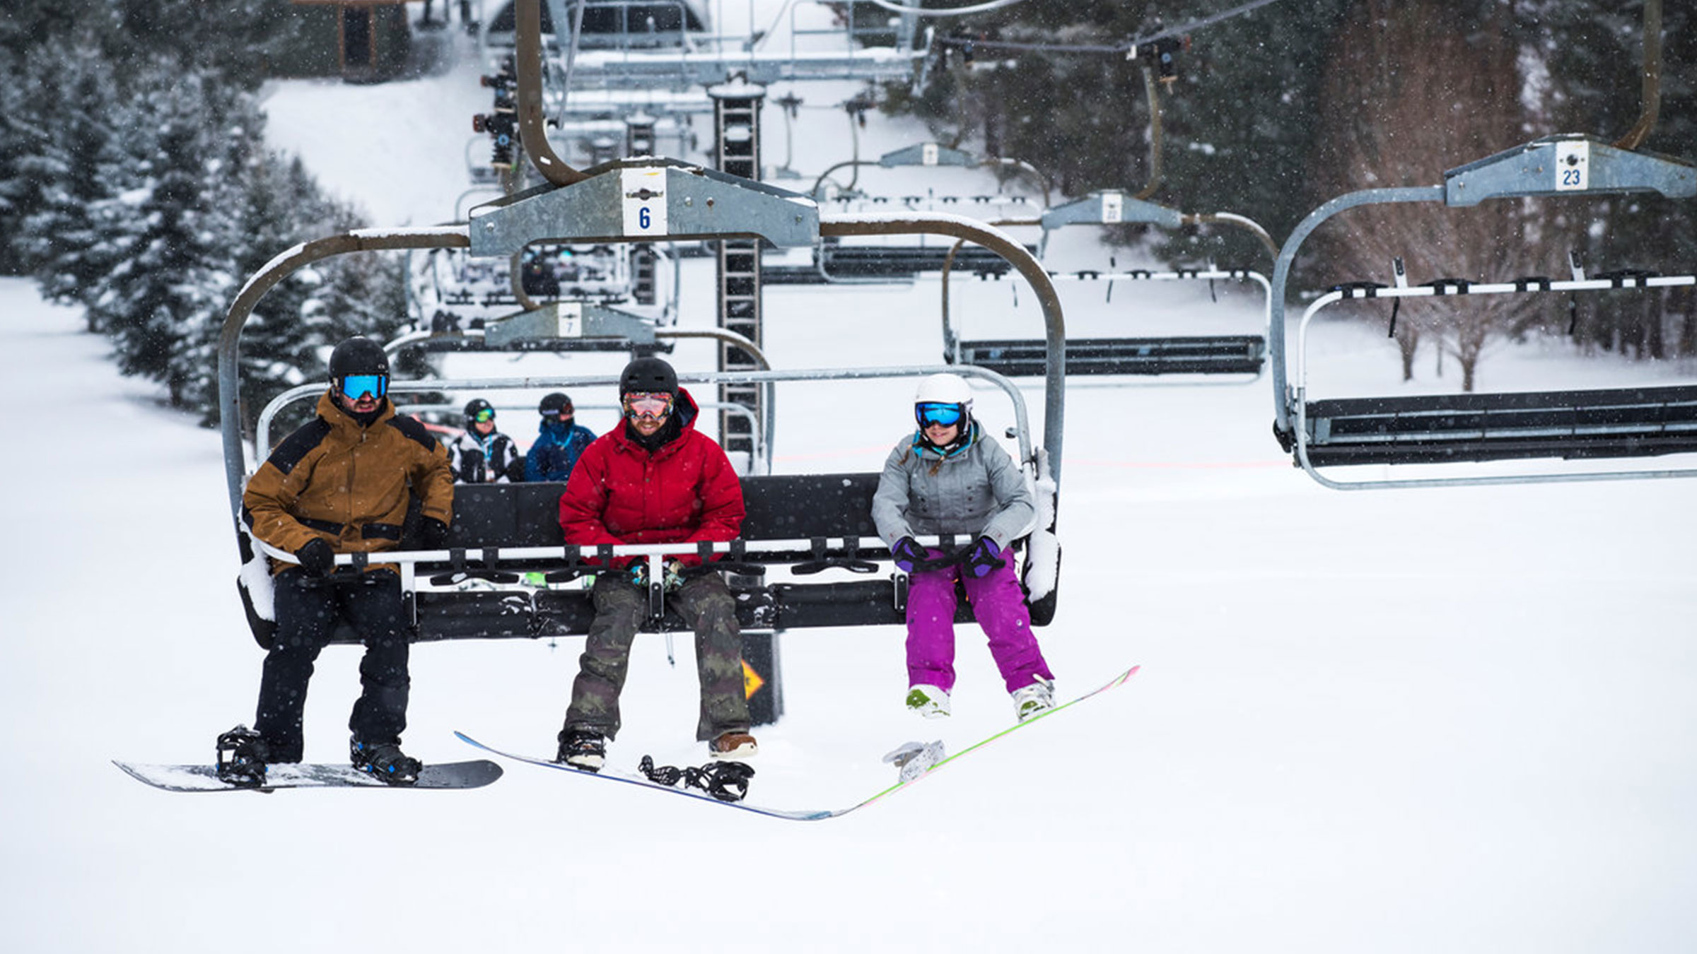

###### SNOW SCHOOL

We all have room for improvement, and when it comes to winter sports on the slopes our snow school has a program, lesson and pro that’s suited to your skill level. Our innovative and comprehensive programs make Blue Mountain the perfect place to nurture lifelong skiers and riders. Introduce this favourite Canadian pastime to kids and see their personal and athletic development grow while staying active and outdoors.

