DROIDLAB

Rolland Vida, BME

vida@tmit.bme.hu

Participant 1 (lead) | Rolland Vida, BME
Participant 2 | Balázs Lajtha, BME
 | Miklós Máté, BME

Overview of DroidLab

Focus and organization
DroidLab is a scalable platform that uses two modern computing paradigms to solve sensory tasks on a large scale. On one hand, we have the cloud: an army of obeying faceless machines. On the other hand we have the crowd: a colorful collection of volunteers who can be enrolled to perform a specific task. In this document, we present the context of our work: we introduce the crowd sourcing paradigm through two influential projects. Then we move on to evaluate concurrent mobile crowd sensing platforms and applications. Finally we present the approach that we have taken when designing DroidLab: we present the major technical and ethical challenges and lay out or solutions. We then move on to the architecture and components of the created software. We present the interfaces and protocols used; giving an inside to the DroidLab framework that helps future researchers to better understand how their measurements will run on our platform. Finally we present the current state of the implementation, and our plans for the next semester, including the planned integration with the OneLab portal.

Basic principles
DroidLab is a cloud-backed framework running on Android-based smartphones and supporting the implementation, testing and evaluation of mobile crowd-sourcing applications.
DroidLab is still under development, as part of the European research project EIT ICT Labs FITTING, but many of its elements are already operational.

Crowdsourcing
”Crowdsourcing is the act of taking a job traditionally performed by a designated agent (usually an employee) and outsourcing it to an undefined, generally large group of people in the form of an open call.” This was the initial definition of crowdsourcing when first used in 2006 by Jeff Howe and Mark Robinson [15]. Two main orthogonal problem sets can be solved using crowdsourcing: data gathering and data processing. When a data gathering problem is distributed among members of the crowd we use the term crowdsensing or participatory sensing, while for distributed computational tasks we use the general term crowdsourcing. Another way to categorize crowdsourced applications is whether the contributors profit directly of the gathered or processed information. Wikipedia uses the power of the crowd to provide a service that can directly be used by the contributors. When it comes to crowdsourcing platforms, creating a framework to acquire information is much easier than creating a generic framework that is able to present users with the results. In many cases the beneficiaries of the crowdsourced tasks are different than those providing the data. DroidLab targets these scenarios.
Probably the most popular crowdsourced computational problem was SETI@home [17], a project lasting several years and aimed to search for extraterrestrial intelligence by analyzing radio waves. The problem was divided into a large number of subtasks and distributed among the willing participants. Users could set a SETI screen-saver that downloaded and solved these subtasks when the user was away. SETI’s success came from its innovative design and from the interesting task that it performed. From the point of view of the volunteer, this was a low cost, low gain activity. PCs back than had long startup times and high standby power consumption, so once SETI was installed it didn’t generate a visible overhead, and provided the user with an insight of the performed work. Some early gamification elements, like leaderboards, were also implemented.
A somewhat different example is the ESP Game [21]: a classification game, in which two players cooperated to solve a simple puzzle. The goal of the game was to tag images: a task that is still hard for an algorithm, as it’s not sufficient to identify object on an image, but one has to determine the relevance of the object, which may not be proportional to its size or location on the image. To solve this problem, the following game was invented: an image was displayed in both players’ browsers. The first player had to find five words that described the image. Then, the second player had to guess those words. This human image processing game allowed association of more relevant tags to images. The players were motivated to play the game for the game itself, and for added gamification elements.
Both examples involved utilization of computational resources owned by the users to perform a highly parallelized task that the users perceived as common good, but they didn’t benefit directly from the results of their work. In both cases, users received an input that they processed based on a given algorithm. The tasks were not personalized. SETI@home’s tasks were solely performed by a machine, while the ESP Game had to be solved by human users.

Crowdsourcing
Participatory sensing on the other hand involves distributed data collection. Sensing can be automated, or can involve the active participation of the user. Before smartphones, sensing was usually done through mostly fixed sensors that were deployed to monitor a given phenomenon at a specific area. They were not able to move, and they had very restricted computational, memory and communication resources, so as to spare their very limited batteries. In case those batteries were depleted, sensors had to be collected, recharged and redeployed, which was a very cumbersome, and sometimes even impossible task. The evolution of smartphones opened the way for many new complex sensing applications. Smartphones have the connectivity that enables real time, high bandwidth communication. The devices can access precise location data, and are equipped with a wide range of sensors from cameras and microphones to accelerometers, gyroscopes and barometers.
New mobile operating systems offer many seamless ways for the sensing system to prompt for user input. In addition, smartphones are owned by individuals who recharge them regularly, so energy efficiency becomes less critical. Given these possibilities, a large number of smartphonebased crowdsensing applications emerged recently. However, on one hand, all these applications have several common parts (e.g., communication with the sensor, data collection, data sending, or data processing modules) which are written from scratch by each application developer, resulting in redundant development, and also redundant resource usage in the case of two or more such applications running on the same device. As they will all consume memory and CPU resources for tasks that could be merged. On the other hand, once the application is written, a large number of users is needed to test, run and use this application. Gathering such a crowd is however a difficult task, as the users should be motivated in a way to upload and run these specific applications on their personal devices.
DroidLab is designed to tackle exactly these issues. First, it provides the research community and the mobile application developers with an easy-to-use skeleton on which they can readily build their own crowdsourcing applications, benefiting from the provided sensing and communication modules. Second, the DroidLab framework will run on a large number of smartphones, enabling application developers to upload their own code on these devices and test it on a large-scale testbed. DroidLab is being developed as part of the EIT ICT Labs FITTING European research project, which aims to federate several large scale wired and wireless testbeds, such as PlanetLab, OneLab or SensLab. The goal of the project is to provide a common interface and a transparent access to this large set of heterogeneous resources, enabling researchers to run experiments and test their various protocols and applications. DroidLab adds to FITTING the ability to support mobile nodes and mobility scenarios, a feature that was not addressed by the other, previously mentioned testbeds.

Terminology
DroidLab is a cloud backed mobile platform. It has two main components, the backend and the client. The server has two entry points for users: the client portal allows users to log in and review the data that was collected through her device, get an overview of her participation, and browse the published results of finished experiments. The server’s second entry point is the researcher portal. This part will be integrated with the OneLab project to provide a single sign on solution and proxy the results and requests. For now the researcher portal allows researchers to upload measurement code and request user resources.
The mobile devices participating in DroidLab are running the client. The client is not a monolithic application. It consists of the core and several plugins. The core is capable of downloading and running crowdsourcing applications, called measurements.. Applications rely on events fired by the plugins and methods offered by the plugins to perform sensing tasks. The core provides means to the applications for uploading results.

Related Work
We already mentioned two successful examples of crowdsourcing, both targeting desktop platforms. SETI@home was an automated solution while the ESP Game involved user interaction. While it’s easy to find proposed applications for participatory sensing, and academic papers discussing the challenges of such applications and their effects on society [12], there is a very limited umber of successfully deployed applications. In 2012 the mobile broadband penetration was 74.8% in the developed world, but only 19.8% in the developing world [2]. While this equals in a larger number of subscribers in the developing regions, most application downloads come from the developed countries [6]. Hence, most crowdsourced applications address ”first world problems”. Here is a short survey of the tackled scenarios, and a brief presentation of some existing crowdsourcing frameworks.

Mobile crowdsensing applications
Transportation is an area where several crowdsensing applications emerged recently. When using a car, knowing the traffic conditions in advance gives a huge advantage. Waze [8] is one of the many traffic aware navigation applications that uses smartphone sensors to identify traffic conditions. Besides traffic, road quality is an important factor too, both for drivers and cyclists. Smartphone acceleration sensors can accurately detect potholes. While no single pothole detection application has emerged, several publications discuss such a framework [18], [11].
When arriving to the destination finding a parking spot will become the main concern. Google launched Open Spot [3], an experimental application that relied on user interaction to detect freed up parking spaces. The application was a failure, and the problem remains unsolved. Finally, public transportation can also benefit of crowdsensed information. HopStop Live [4] is for example an application that provides live transit information gathered by the users.
Presence and phone book applications can also benefit of crowdsensing.The user’s presence can be detected using sensor information, enabling a framework to communicate detailed information about a contact’s state before calling him/her [19] Phone books can be (partially) shared among users to ease reverse lookup of phone numbers. Mr Number helps its users to avoid unwanted calls by collaboratively maintaining a black list of telemarketers and robocallers [5].
Weather and environment monitoring is probably the most popular crowdsensing scenario. We participated in the development of the mobile application Id¨ok´ep, a Hungarian weather service. Id¨ok´ep had more than a hundred deployed online weather stations and the mobile application enabled users to share weather photos, perceived weather conditions and analogue measurement results.
While smartphones are not equipped with the proper sensors to become a weather station, their near field communication technologies (Bluetooth, WiFi, NFC) enable them to be extended with peripherals capable of measuring air quality, humidity or temperature. In the Common Sense project Bluetooth enabled air pollution sensors were deployed with the mobile application to measure and report air pollutants. Microphones enable smart phones to capture noise level and process noise pollution.
Finally, CreekWatch [1] is an application that helps to monitor water quality and pollution relying on user reports and photos.
Monitoring network coverage and connection quality can also be done through crowdsensing. The two most important communication channels for smartphones are WiFi networks and cellular networks. WiFi Finder [9] builds and maintains a database of open WiFi networks and their properties. Root-Metrics [7] on the other hand monitors cellular coverage, as it lets users share their active measurement data to process a coverage map.
Healthcare in modern societies is a main concern. Smartphones’ sensors can help on many different levels. For individuals it can help to monitor activity, track exercises, with external Bluetooth devices log blood pressure and other metrics. In a family results of the elderly members can trigger alarms at the younger generations. Same can be implemented in a smaller community. On national scale data provides insight of the health level of the people. On a global scale these statistics can help find correlation between lifestyle and health [16].
A crowdsourced ad-hoc communication network can be useful both on outdoor events where cellular coverage is not designed for many users, and in case of an outage to help first responders contact those without mobile service. Crowd sensing is useful to detect and track parades, estimate number of participants.

Mobile crowd sensing frameworks
Several frameworks have been proposed for different aspects of mobile crowdsourcing, most of them being experimental. mCrowd is a mobile crowdsourcing platform that enables iPhone users to post or tag images or answer questions. mCrowd [22] was a prototype application that demonstrated a micro-payment system rewarding the contributors. mClerk [13] is a platform that distributes tasks and enables workers to post their responses. mClerk targeted third world users without smartphones. The key challenge of mClerk was to create a communication protocol that enables data transfer over text messages, enabling traditional phone users to receive complex tasks and report results. Both platforms focus on the active contribution of the users. Other frameworks target the communication protocols used in crowdsourcing applications. When information is both gathered and consumed by the same crowd, it is crucial to have a robust, multi-source, multi-destination multicast infrastructure. Fan-Bai et al proposed such a system for vehicular networks. Demirbas et al [10] developed an overlay that uses Twitter to distribute sensor information.
Haderer et al [14] presented the design of a crowdsensing framework called APISENSE. They identify the main challenges that they face. Their solution, a multi-cloud based SsaS platform focuses on the serving architecture. They promote a multi-tenant approach to increase security, privacy and robustness. APISENSE is composed of a central cloud component and of discrete sensing nodes, each running in the cloud. Sensing tasks are defined using their domain specific language. These definitions are then processed by a Software Production Line that creates the cloud based sensing nodes. Device users are then prompted to join these sensing nodes.
APISENSE takes a cloud centric approach, focusing on the gathering, storage and processing of the received data. Aiming to solve the same problem, with DroidLab we take a more client centric approach. Our solution is designed to comply with Android application guidelines. By adjusting DroidLab to the Android eco system, we believe that it will be more appealing and more trustworthy to the users, resulting in higher level of engagement.
MEDUSA [20] is also an experimental framework that enables the execution of sensing tasks on a swarm of devices connected to a cloud based server. Ryong Ra et al created a scripting language MedScript and a prototype of the runtime. MedScript introduced an abstraction that helps to describe crowdsourcing tasks along with language constructs that map to user involvement, like requesting user input or user actions and rewarding users. MEDUSA also defines a software architecture and provides a reference implementation for cloudbacked crowdsourcing frameworks.
As opposed to MEDUSA, DroidLab focuses on automated sensing. We designed our framework to be able to operate in the background, but taking in consideration the user’s resources. Our first contribution is a detailed permission and quota management system that gives full control to the users who run the DroidLab framework on their phones.
Our second contribution is the plugin-based design that allows the framework to be tailored to the capabilities of the specific device. There exist several thousand different makes of Android devices, dozens of sensors, several different network stack implementations with different feature sets. DroidLab contains different plugins for different sensors. This enables the user to configure his DroidLab installation to match his comfort zone. The plugin architecture is designed to fit Android permission system. The framework’s core to require only network access and every feature requests only privileges crucial to its operation. Our third contribution is the DroidLab API, a Java API that eases the development of crowdsourcing application with functions to utilize the plugins’ functionality, and gives access to sensing related tasks, like scheduling and data collection. In the following section we present the intended use cases of the framework.

Usecases
Applications mentioned in the related work sections have several properties in common:
- they only work if the contributors reach a critical mass. In location based applications the distribution of the users has to be taken in account too. As Google Play is a global service, an application can reach millions of users, but if these users are scattered around the Globe, some crowd sensing applications will still fail;
- - they provide services to the users;
- - provided services can be consumed on the same mobile device, through a specific application;
For such an application to succeed, the provided service has to be in balance with the required contribution, and the application has to be advertised and distributed rapidly. These requirements result in well-polished, feature rich applications that emphasize the provided services, and have high marketing costs. If an application doesn’t reach enough users or active user contribution is required which is too costly (see Google’s Open Spot), the service dies out.
This is a high cost, high risk business. A crowdsensing platform on the other hand takes quite a different approach. It doesn’t provide value to the user, at least not as directly as a specific application can. The user base doesn’t have to grow exponentially to sustain the provided services. DroidLab will host different kinds of applications, in different stages of growth.
DroidLab is designed to be used in several ways, with different goals in mind. DroidLab can act as a bootstrapping device for a mobile crowdsensing application. Until the critical user mass is reached, DroidLab nodes can provide the missing information for the crowdsensing service to operate correctly. If a given service requires mobile sensor data, but doesn’t offer content to the mobile users, it is especially hard to motivate users to download yet another application that will run in the background and consume resources, without providing any value to the device owner. If a device runs DroidLab, such applications can be deployed seamlessly, without distracting the user. There is no need thus to convince a large group of users to download and run each specific application, they have to be convinced just once, to install the DroidLab framework, and for the same entry cost of a single mobile sensor application, the user will be able to participate in different sensor networks over a long period of time.
Finally, DroidLab’s initial purpose is to be a research platform, a large-scale mobile test network similar to PlanetLab and SensLab, over which researchers can test their developed algorithms and protocols. This is because it is especially difficult to deploy large-scale applications for research purposes, as they usually don’t provide any value to the user, operate only for short periods of times, and usually target specific user groups. DroidLab can be regarded thus as a large-scale testing infrastructure for mobile applications.

Architecture and operation overview
In the following we lay out the chosen architecture for DroidLab, and present the answers we gave to the most important challenges we had to tackle during the design and implementation of the framework.
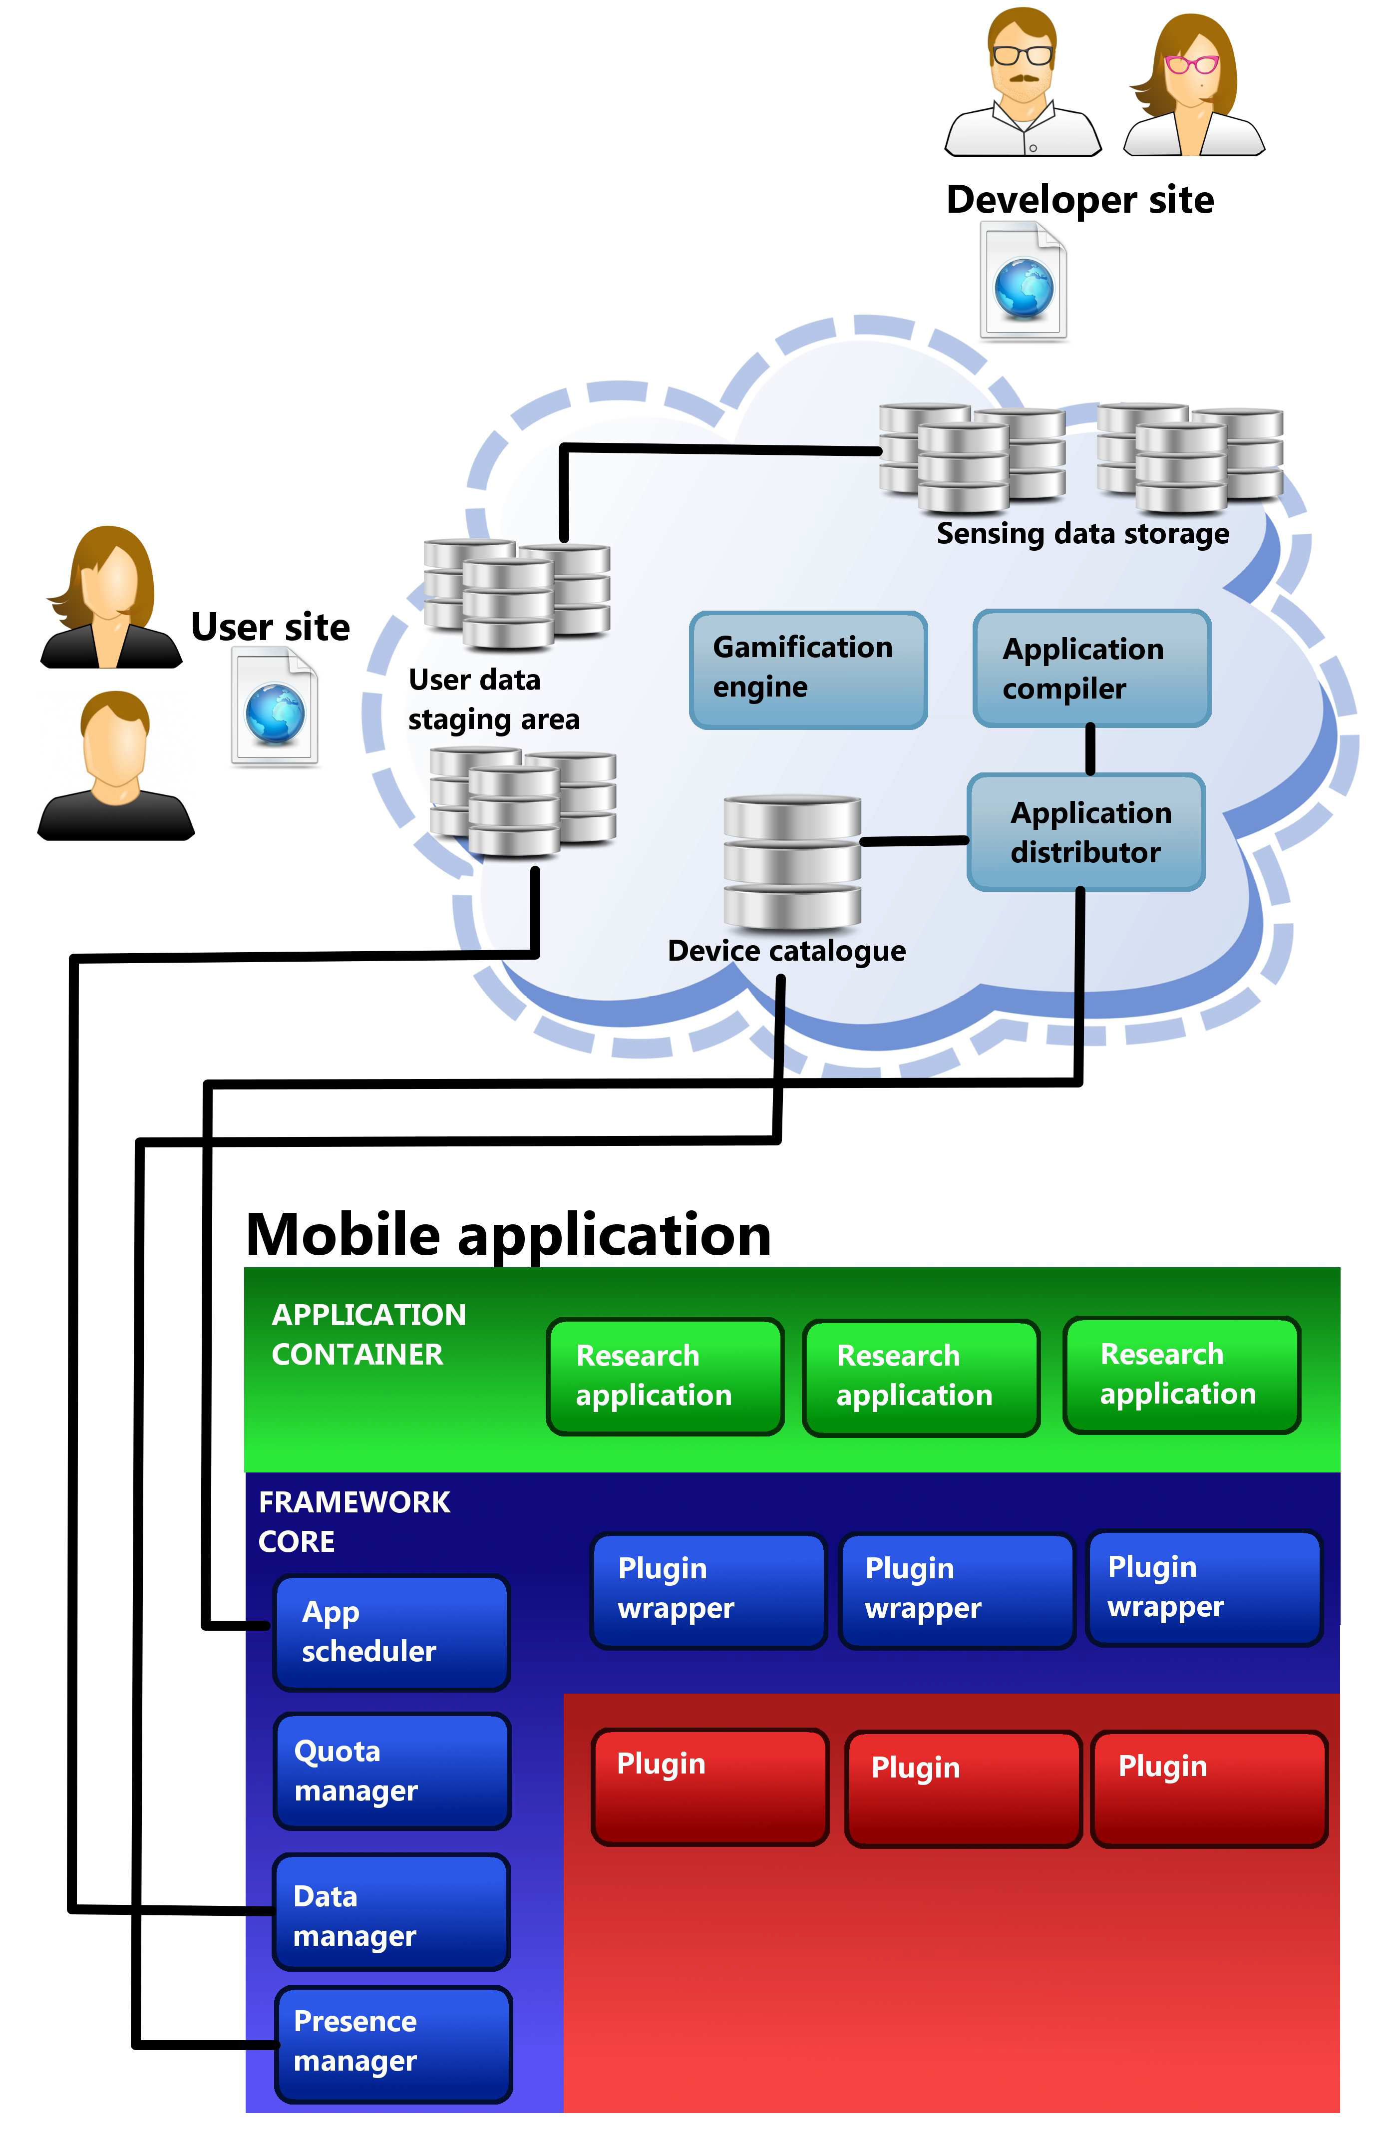Figure 1 shows an overview of the DroidLab framework. In the center of DroidLab is the server. Different server components communicate with different client modules. The concept of DroidLab is that installations are configurable through plugins that the user can choose to install, and permissions that the user may or may not give to the client. This results in a heterogeneous device pool. On the other hand application developers arrive with different needs. The server’s task is to match the needs with the resources, and handle the communication between the applications running on the client devices and the developers. The process is the following.
Developers upload the source code of their application, along with a descriptor file containing the requirements towards the device and the installed DroidLab setup. The descriptor file is matched to the available device pool. If needs are met, the server compiles a downloadable binary, and pushes it to the device alongside with the granted permissions and resource quotas the application is allowed to consume. The packet is received by the App scheduler which in turn manages the lifecycle of the applications.
Once an application is pushed to a device, the App scheduler takes care of its lifecycle. Applications can rely on timers and sensor events to trigger their operation. Applications can be written using a limited feature set of Java, building on top of a lightweight API, instead of using an own domain specific language. This way sensing tasks or protocols can exploit the full power of base Java classes to implement complex business logic.
Sensor functionality is provided by the installed plugins. While plugins do the sensing tasks, plugins don’t save sensor data. Sensor functions return with their results, which might than be processed or dropped by the application. Or compressed, aggregated with other sensors measurements and only then sent to the server. We decided to use this more flexible approach to limit bandwidth and storage space needs.
Applications use the Data manager to persist information The Data manager is responsible for the local storage of this information, and for the scheduling of uploads.
The fourth main component of the framework core is the Presence manager. In order for the server to work properly, it must maintain an up to date device list, with the DroidLab installation details and the amount of available resources. The Presence manager notifies the server about device configuration changes and device state.
Applications run in a managed sandbox. Each delivered event and called method is monitored by the framework and authorized by the resource manager running on the device. Once the application’s quota level is reached or the overall quota limit has expired, the framework denies the request.
Figure 2 shows the control flow of a sensor access. It starts off by a trigger. Either the scheduler can notify the core about a timeout that has been scheduled, or a plugin fires an event based on sensor values. The Core finds the Applications that have to be launched. Applications get to run only for a very short time, and during this period they have to process the received event. In response they can initiate sensor readings, subscribe or unsubscribe from events, and set timers. If the application places a sensor request, a callback is registered and the framework handles the call asynchronously. First, permissions need to be checked. If the user authorized the call, the core asks for a quota estimate for the given parameter set from the plugins. If the application has enough credit for the call, the plugin method is called. When a plugin returns a result, the application’s available credit is decremented, and the callback is called. This mechanism is both secure and flexible.
Application terminates if one of the required quotas or predefined lifespans expires, the user explicitly removes it from the framework, a required permission is revoked, or a required plugin is uninstalled. Application is then removed from the device. Data generated by the application is cached until uploaded to the server.

Challenges
We faced several challenges during the design and development of the framework. Some of the challenges come from the goals we wanted to achieve, others were the result of the chosen architecture, and some challenges were result of the user’s requirements. We will briefly explain how DroidLab tackles them.

Modularity
The DroidLab distribution, from an Android perspective, consists of several applications, namely the core, and a set of chosen plugins. Each plugin can be installed or removed as an Android application. Each plugin is responsible of a hardware component (location, WiFi, Bluetooth, battery) or dataset (phonebook, messages, installed applications…). The Android platform obliges the developers to state the required permissions for each application’s execution. Our approach enables us to have a privacy footprint that the user is comfortable with, and have a feature set that the device can handle. The user can assemble a setup that he/she is comfortable with, and is suitable for the capabilities of the device. If for example the user doesn’t want to share his/her location, then by omitting that plugin the framework will be limited on the OS level not to use the location services, hence respecting the privacy of the user not based on an application setting that the user has to trust will be honored, but through the well understood and accepted permission system of the platform. If the location plugin is not installed, the DroidLab distribution present on that phone will not be able to access the location of the user in any way.
The clear benefits of this modular approach come with some drawbacks. The DroidLab distributions will be fragmented, devices will have different plugin sets and even plugin versions. Users will also have the possibility to revoke permissions from the framework and limit the resource usage of plugins.

Security
DroidLab ensures that the user is protected from both outside attacks and malicious applications. We identified a number of high risk points in the architecture.

Vulnerabilities
As the client is composed of multiple applications the inter process communication that the framework is relying on heavily may be targeted. Another vulnerability is the communication between the client and the server. The attacks can target the downloading of measurements, in order to inject malicious code into the client. Attackers may also be interested in capturing uploaded data, or altering it. Finally attackers can alter the presence of the device pool.

Attackers and intentions
We identified three main motivations for an attack.
- The attacker may target our system to run his measurements without reserving the resources on the researcher’s portal.
- The attacker might want to acquire data collected by other measurements
- The attacker may want to alter his own measurements to “clock in” more contribution for his account and benefit of the status provided by the gamification system
Attacks performed by a user for his own benefit are hard to counter. While Android emphasizes security, it’s also an opened platform. Users are encouraged to experiment, alter the platform, to push the boundaries. Users can have full control over their devices and can run any application in a sandboxed mode with mocked hardware and services, or even in a virtualized environment, without the application knowing it’s been feed with fake information.
Acquired data could be checked for integrity but with a heterogeneous user base, and wide range of user behavior it would be really hard to distinguish an elaborate scam from an ordinary user’s feed. We trust our users and hope that human filtering of outstanding results will be enough to catch those who want to cheat the system for fun or glory.
For external attacks targeting the client, we rely on Android Play Store’s security measures to guarantee that neither the framework nor the plugin codes can be compromised. Both the framework and the plugins can be downloaded from the Play Store. This ensures that no third party application will be able to impersonate a plugin when communicating with the core, or the core when communicating with a plugin. The Android user management system ensures code integrity; thus, even if DroidLab consists of a variable number of applications, it isn’t more fragile than any Android application.
Another vulnerability is the communication between the server and the client. An attacker could compromise the DroidLab client by pushing to the client an application that either has altered quotas and permissions, or contains code that was not checked and compiled on the DroidLab server. To prevent such an intrusion, every application and accompanying resource descriptor is signed by DroidLab’s asymmetrical key. The application has the public key compiled inside itself. This signature is checked every time the application is loaded from local storage.
Compromising the client may be possible by uploading malicious measurements that circumvent the sandbox and take control over the plugins. Applications are written in Java, compiled by the server without Android packages and other external libraries. The code is checked for forbidden elements and imports. To make sure the client framework has full control over the application, only a limited set of the Java language can be used. Developers are limited to java.lang, java.util and java.math packages, excluding threading, Timer and class loading, reflection and many components that were deemed dangerous during our evaluation of the Java language.
Developers are allowed to use DroidLab’s interfaces package, but cannot reference any class from the framework. Source code is checked for these imports and compiled without any external library. This ensures that applications cannot reach outside of the designated sandbox.
Finally, DroidLab uses intents to communicate on the device between the different components. Android permissions are defined and enforced for these intents, limiting senders and receivers of the intent to the trusted components of the client (framework and plugins). It is up to the user to keep his device safe, any installed Android application has to be authorized, and permissions have to be granted manually.

Privacy
One of the main user concerns is privacy. A crowdsourcing framework can be successful only if the users can be certain that the data shared through the application doesn’t violate their privacy. The required level of privacy varies from person to person, and DroidLab is designed to allow different levels of privacy. The common basis of privacy is device anonymity. Each device generates a unique identifier and every data is associated to that identifier. The identifier is independent of any other device or user identifier. That means that if a user reinstalls the application, the two installations will have different identifiers and cannot be associated. Nor can an attacker identify the user based solely on his DroidLab id. As the framework only handles the task of storing log lines generated by the applications, other privacy issues are taken in account on the plugin level.
We design every plugin with user privacy in mind. Permissions defined by the plugins are designed in a way to accommodate different privacy needs. There is a tradeoff between anonymity and the value of the acquired sensory data. Perturbing time and location information can conceal the user’s identity form an attacker but compromises the sensing tasks precision. Similarly users might be identified from their social connection graph even if each node is anonymous. Such concerns will be addressed when designing the plugins’ functionality.
Prior to uploading, log files have to be stored on the external storage, as most current phones have limited internal storage available. These files can be read and altered by any application having permission to the SD card. To protect the sensitive information, we use a XOR symmetric key coding and sign the saved files. This guarantees integrity and privacy.
Files will be uploaded through a secure channel either manually or automatically. In case of manual settings the user can review file contents before deciding to delete or upload them. Files uploaded to the server are stored in the user’s private staging area. Users can access the information that will be shared by them. Three sharing options will be available to the user. Always share will grant developers access to the files immediately, speeding up the data processing. Share if not removed will grant developers access to the files after a given period, if the user didn’t delete them Finally, the strictest option, share when permitted, keeps files private until the user doesn’t give explicit permission to share the files with the developer. Files can be reviewed but not altered by the user.

Seamlessness and resource management
DroidLab will run on user equipment, tablets and phones that have to perform well, in a seamless manner their usual tasks, even when DroidLab is running resource-hungry sensing applications in the background. Moreover, these devices are mostly mobile, with limited or costly network access. Thus, all these aspects (limited battery, CPU and communication resources vs. seamless and efficient operation) have to be taken into account when designing the framework.
Our preliminary experiments show that the framework in itself doesn’t influence battery life. We created three passive monitoring applications: a battery meter, a CPU utilization capturer, and a running application capturer, all scheduled to run each second. Running these applications didn’t increase the battery usage considerably: battery lifetime was not compromised.
On the other hand, active sensing like the use of the gyroscope, the accelerometer, WiFi or Bluetooth discovery, or active bandwith measurements will naturally consume considerably more battery, resulting in a bad overall user experience. Most of these tasks just cannot be accomplished without the extra power usage, but plugins will attempt to optimize power consumption if possible.
To prevent the framework from draining the battery, thresholds can be set by the user, when to disable battery intensive tasks, and when to stop the framework altogether.
Another battery intensive task is the periodic upload of the collected sensing data. As this usually is not a time sensitive task, the framework takes in consideration the user’s network preference, and also his indications on the minimum battery level at which the framework should upload the gathered data.
Current Android distributions don’t support Android application level CPU limits and quotas, let alone thread-level CPU limits. So our options were limited in terms of processor usage management. As the DroidLab application source code is checked to prevent starting new threads, the lifecycle of the application is managed by the framework. We are measuring the runtime of each application method call and flagging applications that take too long to return. However, plugin methods initiated by the applications are asynchronous, hence we are not able to measure CPU load resulting from a plugin call directly.
An estimation of the CPU usage of CPU intensive plugin method calls will be incorporated in the quotas defined by the plugins. Our application design guidelines suggest a timer or event based operation, with small tasks that aim to filter sensor data or change the state of the application. DroidLab was not intended to be a distributed mobile computation platform.

Scaling
When talking about scaling in the IT world, the main issue is usually large scale, but with crowdsensing applications small scale, and initial growth is a major issue too. If an application doesn’t have the minimal required penetration, de provided data will be useless. Having a cellular coverage map with a single user in each city on the planet won’t answer the important questions. The other issue with small scale is that if the application doesn’t provide the advertised services for the users, user retention will be low.
From a user’s perspective, DroidLab is not a crowdsensing application. The user value of DroidLab is not a service based on the processed data. Users will download and use it as a way to be part of a research community, contribute to greater causes, and get rewards and feel the sense of achievement thanks to the gamification.
As DroidLab doesn’t provide a service that relies directly on sensing data, the first user will enjoy the same user experience as a user joining the system when it is already wide spread. In fact, early adopters will benefit from their longer usage history when it will come to leaderboards or badges. The platform can incorporate badges like “5 years of service” which will be available to early users first. And may have unique badges like “The first hundred”, that won’t be achievable any time later. Measurements will be able to provide badges too. While measurements are equal, and as such if the hardware requirements allow it, are available to the same number of users, if a measurement was available only at the launch of the framework, badges will be rare, and as such more valuable. Another benefit of early access. This way we believe that DroidLab’s success won’t depend on its startup speed.
DroidLab addresses scalability issues arising from large scale by using a cloud backend. Most of the tasks that are performed during operation of DroidLab scale linearly with the number of participants: the amount of data generated, the device resource tracking, the authentication tasks.
The single component that scaled O(n^2) with the number of participating devices was the scheduling of new measurements. To overcome this issue we investigated sub-optimal scheduling solutions, and found through simulations that a linearly scaling algorithm can schedule more than 90% of the total servable requests under full load, and results get better with the number of users present in the system and improve considerably if the load is less than 80%.
Most gamification related server requests will also require only a single user’s information. Leaderboards will be cached and evaluated periodically. This makes the cloud an ideal platform for DroidLab.

User Incentives
Many crowdsourced applications provide value-added services to the users in return for their collaboration. Another approach is the introduction of micro-payment systems to incentivize users in participating. A micropayment system in an automated sensing scenario opens up however many issues. As opposed to easy to evaluate tasks, like answering a question or taking a picture at a given location, it is hard to put a price tag on a periodic or event based sensing task. A monetary reward would also attract cheaters. We believe thus that other extrinsic motivators should be used to increase public involvement.
We propose a gamified approach. The framework in itself is just a delivery system for applications. Our goal is to be able to run more applications on more devices, and to be able to target specific user groups. This requires that users install more plugins, give more permissions and higher quotas. Moreover, they should provide detailed user profiles about themselves.
On the other hand each application benefits from different user behaviors. A pothole detecting application needs car users. Drivers using roads that are not yet part of the database are more valuable than users taking the same path every day. For an application that maps open WiFi networks, people not switching on their WiFi connection, or devices that are not mobile (like Android based home entertainment centers, or family tablets that are only used at home) are useless. We plan on implementing a gamified framework that has both a unified and an application level reward system.
The gamified system will be composed of points, leaderboards and badges. Points will be awarded for quotas that the applications spend. As developers have limited available quota, applications will be optimized to use fewer resources. So a quota spent by the application will bring value to the developer. Users will be also motivated to run more applications.
The users to succeed in the game will have to make their setup desirable to the applications, meaning more plugin installations, permissions and higher quota limits. Leaderboars will be based on the points awarded to the users. With the increase of the user count, we will create different leaderboards for different time windows, and social leaderboards allowing users to compare themselves to their peers.
Badges will help the application developers control their users through rewards. Measurements will have the possibility to define badges that will be part of the gamified system. Badges will be earned by meeting certain requirements or accomplishing meta-tasks. Specifications of the task that has to be accomplished to earn the badge can be secret or known to the user. In the latter case, the framework will present the user with the description of the task when the measurement is installed to give the user a chance to modify his behavior in order to gain the badge. The measurement will be responsible for checking whether the requirements have been fulfilled or not. The framework will also define badges, which will be part of the tutorial introducing the user to DroidLab. Tasks will guide the user through the settings, and give the user some insight about the system. Badges will be present on the user profile on the user portal, but a more important usage will consist of users sharing their badges and achievements on social network sites.

DroidLab implementation details
As mentioned earlier DroidLab is a measurement framework consisting of server and client side component. In this chapter we will present the current deployment of DroidLab with implementation details of both the client and the server components. We will start by presenting the platforms used to create DroidLab, then go on to platform-specific architectural choices.

Platforms used in our project
As we were planning this project our intention was to use free, open-source tools as a base from the beginning. Our reasons for choosing such tools were partially driven by financial reasons, but the wide availability, and the large user base of these tools promised fast and painless deployment of our application as well.
We chose the Android operating system for our client application, because it runs on a wide variety of smartphone hardware, and it is the most wide-spread mobile operating system today. It is based on a specialized Linux distribution, and contains a Java virtual machine, which is responsible for running the applications developed for this platform. Using Java as an application development environment may seem as a downside from performance perspective, as the application code runs in a virtual machine, but it has a tremendous benefit: the applications in their final, binary form are completely portable; therefore, the Android operating system is able to run on a wide variety of hardware architectures, while remaining compatible with all the applications that were created for this platform. The virtual machine approach also enables better security, as the individual applications are better separated from each other, and from the system itself.

Architecture of the DroidLab client
Perhaps the component of Droidlab that is the most apparent to its users is the client application that they have to install on their smartphones to participate in our project. It consists of several different components that work together to form an automated measurement platform.
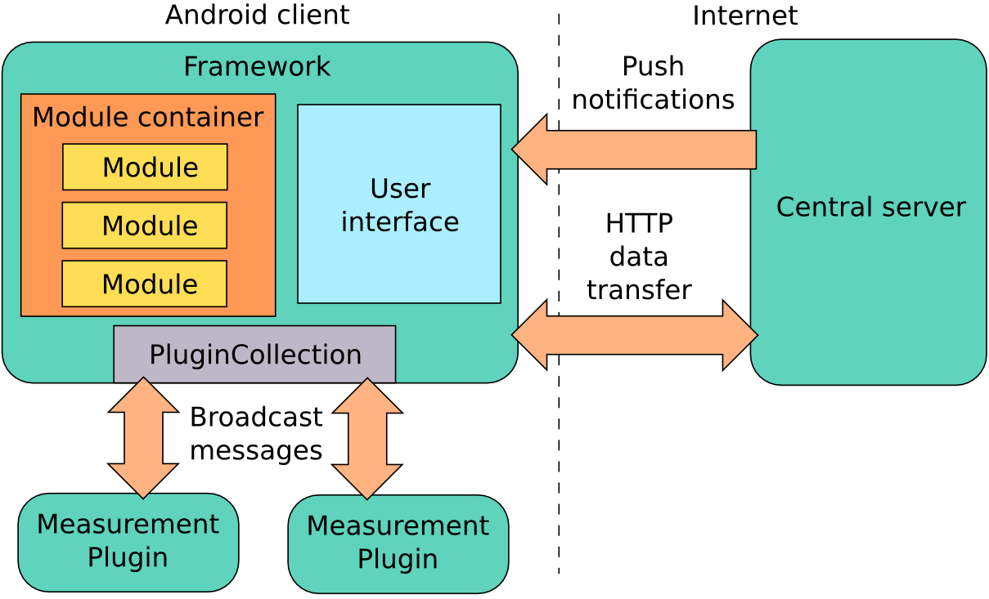
The central component of our application is called Framework. It acts as a message relay between the other components, and it also presents the graphical user interface on the smartphone, where the status of the components and the measurements can be monitored.
The Plugins are applications that need to be installed separately from the Framework. These applications perform the measurements themselves, and report their results via the Framework. The advantage of this design is that the Framework doesn't need access to any special resource on the phone, instead, the individual Plugins are the ones that ask for permissions and handle the data themselves. This not only improves security, but also helps achieve better scalability and makes distributing software updates much easier.
The Modules are the components that are supplied by the actual users of the Droidlab system: the researchers who want to conduct measurements on the testbed. The modules are program snipplets that are run by the Framework, and define the process of the measurement, the required resources, and the conduct the data collection.
In the following sections the detailed description of these components and their interactions will be presented.

Modules
Initially we planned to include a Lua inperpreter in our Framework, and accept the Module codes as Lua scripts. Lua is a small programming language intended for embedding in other applications, providing a way of extending functionality via scripting. It is easy to learn, yet it provides powerful features such as automatic garbage collection, sophisticated string manipulation, full support for functional programming, and a prototype-based object model similar to JavaScript. Lua is widely used in the videogame industry, because it enables rapid development of game logic and scripted events. This solution would give us excellent sandboxing and supervising of the untrusted code handed to the Droidlab testbed from external sources. Unfortunately, we had to abandon this plan in the first phase of the development due to our limited manpower. In the current implementation the Framework accepts modules as Java code that doesn't use Android-specific calls, just communicates with the Framework. In our SDK we provide an abstract interface for module developers, which will be publicly available.
The Java Archive (JAR) files containing the modules can be created with the standard Java Development Kit (JDK) and the Android SDK. We automatize the build process with our own ant script, which reads the module-specific paths and file names from a configuration file. In the future we plan to add module compilation capability to the central server of the Droidlab project, where the researchers can simply upload their Module in source code, which is than automatically compiled, and distributed to the client devices. The server will check the uploaded code for malicious behavior, and reject code that tries to call blacklisted interfaces, use system resources directly, or tries to circumvent the limitations imposed by the Framework, for example starts new threads or registers new event handlers. We are still evaluating whether this code verification or the transition to Lua would be the better choice in the long run.

Validating modules
The main purpose of checking the modules is protecting the users of the participating devices. A module can violate the privacy of the user or exhaust the resource of the device either deliberately or due to a programming error. Deliberate attacks can target the data of the user or the resources of the phone in several different ways, or they can generate excess network traffic, initiate phone calls, send SMS messages etc. The programming errors may produce similar unwanted effects, but additionally an unintended endless loop can also exhaust the computing capacity of the device.
To avoid such attachs the Droidlab server analyses the uploaded source codes before compilation. During compilation only the interfaces supplied by the Framework and the standard Java libraries are available; thus, any code that tries to use Android-specific code will fail to compile. The standard Java libraries are also limited to java.lang, java.util and java.math packages, and threading is forbidden.
The Java language provides runtime discovery of object types and their capabilities through the reflection framework. Only by completely disallowing this framework can we guarantee that a module cannot access forbidden interfaces and objects. As the normal operation of the modules doesn't require the use of the reflection framework, the module developers are not hindered by the removal of this. The list of allowed functions and libraries may extend in the future, but according to our experience the current list is sufficient for developing any problems that may arise when developing a module.

Operation of the modules
A module may keep persistent state, but it needs to assure that its data is correctly preserved between runs. The framework unloads the measurement modules when the phone is turned off, and reinitializes them when the phone is switched back on. The framework supplies four interfaces to the modules, which help its operation:
- PluginCollection: through this interface the installed resource plugins can be enumerated, and their data queried
- Preferences: this is the persistent data storage where the module can place its data, which are not yet ready to be sent to the result collection server; the Preferences supplies isolated space for each module
- Logger: modules can write results collected while running the module, for example debug information; developers can access the messages written to the Logger separately for each device the module ran on
- Timer: this allows the module to set periodic or single use delayed callbacks; the registered callbacks are not persistent, when the application is stopped or the phone is turned off, they are completely forgotten, and need to be re-registered if desired

Communication between the modules and the plugins
As all modern operating system, Android separates applications from each other with the use of virtual memory, guaranteeing that the applications cannot access each other's data. This separation is provided by the Android Application Sandboxing (AAS) technology as follows:
- Android is based on Linux, which is a multi-user operating system, Android runs each application as a separate user
- By default the operating system generates a Linux user ID for each application. This UID is only known to the system, and all system resources are set to disallow access from other users
- Every application runs in a different Java virtual machine, which guarantees that they are completely isolated
- By extension of the previous, every application runs as a separate process. The process is started along with the application, and can be ended in tow different ways: either the application stops running, or the operating system needs to allocate memory for an other task, and unloads a process to free more memory
In our system we run the plugins as separate processes, but the framework instantiates the modules as part of its own application. To facilitate the communication between the plugins, and the modules running in the framework we needed to use an inter-process communication method provided by the Android operating system. This separation has multiple advantages:
- There is minimal dependence between the components of the system
- The development of the components can be separated in both time and space
- Each component has its well-defined responsibilities; thus, the components can be developed faster and by combining multiple plugins the module developers may achieve higher-level tasks
We compared the IPC mechanisms available in Android to find the most appropriate one for our purposes. The ones available are:
- AIDL (Android Interface Definition Language): this is a statically compiled Java interface between applications, where a message passing framework acts behind the scenes. The two applications need to implement a shared interface that is automatically generated from an XML descriptor file
- LocalSocket: this is analogous to normal networking sockets, but it operates within a single computer. One application opens a socket and listens on it, while the other can connect to it and then they can send and receive messages using the standard networking API. This communication is always confined within the device
- Broadcast messages: this is an Android-specific message broadcasting scheme. The sender creates a so called Intent, which is then sent with the specified message type. Any application can receive such Intents, if it subscribes to the appropriate message type
We measure the latency of each IPC mechanisms, and we found that broadcast messages were by far the fastest among the three, and it produced the smallest delay fluctuation (jitter). The measurement used two applications, one sent a message to the other, which replied with an other message. The first application simply measured the time between sending its message and receiving the answer.
The BroadcastReceiver API not only provides good latency, it is also very easy to use. An Intent can contain an arbitrary number of key-value pairs; thus, it is suitable for implementing any protocol we want.
The communication between the framework and the plugins must not only be fast, it must also be secure. We cannot allow rogue applications trick the framework into believing that they are legitimate plugins, and we must also prevent evesdropping and man-in-the-middle attacks against our communication. This is especially important if we want to recruit users to join our testbed with their smartphones. The Android system ensures integrity check on the broadcast messages automatically, we only need to implement encryption and MitM protection.
We can avoid MitM attacks, if we use a secret identifier as the type of the Broadcast messages, because only the applications that are subscribed to the correct message type receive the messages. If this identifier is only known by the framework, and the plugins we developed, no other applications will be able to receive these messages. Starting with Android 4.0 (Ice Cream Sandwich) it is possible to use Broadcast messages as targeted communication.
It is not possible to encrypt the Broadcast message itself before sending, but we can encrypt the data we write into the key-value pairs with an appropriate cypher. As these ncryption mechanisms tend to be quite computation-intensive, it might be advantageous to only encrypt the values, but not the keys.
The communication between the Modules and the Plugins is proxied by the Framework. The modules can use the PluginCollection interface of the Framework to communicate with the plugin they intend to get information from. The PluginCollection creates a PluginAdapter object for each discovered plugin, and these provide the necessary communication primitives.
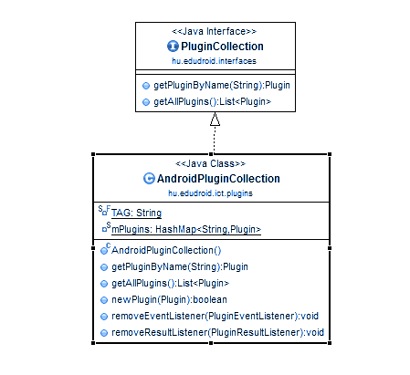
The PluginAdapter has the following interface:
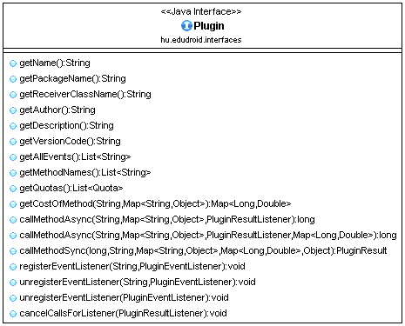
This interface supports two kind of communication schemes: the query-reply and the subscribe-notify schemes. Both of these methods are asynchronous, which might be unfamiliar to some of the module developers, but this cannot be avoided for performance reasons.
In the query-reply scheme only the module that initiated the query will be notified about the result, and only one reply is generated for each query. If there is no reply for a query for a long time, the Framework marks the given Plugin as invalid. In this scheme the Plugin subscribes to an Intent type, and the Framework sends the appropriate Broadcast message in behalf of the Module. The reply is delivered in the same fashion.
In he subscribe-notify scheme the events are generated in the Plugin, and sent to the Framework, which hands them over to all subscribed Modules. This scheme doesn't allow automatic detection of a faulty Plugin, unless a supplementary heartbeat mechanism is implemented. The subscriptions are not persistent, when the Framework is restarted, all Modules need to subscribe to the events they wish to be notified about. This communication scheme is one-way: the Framework subscribes to the Intents generated by the Plugin, but no reply is sent.
Both query targets and subscribed events are identified with a name, which is a human-readable string. This is probably less effective than using numeric identifiers, but it makes adding new Plugins and new events much easier.

Developing Modules
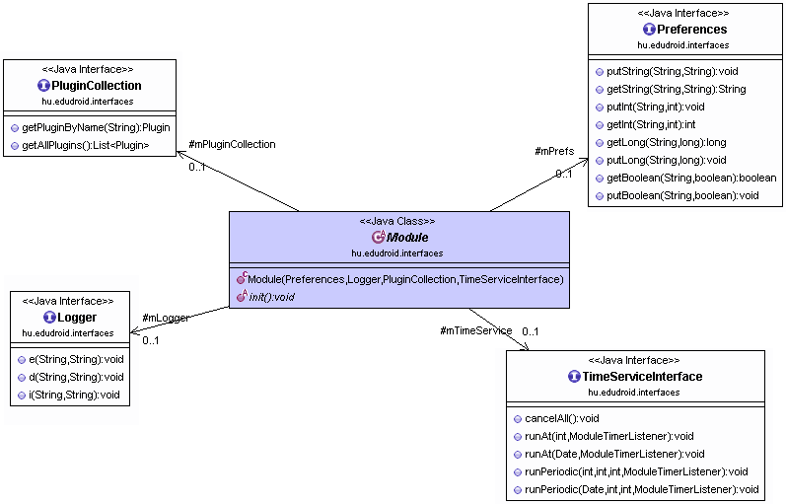
The modules usually don't need complicated logic, because they simply gather measurement results. There are three typical use cases for a Module:
- Active measurement: this module conducts measurements on the network by sending and receiving packets to a network node, and analyzes the latency for example. This can be implemented as a module, which only uses one networking Plugin, but in the future we might implement a specialized Plugin for this use-case, and then the Module only need to set the parameters of the measurement, and subscribe for the results
- Protocol implementation: this module implements an experimental networking protocol, most likely designed for distributed systems. In this case the Modules running on different devices communicate with each other, gather performance data, and send it to the server
- Monitoring: this module only does passive measurements, typically running periodically. After an appropriate preprocessing the results are sent to the server

Currently we enforce that the module must be consisted of a single Java class, which is inherited from ModuleBase. Its init() method initializes the module, reads the persistent state from the Preferences, subscribes to the appropriate events, and possibly starts timers.
The receiver methods are called by the Framework when an event arrives, and the run() method is called when a timer is expired.
At every state change it is advised to save it to the persistent storage to prevent data loss. The Logger collects text output from the Module, it is write only from the Module's point of view.
Additionally to the Java class, the modules also need to have a descriptor file that specifies the dependencies, the scheduling and the permissions of the Module. The ModuleDescriptor is a JSON-formatted file generated by the server from the instructions supplied by the researchers and the resource allocation system, the Framework downloads it from the server, and processes it before running the Module. In the final release the descriptor files will be digitally signed to provide integrity verification.
The ModuleDescriptor also contains the meta-data needed for running the Module: the name of the class, the permissions approved by the server, the Plugin dependencies (with required minimal version numbers), the resource quotas, and the measurement scheduling.
The users of the devices are also notified about the measurement Modules running on their devices, and they can also disable Modules if they don't want to participate in some measurements. In the future we want to extend range of possibilities with an option to request participation in selected measurement projects. The following information is available for each Module: its name, a short description, the name of the researcher or the institution, and an URL to the homepage of the research project.

Plugins
As explained earlier, the Plugins are separate applications running independently from the Framework. They need to be installed separately, which allows control for the owner of the device over the types of data shared with our measurement framework.
The installed Plugins respond to the broadcast intent sent by the framework, informing it about their name, description and the available methods. The PluginCollection creates a PluginAdapter for each discovered Plugin. The running modules can call the methods on these PluginAdapter objects to communicate with the Plugins. The PluginAdapter verifies the validity of the requests before sending the messages to the Plugins.

Developing Plugins
We developed a skeleton Plugin that contains the bare minimum code that a Plugin needs during its lifecycle. This skeleton can be copied into a new project when starting the development of a new Plugin, and one only needs to add the necessary functionality. If a Plugin only contains synchronous methods, it is sufficient to implement the PluginCommunicationInterface, and extend it with the desired application logic and measurement apparatus.
When an Intent containing a method call arrives from the Framework on behalf of a Module, the PluginCommunicationInterface reads the parameters and hands them over to the callMethodSync() method. The program logic implemented by the developer of the Plugin must interpret these parameters at this point, and perform an appropriate reaction. If this method only perform synchronous calls, its return value is sent back to the Framework by the PluginCommunicationInterface in the broadcast Intent.
It is also supported to use asynchronous tasks in callMethodSync(), if the required information needs to be gathered first. In this case the method must throw an exception called SyncMethodException, which cancels the returning of an Intent. After the information is gathered, and it is ready to be sent back to the Framework, the generation and sending of the intent are the responsibility of the author of the Plugin.
If a Plugin contains asynchronous methods, those should be implemented in the constructor of the IntentService class supplied by Android, because starting new threads is not possile in a PluginCommunicationInterface. This limitation stems from the architecture of this interface, as it starts its lifecycle as a BroadcastReceiver. To help creating the reply Intent the PluginCommunicationInterface supplies a static method, but calling it is the responsibility of the developer of the Plugin.

Basic Plugins
We evaluated the possible use cases of our Droidlab testbed, and determined the list of Plugins that are necessary for building a versatile measurement platform that will attract a wide user base in the scientific community. As the architecture is modular, the functionality of these Plugins may be extended at any time, and new Plugins can be added on demand. The list below contains the initial set of Plugins we intend to ship the Droidlab testbed with.

Clinet core
The core is the central component of the client part of Droidlab. It controls the other components installed on the smartphone, and communicates with the server: it downloads measurement Modules, and uploads the measurement results. The Framework enforces the security restrictions, measures the resource usage, and handles the resource quota. Presenting a user interface is also the responsibility of the Framework, however, we plan to allow the individual Plugins to have their own user interface.

Module handling
The module manager consists of two main components. The component communicating with the server is responsible for downloading the measurement Modules the phone needs to run when the network connection is sufficient. The modules arrive as a description in JSON format, and a compiled Java code in a JAR package. These are downloaded from the server, and saved into an appropriate folder on the phone. Currently we use the Google Cloud Messaging (GCM) service to notify the participating phones about the availability of a new Module. As the Android phones use GCM for the Google applications, it doesn't add extra load, and the development effort was minimal. After the phone has been notified via GCM, it downloads the specified packages using HTTP.
The other component of the module manager is responsible for finding the downloaded modules in the target folder, reading their descriptors. If a module is valid, and needs to be run, the module manager loads its code, and initializes it.
During development we allowed direct module upload to the phone by simply copying the appropriate files into the target folder, but in the release version this option will be disabled for obvious security reasons.

Monitoring modules
We had two options for implementing capabilities in the Framework to overwatch the activity of the modules. One is to use an embedded interpreter and write the modules in a script language, while the other is to accept the module code as a Java source file and automatically check it for malicious behavior.
For the scripting language Lua seemed to be the most obvious choice. It was designed specifically for adding scripting capability to applications, it offers excellent sandboxing features, and it's easy to extend with task-specific libraries. We ended up not using it for two reasons. One is that this language is not well known in the scientific community, during our demand survey we found nobody who knew it. The other was a technical problem: we found no good implementation of it on the Android platform. We also thought of using JavaScript, as it is a widely used language, and several implementations are available for Android. One such implementation is the WebView component of Android, which allows JavaScript code in the HTML documents it handles, but we might not be able to sandbox it properly. An other possibility is to use a JavaScript interpreter written in Java, like the Rhino project developed by Mozilla. As it is open source, we could have tailored it to our needs, but we didn't have enough manpower to realize this plan. In the end we decided to accept the Modules as Java source code, and run a static analyser to enforce our restrictions on it.
The researchers thus upload their module code to our server, and the server compiles it after preprocessing. The preprocessing is a lexical analysis that produces a syntactic tree, and we analyze this tree with pattern matching to find forbidden elements. If this analysis passed without error, we add performance monitoring code pieces to specific points, and hand over the result to the actual compiler. The added code pieces add semaphores that check for the CPU utilization of the code, and verify that it's within the limits imposed by the quota. If the quota is exhausted, the thread running module is put into a sleep state for a short time.

Uploading measurement results
The system doesn't collect the output of the Plugins, just the data generated by the Modules. The Modules use the Logger framework to output their measurement results, which allows the researchers to interpret the data in context. The Logger framework collects the submitted logs, and transmits them to the server as a batch when the time is appropriate.
The Logger supports several different categories and importance levels that help the researchers categorize the different messages generated by their Module. The Logger stores the acquired log messages persistently to avoid losing precious measurement results. This effectively means that the data is written into files on the storage space of the phone. Periodically a new file is started, and the closed files are sent to the server compressed.

Quota system
The resources of a mobile device can be divided into three categories:
- Communication resources: SMS, MMS, phone calls, IP traffic over cellular network impose cost on the user, because billing is based on traffic; thus, it is important to minimize their usage
- Energy: high-performance smartphone hardware draw lots of power, and a full charge of the battery often lasts for only a day; thus, our client application needs to minimize its power consumption by doing as little computation as possible, and conserving the usage of power-hungry peripheral, such as GPS and WiFi.
- Storage: although the storage space is not painfully limited on smartphones, we decided to impose storage quotas on the Modules to avoid excessive amounts of data written to the storage, which adversely affect the lifetime of the solid state storage
Quotas are by their nature very specific to the devices; thus, they are measured and limited at the Plugins, because those are the components that directly access those devices. The quotas themselves are specified by the Plugins, and reported to the Framework. On the other hand a Module uses resources by simply running for too long. To avoid excessive processor usage by the modules either for malicious intent (BitCoin mining, botnet forming) or simply due to a coding error (infinite loop, infinite recursion) we monitor the processor usage of the Modules, and insert sleeps or terminate their threads.
Monitoring the processor usage of the Modules was a challenge, because the Android SDK provides poor support for such tasks. We opted to use the capabilities of the underlying Linux kernel for this purpose. Although Linux provides a wide range of monitoring capabilities, most of them are not available in the version used by Android. Several Linux system utilities are available for obtaining information about the state of the processes, for example “top” and “ps”. These utilities read their information from the proc virtual file system, which contains various data about each process in the system, and even some information about the state of the Linux kernel. On Android this virtual file system is readable by normal applications.
The proc file system contains a folder for each process, the name of this folder is the numeric process identifier (pid). Android supplies an interface to match pids and applications. The information we need about the processes are contained in the following files:
- /proc/uptime: it contains two numbers, the first is the number of seconds elapsed since the startup of the system, the second is the number of seconds the system was idle during that time
- /proc/[pid]/task: this folder contains information about the threads of the process identified with [pid], the folder contains folders for each thread, named as the thread id
- /proc/[pid]/stat and /proc/[pid]/task/[tid]/stat: contains a series of numbers that provide information about the process/thread, we are interested in three of these numbers:
  - utime (14): the time the task was running in user mode
  - stime (15): the time the task was running in kernel mode (during system calls)
  - starttime (22): the time when the task was started (seconds since boot)
After this information is acquired about the thread running the Module we want to monitor, we can calculate its processor usage with the following formula:
On modern, multi-core devices which use advanced power management functions to extend the battery life the numbers extracted as described above are not accurate, but they are still a good estimate of the power usage of a Module.

DroidLab server
The DroidLab’s server is a J2EE application running on the Goolge App Engine platform detailed earlier. The backend consists of three main areas: a researcher portal, a user portal and the application backend. The three components are strongly interconnected through shared data. We could have chosen a service oriented architecture to separate the three components but the time limitation and the future refactoring due to the integration to the OneLab portal made us choose the easier, integrated solution.

Application backend
The Android client uses several services. Some of these services are required for the proper operation of the measurement system. Another part of the services is responsible for providing data to the user.

Core services
Core services have been created to handle the basic tasks required for the measurements to work properly.
The device management service lets new users register to DroidLab. While user authentication is not required for the measurements to work properly, a user account is needed for the user to be able to review her contributed data online and to receive the badges that she achieved while using the system. Each user and device has a single record in the AppEngine datastore. This approach minimizes the cost of data storage of the user and managements. These records contain the devices actual state, the user’s credentials and profile, and a snapshot of badge and achievement progress. Registration, login and device management services use and update these records in order to provide session management to the client and the backend.
The most used core service is the data receiver service. For the pilot run, data is uploaded to the server record, and stored in the datastore. While this is a very expensive solution it allows for a more comprehensible demonstration of the system. We have prepared a more cost efficient batched upload solution as well, which compresses several records on the client side and uploads the resulting zip file to the server. The server stores the received file in the blob store, and creates a reference in the datastore that contains the metadata for the upload. This facilitates the retrieval of the file for the researchers and users.
The measurement distribution service is not yet ready. For now measurements can be assigned to the registered devices through an admin UI. The measurements are than pushed to the device through the measurement publication service.

Meta data services
Contrarily to the initial approach where we designed the system for a passive user, the current implementation promotes user choice. To provide background information to these choices, a large amount of meta data is available through services. The client application can provide a list of available plugins with download links and user rating. Information.

User portal
While the users can access every feature of the framework through the mobile app, we plan to develop a user portal for the framework as well. The goal of the user portal is to provide a landing page for new users, display legal and technical information, and provide detailed user profile for the users. This portal will display the gamification elements of the framework, the leaderboards, the badge and achievement statistics and explanations.

Researcher portal
The researcher portal is the entry point of the system for researchers. The researcher portal is in design phase, but will be one of the priorities for the next semester. The researcher portal will provide access to the testbed’s resources to the researchers. It will handle measurement requests, schedule measurements and maintain a profile for the researchers based on their prior history and reviews of their measurements. These profiles will constitute a quality assurance for the users when they will have to decide whether to run or reject the measurement that was assigned to their device.
The researcher portal will also allow the researchers to review the results and statistics of their running measurements, in order to terminate it or apply for more resources.

Conclusion
With the radical increase in the number of Android smart phones, the number of application developers has also steadily grown. Lots of useful and useless Android applications emerge constantly, some of them become very popular, almost independently of their usefulness, while others don’t. Writing and testing an application that runs in parallel on a number of mobile devices and builds on the cooperation of several users is usually not an easy task on its own. In addition, the right incentives should be found to convince a critical mass of users to install and run the application to be tested, which is sometimes even harder than writing the application itself.
DroidLab is being developed to handle exactly these problems. Application developers can upload their code on a large-scale Android testbed, run their experiments, test their algorithms, and gather the results in a straightforward way. On the other hand, users who are willing to install the DroidLab framework on their personal smartphones will have the possibility to control and monitor the resources consumed in the background, their interaction will not be needed, but their security and privacy will be ensured, thanks to the sandboxed approach used in the implementation of the framework.
Mobile crowd-sensing applications are the perfect targets of DroidLab, as we analyzed throughout this paper. However, other application scenarios can also be envisaged. Being developed as part of the FITTING European project, DroidLab intends to be part of a federated global test environment, next to infrastructures such as PlanetLab and SensLab, providing a leap ahead in the development of applications and services running in the heterogeneous environments of the Future Internet.

References
[1] Creekwatch, http://creekwatch.researchlabs.ibm.com/, July 2013.
[2] Global mobile statistics 2013, http://mobithinking.com/mobilemarketing- tools/latest-mobile-stats/a, July 2013.
[3] Google labs’ Open Spot: A useful application that no one uses, http://www.androidauthority.com/ google-labs-open-spot-a-usefulapplication- that-no-one-uses-15186/, July 2013.
[4] HopStop, http://live.hopstop.com/, July 2013.
[5] MrNumber, https://play.google.com/store/apps/details? id=com.mrnumber.blocker, July 2013.
[6] Per-capita app download rates show where mobile growth is heading, http://au.businessinsider.com/comparing-app-downloadsacross- countries-2013-6, July 2013.
[7] Root metrics project page, http://www.rootmetrics.com/, July 2013.
[8] Waze app home page, http://www.waze.com/, July 2013.
[9] Wifi Finder, https://play.google.com/store/apps/details? id=com.jiwire.android.finder, July 2013.
[10] Murat Demirbas, Murat Ali Bayir, Cuneyt Gurcan Akcora, and Yavuz Selim Yilmaz. Crowd-sourced sensing and collaboration using twitter. Engineering, pages 1–9, 2010.
[11] Jakob Eriksson, Lewis Girod, Bret Hull, Ryan Newton, Samuel Madden, and Hari Balakrishnan. The Pothole Patrol : Using a Mobile Sensor Network for Road Surface Monitoring. 2008.
[12] Deborah Estrin. Participatory Sensing: Applications and Architecture. IEEE Internet Computing, 14(1):3–4, 2010.
[13] Aakar Gupta, William Thies, Edward Cutrell, and Ravin Balakrishnan. mClerk : Enabling Mobile Crowdsourcing in Developing Regions. pages 1843–1852, 2012.
[14] Nicolas Haderer, Inria Lille, Nord Europe, Romain Rouvoy, and Lionel Seinturier. A preliminary investigation of user incentives to leverage crowdsensing activities. 2013.
[15] Jeff Howe. Crowdsourcing: A definition. Crowdsourcing: Tracking the rise of the amateur, 2006.
[16] A Jeffrey, J Burke, D Estrin, M Hansen, A Parker, N Ramanathan, S Reddy, and M B Srivastava. Participatory Sensing. 2006.
[17] By Eric Korpela, Dan Werthimer, David Anderson, Jeff Cobb, and Matt Lebofsky. SETI @ HOME M ASSIVELY D ISTRIBUTED C OMPUTING FOR SETI. pages 78–83.
[18] Artis Mednis, Girts Strazdins, Reinholds Zviedris, Georgijs Kanonirs, and Leo Selavo. Real time pothole detection using Android smartphones with accelerometers. 2011 International Conference on Distributed Computing in Sensor Systems and Workshops (DCOSS), pages 1–6, June 2011.
[19] Emiliano Miluzzo, Nicholas D Lane, Krist´of Fodor, Ronald Peterson, Hong Lu, Mirco Musolesi, Shane B Eisenman, Xiao Zheng, and Andrew T Campbell. Sensing Meets Mobile Social Networks : The Design , Implementation and Evaluation of the CenceMe Application. 2008.
[20] Moo-ryong Ra, Bin Liu, Tom La Porta, and Ramesh Govindan. Medusa : A Programming Framework for Crowd-Sensing Applications Categories and Subject Descriptors. (Section 2):337–350.
[21] L. von Ahn. Games with a Purpose. Computer, 39(6):92–94, June 2006.
[22] Tingxin Yan, Matt Marzilli, Ryan Holmes, Deepak Ganesan, and Mark Corner. Demo Abstract : mCrowd - A Platform for Mobile Crowdsourcing.

Table of Contents
DROIDLAB 1
Rolland Vida, BME 1
vida@tmit.bme.hu 1
1 Overview of DroidLab 2
1.1 Focus and organization 2
1.2 Basic principles 2
1.2.1 Crowdsourcing 2
1.2.2 Crowdsourcing 3
1.2.3 Terminology 4
1.3 Related Work 5
1.3.1 Mobile crowdsensing applications 5
1.3.2 Mobile crowd sensing frameworks 6
1.4 Usecases 7
1.5 Architecture and operation overview 8
1.6 Challenges 12
1.6.1 Modularity 12
1.6.2 Security 12
1.6.3 Privacy 14
1.6.4 Seamlessness and resource management 15
1.6.5 Scaling 15
1.7 User Incentives 16
2 DroidLab implementation details 18
2.1 Platforms used in our project 18
2.2 Architecture of the DroidLab client 18
2.2.1 Modules 19
3 Conclusion 25
4 References 26

