# Evaluation Functions and Performances

1. eval_1: the difference of squares of own moves and opponent moves.

Balanced strategy which amplifies own and opponent moves exponentially. Weaker than ID_Improved.

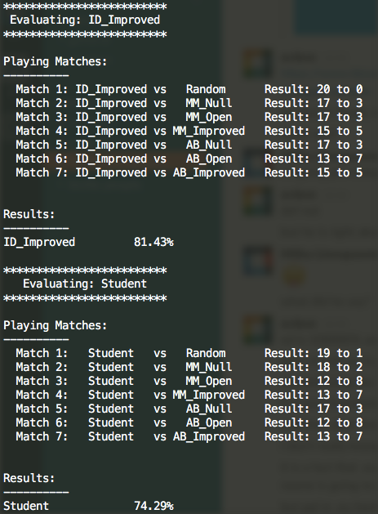

1. eval_2: own moves – 2 * opponent moves

a defensive strategy. Similar performance to ID_Improved.

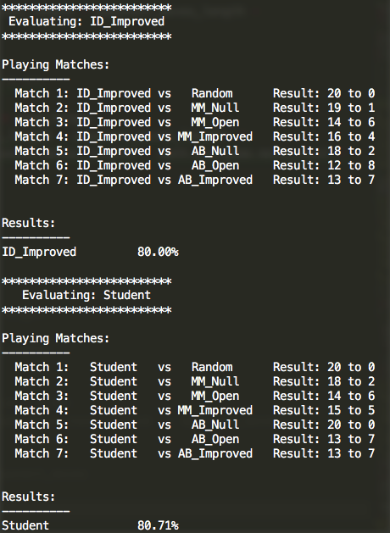

1. eval_3: own moves – opponent moves – move count

balanced strategy which prefers less game progression. A bit more performant than ID_Improved.

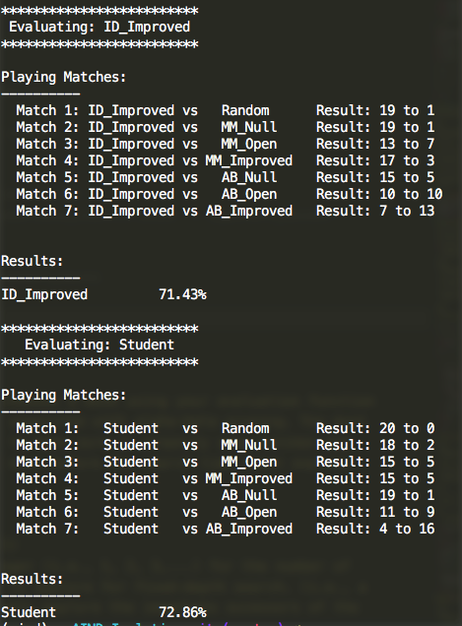

1. eval_4:

if move count few: own moves – opponent moves

else if move count middle: own moves – opponent moves – move count

else: move count high: own moves – opponent moves

hybrid strategy based on game progression. Initially balanced, then also considers game progression, but in the end returns back to pure balanced strategy. Weaker than ID_Improved.

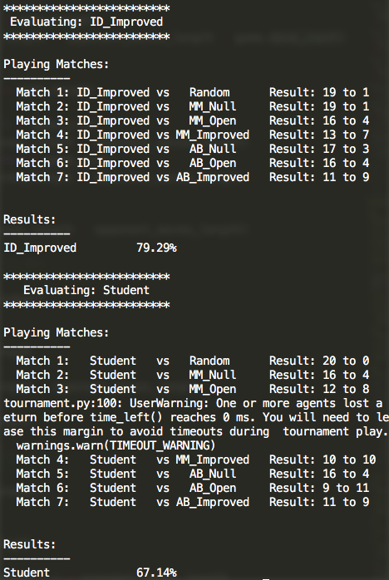

1. eval_5:

random selection, 40% own moves – opponent moves, 60% own moves – opponent moves – move count

hybrid probabilistic approach with combination of balanced and balanced with anti-progressive strategy. Weaker than ID_Improved.

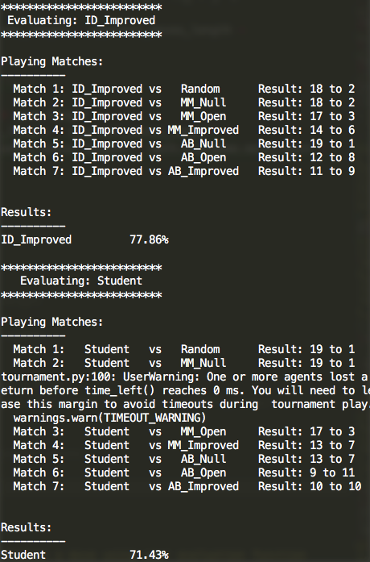

1. eval_6:

move count < 0.9 * game size: own moves – opponent moves

else: own moves – opponent moves – move count

hybrid strategy based on game progression. Until end of game balanced strategy. At the end anti game progression strategy. A bit weaker than ID_Improved.

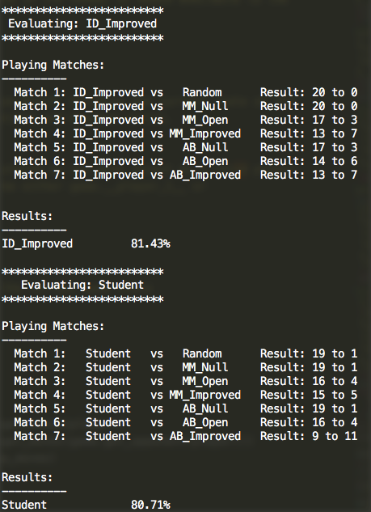

1. eval_7:

if move count < 0.1 * game size: own moves

else if move count < 0.9 * game size: own moves – opponent moves + move count

else move count: own moves – opponent moves – move count

hybrid strategy. This time initially try open strategy. Until end of the game pro game progression strategy. At the end anti game progression strategy. More performant than ID_Improved.

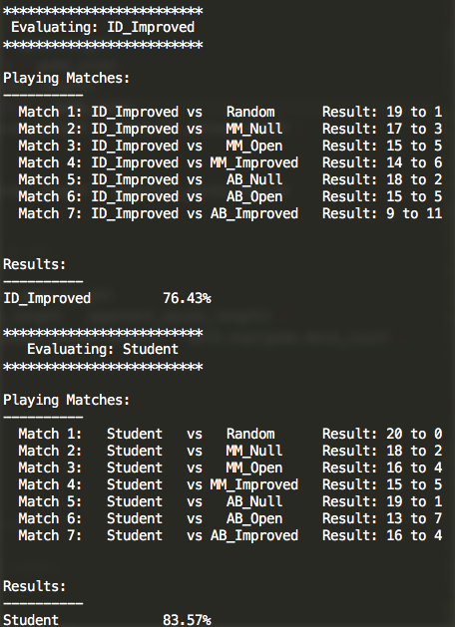

1. eval_8:

if move count < 0.1 * game size: own moves

else: own moves – opponent moves + move count

hybrid strategy. Initially open, then pro game progression strategy. More performant than ID_Improved.

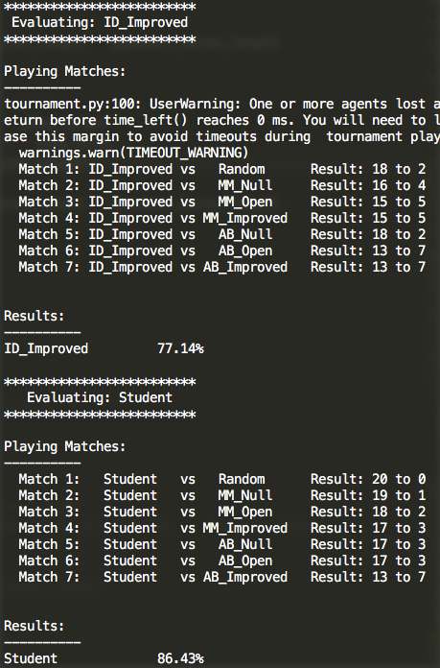

1. eval_9: own moves – opponent moves + move count

balanced strategy with pro game progression approach. Remarkable more performant than ID_Improved.

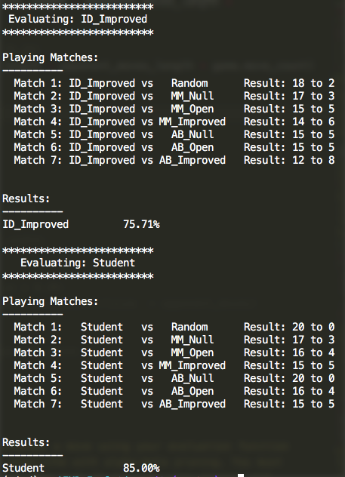

1. occupancy * (own moves – opponent moves ) + move count

balanced strategy combined with occupancy and pro game progression approach. More performant than ID_Improved.

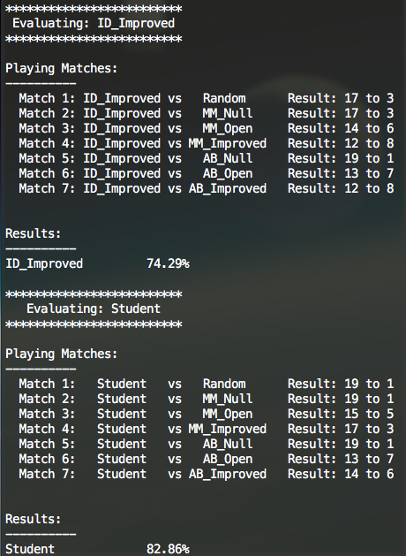

1. occupancy * (own moves – (2 * occupancy) * opponent moves ) + move count

hybrid strategy combined with occupancy and pro game progression approach. Adaptive offense/defense according to occupancy. Initially offensive, but then defensive approach. More performant than ID_Improved.

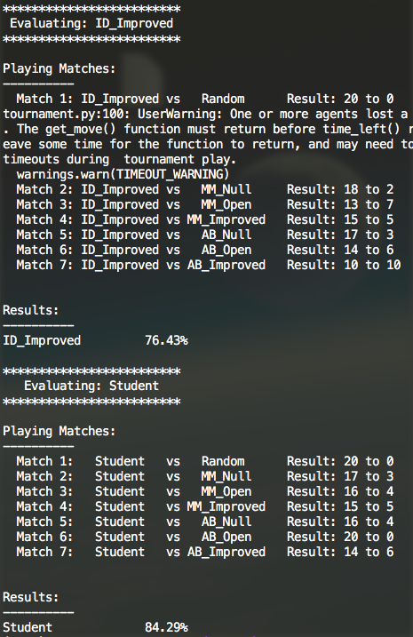

# Recommendation for Evaluation Function

eval_9 is the winner of all. As seen in eval_7, 8, 9, 10 and 11 the pro game progression approaches ( + move count ) are clearly more performant. Balanced strategy also performs better than aggressively offensive or defensive strategies. Random and probabilistic approaches lead to weaker results as seen in eval_4 and 5.

Hybrid approaches do not necessarily always improve the results as seen in eval_5, 6 and 11.