Group 5

Nicholas Bushnell - Eva Dukerschein - Samuel Litton

Outland Adventures

MILESTONE 2:

ERD version 2:

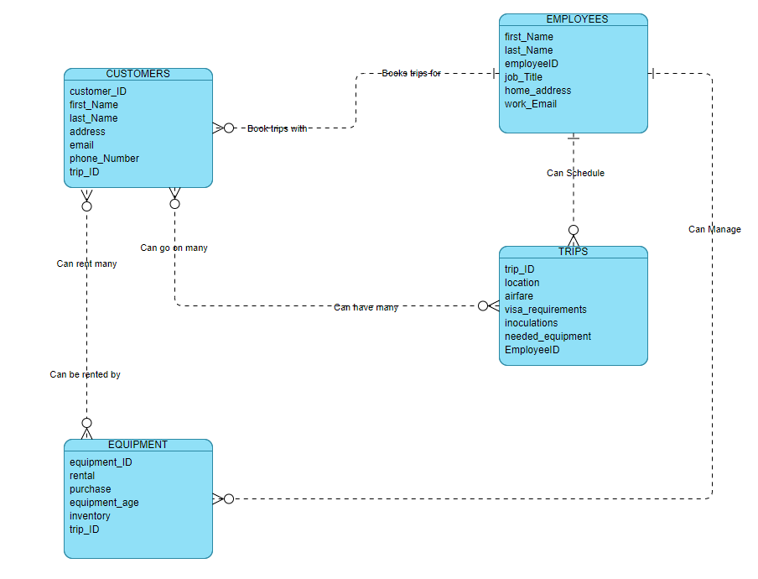

"user": "outland_user",

"password": “adventure",

"host": "127.0.0.1",

"database": "outland_adventures",

"raise_on_warnings": True

DROP TABLE IF EXISTS customers;