Eva Dukerschein

DevOps

7/21/2024

Assignment 10.2: Shared Code Repository

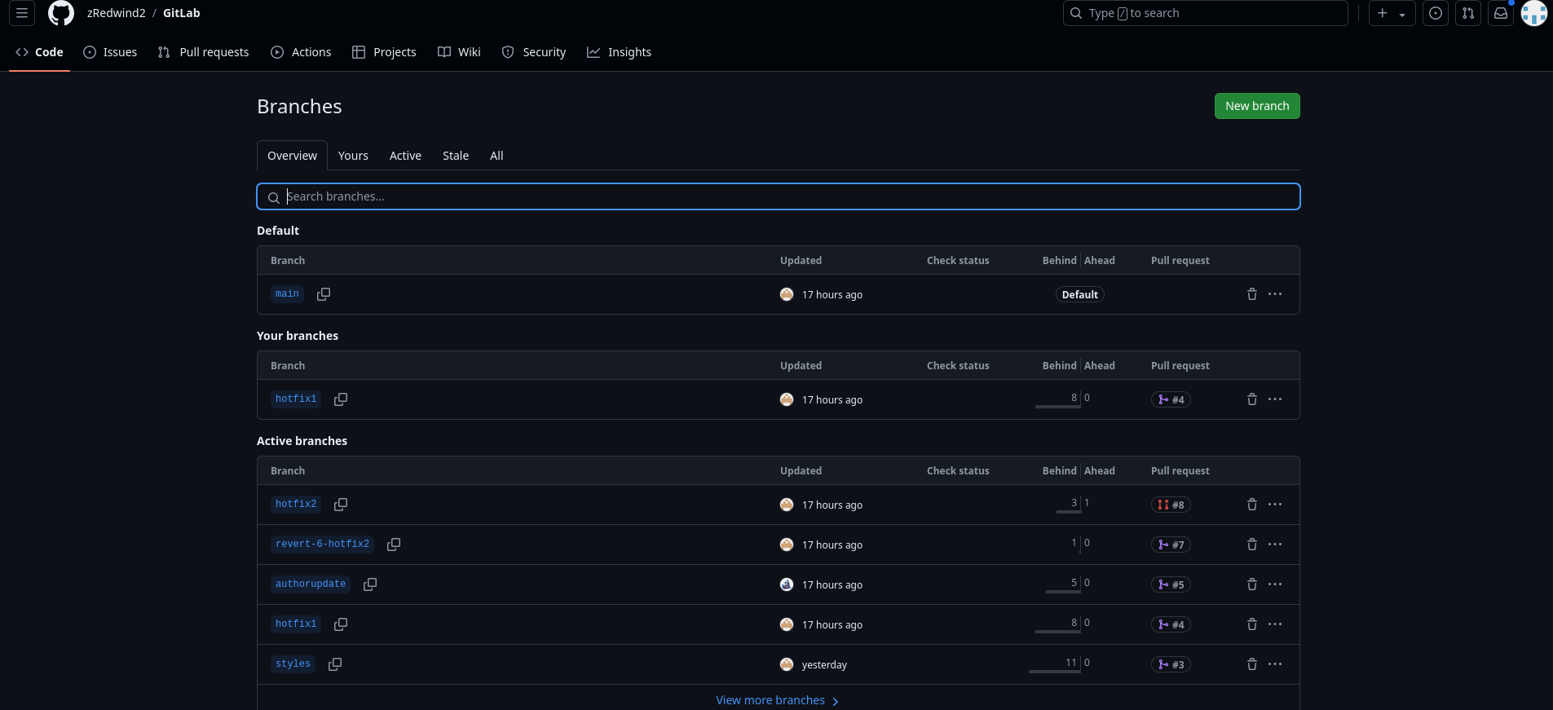

Link: <https://github.com/edukerschein/csd-380>

User name: edukerschein