An alert on the recent fall of the fiscal reaction in Brazil

Um alerta sobre a recente queda na reação fiscal no Brasil

Eduardo Lima Campos[1]  
Rubens Penha Cysne[2]

Resumo - Avaliações recentes de como o superávit primário do governo brasileiro reage à evolução da relação dívida/PIB transmitem duas mensagens importantes (e preocupantes): em primeiro lugar, a função de reação fiscal vem diminuindo quase constantemente desde 2012. Em segundo, passou de positiva para negativa a partir de outubro de 2017. Com taxas de juros reais efetivas (sobre a dívida pública líquida) maiores do que as perspectivas de crescimento do PIB, os números negativos para a função de reação fiscal significam uma trajetória não sustentável da dívida. Portanto, ajustes fiscais significativos terão que ser feitos no curto prazo.

Palavras-chave: Brasil; dívida pública; reação fiscal; sustentabilidade fiscal; filtro de Kalman.

Abstract - Recent evaluations of how the Brazilian government’s primary surplus reacts to the evolution of the debt to GDP ratio convey two important (and worrisome) messages: first, the reaction function has been almost steadily decreasing since 2012. Second, it has turned from positive to negative figures as of October 2017. With effective real interest rates (over the net government debt) higher than prospects of GDP growth, negative figures for the fiscal reaction function mean a non-sustainable debt trajectory. Therefore, significant fiscal adjustments are required in the short run.

Keywords: Brazil; public debt; fiscal reaction; fiscal sustainability; Kalman filter.

JEL Classification**:** H 30, H 60, E 50.

Introduction

A usual debt-sustainability condition requires that the discounted sum of anticipated future primary surpluses is sufficient to pay off the debt. The use of statistical analysis is adequate in the evaluation of this condition for at least two reasons. First, future values of GDP growth and real interest rates are subject to uncertainty. Second, past data and past behavior somehow translate the institutional, legal and political conditions under which the control of public revenue and expenditures is to be achieved in the future.

One approach to investigating debt sustainability [Bohn (1998)] relies on the concept of a fiscal-reaction function, which establishes a relationship between primary surpluses and the debt/GDP ratio. The underlying idea is to assess if, and to what extent, fiscal revenues and expenditures react to the evolution of the debt/GDP ratio.

This paper draws on Campos and Cysne (2018) to investigate two specific issues. First, the fall of the fiscal-reaction function in the more recent period, leading to negative values of this coefficient as of October/2017; and second, the robustness of the results achieved Campos and Cysne (2018) regarding an alternative concept of government. The database is extended, relatively to Campos and Cysne (2018), to a different definition of government and to a more recent period.

We estimate the Brazilian fiscal-reaction function allowing for time-varying coefficients. The data covers the period from January 2012 to June 2018. The specifications follow the functional form proposed by Bohn (1998), while taking into consideration specificities of the Brazilian case.

The data indicates a non-sustainable public debt trajectory. As in Campos and Cysne (2018), we reject the constant-coefficients hypothesis for the Brazilian fiscal-reaction function for all the study period, reinforcing the relevance of applying time-varying coefficient methods.

On the remaining of this paper, the next section presents a general overview of the main variables used in the econometric procedures. The third section presents basic debt dynamic equations and define fiscal sustainability under some simplifying assumptions. Under the framework presented, debt sustainability requires the difference between the real effective interest rate – corrected for GDP growth - and the fiscal reaction coefficient to be negative. Since effective real interest rates accruing on the net public debt are clearly higher than the prospects of GDP growth, a negative fiscal reaction function, as obtained in the more recent period, indicates very clearly the non-sustainability of the present fiscal policy in Brazil.

The fourth and fifth sections presents, respectively, a detailed description of the variables used in the econometric model and the basic results. The last section concludes.

Data Overview

Figure 1 shows the evolution of the two main variables in the calculation of the fiscal-reaction function, the debt to GDP ratio and the primary surplus. A complete description of these variables is presented at the fourth section. In both cases, we extend the analysis presented in Campos and Cysne (2018) and work with two definitions of government: the “Consolidated Public Sector (CPS)” and the, so called, “General Government (GG)”. In Figure 1, PSND and GGND stand for the net debt, respectively, of the Consolidated Public Sector and of the General Government.

Figure 1. Primary Surplus/GDP x Net Debt/GDP

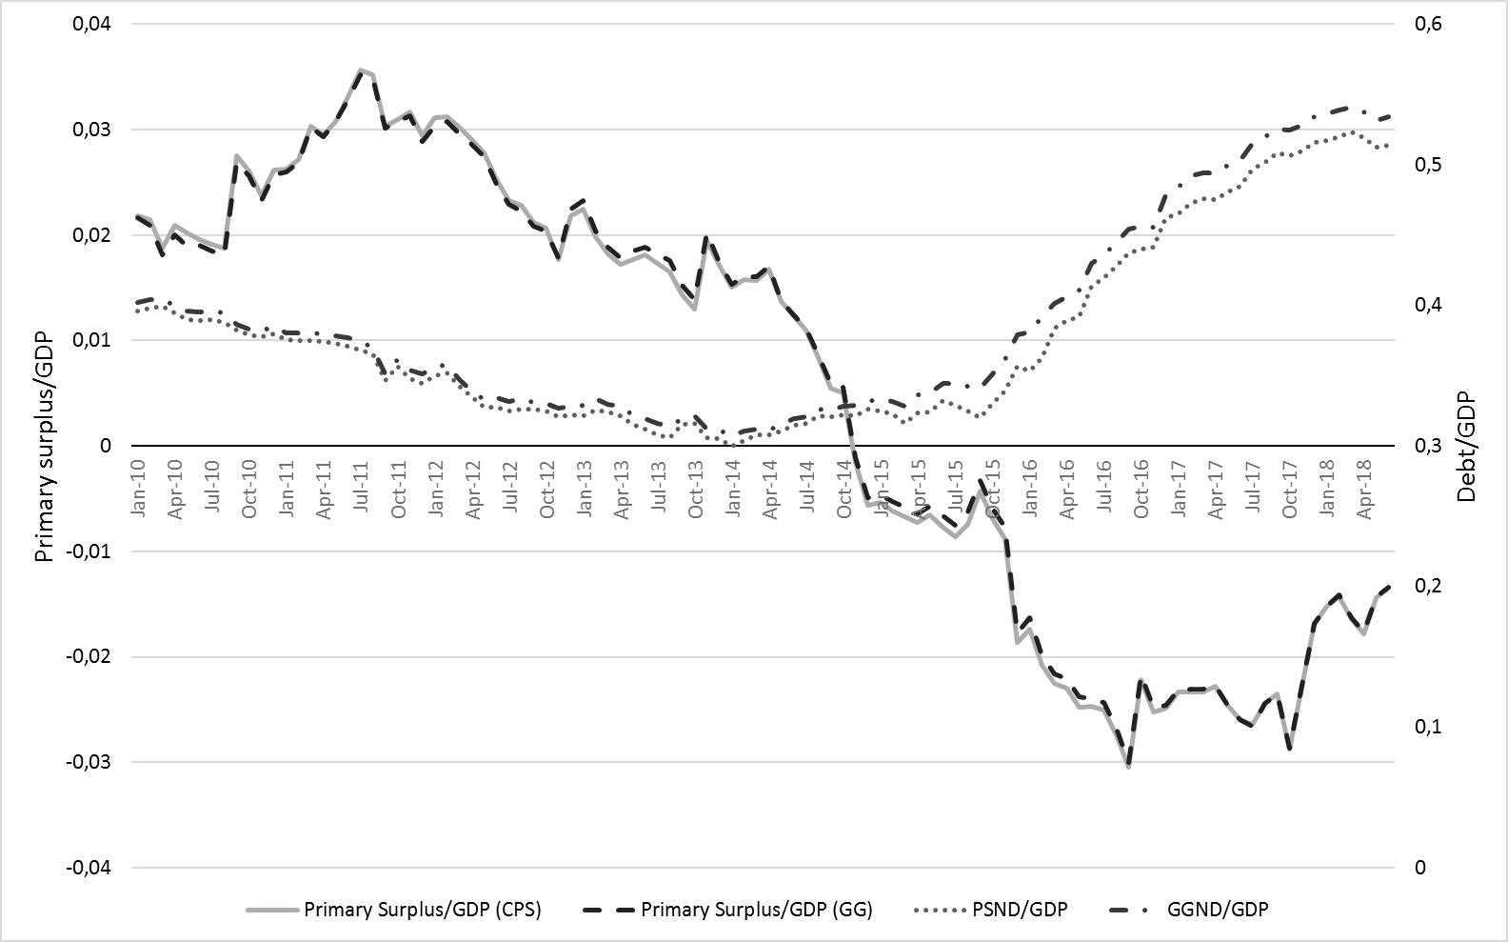

As one can note from Figure 1, the differences concerning the two definitions of government is practically immaterial for the variables considered. Very close results, therefore, should be expected from the empirical analysis under these two different sets of data.

The debt/GDP ratio shows initially a decreasing trend, and then an increasing trend as of January of 2014. The series change the sign of the correlation, as shown by the 48-month moving-average correlations below, in figure 2. The negative correlation of these two variables as of January 2015 is a hint about a possible change of sign of the fiscal-reaction coefficient. In order to have a sustainable debt/GDP ratio, one would wish a positive, rather than a negative statistical correlation between these two variables.

Figure 2 – Debt/GDP and Primary Surplus/GDP correlations (48-month moving window)

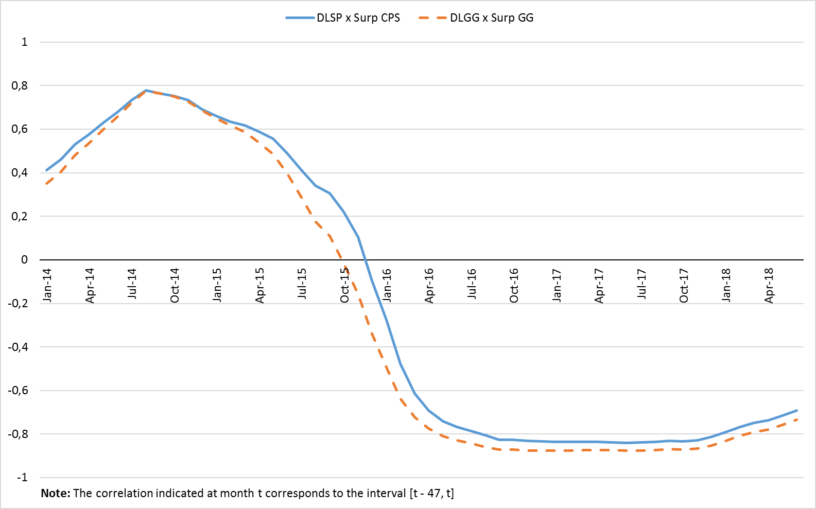

Debt Sustainability

This section draws on Campos and Cysne (2018) to derive a condition on debt sustainability in the present framework. It requires that the fiscal-reaction coefficient to be big enough to compensate for the positive difference between real-interest and GDP growth rates.

The government budget constraint, in nominal terms, is represented as follows:

|  |  |
| --- | --- |
| $$B_{t}=G_{t}-T_{t}+\left(1+i_{t}\right)B_{t-1}$$ | (1) |

where $B_{t}$ stands for net debt[3], for government's primary expenditures (consumption, investment and transfers, not including interest payments), $T_{t}$ are the primary revenues (tax plus other net current revenues) - all computed at the end of time $t$- and $i_{t}$ is the nominal interest rate, associated with a public security purchased at time $t-1$ and remunerated at $t$.

A public debt series or, accordingly, the fiscal policy associated with it, is characterized as sustainable if the present value of future surpluses is sufficient to offset the present debt value. To formalize this condition, the budget constraint in (1) must be solved iteratively for $t=1, 2, ..., T$ (it is considered, for simplicity, that $i_{t}=i ∀ t$):

|  |
| --- |
| $$B_{t}={\left(1+i\right)}^{t}B_{0}+\sum_{k=1}^{t}{{\left(1+i\right)}^{t-k}}(G_{k}-T_{k})$$ |

or even:

|  |
| --- |
| $$B_{0}=\frac{B_{t}}{{\left(1+i\right)}^{t}}+\sum_{k=1}^{t}{\frac{S_{k}}{{\left(1+i\right)}^{k}}}$$ |

Where $S_{k}=T_{k}-G_{k}$ is the primary surplus at $t=k$.

The condition for debt sustainability is:

|  |  |
| --- | --- |
| $$\lim_{t→∞}{\frac{B_{t}}{{\left(1+i\right)}^{t}}}=0$$ | (2) |

At (2), $B_{0}=\sum_{k=1}^{∞}{\frac{S_{k}}{{\left(1+i\right)}^{k}}}$, i.e., the discounted sum of primary surpluses at present value is equal to the current debt.

The following notation is now defined: Let $X$ be any variable (representing, for instance, $B$, $G$, or $T$), $Y$ be the GDP and $x=X/Y$. Divide both sides of (1) by $Y_{t}$ $P_{t}$, to obtain:

|  |  |
| --- | --- |
| $$b_{t}=g_{t}-t_{t}+\left(1+i_{t}\right)b_{t-1}\frac{Y_{t-1}}{Y_{t}}$$ | (3) |

Define the GDP growth rate as $θ_{t}$:

|  |  |
| --- | --- |
| $$Y_{t}=\left(1+θ_{t}\right)T_{t-1}$$ | (4) |

Use (4) in (3) and make $s_{t}=t_{t}-g_{t}$ stand for the primary surplus as a fraction of GDP to obtain:

|  |  |
| --- | --- |
| $$b_{t}=-s_{t}+\frac{\left(1+i_{t}\right)}{\left(1+θ_{t}\right)}b_{t-1}$$ | (5) |

Bohn (1998) establishes a fiscal reaction mechanism, defined as follows:

|  |  |
| --- | --- |
| $$s_{t}=ρb_{t-1 }+γX_{t}$$ | (6) |

where $X_{t}$ is a vector of control variables.

With the purpose of evaluating the sustainability condition for the simplest case, the parameters $ρ$, $i$ and $θ$ are considered constant[4].

Replacing (6) in (5)[5]:

|  |  |
| --- | --- |
|  | (7) |

Solving (7) iteratively:

|  |  |
| --- | --- |
| $$b_{t}={\left(\frac{1+i}{1+θ}-ρ\right)}^{t}b_{0}$$ | (8) |

Under the approximation $\frac{1+i}{1+θ}≅1+i-θ$, the debt sustainability condition implies:

|  |  |
| --- | --- |
| $$ρ>i-θ$$ | (9) |

Data

In this paper, we used monthly data from January 2012 to Jun 2018. The concept of government considers not only the Consolidated Public Sector (federal, state, and local governments, social security, Central Bank and government-controlled companies - except Petrobras and Eletrobras), but also the General Government (federal, state and local governments, and social security). This concerns both the debt and primary surplus figures.

For $S_{t}$ we used the consolidated primary result of the public sector accumulated for the previous 12 months. This is the reference used in the Budget Guidelines Law for the elaboration of the annual primary-income targets.

To calculate the Debt-to-GDP ratio $b_{t}={B_{t}}/{Y_{t}}$ and the primary surplus-to-GDP ratio $s_{t}={S_{t}}/{Y_{t}}$ it was considered that $Y_{t}$ = monthly nominal GDP estimated by the central bank - based on IBGE quarterly data - also accumulated for 12 months (accumulating variables attenuates the impact of seasonality).

Bohn (1998) suggests, as control variables, the output gap - to capture the effect of oscillations in economic activity - and a variable indicative of sudden rises in spending. Both effects were considered. In order to calculate the output gap of period $t$ we used the monthly estimated GDP, $Y_{t}^{R}$, provided by the IBRE/FGV GDP monitor[6]. The potential GDP $Y^{*}$ was obtained via Hodrick-Prescott filter, applying the formula: $h_{t}={(Y_{t}^{R}-Y_{t}^{*})}/{Y_{t}^{*}}$. To represent the cycles of sudden rise in expenditures, binary variables indicating the election years were used.

We list below some controls important for the Brazilian case:[7]

: basic interest rate (Selic);

$i_{t}^{*}$: implicit interest rate[8];

: debt Risk-measure of risk perception associated with debt insolvency, calculated as a ratio between EMBI+ (monthly average) and the rating risk assigned by Standard &Poors[9];

: inflation - monthly series obtained as IPCA relative variation for the previous 12 months;

To estimate the reaction function (6) proposed by Bohn (1998), we allow the coefficients of the function to vary over time, making possible to incorporate in the analysis structural changes and discretionary policy. Additional technical details regarding the estimations can be obtained in Campos and Cysne (2018).

Results[10]

The Fiscal-Reaction Function

The fiscal-reaction function (Consolidated Public Sector[11]) estimated by the Kalman-Filter [Kalman (1960), Kalman and Bucy (1961)] for June 2018 (last point of the sample) is given below:

|  |  |
| --- | --- |
| $$s_{t}=0.021+0.947s_{t-1}-0.027b_{t-1}+0.029h_{t-1}-0.011PR_{t}$$ | (10) |

This indicates that in this month, given the value of GDP, a debt increase of 1% of GDP roughly corresponds to a reduction in the primary surplus of around – 0.027 % of GDP, a negative fiscal reaction. This fact can be inferred from figures 1 and 2 and by the evolution of the tax reaction coefficient over the study period, which will be presented in the next section.

The lagged surplus coefficient ($s_{t-1}$) is significant, indicating a strong inertial component of the primary outcome series, as expected. The output-gap coefficient $h_{t}$ is positive and significant, indicating that, in periods of expansion a larger primary surplus is generated, either by increasing revenues or reducing public spending (for example, unemployment insurance).

The coefficient for the inflation variable is not significant, which is in line with the fiscal reaction literature for the case of Brazil in the post-stabilization period (1994).

Evolution of the Fiscal-Reaction Coefficient

Figure 3 below shows the evolution of the fiscal reaction coefficient (Consolidated Public Sector) over time, estimated by Kalman filter.

**Figure 3. Estimated Fiscal Reaction Coefficient (CPS)**

Note the negative sign of the fiscal reaction coefficient as of October 2017. The average in the last 12 months of the sample was equal to -0, 0157.

Implications Regarding Debt Sustainability

Table 1 summarize the sustainability results, based on condition (9), considering the Selic and the implicit interest rate on the net debt (calculated by the Central Bank) at different periods. The calculations using the implicit rate are in brackets. They are taken into consideration because we work with the net debt, rather than with gross debt (see footnote 3). All rates considered here are logarithmic, which allows for sums and subtractions to translate exact values.

**Table 1. Public Debt Sustainability per Sub-Period (CPS)**

|  |  |  |  |
| --- | --- | --- | --- |
| Variables | Jan /12 – Jun /14 | Jul /14 – Jun /17 | Jul /17 – Jun /18 |
| SELIC [Implicit interest rate] | 8.71 [16.00] | 12.90 [21.68] | 6.40 [12.59] |
| % (Nominal GDP) | 10.53 | 5.14 | 4.21 |
| Interest rate – Nominal GDP | **-**1.82 [5.47] | 7.76 [16.54] | 2.19 [8.38] |
| Fiscal Reaction (Mean) | 5.27 | 3.55 | **-**1.57 |
| Sustainability (condition 9) | Sustainable - when Selic is considered  Unsustainable - when the implicit rate is considered | Unsustainable - whatever the interest rate considered | Unsustainable -whatever the interest rate considered |

Particularly in the case of the Selic-based analysis, the transition to unsustainability as of January 2014 (in relation to the period beginning in January 2012) is due not only to changes in GDP and interest rates (with $i-$ rising from -1.82% to +7.76%), but also to the reduction of the fiscal-reaction coefficient.

The debt trajectory is unsustainable as of June of 2014, whatever the interest rate considered. Between June 14 and June 2017, the fiscal reaction is positive and partially compensates for the difference between interest rates and GPD growth. As of June 2017, it adds to the difference, making the debt trajectory clearly unsustainable.

Conclusions

This paper draws attention to the recent fall of the fiscal reaction function in Brazil. Moreover, to the fact that it turns into negative figures as of June 2017. This is to say that any positive value regarding the excess of effective interest rates (accruing on the net public debt) over GDP growth leads to a situation of unsustainable debt trajectory. The underlying message is that the country should be prepared for sharp changes regarding its conduction of fiscal policy.

A second contribution of the paper is to show that the analysis developed here, as well as the one previously developed in Campos and Cysne (2018), are robust with respect to the definition of public sector. The study of fiscal imbalances based on the fiscal-reaction function shows how important the excess of interest rates over GDP growth may be for the sustainability of the debt to GPD ratio.

Bibliographic References

BCB (Banco Central do Brasil) [1] (2016), Relatório de Indicadores Fiscais de junho/2016.

BCB (Banco Central do Brasil) [2] (2016). Série histórica da Dívida líquida e bruta do governo geral.

BCB (Banco Central do Brasil) [3] (2016). Sistema Gerenciador de Séries Temporais (Código: 4189)

Bohn, H. (1998). “The Behavior of U.S. Public Debt and Deficits”. The Quarterly Journal of Economics, 113, 949-963.

Campos, E. Lima and Rubens P. Cysne (2018) “A Time-Varying Fiscal Reaction Function for Brazil “Forthcoming, Estudos Econômicos - USP.

Funcex. (n.d.). Retrieved 2018, from FuncexData: http://www.funcexdata.com.br

Jesus, C. S. (2013). “A Macroeconomia da Política Fiscal: Modelo Dinâmico e Evidências para o Brasil”. Trabalho de final de curso, contemplado pelo XVIII Prêmio do Tesouro Nacional.

Kalman, R.E. (1960). “A new approach to linear filtering and prediction problems”. Journal of Basic Engineering, 82, 35-45.

Kalman, R. E.& Bucy, R.S. (1961) “New results in linear filtering and prediction theory”. Journal of Basic Engineering, 93. 85-108

Lopes, D. T. (2007). Função de reação da política fiscal e intolerância da dívida: o caso brasileiro no período pós-real. Master Thesis, Faculdade de Economia, Administração e Contabilidade de Ribeirão Preto, Universidade de São Paulo, Ribeirão Preto.

Megale, C. (2003) “Fatores externos e risco-país”. Dissertação de Mestrado, Departamento de Economia, PUC-RIO, Rio de Janeiro

Nguyen, P. (2007), “Macroeconomic factors and Japan’s industry risk”, Journal of Multinational Financial Management, 17, pp. 173-185

IBGE (2016). Séries Históricas.

IBRE, FGV. Monitor do PIB.

Ipea. (n.d.). Retrieved August 2018, from Ipeadata: http://www.ipeadata.gov.br

Standard and Poor's. (n.d.). Retrieved 2018, from S&P Global: https://www.standardandpoors.com

Tesouro Nacional (2016). Several publications.

1. Professor at the Escola Nacional de Ciências Estatísticas do Instituto Brasileiro de Geografia e Estatística – ENCE/IBGE, Rio de Janeiro/RJ, Brasil and at the EPGE Escola Brasileira de Economia e Finanças da Fundação Getúlio Vargas (EPGE FGV), Rio de Janeiro/RJ, Brasil. E-mail: eduardolimacampos@yahoo.com.br.
2. Professor at the EPGE Escola Brasileira de Economia e Finanças da Fundação Getúlio Vargas (EPGE FGV), Rio de Janeiro/RJ, Brasil. E-mail: [rubens.cysne@fgv.br](mailto:rubens.cysne@fgv.br).

   Submitted: July 14, 2018; Approved: August 16, 2018.
3. Considering $B_{t}$ as the gross debt would imply disregarding the government assets and the remuneration thereof, which would result in equation (1) describing just an approximation for the debt evolution. Equation (1) applies only to net debt, assuming an equal interest rate accruing on government’s both assets and liabilities.
4. The reaction function does not establish whether surpluses are generated by an increase in revenue or a containment of expenses. As a possible alternative, for example, Nguyen (2007) and Jesus (2013) specify their fiscal reaction functions with revenue and expenditure, respectively, as dependent variable.
5. For simplicity, the term $γX_{t}$ is supposed to be convergent and is omitted in the stability analysis; for the present purpose we are only interested in the characteristic root of the homogenous difference equation in
6. Some studies use the industrial production index or IBC-Br of the Brazilian Central Bank, however these series are only proxies for the Real GDP.
7. Sources - Net consolidated debt of the public sector, nominal gross domestic product, annualized implicit interest rate, export volume and net external liabilities: <http://www.bcb.gov.br>; consolidated primary surplus of the public sector: <http://www.tesouro.fazenda.gov.br>; EMBI: <http://www.ipeadata.gov.br>; S&P ratings: <https://www.standardandpoors.com>; Inflation: <http://www.ibge.gov.br> and exchange terms: [www.funcex.org.br](http://www.funcex.org.br).
8. It is assumed that $i_{t}$ is the gross rate on public debt, i.e., without deducing the portion that returns to the government in the form of taxes on interest, such taxes being included in the variable $T_{t}$. The alternative of considering it as the net rate and not including in $T_{t}$ the taxes on interest would not change the results.
9. See Lopes (2007), and Megale (2003). The EMBI+ is an index based on debt securities issued by emerging countries, reflecting the difference between the rate of return on these securities and the return on US Treasury bills. The classifications have been converted into a numerical variable as follows: D (defaulter) = 0; SD = 1; CC = 2; CCC- = 2.5; CCC = 3; CCC+ = 3.5; B- = 4; adding 1 point for each promotion. For the positive (negative) concepts attributed by S&P, an increase (decrease) of 0.25 is considered.
10. To implement the Kalman filter, the dlm function of the software “R” was used.
11. Given the similarity of the results, as well as the figures 1 and 2 for the Consolidated Public Sector and for the general government, henceforth we shall focus only on the Consolidated Public Sector. By way of illustration, the estimated reaction coefficient (June 2018) for the general government was -0.0258, a value statistically equal to the -0,027 presented in the equation below.