Assignment 1

Eswar Dumpa

2024-02-04

## Importing Dataset

diabetes <- read.csv("diabetes.csv")  
head(diabetes)

## Pregnancies Glucose BloodPressure SkinThickness Insulin BMI  
## 1 6 148 72 35 0 33.6  
## 2 1 85 66 29 0 26.6  
## 3 8 183 64 0 0 23.3  
## 4 1 89 66 23 94 28.1  
## 5 0 137 40 35 168 43.1  
## 6 5 116 74 0 0 25.6  
## DiabetesPedigreeFunction Age Outcome  
## 1 0.627 50 1  
## 2 0.351 31 0  
## 3 0.672 32 1  
## 4 0.167 21 0  
## 5 2.288 33 1  
## 6 0.201 30 0

#Importing data from kaggle dataset using the below link <https://www.kaggle.com/datasets/akshaydattatraykhare/diabetes-dataset>

## Descriptive Statistics

summary(diabetes)

## Pregnancies Glucose BloodPressure SkinThickness   
## Min. : 0.000 Min. : 0.0 Min. : 0.00 Min. : 0.00   
## 1st Qu.: 1.000 1st Qu.: 99.0 1st Qu.: 62.00 1st Qu.: 0.00   
## Median : 3.000 Median :117.0 Median : 72.00 Median :23.00   
## Mean : 3.845 Mean :120.9 Mean : 69.11 Mean :20.54   
## 3rd Qu.: 6.000 3rd Qu.:140.2 3rd Qu.: 80.00 3rd Qu.:32.00   
## Max. :17.000 Max. :199.0 Max. :122.00 Max. :99.00   
## Insulin BMI DiabetesPedigreeFunction Age   
## Min. : 0.0 Min. : 0.00 Min. :0.0780 Min. :21.00   
## 1st Qu.: 0.0 1st Qu.:27.30 1st Qu.:0.2437 1st Qu.:24.00   
## Median : 30.5 Median :32.00 Median :0.3725 Median :29.00   
## Mean : 79.8 Mean :31.99 Mean :0.4719 Mean :33.24   
## 3rd Qu.:127.2 3rd Qu.:36.60 3rd Qu.:0.6262 3rd Qu.:41.00   
## Max. :846.0 Max. :67.10 Max. :2.4200 Max. :81.00   
## Outcome   
## Min. :0.000   
## 1st Qu.:0.000   
## Median :0.000   
## Mean :0.349   
## 3rd Qu.:1.000   
## Max. :1.000

#it displays the summary statistics of the “diabetes” Dataset.The Dataset contains 768 observations.

## Transform

library(dplyr)

##   
## Attaching package: 'dplyr'

## The following objects are masked from 'package:stats':  
##   
## filter, lag

## The following objects are masked from 'package:base':  
##   
## intersect, setdiff, setequal, union

diabetes_2<- mutate(diabetes,Outcome=case_when(  
 Outcome==1 ~ "Positive",  
 Outcome==0 ~ "Negative"  
))  
diabetes_2$Outcome <- as.factor(diabetes_2$Outcome)  
summary(diabetes_2)

## Pregnancies Glucose BloodPressure SkinThickness   
## Min. : 0.000 Min. : 0.0 Min. : 0.00 Min. : 0.00   
## 1st Qu.: 1.000 1st Qu.: 99.0 1st Qu.: 62.00 1st Qu.: 0.00   
## Median : 3.000 Median :117.0 Median : 72.00 Median :23.00   
## Mean : 3.845 Mean :120.9 Mean : 69.11 Mean :20.54   
## 3rd Qu.: 6.000 3rd Qu.:140.2 3rd Qu.: 80.00 3rd Qu.:32.00   
## Max. :17.000 Max. :199.0 Max. :122.00 Max. :99.00   
## Insulin BMI DiabetesPedigreeFunction Age   
## Min. : 0.0 Min. : 0.00 Min. :0.0780 Min. :21.00   
## 1st Qu.: 0.0 1st Qu.:27.30 1st Qu.:0.2437 1st Qu.:24.00   
## Median : 30.5 Median :32.00 Median :0.3725 Median :29.00   
## Mean : 79.8 Mean :31.99 Mean :0.4719 Mean :33.24   
## 3rd Qu.:127.2 3rd Qu.:36.60 3rd Qu.:0.6262 3rd Qu.:41.00   
## Max. :846.0 Max. :67.10 Max. :2.4200 Max. :81.00   
## Outcome   
## Negative:500   
## Positive:268   
##   
##   
##   
##

#here the numeric variable “outcome” is transposed into categorical variable, any value greater than zero is assigned as positive and else negative.

## Plot

plot(diabetes_2$Glucose)

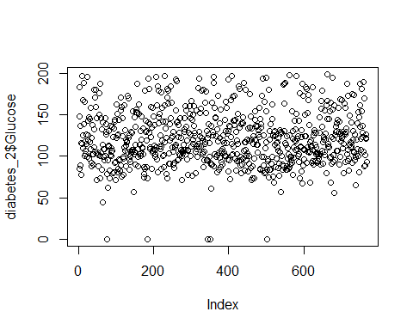

#it creates a scatter plot of variable “glucose” levels of the patients, the max glucose level is 199.0 in the data set.