**Creacion de usuarios y grupos**

Groupadd dba

Useradd oracle –g dba

**Variables de Entorno**

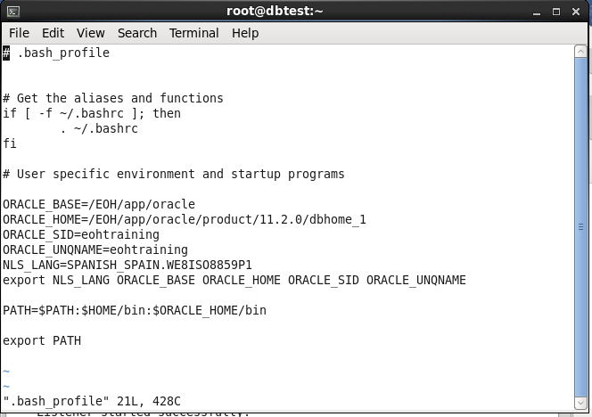

**Script de la base de datos**

**Create Database - Summary**

**Database Configuration Summary**

|  |  |
| --- | --- |
| **Global Database Name:** | eohtraining.duoc.cl |
| **Database Configuration Type:** | Single Instance |
| **SID:** | eohtraining |
| **Management Option Type:** | Database Control |
| **Storage Type:** | File System |
| **Memory Configuration Type:** | Automatic Memory Management |

**Database Configuration Details**

**Database Components**

|  |  |
| --- | --- |
| **Component** | **Selected** |
| Oracle JVM | true |
| Oracle Text | true |
| Oracle XML DB | true |
| Oracle Multimedia | true |
| Oracle OLAP | true |
| Oracle Spatial | true |
| Oracle Label Security | false |
| Sample Schemas | true |
| Enterprise Manager Repository | true |
| Oracle Application Express | true |
| Oracle Warehouse Builder | true |
| Oracle Database Vault | false |

**Initialization Parameters**

|  |  |
| --- | --- |
| **Name** | **Value** |
| audit_file_dest | {ORACLE_BASE}/admin/{DB_UNIQUE_NAME}/adump |
| audit_trail | db |
| compatible | 11.2.0.4.0 |
| db_block_size | 8KB |
| db_create_file_dest | {ORACLE_BASE}/oradata |
| db_create_online_log_dest_1 | /EOH/app/oracle/oradata |
| db_create_online_log_dest_2 | /EOH/app/oracle/fast_recovery_area |
| db_domain | duoc.cl |
| db_name | eohtrain |
| db_recovery_file_dest | {ORACLE_BASE}/fast_recovery_area |
| db_recovery_file_dest_size | 4182MB |
| db_unique_name | eohtraining |
| diagnostic_dest | {ORACLE_BASE} |
| dispatchers | (PROTOCOL=TCP) (SERVICE={SID}XDB) |
| memory_target | 440MB |
| open_cursors | 300 |
| processes | 150 |
| remote_login_passwordfile | EXCLUSIVE |
| undo_tablespace | UNDOTBS1 |

**Character Sets**

|  |  |
| --- | --- |
| **Name** | **Value** |
| Database Character Set | WE8MSWIN1252 |
| National Character Set | AL16UTF16 |

**Data Files**

|  |  |  |
| --- | --- | --- |
| **Name** | **Tablespace** | **Size(M)** |
| <OMF_SYSTEM _DATAFILE> | SYSTEM | 740 |
| <OMF_SYSAUX _DATAFILE> | SYSAUX | 470 |
| <OMF_UNDOTBS1 _DATAFILE> | UNDOTBS1 | 25 |
| <OMF_USERS _DATAFILE> | USERS | 5 |
| <OMF_TEMP _TEMPFILE> | TEMP | 20 |
| {ORACLE_BASE}/oradata/{DB_UNIQUE_NAME}/example01.dbf | EXAMPLE | 130 |

**Redo Log Groups**

|  |  |
| --- | --- |
| **Group** | **Size(K)** |
| 1 | 51200 |
| 2 | 51200 |
| 3 | 51200 |

**Cierre e inicio de sesión**

**C:\Users\Duoc\Desktop\conexion a la bd.PNG**

**C:\Users\Duoc\Desktop\desconectar de la bd.PNG**

**Archivo de parámetros**

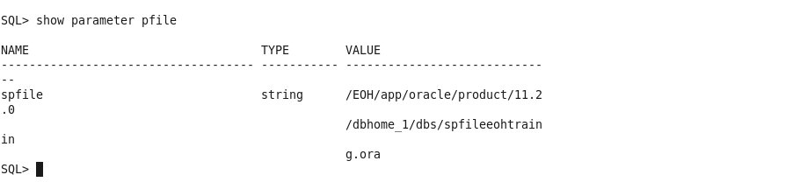

**PARTE II**

**Listener**

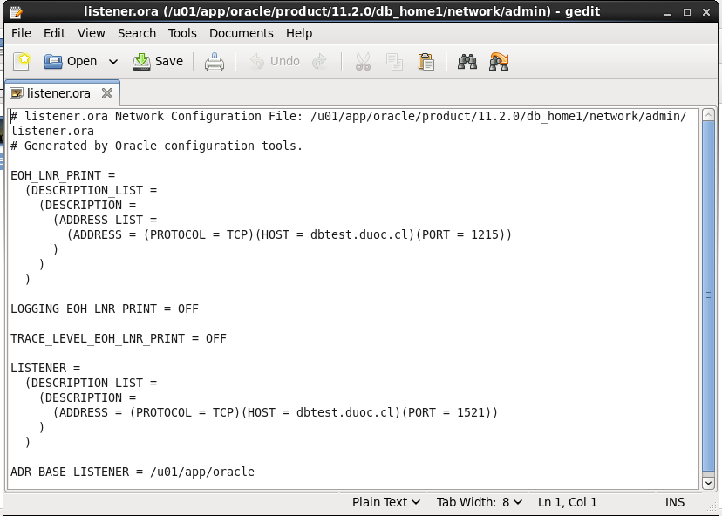

**Tsnames**

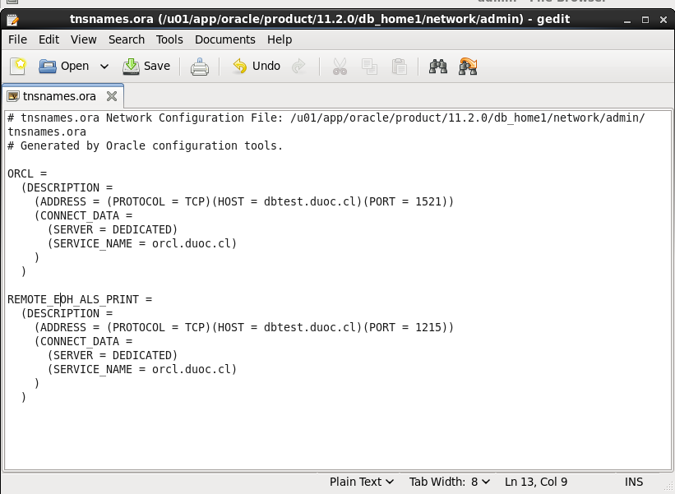

**Tablespace**

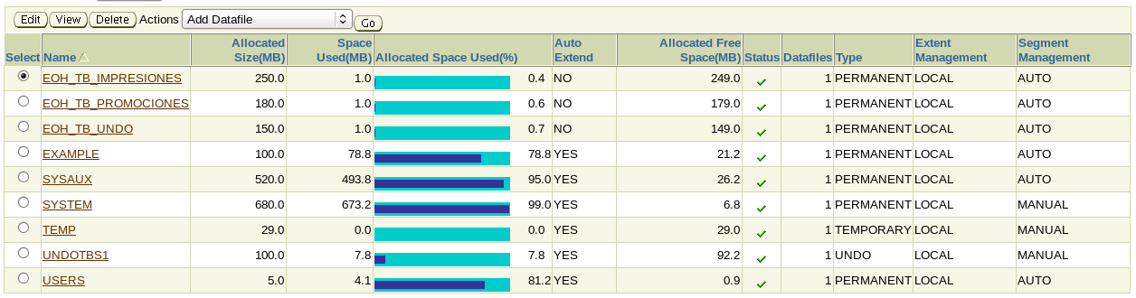

**Perfiles**

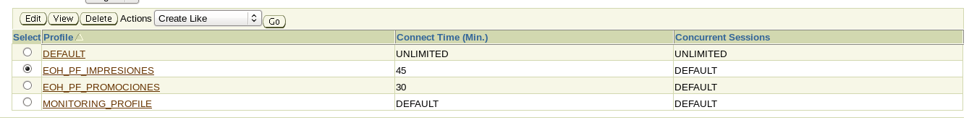

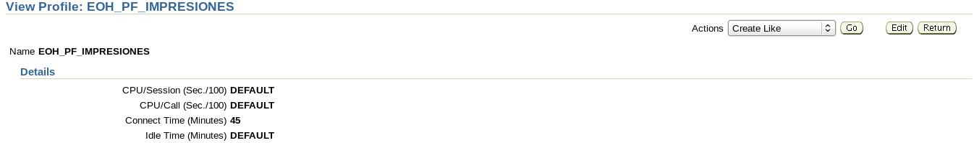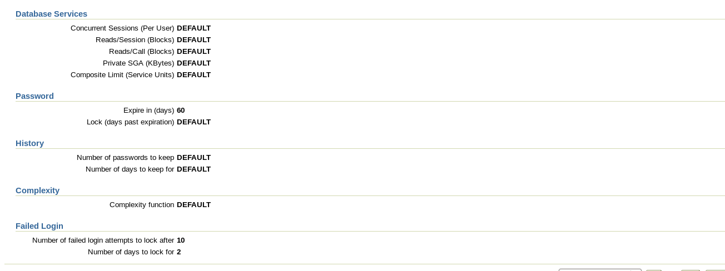

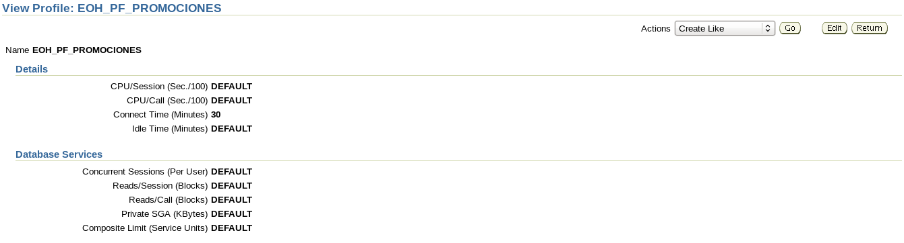

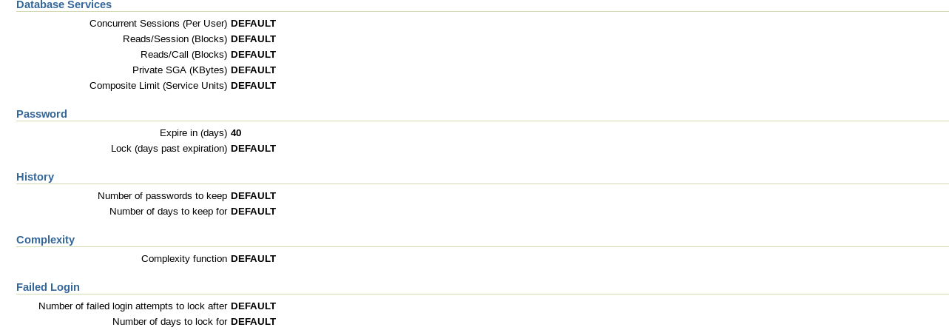

**Roles**

