Emily Durfey

May 11, 2021

Foundations of Python Programming

Assignment 05

GitHub URL: <https://github.com/edurfey/Intro-to-Prog-Python>

Working with Data Dictionaries and Lists in Python

Introduction

In this paper, I will outline the steps taken to create several scripts in Python used to create a dictionary and add a list to a text file and display the output once the steps have been created.

Defining Variables

I began creating my scripts by creating a new project in PyCharm labelled “Assignment05”. Once this had been set up, I created a new file with a title of “Starter.py” and added a header to indicate the developer who had created the script as well as a changelog to describe the actions taken within the scripts further down. I then created several sections of scripts to achieve my desired outcome.

In the first section, I defined the data variables that would be used throughout the scripts. The variables are seen below in Figure 5.1:

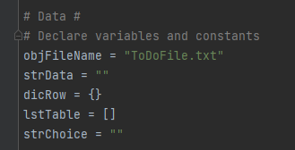

Outlining the Processing Steps

In the first section, “Step 1”, I created a script that would allow the user to start the program and load the data on a text file into a Python dictionary. This script separates any data input into tasks and priorities, which will allow the user to outline their tasks and rank them by importance (as determined by the user). The second section, “Step 2”, displayed a series of menu options that allows the user to alter the text file based on their choice. The menu is seen below in Figure 5.2:

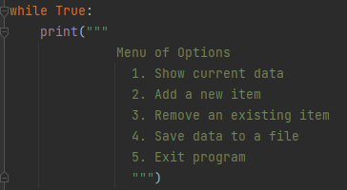

I also added a step that asks the user to select options 1-5.

In the third section, I added additional information for Option 1 (step 3). This section features two print statements that show any tasks that are currently listed in the text file as a reminder of what information is available to the user. In the fourth section, I started by added an “elif” statement for the user to select option 2 (step 4). I then added two string statements that allow the user to add both a new task and prioritize it on the text file. Once this was completed, I added two print statements like the ones used in the third section that allowed the user to show all tasks listed in the text file and remind them what information is available to them once again. The scripts displayed in section four are listed below in Figure 5.3:

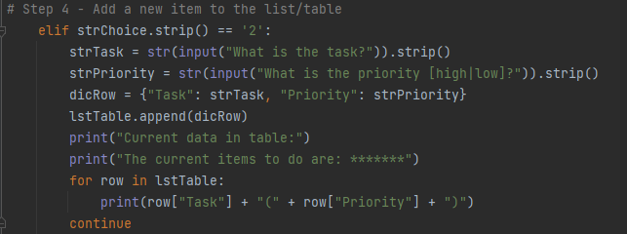

In the fifth section, I created another elif statement for step 5 that allows the user to remove data previously added to the text file. This section also features a string statement and a Boolean value used to identify which row will need to be removed. This also identifies whether the row is already listed in the text file so the information can be deleted. Once the information has been deleted, I added two print statements that the user can run to confirm if the information has been deleted or not. There is one additional print statement the user can run in order to show the full list of current priorities listed in the text file.

In the final section, I created two elif statements that allows the user to save the data that had been previously written to the file. The first part, step 6, has several print scripts and string values that, when run, allows the user to save their changes and export the output to a text file. It also features a warning message that informs the user if their changes have or have not been saved and defines the information by task and priority to align with the rest of the scripts created earlier. The elif statement in step 7 allows the user to exit the program once their updates have been made. This is outlined in Figure 5.4 below:

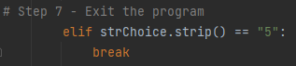

Running the Scripts

Once I had created all my scripts, I then executed them in PyCharm to confirm they were working properly. I confirmed the output was successfully written to a text file, with the results listed below in Figure 5.5:

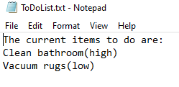

Creating a GitHub Repository

Once the scripts and text file were created, I wrapped up the assignment by creating a new repository to my GitHub account. This repository, “Intro to Prog-Python” will be used to review homework assignments for future modules, and I will plan on posting both the assignments as well as the write up for other classmates to review. The repository can be found below in Figure 5.6:

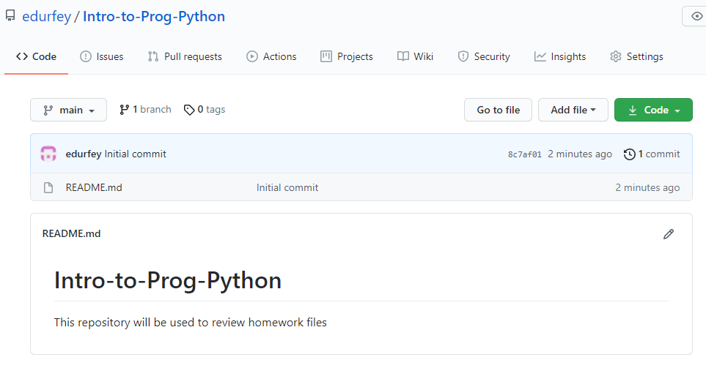

The link to my respository is also listed at the top of this paper for easier reference.

Summary

By using the examples provided in the textbook, Module 5 video, and supplemental websites, I was able to use the techniques learned in Module 4 and create a dictionary/list of priorities and add/delete the information as needed. I also continued to expand my knowledge of PyCharm and am looking forward to becoming more familiar with GitHub as we use it more frequently in this class.