Emily Durfey

May 18, 2021

Foundations of Python Programming

Assignment 06

GitHub URL: <https://github.com/edurfey/Intro-to-Prog-Python>

Working with Functions, Variables, and Parameters in Python

Introduction

In this paper, I will outline the steps taken to modify scripts in Python to work with functions, variables, and parameters, which allows the user to continue to prioritize tasks added to a to do list.

Defining Variables

I began creating my scripts by creating a new project in PyCharm labelled “Assignment06”. Once this had been set up, I created a new file with a title of “Starter.py” and added a header to indicate the developer who had created the script as well as a changelog to describe the actions taken within the scripts further down (this also included changes made as part of Module 6). I then created several sections of scripts to achieve my desired outcome.

In the first section, I defined the data variables that would be used throughout the scripts. The variables are seen below in Figure 6.1:

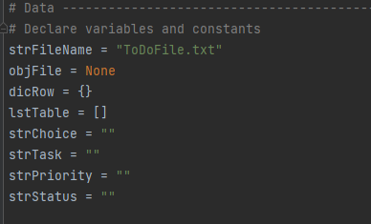

Outlining the Processing Steps

In this section, I created a processing section that incorporates the steps created in module 5 and allows the user to either remove or add items to their to do list. This also allows the user to modify the data if they need to.

Creating the Presentation Steps

In this section, I created a series of scripts to indicate whether a step could be defined as a task or a priority. This section also re-defines part of the menu options offered to the user and allows them to show any data that is currently on the to do list. Part of this script is displayed in Figure 6.2 below:

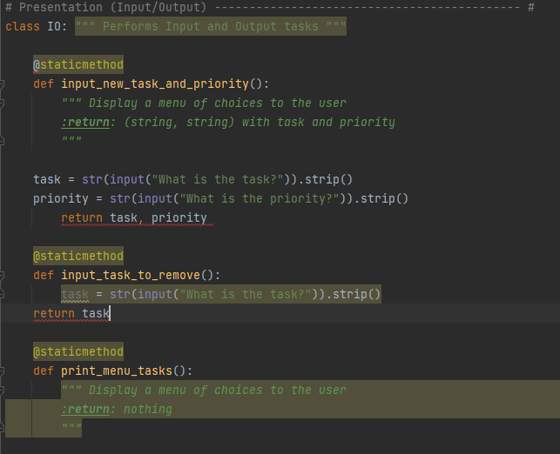

Creating the Main Body of the Script

After defining the processing and presentation steps, I was ready to create the remaining scripts and add functions to build the program. I began by running the program and loading the data currently featured on the to-do list, which was accomplished by using a processing statement to pull in the data. The second section features a print statement that displays the menu options as a reminder of what information is available to the user. In the third section, I added a few I/O statements that allows the user to display the current data. These statements are listed below in Figure 6.3:

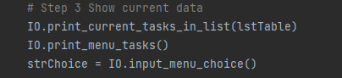

For section four, I added several string statements that allow the user to add both a new task and prioritize it on the text file depending on the option they choose. Once this was completed, I added two print statements like the ones used in the third section that allowed the user to show all tasks listed in the text file and remind them what information is available to them. I also created several elif statements that allows the user to remove data previously added to the text file. This also identifies whether the row is already listed in the text file so the information can be deleted. Once the information has been deleted, I added two print statements that the user can run to confirm if the information has been deleted or not. There is one additional print statement the user can run in order to show the full list of current priorities listed in the text file.

In the final section, I created two elif statements that allows the user to save the data that had been previously written to the file. The first part, step 6, has several print scripts and string values that, when run, allows the user to save their changes and export the output to a text file. It also features a warning message that informs the user if their changes have or have not been saved and defines the information by task and priority to align with the rest of the scripts created earlier. The elif statement in step five allows the user to exit the program once their updates have been made. This is outlined in Figure 5.4 below:

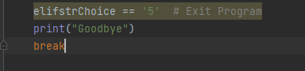

Summary

By using the examples provided in the textbook, Module 5 video, and supplemental websites, I was able to use the techniques learned in previous modules and add functions to my code. This module was slightly more challenging that previous modules, but I look forward to learning how to improve upon these concepts and continue to become a better Python programmer.