Emily Durfey

June 5, 2021

Foundations of Python Programming

Assignment 07

GitHub URL: <https://github.com/edurfey/Intro-to-Prog-Python>

Files and Exceptions in Python

Introduction

In this paper, I will outline the steps taken to modify scripts in Python and create error messages when working with different file types. In order to complete this module, I used a technique known as the pickling method, which can be used when working with binary file types.

Pickling

I began creating my scripts by creating a new project in PyCharm labelled “Assignment07”. Once this had been set up, I created a new file with a title of “Assignment07.py” and added a header to indicate the developer who had created the script as well as a changelog to describe the actions taken within the scripts further down. I then created several sections of scripts to achieve my desired outcome.

In the first section, I created an import pickling script that would be used throughout the remainder of the assignment. Once this was completed, I then created a script to demo the data included with the pickling method, which included prompts for the user to add a customer ID and name. As more values are added into the program, the values can be complied into a customer list (using the binary file format).

The next scripts in this section allow the user to both store and read the data using the pickling method. This contains all values added to the customer list and can be seen in Figure 7.1 below:

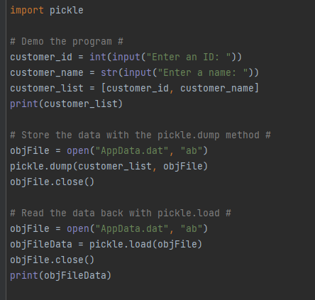

Handling Data Errors

In this section, I outlined three different error messages that can be triggered for the user if they do not input a value allowed by the program. As defined by the program, when a user inputs new data into the program, they cannot use the number zero as the second value.

Error Messages

While the three error message scripts are similar, they are slightly different in terms of their complexity. The first script, Demo 1, only lets the user know they have committed an error if they input the number zero as their second value. The second script, Demo 2, builds on this premise and allows a built in Python error message to be displayed if the user enters zero as their second value. This is defined as an exception error and noted by the letter “E”. This script also references documents and strings created as part of the pickling import.

The last error message, Demo 3, explicitly states the user cannot enter the number zero as their second value. The error is defined as a “ZeroDivisionError” and references the original error message coded in Demo 1 (“There was an error!”). Like the error message created in Demo 2, this script also pulls information from the documents and strings created as part of the pickling import.

All three error messages feature a series of “try” and “except” statements, and they are displayed in Figures 7.2 and 7.3 below:

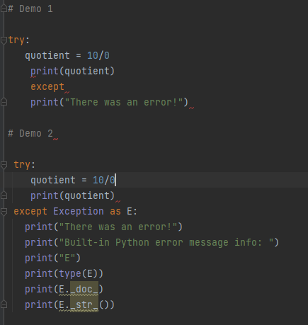

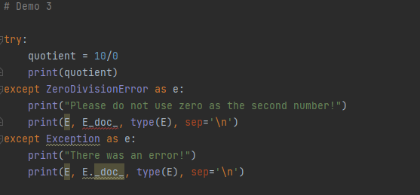

Testing the Binary File

The final section of the code allows the user to test the error messages created in the second section while running values input as part of the first section. These scripts feature a combination of “try” and “except” statements.

The first part of the script instructs the user to add new ID and name values to the customer list and will prompt an error message if the second value is zero. Once the testing has been completed, the user is able to store the data using the pickling method and will have an exception error message prompted if the user is not allowed to view the data included on the file. The final section of the script prompts the values to be read back to the user and displays an error message if there are no information included in the file.

The scripts are outlined below in Figures 7.4 and 7.5:

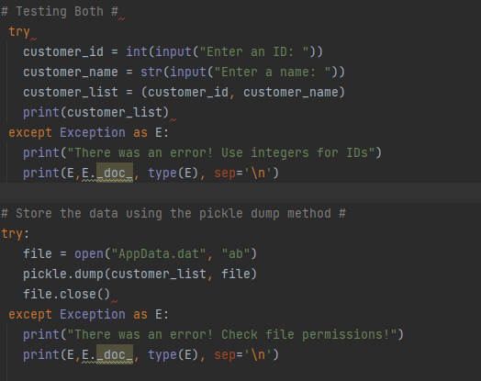

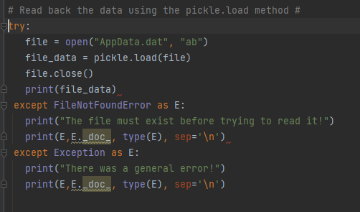

Summary

By using the examples provided in the textbook, Module 7 video, and supplemental websites, I was able to include error messages within my Python code and adjust the scripts by using the pickling method. I was glad to build upon my knowledge of creating files by learning how to work with binary files in addition to text files, and I look forward to continuing to learn more about file creation as I work through the next modules in the class.