CMSC203 Assignment 2 Implementation (Documentation)

Class: CMSC203 CRN XXXX
Program: Assignment 2
Instructor: Farnaz Elyazi
Summary of Description: This JavaFX program allows the user to enter patient information and three medical procedures, save the information, display it, and calculate the total procedure charges.
Due Date: 06/29/2026
Integrity Pledge: I pledge that I have completed the programming assignment independently.
I have not copied the code from a student or any source.

Part1: Pseudo Code: Here is a pseudo code for Assignment 2 program:
1. Start program.
2. Create the JavaFX window.
3. Create text fields for patient information.
4. Create text fields for three procedures.
5. When Save Patient is clicked, store the patient information.
6. When Save Procedure is clicked, store that procedure's information.
7. When Show Output is clicked:
• Display patient information.
• Display all three procedures.
• Calculate and display total charges.
• Display 'Program developed by: Edwin During'.
8. Exit when Exit button is clicked.

Part2: Comprehensive Test Plan
A good test plan should be comprehensive. This means you should have a few test cases that test when the input is in and out of range, division by 0, incorrect Data type, etc. (Provide valid and invalid input)
Cases | Input | Expected Output | Actual Output | Did Test Pass?
Case 1 | Enter valid patient information and click Save Patient | Patient information is saved successfully | Patient information was saved and displayed correctly | Yes
Case 2 | Enter Procedure 1 information and click Save Procedure 1 | Procedure 1 is stored and displayed | Output matched the expected result | Yes
Case 3 | Enter all three procedures and click Show Output | Patient information, all procedures, and total charges ($725.50) are displayed | Output matched the expected result | Yes
Case 4

Part3: Screenshots related to the Test Plan:
Case 1
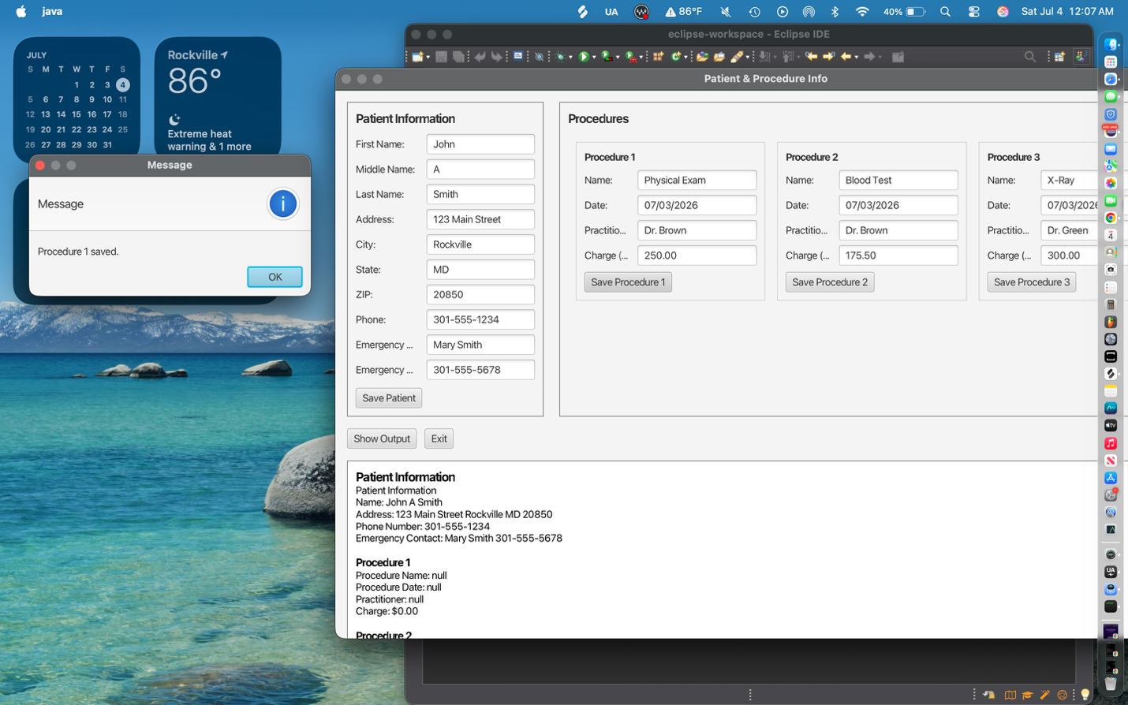

Case 2
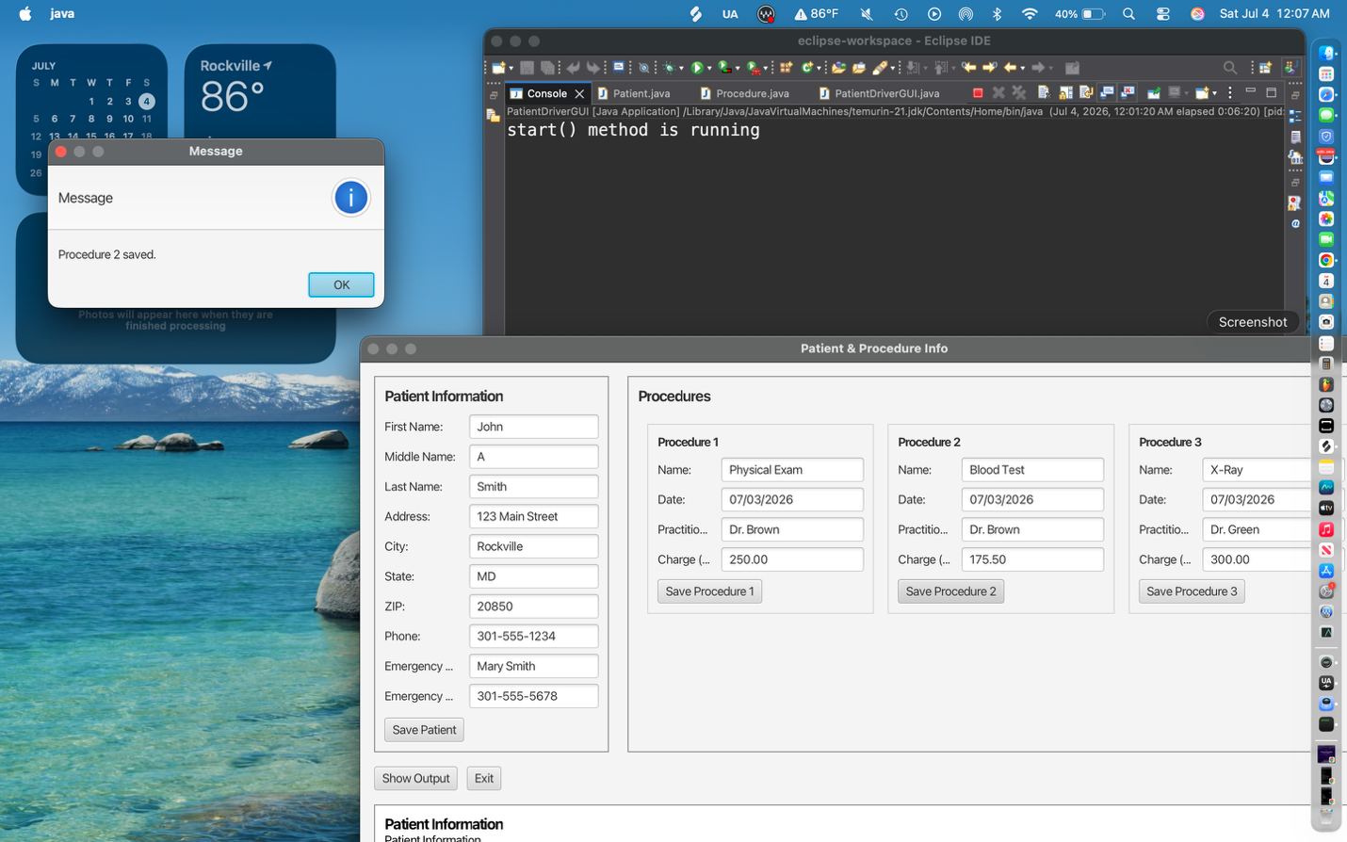

Case 3
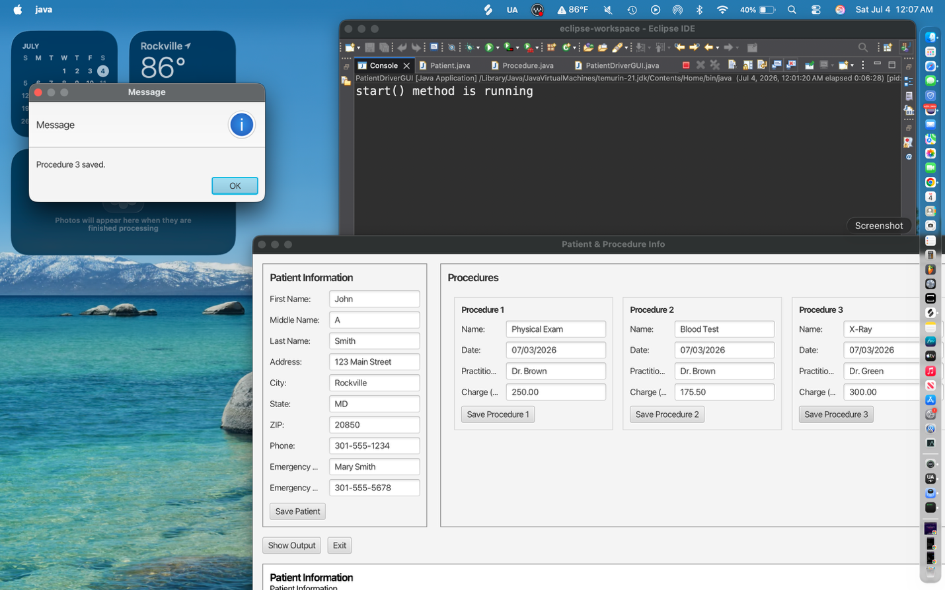

Case 4
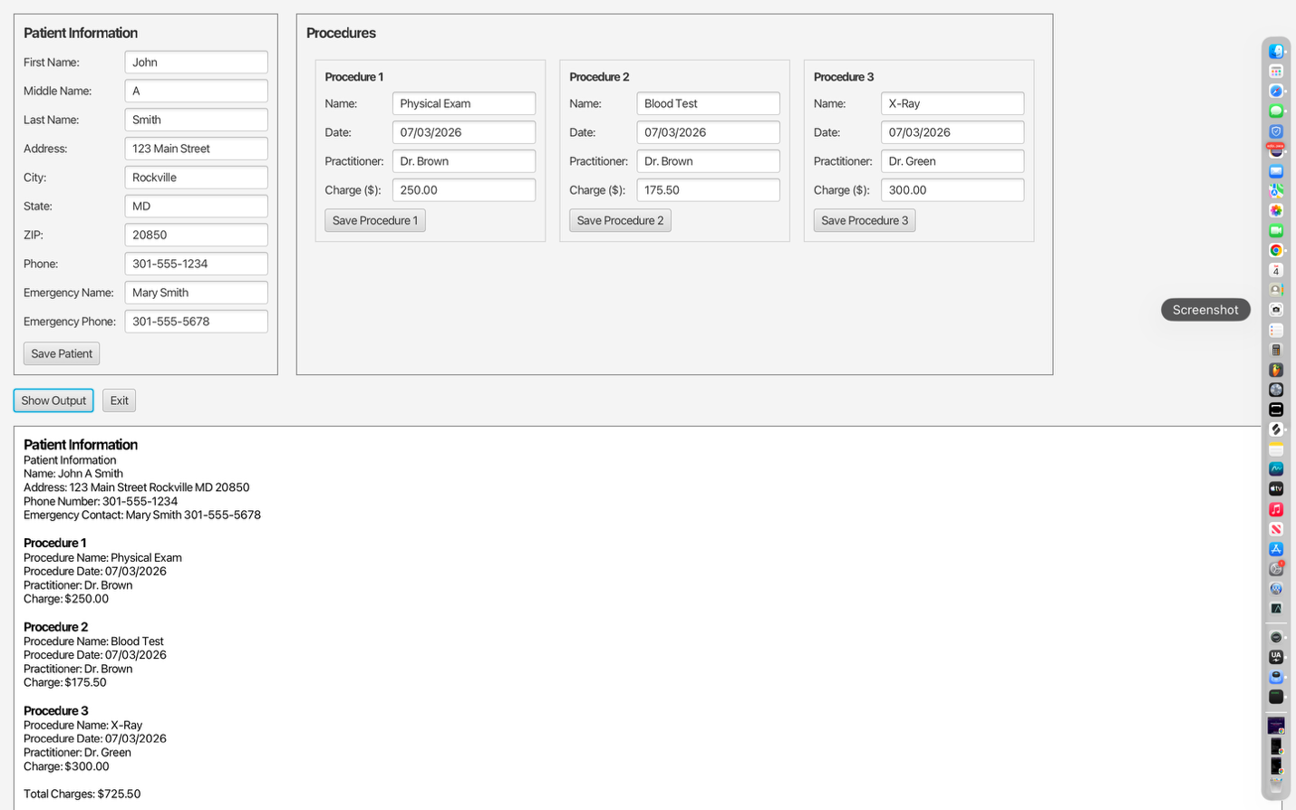

Lessons Learned <Provide answers to the questions listed above>:
I learned how to create a JavaFX GUI, work with classes and objects, use constructors,
getters and setters, and display object information using toString(). The most difficult
part was connecting the GUI with the Patient and Procedure classes and debugging the
program. Next time I would test each feature as I build it. I was successful creating the
GUI and calculating the total charges.

Write about your Learning Experience, highlighting your lessons learned and learning experience from working on this project.

What have you learned?
I learned how to create a JavaFX GUI, work with classes and objects, use constructors, getters and setters, and the toString() method. I also learned how to connect the GUI to the Patient and Procedure classes, calculate the total charges, generate Javadoc, and debug Java programs in Eclipse.

What did you struggle with?
The most difficult part was setting up JavaFX and getting the GUI to run correctly in Eclipse. I also had trouble debugging the program, fixing constructor errors, and making sure the patient and procedure information was displayed correctly. Learning how the different classes worked together took some time.

What would you do differently on your next project?
On my next project, I would plan the program before writing code by creating the UML diagram and pseudocode first. I would also test each part of the program as I build it instead of waiting until the end. This would help me find and fix errors more quickly.

What parts of this assignment were you successful with, and what parts (if any) were you not successful with?
I was successful in creating the Patient and Procedure classes, building the JavaFX interface, saving and displaying the information correctly, calculating the total procedure charges, and generating the Javadoc documentation. The most challenging part was configuring JavaFX in Eclipse and troubleshooting runtime issues, but after working through the problems, I was able to complete the project successfully.

Provide any additional resources/links/videos you used to while working on this assignment/project.

Check List: <Provide answers to the column Y/N or N/A >:

# |  | Y/N | Comments
 | Assignment files: | Y | ZIP file created with project files.
 | - FirstInitialLastName_ Assignment#_Moss.zip | Y | Documentation completed.
 | - FirstInitialLastName_Assignment#.docx/.pdf | Y | Documentation completed.
 | - Source java files | Y | Included Patient.java, Procedure.java, and PatientDriverGUI.java.
 | Program compiles | Y | Compiles successfully using Java 21.
 | Program runs with desired outputs related to a Test Plan | Y | GUI runs correctly and displays patient, procedures, and total charges.
 | Documentation file: | Y
 | - Comprehensive Test Plan | Y | Included in documentation.
 | - Screenshots related to the Test Plan | Y | Screenshots included.
 | - Screenshots of your GitHub account with submitted Assignment# (if required) | Y | included
 | - UML Diagram (if required) |  | included
 | - Algorithms/Pseudocode (if required) |  | included
 | - Flowchart (if required) |  | included
 | - Lessons Learned |  | included
 | - Checklist is completed and included in the Documentation |  | Completed

