1. **Background**

* Background of skills that will be showcased:
  + Graphic Design
  + Web Design
  + Illustration

1. **Goals**

* What is the purpose of the site:
  + The purpose of this site is to advertise myself and attract potential employers while showcasing my graphic design, web design, and illustration skills.
* Who is the intended audience:
  + The intended audience is potential employers.
* Who are my potential employers:
  + My potential employers are anyone who is looking for an entry level front end web developer, graphic designer, or illustrator.
* Who within a company might be visiting the site:
  + The hiring manager for any interested company is the most likely to visit the site.
* Who will I be demonstrating my skills to:
  + I will primarily be demonstrating my skills to the hiring manager or whoever is in charge of hiring for the position I’m interested in.
* Why specifically will people come to this site:
  + People will most likely come to this site as a part of looking at my resume/portfolio during the hiring process.

1. **Audience Definition**

* Who are the users:
  + The users are likely potential employers and hiring managers.
* What are the user’s goals and objectives:
  + The users goals and objectives are to get an accurate idea of my skills and accomplishments so they can make an informed decision before reaching out or hiring me.
* What technology will users use to access the site:
  + Users could access this site with any number of devices including desktop computers, phones, and tablets.

1. **Flowchart**

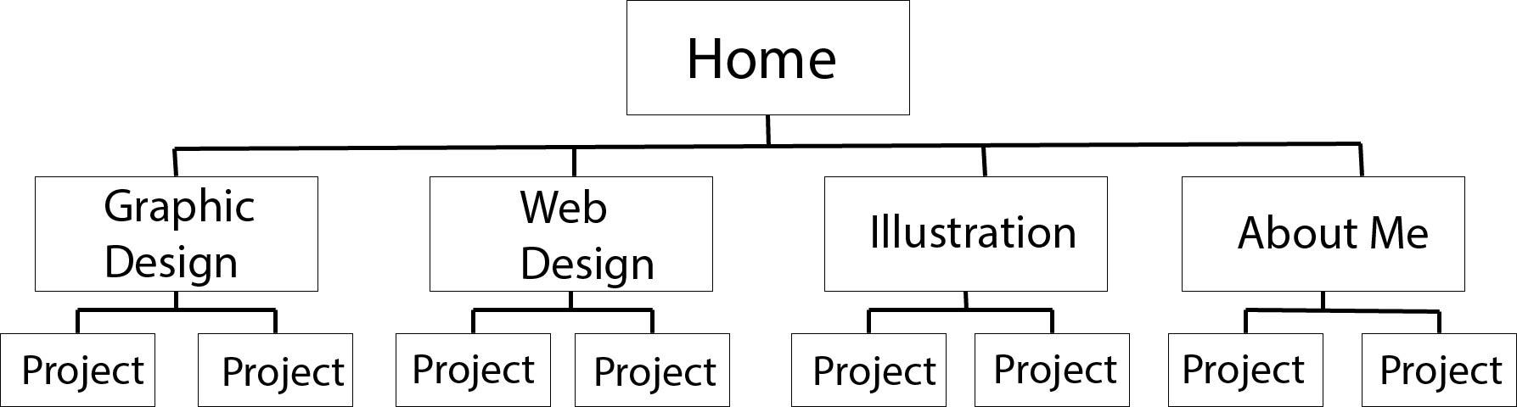

1. **Features List**

* HTML5 Coding
* CSS3 Elements
* Responsive Design

1. **Website Mockup:**

