EduAdvisorHub

Topic - EduAdvisorHub

EQ - How can we create an effective website how to boost students' emotion, social awareness for teachers and students in Myanmar?

DQ - How can Year8 students build a informative website to educate both students and adults, encouraging a better lifestyle awareness?

Color - dark blue = #3D4B5F

black = #000000

white = #FFFFFF

Wireframe Screenshot

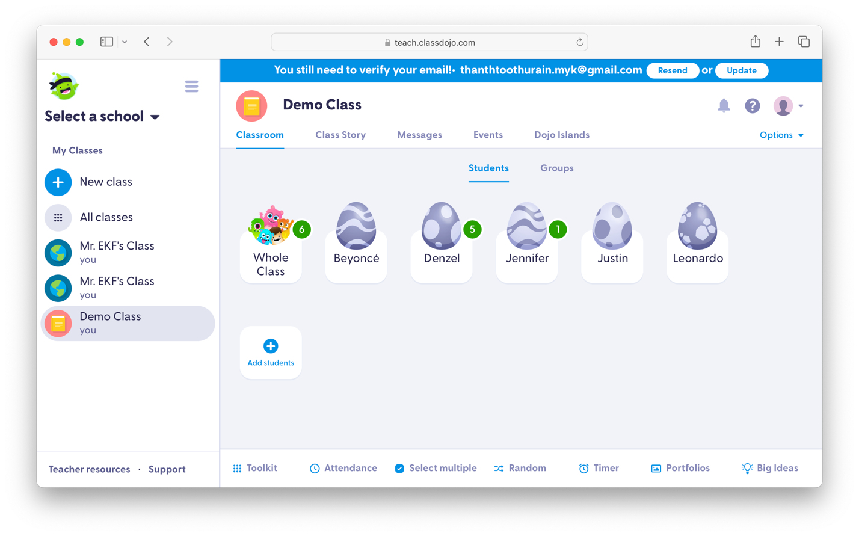

References

======

must collect all of resources

https://youtu.be/Y3s0_Vy6Uy0?si=oENC5RDp8tV47U8J

https://innerspacetherapy.in/mindfulness-meditation-residential-retreat/

https://www.sdstate.edu/ness-school-management-and-economicsblog/power-positive-thinking

https://www.colorhub.app/

https://classdojo.com/

https://www.proprofs.com/quiz-school/story.php?title=mjg3mzkxmgm9s4

https://www.youtube.com/@Psych2go

https://www.youtube.com/@TheArtofImprovement

https://code.visualstudio.com/

https://www.sublimetext.com/index2

https://github.com

https://getbootstrap.com

https://fontawesome.com/search?s=thin&o=rm/

https://cdnjs.com/

https://www.canva.com/

https://casel.org/fundamentals-of-sel/#:~:text=SEL%20is%20the%20process%20through,and%20make%20responsible%20and%20caring

https://www.nu.edu/blog/social-emotional-learning-sel-why-it-matters-for-educators/

https://casel.org/fundamentals-of-sel/what-is-the-casel-framework/

https://www.wgu.edu/blog/what-is-growth-mindset-8-steps-develop-one1904.html#:~:text=A%20growth%20mindset%20means%20that,are%20all%20susceptible%20to%20growth.

https://www.kornferry.com/insights/this-week-in-leadership/what-is-emotional-self-awareness

https://symondsresearch.com/emotional-intelligence-self-awareness/

https://www.mindful.org/what-is-mindfulness/

https://www.keystepmedia.com/shop/emotional-self-awareness-primer/#:~:text=Emotional%20Self%2DAwareness%20is%20the,as%20many%20aspects%20of%20life.

https://psychcentral.com/health/self-awareness#what-is-self-awareness

https://cordellhealth.co.uk/blog/12-steps-to-improve-your-personal-resilience/

https://www.quora.com/How-can-people-build-resilience-in-their-personal-life

https://www.healthdirect.gov.au/self-talk

https://www.quora.com/What-does-it-mean-to-control-your-mind-control-your-life-Does-this-mean-to-focus-on-those-things-which-you-dont-want-to-do

https://www.betterup.com/blog/how-to-control-your-mind#:~:text=The%20Merriam%2DWebster%20dictionary%20defines,of%20control%20is%20also%20important.

https://www.quora.com/What-is-the-meaning-of-trying-to-achieve-your-goals-reach-the-top-and-become-someone-great-on-what-you-love-to-do-if-one-day-everything-will-end-and-you-and-everything-youve-done-will-be-forgotten

https://www.verywellmind.com/what-is-peer-pressure-22246

https://www.quora.com/How-can-I-achieve-my-goal-if-my-parents-dont-support-me-and-I-dont-know-what-correct-steps-should-I-take-to-achieve-it