Masteryship reference

Topic: Masteryship

Essential question: how can we develop a website to provide people who interested in effective online learning for their education development?

Color scheme: Black/ White/ Grey

Font style:

Wireframe (at least one wireframe): (main 4 pages, extra 6pages)

**Home page**

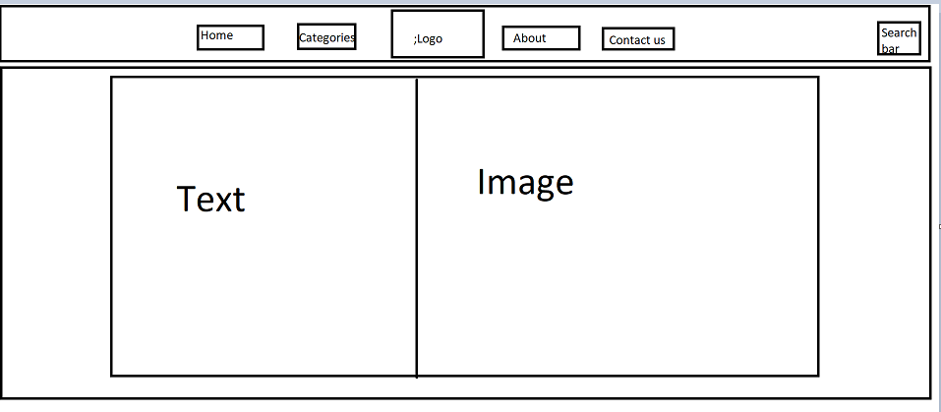

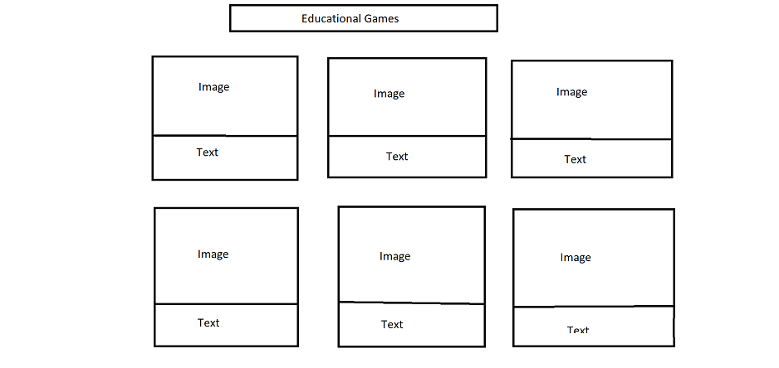

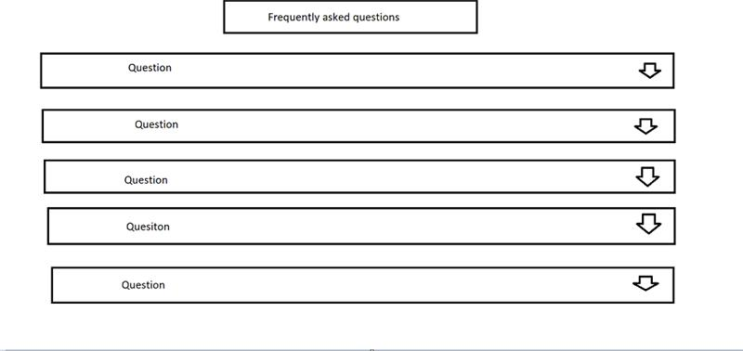

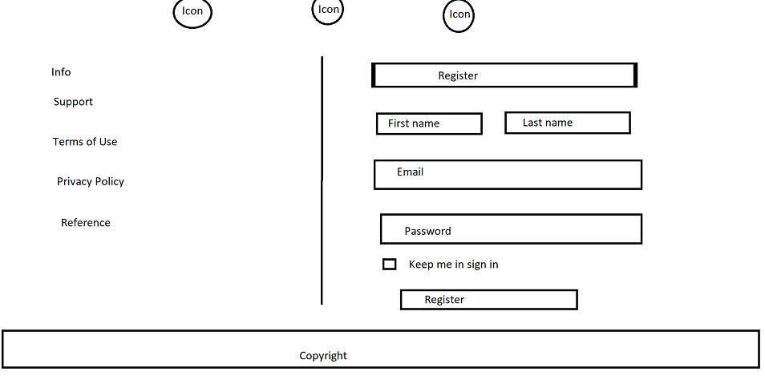

**Category**

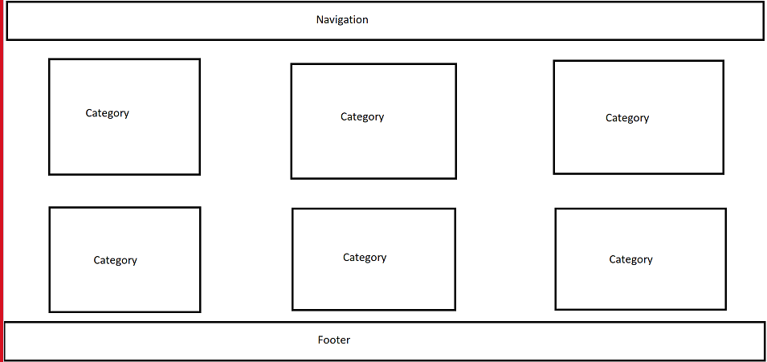

**About us**

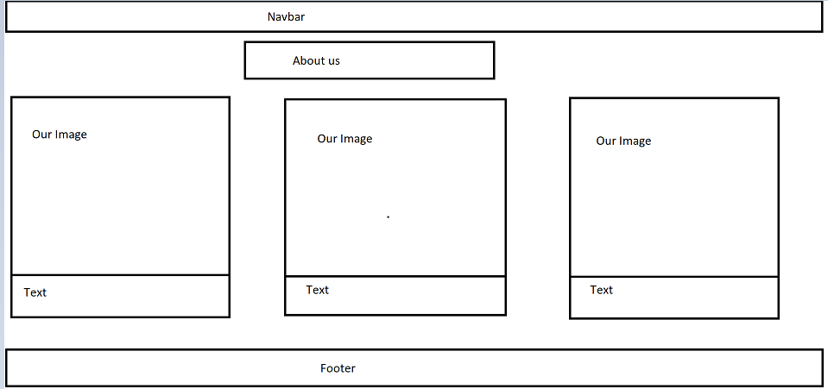

**Contact**

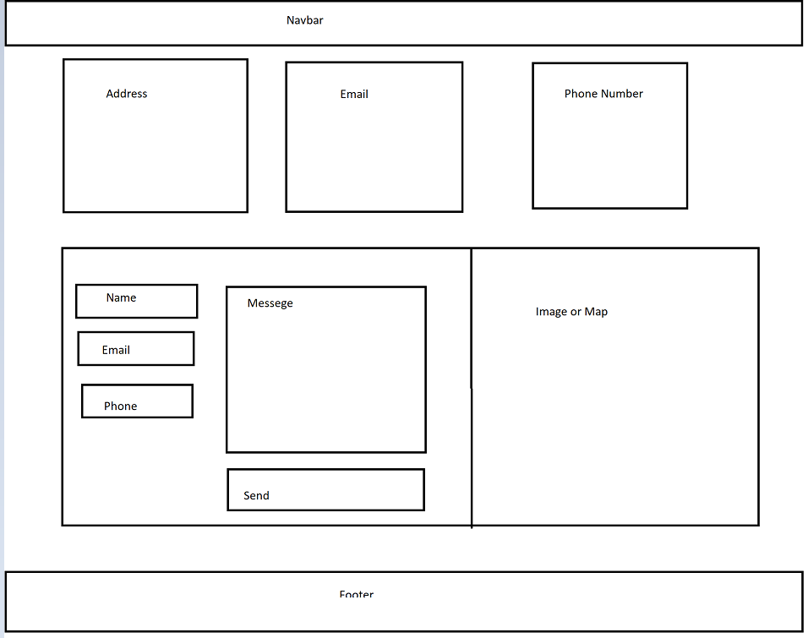

Website link

<https://www.udemy.com/?utm_source=adwords&utm_medium=udemyads&utm_campaign=Generic-Exact_la.EN_cc.ROW&utm_content=deal4584&utm_term=_._ag_86841140576_._ad_535632329505_._kw_e%20learning%20sites%20online%20education_._de_c_._dm__._pl__._ti_kwd-306319229679_._li_1010216_._pd__._&matchtype=e&gclid=CjwKCAiA_6yfBhBNEiwAkmXy58w-PDPNzf2qMXd4s7FH5nDLnqUSL2aQraKg22GSXmBqCw9vcKA84xoCG7sQAvD_BwE>

<https://www.odoo.com/app/elearning?utm_source=google&utm_medium=cpc&utm_campaign=APAC-EN-eLearning&utm_gclid=CjwKCAiA_6yfBhBNEiwAkmXy52nyP5Jv2OJTyLDxDMqCb-kIr-wsoRhwM2Xx9XUFdMPaOg3LcnQk-RoCncoQAvD_BwE&gclid=CjwKCAiA_6yfBhBNEiwAkmXy52nyP5Jv2OJTyLDxDMqCb-kIr-wsoRhwM2Xx9XUFdMPaOg3LcnQk-RoCncoQAvD_BwE>

<https://alison.com/>

<https://www.skillshare.com/en/>

<https://www.udemy.com/>

<https://www.wix.com/website-template/view/html/2988?originUrl=https%3A%2F%2Fwww.wix.com%2Fwebsite%2Ftemplates%3Fcriteria%3DOnline%2Blearning&tpClick=view_button&esi=d5d09e9a-54a3-4edf-a037-ddcb2f9a8183>

<https://codepen.io/baahubali92/pen/PLLzNb>

For navbar

<https://www.youtube.com/watch?v=1uEAt51fEos>

Color code link

<https://coolors.co/>

<http://colormind.io/>

<https://mycolor.space/>

<https://huemint.com/brand-intersection/>

<https://paletton.com/#uid=12d0u0kllllaFw0g0qFqFg0w0aF>

Font and logo/ icon

<https://fonts.google.com/>

<https://fontawesome.com/icons>

Code   
<https://codepen.io/search/pens?q=footer+animation&cursor=ZD0xJm89MCZwPTI=>

<https://www.w3schools.com/>

Youtube

<https://www.youtube.com/watch?v=MMNEEdGa5eE>

https://www.youtube.com/embed/9-szziqmTMs

https://www.youtube.com/embed/i5sDhcCzPPs

https://www.youtube.com/embed/UMV345N_YSs

https://www.youtube.com/embed/yrGda5ConAg

https://www.youtube.com/embed/ecq2OAAmfAg

https://www.youtube.com/embed/LZZml3FrEaY

https://www.youtube.com/embed/FT9I_7YpNMc

https://www.youtube.com/embed/bqsBl1VTDyU

https://www.youtube.com/embed/zFdtXfTXFF4

https://www.youtube.com/embed/N775KsWQVkw

https://www.youtube.com/embed/HIj8wU_rGIU

https://www.youtube.com/embed/bJzb-RuUcMU

https://www.youtube.com/embed/qz0aGYrrlhU

https://www.youtube.com/embed/wRNinF7YQqQ

https://www.youtube.com/embed/W6NZfCO5SIk

https://www.youtube.com/embed/sHetKwDx2bI

https://www.youtube.com/embed/QSAX1NCMGdU

https://www.youtube.com/embed/lFjMkUmp_lk

https://www.youtube.com/embed/Ngk09xRRzW8

https://www.youtube.com/embed/6TiYT81v6i4

https://www.youtube.com/embed/T5PwyuzSYcs

https://www.youtube.com/embed/NSCFxDKJWwo

https://www.youtube.com/embed/RwSYrsjTiW4

https://www.youtube.com/embed/yoGDroecVT0

https://www.youtube.com/embed/eXSs0QJ3Dww

https://www.youtube.com/embed/YBP1Pz-5v4I

https://www.youtube.com/embed/Nnqa1k8jtr4

https://www.youtube.com/embed/aQOUSJOVHp8

https://www.youtube.com/embed/_He6-L3Kztw

https://www.youtube.com/embed/vL-seHs-YAY

https://www.youtube.com/embed/qE-03EATjho

https://www.youtube.com/embed/ktYjQ9zqiC8

https://www.youtube.com/embed/rJJ1mrWAKrw

https://www.youtube.com/embed/jFGzpEkeNj4

https://www.youtube.com/embed/3tBmFd-1bfI

https://www.youtube.com/embed/OuRR734xITo

https://www.youtube.com/embed/rgaTLrZGlk0

https://www.youtube.com/embed/CuHrKkgyXhI

https://www.youtube.com/embed/_VvKeiwddPI

https://www.youtube.com/embed/ZN41d7Txcq0

https://www.youtube.com/embed/orp7WHibnaU

https://www.youtube.com/embed/Ud9CpGOG1GE

https://www.youtube.com/embed/eTtxQhmiY18

https://www.youtube.com/embed/Mu01Rwz2qQo

https://www.youtube.com/embed/ZTk4_ZZfL4A

https://www.youtube.com/embed/66n1RV-FMzo

https://www.youtube.com/embed/AVYfyTvc9KY

https://www.youtube.com/embed/juKd26qkNAw

https://www.youtube.com/embed/OJL8zJi-oXA

https://www.youtube.com/embed/OmJ-4B-mS-Y

https://www.youtube.com/embed/PYrgjMubh-c

https://www.youtube.com/embed/VXLSWzpQiQI?list=PLaNqYRUcR9Mwr8BoqfPQqek8JOv5KBNwf

https://www.youtube.com/embed/yiTVkCy7DwA

[What is Science?](https://www.youtube.com/embed/w-8gEUAyjkc)

[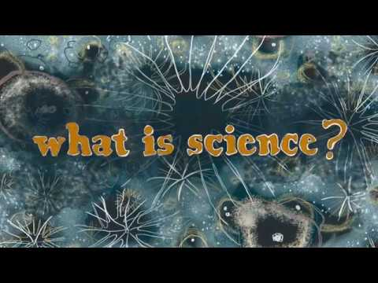](https://www.youtube.com/embed/w-8gEUAyjkc)

(Video card)

<https://www.youtube.com/watch?v=wnseY8goQoc>

(FAQs Section)

<https://www.youtube.com/watch?v=4qnWreynXLU>

<https://www.youtube.com/watch?v=PgEdW5ea2so>