 ICT Data Collection For PBL

---------------------------------------------------------------------------------------------------------------------

Title – Sustainable Smart City
Sub-Topic – Green City Lifestyle
-------------------------------------------------
Aim – To design and develop a digital website that educates local residents about smart planting techniques and sustainable practices, in order to improve air quality and enhance green spaces within the community.

Driving Question – How can Year 8 students create a digital platform to raise awareness among local residents about sustainable smart city while sharing solutions and ideas?

Essential Question – How can we, as Year-8 Taungoo students, create a digital website to educate our community about smart planting and sustainable solutions for improving air quality and green spaces?
Pages – 6 pages, 3 navbars
Action taking – Create a wireframe and layout of the website, create folders and file to save data, create a website and share it

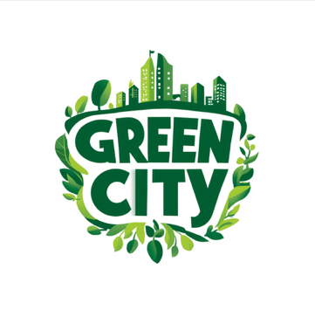 ICT Group Logo
ICT Information
A “Green City” is meant to be environmentally friendly, sustainable, and healthy, but in reality, even green cities face several challenges. Here are some of the main problems:

Problems caused by lack of green spaces

Problems

- Waste management issues: Recycling systems can be inefficient or underused.

- Loss of biodiversity: Expanding urban a kooo reas can reduce natural habitats for plants and animals.

- High implementation costs: Building eco-friendly infrastructure (solar panels, green buildings) is costly.

- Poor Air Quality: Trees and plants help filter pollutants.
Without them, harmful gases and dust remain in the air, increasing pollution levels.

- Health Issues: Less access to nature can increase stress, anxiety, and depression.
People also have fewer places to exercise, affecting physical health.

Reference List

World Health Organization. (2016). Urban green spaces and health.

United Nations. (2019). World Urbanization Prospects.

United States Environmental Protection Agency. (2023). Heat Island Effect.

Food and Agriculture Organization. (2018). Urban forests and sustainable cities.

National Geographic Society. (n.d.). Urban green spaces.

The World Bank. (2020). Cities and climate change.

https://colorhunt.co/

Benefits

- Better Air Quality

Trees and plants clean the air by absorbing pollutants and producing oxygen through Photosynthesis.

- Better Physical Health

Parks provide space for walking, sports, and exercise.
This helps reduce obesity and other health problems.

- Supports Biodiversity

Green spaces provide habitats for birds, insects, and small animals.
This helps maintain ecological balance.

- Climate Benefits

Plants absorb carbon dioxide, helping reduce climate change.
They also improve overall environmental sustainability.

Reference List

World Health Organization. (2016). Urban green spaces and health.

United Nations. (2019). World Urbanization Prospects.

United States Environmental Protection Agency. (2023). Heat Island Effect.

Food and Agriculture Organization. (2018). Urban forests and sustainable cities.

National Geographic Society. (n.d.). Green spaces.

The World Bank. (2020). Cities and climate change.

Importance of Green Space

Green spaces are essential in urban areas as they help improve air quality, reduce heat caused by buildings and roads, and create a healthier environment for people. However, due to rapid urbanization and limited awareness, many communities lack sufficient greenery.
Through our digital platform, we aim to highlight the importance of green spaces by educating residents and sharing practical ideas that encourage them to take part in creating and maintaining a greener, more sustainable city.

Solutions

- Home Gardening

- Rooftop Gardening

- Planting trees in public area

