






FREE
Success…
Guaranteed!

Regular cost for the course is $1299. The discounted rate for enrolling more than 12 days in advance is $1199. Attractive group discount prices also available.

Weekend classes and discounts for dedicated on-site corporate classes are also available – call for details.

Classes held in Chicago, Atlanta, Boston, Miami, Phoenix, San Francisco, Washington DC, Calgary, New York, Los Angeles, Toronto, and other cities. For complete listing of locations and class schedule dates, please visit www.ITILstudy.com

ITILstudy is an APM Group Accredited Training Organization specializing in providing quality education to prepare students for ITIL Certification Exams.

About ITILstudy

Six Sigma Green Belt Certification and 25 PMI PDUs worth $ 250.
OR
Human Resource Development Certification and 20 PMI PDUs worth $250

ITIL® is a Registered Trade Mark of the Office of Government Commerce in the United Kingdom and other countries. IT Infrastructure Library® is a Registered Trade Mark of the Office of Government Commerce in the United Kingdom and other countries. The Swirl logo™ is a Trade Mark of the Office of Government Commerce.

ITIL® is a registered trade mark of the Cabinet Office in the United Kingdom and other countries. IT Infrastructure Library® is a registered trade mark of the Cabinet Office. The Swirl logo™ is a trade mark of the Cabinet Office..

Best ITIL® Foundation Exam Prep Boot Camp


18 PMI® PDUs: Study Guides, Chapter Tests and Podcasts for all the chapters: 90 days (3 month)

$ 450

ITILstudy also offers online course (with exam voucher) for ITIL Foundation Certification

marketing@pmstudy.com

marketing@pmstudy.com

marketing@pmstudy.com

marketing@pmstudy.com

marketing@pmstudy.com

marketing@pmstudy.com

Most Effective 2-Day Class: Pass ITIL® Exam on Day 2! *
Courses starting at $1199
Includes the cost of ITIL Foundation Exam
100% Money Back Guarantee
Proven Result-oriented Methodology

VMEDU, Inc.
4539 Metropolitan Ct.
Frederick, MD 21704
USA

Phone: 1-855-234-8454
Email: marketing@ITILstudy.com

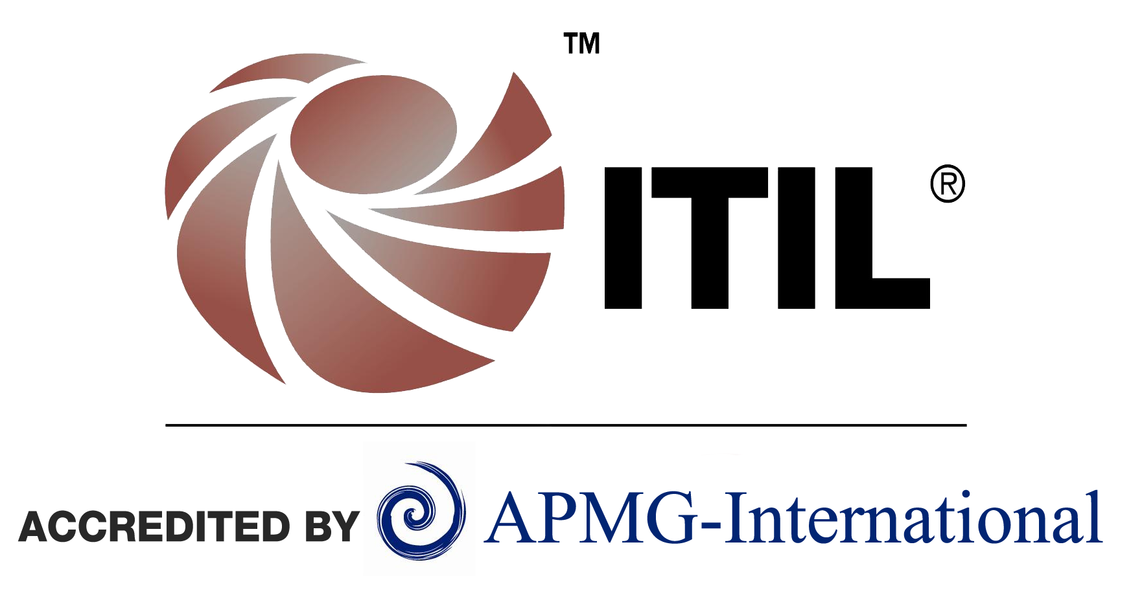



About the ITIL®
ITIL (IT Infrastructure Library®) is the most widely adopted framework for IT Service Management in the world. It is a practical approach to the identification, planning, delivery and support of IT services to the business. It describes how IT resources should be organized to deliver business value, documenting the processes, functions and roles of IT Service Management (ITSM).
ITIL is created and owned by the Cabinet Office. The ITIL best practices are explained in five core guidance publications outlining the fundamental ITIL principles which focus on areas within the service management discipline.

About The Course
The 2-Day ITIL® Foundation Exam Prep classroom course is structured with the goal of providing students exactly what they need to pass the exam. Our study strategy will increase comprehension and retention of key elements while providing students with practical information that can be applied immediately to the project work environment.
ITILstudy provides the Most Comprehensive and Highest Quality ITIL® Foundation Exam Prep Classroom Training. Coursework is primarily based on key topics and areas required for success in the exam. Course includes:
- High quality, comprehensive classroom study materials - nothing additional to be brought for the class
- The cost of ITIL Foundation exam
- Complementary Six Sigma Green Belt online course and 25 PMI® Approved PDUs or Human Resource Development Certification and 20 PMI® PDUs
- 18 PMI® Approved PDUs
- 100% Money Back Guarantee

Classes are typically held from 8AM to 6PM. Lunch, snacks, coffee and tea will be provided.

Proven expertise in quality ITIL training
ITILstudy is an APM Group Accredited Training Organization specializing in providing quality education to prepare students for ITIL Certification Exams.

ITILstudy will be your best partner to ensure success in the ITIL® Foundation Certification Exam.

Best Faculty
Our faculty are the best in the industry and accredited by APMG/CSME. They have extensive industry experience and are trained in ITILstudy classroom training techniques and adult learning processes aimed at delivering an exceptional training experience.

Best Guarantee
We guarantee that you will be successful in your ITIL® Foundation Certification Exam after attending the classroom training program offered by us or we will pay for your exam retake. If you fail again, we will refund your money as per our 100% Money-back policy.

Best Value
We provide the best quality in training for a very economical price and offer classes at convenient locations in major cities nationwide.

Why Choose ITILstudy?
Call Us Today at
1-855-234-8454 or visit ITILstudy.com

