Data Interpretation and Analysis
Kinetics of Color Change in Marionberry Preserves
The color of food is an important component in consumer decisions. Ultraviolet rays from the sun and other chemical processes can break chemical bonds and cause food color to fade. The time that it takes for the color of food to fade depends on the kinetics of the chemical reactions occurring in the food. A company makes marionberry preserves and places the food in sealed glass jars. In one experiment, food scientists place some jars near a window where the preserves are exposed to light and the temperature is kept constant at 25.0 °C. The scientists periodically measure the color intensity of the preserves during a 200-day period. Table A displays the change in color intensity of the preserves (as a percentage of the original) in the presence of light at 25.0 °C. Figure A below plots the data in Table A as a graph.
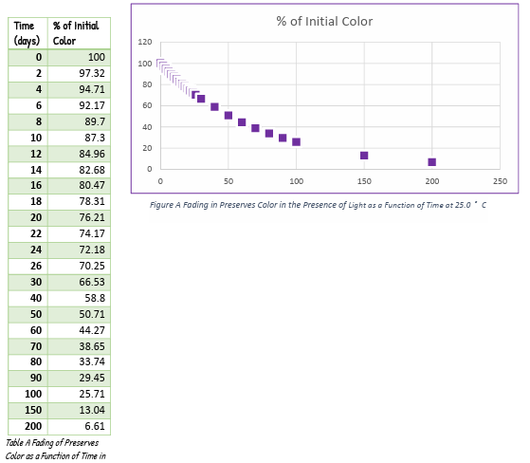
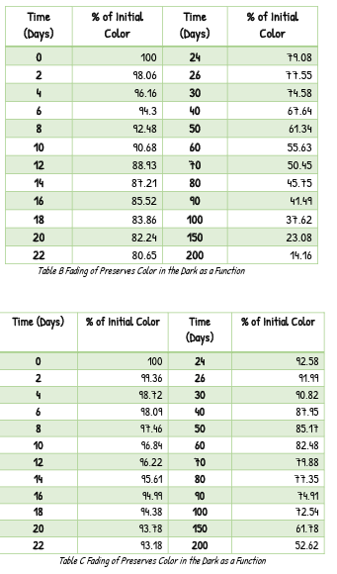
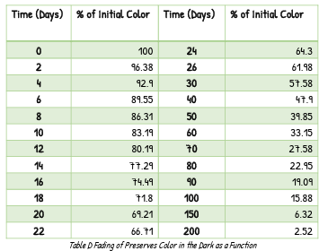
In another experiment, scientists place several jars of the preserves in a dark room. Tables b-d list the color intensity (as a percentage of the original) of the preserves stored in the absence of light at three different temperatures (5.0 °C, 25.0 °C, and 40.0 °C) over a 200-day period. Use the information provided in the figure and the tables to answer the following questions (assume the % initial color is directly proportional to concentration of color-causing compounds in the preserves):
a. Which order of reaction does the degradation of the preserve color follow? Explain and justify your answer.
Since there is the assumption that the percentage of the initial color of the preserves is directly proportional to the concentration of color. Then, the degradation of the color of the preserves follows the first order of reaction because it is proportional to the time amount spent stored and to the concentration of color-causing compounds.
b. Determine k, the rate constant for the preserves stored in the presence of light at 25.0 °C and the rate constant for the preserves stored in darkness at 25.0 °C. Which has the lower rate constant? Assuming color preservation is the goal, is it better to store the preserves in the dark or in the presence of light? Explain.
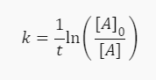
k rate constant at 25.0 °C with light,
k=1/70 days ln(100/38.65) = 0.03697
k rate constant at 25.0 °C in the dark,
k=1/70 days ln(100/79.88) = 0.01789
The rate constant of the preserves stored in the dark at 25.0 °C, seems to have a smaller rate of degradation of color than the preserves stored in the light at 25.0 °C. Apparently, the light makes the preserves lose their color faster in combination with the temperature.
c. Does temperature (5.0 °C, 25.0 °C, and 40.0 °C) influence the degradation of color for the preserves stored in the dark? Explain.
Yes, temperature may affect the color fading of preserves stored in the dark. This is because temperature influences the pace of chemical processes, including those that cause color deterioration. At higher temperatures (for example, 40.0 °C), the molecules in the preserves move quicker and collide more often, resulting in a greater rate of reaction. Colors may deteriorate faster because of this. At a lower temperature (such as 5.0 °C), the molecules travel slowly and clash less frequently, resulting in a slower rate of reaction. This can assist in keeping the colors for a longer amount of time. The rate of color loss would be moderate at a temperature of 25.0 °C.
d. When storing the preserves in the dark, which temperature (5.0 °C, 25.0 °C, or 40.0 °C) has the lowest rate constant? In the dark, is it better to store the preserves at a cool or warm temperature? Explain.
The rate constant of a reaction decreases with decreasing temperature. This is because most reactions are exothermic, which means they generate heat. Molecules have less kinetic energy at lower temperatures, they collide less frequently and with less force, resulting in fewer reactions. As a result, while storing preserves in the dark, the lowest rate constant is at 5.0 °C. It is preferable to keep the preserves at a cold temperature rather than a heated one.
e. Determine the activation energy of the degradation reaction in the dark, Ea, in units of kJ>mol.
k in the dark at a temperature of 25.0 °C = k=1/70 days ln(100/79.88) = 0.01789
k in the dark at a temperature of 5.0 °C = k=1/70 days ln(100/50.45) = 0.02832
ln(0.01789/0.02832) = 0.63171
(Ea/8.3145 J/Kmol)(1/278.15K-1/298.15K) = 0.00201
0.63171/0.00201 =314.28358/1000 = 0.3143 kJ/mol

