Maple CAS calculator software operation using MS Windows with NVDA screen reader

# Maple 2022 Operation

Acknowledgements

Thanks to Robert & Raymond from ASES and Nathaniel from EduVis, for contributing to this document.

Description

• Maple Computer Algebra System (CAS) software can algebraically manipulate unbounded integers, exact rational numbers, real numbers (with arbitrary precision), symbolic formulas, polynomials, sets, lists, equations, arrays, vectors, and matrices. It can solve systems of equations and differentiate and integrate expressions. Maple can run on Windows, Mac & Linux operating systems.

Screen reader Accessibility in Maple 2022

Maple now has an accessibility mode which optimizes the Standard interface for users of the NVDA screen reader. To turn on screen reader mode in Maple 2022: From the Tools menu, select Accessibility > Use Screen Reader Settings. Alternatively, use the shortcut key F10.

Maple 2022 Screen Reader settings (standard interface) are tested and optimized for NVDA. Image of the standard interface in Screen Reader mode is below.

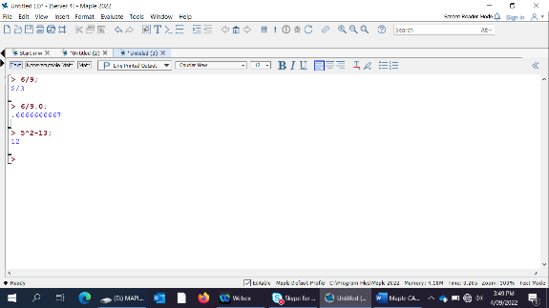

However, JAWS users will still need to operate in the command-line interface by selecting the Windows key, then Maple 2022 (command-line). NVDA users can also operate in the command-line interface if they wish. See picture below of the command line interface.

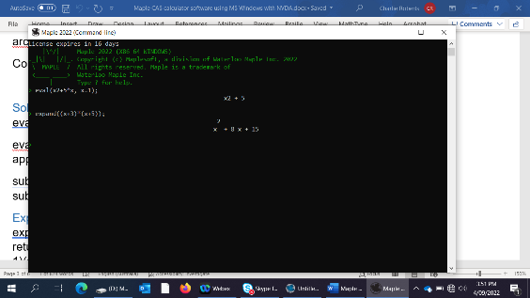

Maple standard interface worksheets and documents can be saved using Alt, File, Save as….

Maple has a range of topic packages. For example, if you want to see commands for Statistics, type ?Statistics. Accessibility options are found at ?worksheet,managing,accessibility.

## Maple 2022 (standard) document types

Ctrl & N will open a new worksheet document, which allows you to toggle between Math & Text entry by using the F5 key.

Alt, (F)ile, (N)ew, (D)ocument: to open in Document Mode, which allows you to toggle between Math, Text, & non-executible Math by using the F5 key. However, the screen reader does not announce the mode.

## NVDA Screen reader commands

* To receive output in 1D (horizontal set out) in Maple 2022; select Alt (T)ools, (O)ptions, right arrow to Display then TAB once to “Input display” and arrow down to Maple Notation. TAB down once again to “Output display” and arrow down to Maple notation.
* For feedback as you type, press NVDA key to toggle the speaking of characters/words. If you are using laptop mode as your keyboard layout, CapsLock should serve as a sufficient NVDA modifier key. If using desktop mode, you may be able to use the Insert key, or numpad Insert.
* Note the following:
  + By default, unless you have modified it, NVDA doesn’t save its settings automatically, so you’ll either have to go into preferences and turn on the ‘save on exit’ option, or otherwise press CTRL+NVDA+C to save configuration.
* Use NVDA+L to read the current input line. Some symbols, such as ^ caret (power of) are not announced when pressing NVDA & L or arrowing up & down. Therefore, **press** NVDA+L **twice for it to be spelt out**. Press three times for phonetic rendering. Alternatively, hold down the NVDA key and press right & left arrows to hear each character announced.
* Use the review cursor to review the previous logs of input and output. Press NVDA+Up/Down arrows in the command line interface, or Up/Down arrows in the standard interface, to go up or down a line in the current Navigator object. NVDA+Left/Right arrows to navigate by character and include the Control key with the left/right arrows to move by word.
* If you have accidentally changed from object to screen review, then press NVDA+PGDN (or page-down) to cycle to object review.

## Common Mathematical Operations

At the end of every command line, you need to input the ';' for Maple to know the line is finished.

x + y - z; addition and subtraction

x * y; multiplication

x / y; division

x^y; power (use NVDA key with L twice to read the term x caret y).

sqrt(x); square root √

exp(x); exponential

sin(x); cos(x); tan(x); trigonometric functions 

arcsin(x); arccos(x); arctan(x); inverse trig functions

Control & space= command prediction in the standard interface.

## Solving

eval(xˆ2+5*x, x=1); evaluates the polynomial x^2 + 5x at x= 1 and returns 6.

evalf(expression ); Numerically evaluates expression and returns its decimal approximation. e.g. evalf(Pi); returns numerical approximation 3.141592654.

subs(x=value,expression ); Substitutes the given value into expression. e.g. subs(x=2,xˆ2+2*x+1); gives 9.

## Expanding

expand(expression ); Distributes the given expression. e.g. expand((x+3)*(x+5)); returns x 2 + 8x + 15. factorising polynomials e.g. factor(4*xˆ2+12*x+8); returns 4(x + 1)(x + 2).

evalf(6/9);

0.6666666667

Eval(6/9);

2/3

square root:

sqrt(8);

2*2^(1/2)

cube root:

root(8, 3);

2

Solve Equations

solve(n/6 = 5);

30

solve(2*b - 4*b = -b + 3);

-3

Inequalities

One step linear inequalities

solve(`>=`(z + 4, 1));

RealRange(-3, infinity)

Exponential Functions

solve(8^x = 9);

2/3*ln(3)/ln(2)

fsolve(8^x = 9);

1.056641667

Monomials

4*u^5 + u^5;

5u^5

(9*u^5)*(3*u^6); need to put asterix between the brackets

27*u^11

(4*g^2)/(4*g^9);

1/g^7

Polynomials

add and subtract polynomials

(5*x^2 + 2*x - 4) + (-2*x^2 + 4*x - 5);

3 x ^2+ 6 x - 9

Multiplying polynomials (expanding)

expand((q - 3)*(q + 3));

q^2-9

Factorising

factor(g^2 + 14*g + 13);

(g + 13) (g + 1)

factor(m^2 - 10*m + 25);

(m-5)^2

Quadratic Equations

solve(2*(y + 4) = 0);

-4

Simultaneous equations

solve({x+y= 6, x-y = 2}, [x, y]); solves the system of two equations

[[x = 4, y = 2]].

## Statistics

call up the stats package by typing the next line:

with(Student[Statistics]):

E.g.1

|  |  |
| --- | --- |
| **>** | Mean([2,4,4.0]) |

|  |  |
| --- | --- |
| 3.333333333 |  |

Compute the mean of data not containing any floating point values. This leads to an exact result.

|  |  |
| --- | --- |
| **>** | Mean([2,4,4]) |

10/3

E.g.2

A:=[5,4,3,2,1]:

Mean(A);

3

Quartile(A,3);

4

Quartile(A,1);

2