Romare Bearden’s Emphasis on Community through his Last Supper

Meghan Gwaltney
ART 4715
Dr. Bullinton
11 November 2009
Romare Bearden’s Last Supper (Figure 1), which is on display at Fisk University’s Carl Van Vechten Gallery, is one of the lesser known works by one of the greatest artists of the Harlem Renaissance. Completed sometime during the 1950s, this piece is part of his early collection of works and therefore was completed before the collage works that he is most known for. However, looking at the life and influences of Romare Bearden makes it possible to interpret this painting. This painting can be interpreted by looking at its emphasis on community, humanity, and religious themes, the formal influences attributed to other artists and Bearden’s interest in jazz music. Though these influences cover everything for formal style to jazz music, cartoons and religious symbols, ultimately Bearden is most influenced by the community that he surrounds himself with. It is this desire for community that speaks the loudest in his piece Last Supper.
Bearden’s Last Supper was completed sometime during the 1950s and has been housed only at Fisk University. The gouache on paper piece was a gift to the University from the Harmon Foundation. There are eight figures in the painting, three closer together on the right side of the piece, four spread out to the left and one reclining figure at the bottom of the paper. The figures are drawn using thick, expressive black lines that flow throughout the piece, moving the viewer’s eye from one figure to another. The figures embrace a sense of fluidity, as the sweeping motion of one figure’s scarf becomes the back of the figure to the right. These lines also emphasize the figures faces and how they consist of geometric shapes and elongated features, referencing Bearden’s African heritage.
In-between the sweeping lines are an array of different colors. Bearden added water to the gouache to create a more watered-down color. His color palette consists of red, yellow, green, blue, gray, brown and red and varies in tone across the paper.
Before an interpretation of the Last Supper, we must first explore Bearden’s origins and how they affected his work. The most important aspect of Bearden’s artistic vision, is his desire for community. This interest was first established when Bearden and his parents moved to Harlem in the 1930s and his family very quickly settled into the circle of the Harlem elite. Bessye Bearden, his mother, very quickly became a member of the New York Urban League and the treasurer of the national Council of Negro Women. She surrounded herself with such influential woman as Mary McLeod Bethune, later founder of Betune-Cookman College and found herself at the center of Harlem’s social circuit. Bearden’s closest circle then included individuals such as WEB DuBois, Robeson Hughes, Aaron Douglas, Duke Ellington and Fats Waller. These great thinkers and artists of the Harlem Renaissance formed the very foundation of Bearden’s views as an African American during this great time of flux. They influenced his way of thinking in such a way that forever defined him as an artist and black man.
The aforementioned artistic community formed the basis of Bearden’s understanding of good art. As a result of the community creativity that he experienced he came to advocate that community is essential for the production of good art. He also believed that art should be emotional and tied to our memories. For Bearden, the most effective way to produce art that linked with memories, was to choose universal subject matter. By the 1940s, Bearden was producing artwork based on archetypal images in literature and Greek mythology. He also began to create works that somehow made reference to Biblical scenes. His 1941 Two Woman in a Landscape (Figure 2) alludes to the two woman that went to discover Christ had risen from his tomb. Their hand gestures mirror those used in Byzantine artwork to announce the risen Christ. This subtle religiosity infused spiritual themes into what appears to be a simple genre scene upon first glance.
Bearden also believed that art should be created for public display and viewing. With this in mind, his choice of literary, mythological and Biblical subject matter is a good one. Their universality makes it an appropriate choice for public viewing because it would appeal to a variety of audiences.
In the years following World War II, the art scene in the United States took a dramatic turn. With the dissolution of the WPA, many black artists no longer received any support for their work and decided to leave the decaying scene of American inner cities. With Prohibition laws in place, jazz clubs no longer flourished and caused many musicians to abandon their art. This sudden change in atmosphere, left Bearden without the creative community that he was so influenced by. Furthermore, in the depths of the Cold War and McCarthy years, many artists were openly silenced or blacklisted. As a result of these changes times, most artists began to move towards a more “private, individual expression and to make no attempt to address larger social issues”.
This move away from social issues, specifically the socially conscious art of the Depression, led artists to pioneer the Abstract Expressionism movement. While these artists embraced nonobjective abstraction with themes of imagination and dreams, Bearden instead focused on biblical themes and literary works. His small figurative pieces were the antithesis to the “action” paintings of Pollock or the color-field exercises of Rothko or Newman”. Bearden began to criticize those artists who worked in isolation, claiming that any good art is created within the confines of a community. He also criticized those who painted images with a lack of philosophical content. This individualism and lack of depth in content was troubling to Bearden. He suggests that art should be expressive and that we can find this expression in universal themes.
While Bearden was heavily influenced in his philosophical approach to art, he also received formal influences from a number of sources. He attended New York University in 1934 and soon after began drawing editorial cartoons for the university newspaper, New York University Medley. This first dive into art proved to be the beginning of his developing style.
About a year after graduating from NYU, Bearden attended New York’s Arts Student League. It was here that he gained an appreciation for a variety of styles including Byzantine mosaics, 15th century Italian mosaics, Dutch genre painting, African art and Chinese landscape. He also found influence from specific artists, such as Matisse, Picasso and Mondrian. Most importantly, it was during this time that he was introduced to George Grosz (Figure 3), German expatriate and master of political satire cartoons. Grosz introduced Bearden to the work of Käthe Kollwitz and Honoré Daumier. Through his work as a cartoonist, Grosz’s style involved a great deal of sure expressive lines and delineating, realistic figures. Bearden was also working as an editorial cartoonist for the Baltimore, an African American magazine. This period of formal exploration culminated near the mid 1940s with a style that defined by flat, geometric shapes, abstract figures and blocks of color.
Through his community of influence, Bearden met American abstractionist Stuart Davis in 1940. Davis encouraged Bearden to find a way to unite his paintings with the modern cultural endeavor of jazz music. Davis was particularly interested in the work of Earl “Fatha” Hines, and encouraged Bearden to listen closely to his work. Upon listening, Bearden remembers, “I listened for hours to recordings…finally I was able to block out the melody and concentrate on the silences between the notes”. Bearden took the vibrant rhythm of jazz sounds and transformed them into vibrant sprays of color on his canvas. He also took the quiet lulls of the music and represented them in his painting as spaces between the bold, expressive lines that flow like musical notes along sheet of music.
Bearden praised Davis for helping him to see the musical conventions of Harlem musicians in the same realm of avant garde painters as Picasso, Mondrian, Braque and Matisse. This recognition was crucial because it encouraged Bearden to embrace something that he “had inherited from [his] African American environment” and to further develop his style within the confines of his heritage and traditions.
Intellectualizing his work was at the very center of Bearden’s paintings. His text, A Painter’s Mind, is laden with references to “slide rules, Euclidian geometry, Copernicus, the invention of calculus and Sir Issac Newton’s readings in trigonometry”. He reference several style such as Byzantine architecture, Cubist works and Chinese paintings, using these styles to examine the use of voids and negative space. He was particularly interested in the space that is in-between the objects of a painting. This interest in Chinese paintings mixed with his fascination of silence in jazz music, speak to his interest of time and space. The third cornerstone of Bearden’s vision of art is color. Jazz music was especially helpful to him in the “transmutation of sounds into colors…[and to] achieving artistic structures that are personal to [him]”.
Bearden’s first solo exhibit was held at the Kootz Gallery in Harlem in October of 1945. This exhibit, entitled “The Passion of the Christ” featured twenty-four images of biblical scenes from the New Testament. Within two weeks, twenty of the images had been purchased and most prominently, the Modern Museum of Art purchased He is Risen (Figure 4), being the first museum to purchase Bearden’s work. It was this exhibit that established Bearden as a significant artist. Critics praised his exhibit and Carl Van Vecthen referred to Bearden as the “Negro Rouault” This exhibit embodies Bearden’s vision of community, humanity and universality in art. In a statement written for the exhibit Bearden said, “this myth (of the lift of Christ) is one of the greatest, perhaps the greatest, expression of man’s humanism, in none of the other mythological or religious concepts is this sheer human quality so poignantly expressed”.
Formally, this exhibit typifies Bearden’s style of the mid 1940s. By 1944, Bearden was using the thick contours of line to map movement and placement on the canvas. These black lines then created a linear web that stretched across the canvas, influenced by the internal dynamic of both thrust and canter. This fluidity of movement is directly from his interest in jazz music and rhythm. The figures in his works displayed in the Passion of the Christ exhibit, look similar to African sculptures (Figure 5), in their cubist like appearance. His interest in color during the 1940s was mainly centered around the juxtaposition of opaqueness with transparency. He uses this contrast in the Passion exhibit, alternating between opaqueness and transparency in the spaces between the expressive lines. Bearden said that it is this “disharmony [that] helps to move the eye” along the canvas.
After exploring Bearden’s numerous influences, it is easier to provide an accurate interpretation of his Last Supper. This piece simultaneously exemplifies all of his formal training as well as social influences. This piece shows his emphasis of community and humanity, as well as the influence that jazz rhythm had on his work. This piece has also been influenced by his formal training and study with Grosz. Finally, the piece is a religious theme that fits into the collection of work that he had been working on for several years prior to this one.
Bearden was heavily influenced by the artistic and academic community that he was a part of as a result of his mother’s social network. He was constantly surrounded was by individuals who were leading the progress of the Harlem Renaissance. As a result, he put a great emphasis on community and felt that good art was art that was universal, or art that brought us into community with others. This piece depicts the Last Supper which is one of the greatest examples of community in the Western world. The breaking of bread is one of the most communal acts that humans can participate in. Furthermore, the disciples here are breaking bread with Christ right before his Crucifixion. Bearden himself said that Christ is the most universal vision of humanity. Here is this one painting, Bearden has effortlessly represented the importance of community as well as the humanity that we all share within that.
He also was greatly influenced by the emerging jazz music scene in Harlem during the 1930s. The fluidity of the lines in this piece move across the paper as notes would music across a staff. The width of each lines varies and makes references to the varying lengths of notes within a musical score. The viewer’s eye is drawn throughout the painting by this expressive line that moves from thick to thin as it sweeps over the table, across figures and then down towards the table again. Within each space that has been created by this melodic line, lies a color that can be compared to silence within a musical composition. Bearden said strove to “concentrate on the silences between the notes” and the space here seems to be just that, silence that he has chosen to fill with color.
These expressive, black lines appear to be form the influence Bearden received from working as a cartoonist while in college and from the work that he did alongside George Grosz. During their time together, Grosz introduced Bearden to other artists and their influence is also visible in this piece. As Bearden explored the modern cubist movement he found influence in Picasso which is seen here in the elongated, geometric faces of the figures in Bearden’s Last Supper.
During the 1940’s, Bearden focused a great deal on religious artwork. From his Passion of the Christ exhibit as well as other pieces such as Two Women and a Landscape, his interest in religious imagery is quite clear. Part of his interest in this is due to the aforementioned interest in community and humanity, for Bearden religious pieces were the ideal way to intersect those two artistic visions. With this in mind, Last Supper fits nicely into the collection of pieces that he was doing around this time period, especially when related to subject matter. However, clearly it is also possible to see that this works fits into his stylistic choices of this time.
Romare Bearden’s Last Supper seamlessly joins together all of his greatest influences. He was forever changed by the artistic community that surrounded him from childhood and their teachings of embracing one’s heritage and pursuing creativity are shown through the slight Africanisms in this work. Also he was influenced by several formal styles and European artists, whose influence we see here through the thick expressive lines and cubist like features. He found inspiration in jazz music, evident through the fluidity of this piece and finally, his earlier works center around religious themes as Bearden strives to embrace the universal. Each of these influences comes back to community—the artists that surrounded him as a child, the community of teachers that developed his personal style, the community that jazz music creates within the greater African American community and finally, by depicting universal themes such as the Last Supper the community that we all share as human beings. These communities shaped Romare Bearden, his artwork and certainly his Last Supper.

Works Cited

Campbell, Mary Schmidt. “History and the Art of Romare Bearden.” Memory and Metaphor: The Art of Romare Bearden, 1940-1987. Oxford UP: New York, 1991.
Patton, Sharon F. “Memory and Metaphor: The Art of Romare Bearden, 1940-1987.” Memory and Metaphor: The Art of Romare Bearden, 1940-1987. Oxford UP: New York, 1991.
Patton, Sharon F. Romare Bearden: Narrations. Org. Lucinda H. Gedeon, Ph.D. and Dede Young. Neruberger Museum of Art, 2002.
Price, Sally and Richard Price. Romare Bearden: The Caribbean Dimension. Philadelphia, University of Penn Press, 2006.
Schwartzman, Myron. Romare Bearden: His Life and Art. Abrams: New York, 1990.
Image Reference
Figure 1
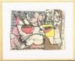
Romare Bearden
Last Supper
Carl Van Vecthen Gallery, Fisk University
(I apologize for the size of this image, it is from the Van Vecthen Gallery Web Page and the only image anywhere that I was able to locate)

Figure 2
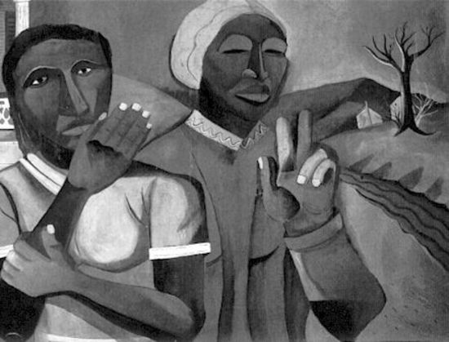
Romare Bearden
Two Women in a Landscape

Figure 3
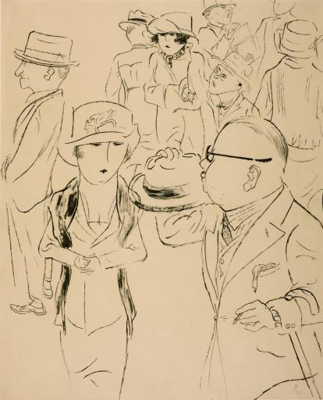
George Grosz
The Mirror of the Bourgeoisie
Tate Museum

Figure 4
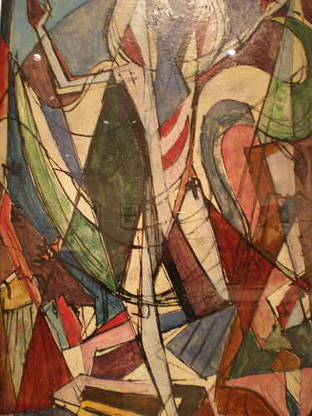
Romare Bearden
He is Risen
Indianapolis Museum of Modern Art

Figure 5
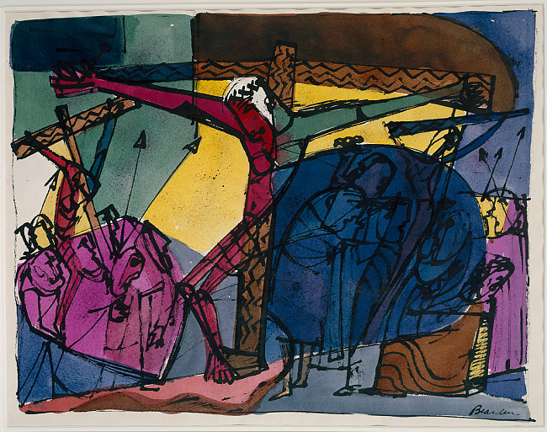
Romare Bearden
Golgotha
Museum of Modern Art, New York

Myron Schwartzman. Romare Bearden: His Life and Art. (Abrams: New York, 1990), 67-68.
Sharon F. Patton. “Memory and Metaphor: The Art of Romare Bearden, 1940-1987.” Memory and Metaphor: The Art of Romare Bearden, 1940-1987. (Oxford UP: New York, 1991), 23-24.
Mary Schmidt Campbell. “History and the Art of Romare Bearden.” Memory and Metaphor: The Art of Romare Bearden, 1940-1987. (Oxford UP: New York, 1991), 13.
Ibid, 14.
Patton, Memory, 27.
Sharon F. Patton. Romare Bearden: Narrations. Org. Lucinda H. Gedeon, Ph.D. and Dede Young. (Neruberger Museum of Art, 2002), 9.
Ibid, 9.
Sally Price and Richard Price. Romare Bearden: The Caribbean Dimension. (Philadelphia, University of Penn Press, 2006), 27.
Ibid, 29.
Patton, Memory, 27.
Patton, Memory, 30.
Patton, Memory, 31.

