Whitney Seals

Professor Bullington

African American Art History

20 October 2009

Aaron Douglas: *Building More Stately Mansions*

For the New Negro Movement

African-American art throughout the centuries has undergone many obstacles, prejudices and movements. Through the combining of African culture and African American culture we can see and feel a distinct artistic style of its own. From the early days of slavery to the emancipation proclamation to the present struggles and triumphs proceed to evoke African-American art. One movement in particular raised the need and opportunity for black artists to perform and create art. The Harlem Renaissance and new Negro movement coincide with each other to allow blacks to move forward in the arts and take economical control as well. Aaron Douglas made a huge and influential impact on the Harlem renaissance, and he opened the door for African American artist at this time and in the future. His famous artwork, *Building More Stately Mansions*, (Fig.1) is a key example of his contribution to this movement, and it conveys the overall theme of African-Americans rising above and progressing in society.

The 1920’s black cultural movement known as the Harlem Renaissance caused attitudes in American society to change toward blacks especially through art (Davis 1984). Alaine Locke a professor and philosopher created the phrase of “the New Negro.” The term was used to denote social and economical improvements since slavery. The image of African Americans that Locke presented in *The New Negro* is one of a fully modernized people with national significance. This progress, is expressed through literature, art and music, and it is in step with that of cultures around the world. The wording of Locke’s references to the *New Negro* points to the kind of simplification and generalization that can accompany the concepts of race (Carroll, 2005). In Essence it was a revolt against traditional values and an exploration of new ideas. African Americans seized the opportunity during the interwar period to promote political, economical and social agendas that would benefit the black community nationally (Patton, 1998).

Literature, theatre, visual arts and, later, music were seen as a means to define and establish ‘membership in the African or black race’ and, simultaneously to enhance the reputation and self-esteem of African-Americans in America. For the New Negro artist, African art was to replace the classical art of ancient Greece and Rome, which was the foundation for western art and art criticism (Patton, 1998). Many artists during this era were self taught artists or those who had minimal education. Others were seen by their works and asked to join the cause.

Aaron Douglas was an art teacher in Kansas at the time, Charles S. Johnson saw his works. He then encouraged him to move to Harlem to pursue his art career (Patton, 1998). Douglas soon began integrating African design in his work, which caught the attention of Alaine Locke, who later called Douglas the “pioneering africanist (African American world). He quickly became friends with Alaine Locke and W.E.B. Dubois (Patton, 1998). Douglas went on to design and illustrate Alaine Locke’s “The New Negro” and contributed to many other pieces (African American World, 2009). Douglas’s unique style, seen in *Building More Stately Mansions*, emerged during intense engagement with other African-American artists, writers and musicians whom he encountered when he moved to Harlem (Aaron Douglas, 2008). Douglas, and other artists and writers who migrated from the Midwest to New York, did not carry the heavy burden of the South directly; thus they may have been freer to explore and innovate (Douglas, 2007).

One of Douglas’s works known as “*Building more stately mansions*,” really stands out and represents the New Negro movement with in its styles and elements, including the overall theme of Africans and African-Americans. Douglas connected his images to both history and modernity through expressive representation of architectural structures, including that modernist icon the urban skyscraper. Redolent with suggestion, architecture is symbolic of the mind, of expansion and possibilities, of cities and urbanism, of future growth and ancient civilizations (Douglas, 2007). The piece was completed in 1944, it is a medium size work from 54 by 42 inches. Oil paint is the primary medium used in this artwork and the actual piece itself can be found at Fisk University in the Carl Van Vechten Gallery in Nashville, Tennessee (Aaron Douglas, 2008). Douglas uses silhouetted figures, concentric circles, historical architectural structures and muted art deco color, of which he is most famous for. The subject matter honors the contributions that black workers made to great civilizations of the past. The title *The Building More Stately Mansions*, implies that the blacks’ movement from Africa to America embodies a progression, not unlike the development from youth to adulthood (Bingham, 1990). This painting was inspired by a poem by Oliver Wendell Holmes, “the Chambered Nautilus.” Here is an excerpt from the poem.

Build more stately mansions, O my soul,

As the swift seasons roll!

Leave thy low-vaulted past!

Let each new temple, nobler than the last,

Shut thee from heaven with a dome more vast,

Till thou at length art free,

Leaving thine outgrown shell by life’s unresting sea! (Holmes, 1895).

*Building More Stately Mansions* symbolizes the labor of black men and women in the creation of great architectural monuments. Aaron Douglas silhouettes these active figures against a utopian background. He uses concentric circles or bands of muted color to suggest waves of history and knowledge linking building of pyramids, temples and churches to the skyscrapers of present and future (Aaron Douglas, 2008). Douglas clearly evokes the continuities that link African and Egyptian laborers with twentieth century African Americans in this piece (Brigham, 1990). Modern building recall primitive stone temples, narrow triangular church steeples evoke Egyptian pyramids. The upward looking figure in the bottom right refers to the Egyptian profile in the upper left (Brigham, 1900). Skyscrapers symbolize modernity for Aaron Douglas, and other artists at this time, in the United States, Europe and elsewhere. Douglas portrayed these iconic structures in a variety of ways: stewed or splayed, stately and towering, suggestive of an actual destination, and often on a bill. He endows the towering buildings with mystery and power, as though they are orators on the mountain top (Douglas, 2007). In this painted collage of layered forms, sculpture and architecture both seem to emanate from a fantasy landscape that encompasses everything from an Egyptian sphinx to a church spire to a modern day construction crane. What links them all are education and labor of African Americans (Douglas, 2007).

Douglas was keenly aware of how significant African-American labor was to the country’s economy and history, which was a point he referenced in his art. With the pull of urbanism competing against a worker’s prospect in the rural South or the plains of the Midwest, younger laborer looks left over their shoulder toward the east as a possible exit from rural labor, just as Douglas had looked to the lure of city life in New York (Douglas, 2007). In addition to scenes dealing with labor, Douglas creates easel and mural paintings that allude to continuities between African culture and African American music, dance and religion (Brigham, 1900). The most recognized murals he created during the 1920’s-1930’s were on subjects such as the ‘Evolution on Negro dance’ (Fig. 2) and ‘the Negro in an African setting’ (Fig. 3) . The murals highlight the many achievements of African and African American culture (Gasman, 2002). Douglas spoke sympathetically of socialism, pictorially he chose African conventions that aligned him with the New Negro movement (Brigham, 1900).

Douglas was known for his treatments of subjects from black history and culture that used angular, silhouetted figures in a manner reminiscent of cubism and ancient Greek vase painting (Gasman, 2002). He believed that flattened pictorial space, tonal rather than coloristic variation, and heavy relevance on geometry and line rather than form and space were pictorial conventions routed in African traditions (Brigham, 1900). Douglas disregarded realism for a more abstract African style. His early black and white drawings as well as ‘Rebirth’ (Fig. 4) displayed forms conforming to hard-edged abstract design similar to art deco paintings of the 1920’s and 1930’s (Patton, 1998).

Human figures stylized and compliment schematic patterns, and they are both flat shapes. While referring to the geometric language of modernism, his transparent circles transcend geometry to become sources of light that are precise yet mystical, almost metaphysical. Douglas’s concentric circles and overlapping transparent planes may symbolize the layered consciousness of African Americans, giving visual form to concepts set forth by Du Bois, Hughes and other key figures of Douglas’s era who sought to resolve the dualities of being both black and American (Douglas, 2007). Aaron Douglas’s signature style was what he called ‘Egyptian form.’ Figures are silhouetted in profile with the eye rendered from a frontal viewpoint as seen in ancient Egyptian tomb reliefs and frescos. His use of single color, varying from light to dark adds more depth. The gradually enlarged circular shapes of color create a visual rhythm, evocative of music and spirituality (Patton, 1998). Douglas’s layering of two somewhat contradictory elements echoed the works of European artists on the eve of World War I who combine abstract with figuration- although without the subtle sense of actual and conceptual layers that Douglas achieves (Douglas, 2008).

Aaron Douglas had many other works including; *Into Bondage*, *Rebirth*, *Crucifixion*, *Idyll of the Deep South*, *the Creation*, *Power Plant in Harlem*, andThe *Old Water Works* (Fig. 5,6 and 7) just to name a few. Almost all of Douglas’s artwork is very similar in the visual elements and styles. The same silhouetted figures are found in most of his works and the muted tonal colors instead of bright coloristic. Concentric circles can be found in the pieces as well. In *The Old Water Works* and *Power Plant in Harlem*, the artist has a totally different style pattern. These two works are more like landscapes, actual pictures of a scene, and have no human involvement in them. They are very different from the typical Douglas pieces people are familiar with. In his *Power Plant in Harlem,* the panting is marked by a naturalistic style that rarely gets attention in scholarship on Douglas’s works. The artist employs the geometric shapes usually evident in his other pieces and explores abstract forms, using a looser brush stroke than in his works with silhouetted figures and transparent overlays (Douglas, 2007).

Painting was not the only aspect of art that Aaron Douglas connected with he collaborated with many other artists in the movement. The young artists, writers, dancers and musicians he met in Harlem believed creative expression could help define a unique racial identity and simultaneously bridge the divide between black and white communities. Douglas collaborated with Harlem Renaissance writers like Langston Hughes, James Weldon Johnson and Claude McKay to create book jackets. He also worked with Wallas Therman, Zora Neal Huston and co-founded *Fire!!*, a quarterly journal devoted to the younger Negro artist. Douglas was also apart of James Waldin’s *Gods Trombone: Seven Negro sermons in verse*.

Douglas’s imagination and forceful ideas, his distinctive artistic form, combine to produce the most powerful visual legacy of the Harlem Renaissance, and made a lasting impact on the history of art and the cultural heritage of the nation (Aaron Douglas: African American Modernist, 2008). Douglas grounded his theory of modernism in many things, including a politicized sense of identity, a layering of condensed space, a blue aesthetic, and the use of geometry and silhouettes to suggest history and offer a stylized sense of modernity. He forged a powerful new aesthetic that was conceptual as well as physical, spiritual yet very real, political yet strongly visual, articulated through mural paintings, book and magazine covers, and illustrations. His aesthetics has influenced generations ever since (Douglas, 2008). *Building More Stately Mansions* is a great example of Douglas’s unique stylization and reoccurring theme of black labor and progression through history.

Works Cited

"Aaron Douglas: African American Modernist." *Traditional Fine Arts Organization*. Traditional Fine arts organization Inc, 2008. Web. 18 Oct. 2009. <http://www.tfaoi.com/aa/7aa/7aa980.htm>.

"Aaron Douglas." *Fisk university Galleries*. 2008. Web. 17 Oct. 2009.

"African American World |." *PBS*. Web. 20 Oct. 2009. <http://www.pbs.org/wnet/aaworld/>.

Brigham, David R. "Bridging Identities: Dox thrash as African American and Artist." *Smithsonian studies in American art* 4.2 (1990): 27-39. University of Chicago Press. Web.

Carroll, Anne E. *Word, Image and the New Negro*. Bloomington, IN: Indiana university, 2005. Print.

Davis, Donald F. "Aaron Douglas of Fisk: Molder of black artists." *The journal of Negro History* 69.2 (1984): 95-99. Association for the study of African American life and history, Inc. Web.

Douglas, Aaron. *Aaron Douglas*. Lawrence, KS: Spencer museum of art, 2007. Print.

Gasman, Marybeth and Edward Epstein. "Modern art in the old south: The role of the arts in Fisk universities campus curriculum." *Educational researcher* 31.2 (2002): 13-20. American educational research association. Web.

Holmes, Oliver W. *The complete poetic works of Oliver Wendell Holmes*. Boston: Mifflin, 1895. Print.

Patton, Sharon F. *African American Art*. Oxford UP, 1998. Print.

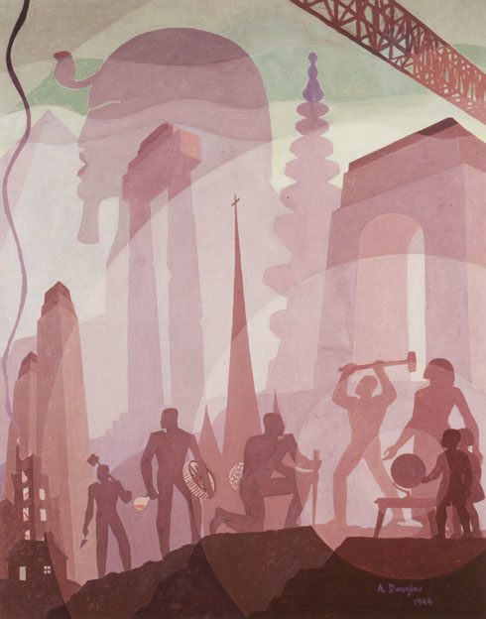

Fig. 1

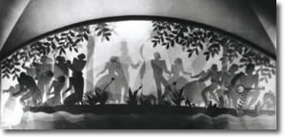Fig. 2

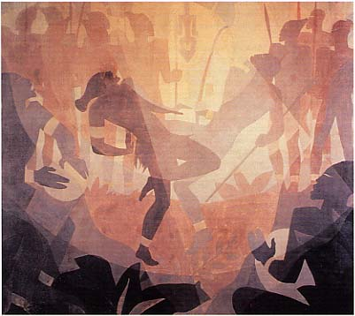

Fig. 3

 Fig. 4

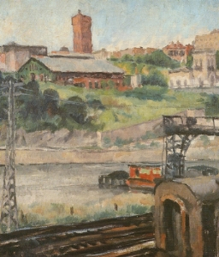 Fig. 5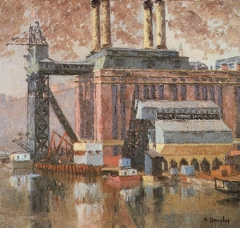 Fig. 6

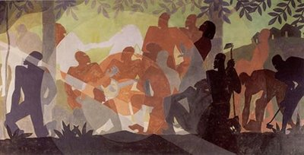

Fig. 7