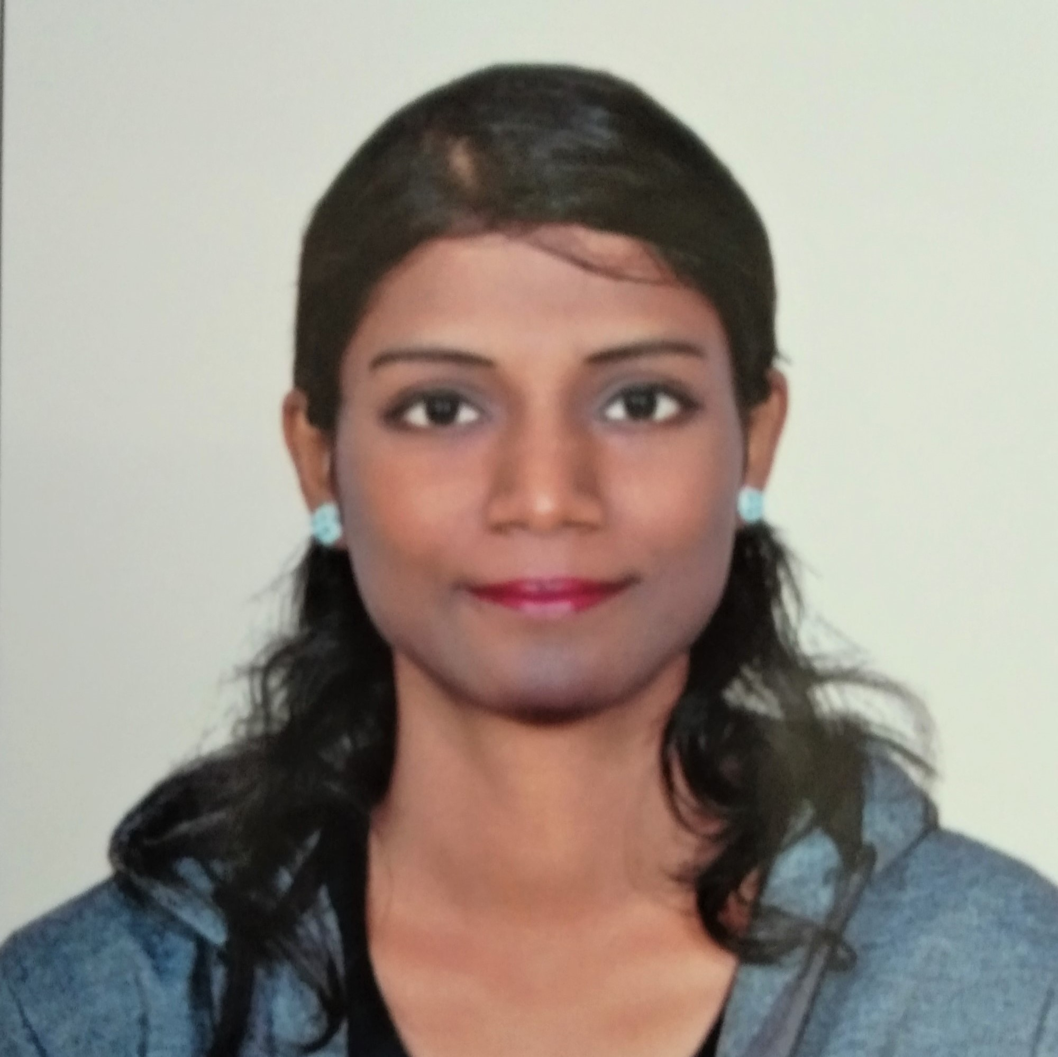
Vidya. T
Operations Executive and Customer Executive Representative
Customer Executive Representative having 5+ years of experience with Pitman Shorthand skills and good typing speed. Proficient with handling and interacting with client in the process.
WORK EXPERIENCE

Concentrix
Senior Representative
3 Year : Feb 2020 – March 2023
- Part of Adobe Creative Cloud, OnePlus, Instakart Process.
- Managing and handling order delivery issues. Troubleshooting critical customer requests.
- Involved in process handling both chat and mails.
- Recognized for achieving quality score of more than 90% consecutively.
- Recognized for achieving customer satisfaction of 94% consecutively.

Aegis Customer Support Services
Executive in Operations
1 Year : 2018 – Feb 2020
- Was part of process involved in handling international and Indian clients of ClubFactory.
- Handling customers and sellers involved in the process.
- Managing and handling order delivery issues.
- Ranked #1 in handling customer requests and troubleshooting consecutively.
- Ranked #1 in quality metrics consecutively.

C-DOT (Centre for Development of Telematics)
Apprentice in Administration
1 Year : 2012 - 2013
- Working closely with CEO of C-DOT on Drafting Notice meetings and scheduling them respectively.
- Proficient with Shorthand skills and Typing.
- Handling Mediclaim, flight bookings and other corporate contracts.
- Maintaining incoming calls and managing activities related to the workflow.
 | thomasdiya24@gmail.com |  | +91 8754193229
 | 8/346 C, Othaveedu, Duraiyoor, Gangaikondan, Tirunelveli, Tamil Nadu - 627352

SKILLS
f
Office applications (MS Word, MS Excel, MS PowerPoint), Pitman Shorthand, Typing speed of 60WPM, Highly skilled at handling customers.

EDUCATION
f
Diploma in Commercial Practice
English Specialization
Graduation Year 2016 – 65%

Bachelor of Commerce
Mysore Board
Graduation Year 2012 – 60%

Pre University (12th standard)
Tamil Nadu Board of Secondary Education
Graduation Year 2008 – 75%

SSLC - CBSE
KV. Rail Wheel Factory
Graduation Year 2008 – 54%

PERSONAL INFORMATION

Date of Birth : | 24th August, 1990
Gender : | Female
Language Proficiency | English, Hindi, Tamil, Kannada
Nationality : | Indian (by birth)
Hobbies : | Reading books, drawing and painting, listening to music

I hereby declare that the above furnished information is true to the best of my knowledge.
Provided an opportunity, I promise to give the best of my abilities to the organization.

Vidya T

