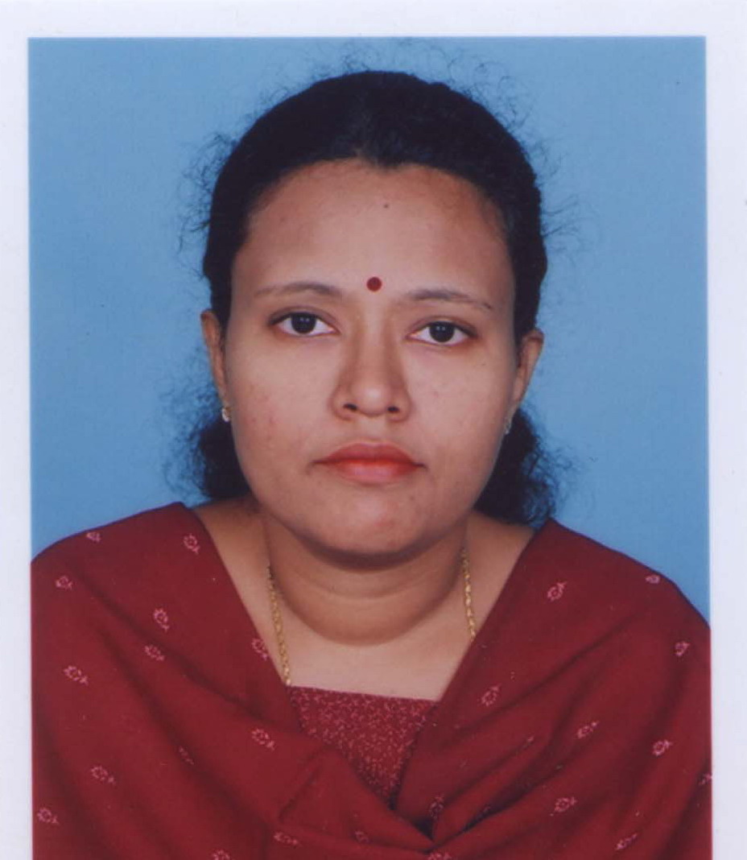

KARTHIYANI DEVI.A.J
Kerala devi2571997@gmail.com
Mobile:+919400571997
Res: +914712571997

OBJECTIVE
To secure a challenging position where I can effectively contribute my supervisory and technical skills and abilities in the Industry that offers Professional growth while being resourceful, innovative and flexible.
Area of expertise

System & Network Administration, Technical Support and Office Administration

WORK EXPERIENCE – 10 Years

 | Company | : | State Level Nodal Agency Integrated Watershed Management Programme
 | Position | : | State Level Management Information System (MIS) Co-ordinator
 | Period | : | July 2013-Present
Responsibilities
- Handling all correspondence and organizing contact between the State and Central Team
- Reporting to the Chief Executive Officer
- Attends Video Conferences, regular management and operation meetings
- Coordinates the administration, maintenance, and training associated with the Project
- Prepares MIS Reports - Financial and Physical progress of the project
- Periodic monitoring & analysis of the Project
- Responsible for hardware and software installation, maintenance and repair.
- Performing routine audits of systems and software.

2 | Company | : | Kerala State Electronics Development Corporation Ltd. (KELTRON)
 | Position | : | Engineer
 | Period | : | April 2011–July 2013
Responsibilities
- ERP Implementation,
- System Administration
- Networking.
- Website updation with added features.

3 | Company | : | National Informatics Centre, Kerala
 | Position | : | Programmer
 | Period | : | October 2009 – March 2011
Responsibilities
- Programming using PHP, Postgresql
- Train users regarding the technical aspects and use of software packages.
4 | Company | : | Command IT Solutions Trivandrum
 | Position | : | Network & System Administrator
 | Period | : | January 2008 – July 2009
Responsibilities
- System / Networks and hardware requirements of the whole the company
- Configure and Maintain Windows 2003.
- Configure Network Services like TCP/IP Services, DNS, DHCP, WINS.
- Crimping and configuring LANs.
- Network Troubleshooting
- Backup & Restore the data on Windows 2000/XP/2003.
- Secure resources with Shared folder and NTFS Permissions
- Monitoring and Optimizing Performance in Windows 2003.
- Windows2003 based network on all flavors of Microsoft Windows based operating systems.
- Managing User Accounts and Group Accounts in Windows 2000/2003 Environment.

5 | Company | : | Job India Consultancy, Trivandrum
 | Position | : | HR Executive
 | Period | : | June 2007 – Dec 2007
Responsibilities

- Time Sheet preparation
- Salary Distribution
- Cheque keeping and Distribution
- Performs other related duties as may be determined by the immediate head from time to time.
- Supports management decisions, requirements and expectations.

PROFESSIONAL CERTIFICATIONS

Microsoft Certification | : | Microsoft Certified Professional (MCP)
Cisco Certification | : | Cisco ID No. CSCO11746122
RHCE Certification | : | Certificate No. 805010037355760
IELTS Score | : | Band 7
TECHNICAL SKILLS
Softwares | : | C, C ++, C#,PHP, QGIS
Platforms | : | Windows xp/98,2000,2010,Windows 2003 Server
Concepts | : | Networking, operating system
DBMS Packages | ; | MS SQL Server 2000,ProgreSQL,Oracle
Front End | : | VB 6.0
Application Package | : | MS Office

ACADEMIC PROFILE

B. Tech Computer Science

College | : | P.A.Aziz College of Engineering and Technology
University | : | Kerala University. 2003-2007
Percentage | : | First Class

MBA - Operations Management

University | : | IGNOU
Division | : | First Class

B.Sc Mathematics

College | : | N.S.S.College For Women Neeramankara
University | : | Kerala University. 1997-2000
Percentage | : | First Class

M.Sc Mathematics

College | : | University College, Kariavattom
University | : | Kerala University. 2001-2003
Percentage | : | Course Completed

PERSONAL PROFILE
Name | : | Karthiyani Devi.A.J
Father’s Name | : | Jayakumar.R.S
Sex | : | Female
Martial Status | : | Single
Nationality | : | Indian
Passport No | : | R1994814
Date of Birth | : | 11-11-1979

I hereby declare that all the details presented are true to the best of my knowledge

Karthiyani devi.A.J

