10+ years of experience in Software Development – IT 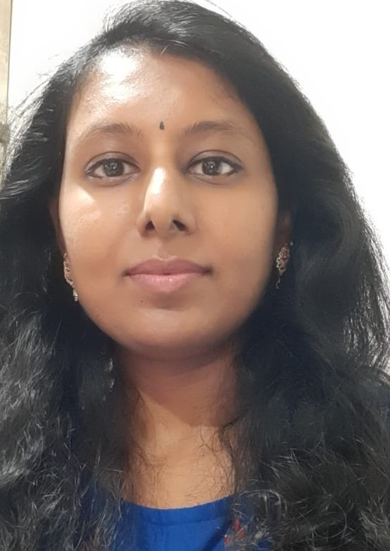

Chaithra B S E-Mail: chaithrabigmudre@gmail.com
Mobile: 91 –9964095525

Experience in

- Databases: Oracle 10g/11g/12c, MS SQL Server 2008/2014, IBM DB2
- Languages: Oracle PL/SQL, T-SQL, Javascript, Shell Script, PHP
- Technologies: HTML, DHTML, ExtJS,, JSON, SSIS Packages, SSRS Reports
- Operating Systems: Windows 9x/XP/2000, Linux

Work History

Working as an Advisor in Evry India Pvt. Ltd
From June 2022 – Till Date

Worked as an Advisor in DELL International Services Pvt. Ltd
From June 2014 – January 2021

Worked as a Senior Consultant in Oracle Financial Services Software Pvt Ltd
From March 2012 – September 2013

Worked as an Application Developer in IBM, Bangalore (Employee of DynPro India Pvt Ltd)
From July 2010 – March 2012

PROFESSIONAL SUMMARY
- Coordinated technical teams with the product implementation teams and managerial personnel.
- Experienced in designing in databases like Oracle , MS SQL SERVER, IBM DB2, MySQL.
- Experienced in writing complex Stored Procedures, Triggers, Packages, Functions, Views, Materialized Views, Collections.
- Having in-depth knowledge of Oracle PL/SQL, T-SQL.
- Hands on Query Performance Tuning, Partitioning, Analytical Functions, SQL Loader
- Experienced in creating Dynamic queries.
- Experienced using tools like Toad, SQL Developer, Git, Control-M (Scheduling tool)
- Experienced in creating Shell Scripts
- Experienced in SSIS (ETL) data migration
- Experienced in SSRS report generation
- Experienced in development of web applications using Object Oriented technologies.
- Experienced working in Agile/Scrum teams (Azure DevOps, TFS)
- Upskilled with Python
- Strong desire to adapt to new technologies and ability to grasp new technologies.
EDUCATION
- B.E. in Information Science from JSS Academy of Technology, Bangalore (Karnataka), VTU University.

Project#1:

Title : HMS PHOENIX
Team size : 9
Duration : June 2022 to Till Date

Description:
HMS is an enterprising healthcare which provides the broadest range of healthcare cost containment solutions and maintains the nationwide eligibility data for all the carriers in United States. HMS helps the clients to ensure that healthcare claims are paid properly and by the responsible party.

Claim Information and Eligibility Information which has the individual Information like First name, Last name, Policy details, DOB, Address etc is captured in Phoenix system for every client of HMS.
In phoenix, claims corresponding to each client are processed every month (Cycles). The claims go through a series of processes in order to identify from whom the claim has to be billed.

Responsibilities:

- Detailed Analysis of the requirement gathered from business.
- Planning and DB Design
- Developed backend processes (Complex Procedures, Functions, Packages, Triggers, Views, Collections, Jobs)
- Worked on Shell Script (Linux Platform) for file management
- Worked on report generation
- Worked on Data Migration
- Testing and Deployment
- Production Support

Environment: Oracle 12c, Oracle PL/SQL, Java , Angular Java, Informatica, Shell Script, Microsoft Sql Server 2019 , T-SQL, SSIS, Agile(Azure DevOps)

Project#2:

Title : Preference Management Center
Team size : 10
Duration : June 2014 to January 2021

Description:
A centralized global data repository to reduce legal exposure caused by the possibility of different systems reporting different preferences for a customer. It ensures consolidation and consistency of customer preference data across all regions to address the challenges currently being faced in DELL.
It provides the capability to onboard new subscribers to customer preference data updates quickly and improves the visibility of a customer’s preferences in key systems.
Responsibilities:

- Worked on Oracle PL/SQL,T-SQL(Sql Server)
- Designed Oracle DB Structure
- Developed backend processes (including Procedures, Functions, Packages, Triggers, Views, Collections, Jobs) in both Oracle and Sql Server DB.
- Worked on Shell Script (Linux Platform) for file management
- Worked on Oracle Queue Messaging system.

Environment: Oracle 11g/12c, Oracle PL/SQL, Informatica, MS Sql Server 2015, T-SQL, Shell Script, JSON, SSIS Packages, Agile methodology

Project#3:

Title : FLEXCUBE Universal Banking
Team size : 4
Duration : April 2012 to December 2013

Description:

FLEXCUBE Universal Banking is an IT solution provider to the banking industry that supports the needs of retail, corporate, and investment banking. With Oracle FLEXCUBE, banks can address customer needs, empower knowledge workers, and provide much-needed agility to their IT divisions.
This helps banks implement the latest technology, allowing customers to have a seamless experience across channels.
Responsibilities:

- Worked on PL/SQL to develop backend processes.
- Designed front end pages using RAD Tool.
- Worked on developing Teller, CASA (Current & Savings Account) and Term Deposit modules.
- Worked on ATM, Master Card, and Credit Card Transaction requirements.
Environment: Oracle 10g/11g, Oracle PL/SQL, Core Java, RAD Framework, XML, Ajax, JavaScript.

Project#4:

Title : Operations Management Tool
Team size : 4
Duration : December 2010 to February 2012

Description:
This is a web tool developed for supporting day to day operations of managers and employess.
All the operations information like Pools,Projects, Clients etc will be available in the tool.

Using this tool, PBA(Process Behavior Analysis) Charts can be automated. All issues,
actions and check lists for pools can be tracked in web tool.
Responsibilities:

- Worked on database design, and stored procedures, functions,triggers,packages.
- Designed web pages using ExtJS.
- Worked on developing PBA Charts.
- Developed Pools, Projects, Issue Tracker, ActionItem Tracker, CheckList Tracker modules.
Environment: Oracle 10g, Oracle PL/SQL, ExtJS Framework, PHP 5.0, Open Flash Chart, HTML, CSS, Ajax, JavaScript, jQuery.

Project#5:

Title : Autotec v1.1
Team size : 5
Duration : July 2010 to December 2010

Description:
Autotec v1.1 is an in-house developed auto-ticketing application. As part of
console monitoring, operator is expected to monitor Tivoli console for alerts. Based on
the type of alerts, operator is expected to create a ticket. This application helps to create
tickets automatically for the selected alert. This tool helps build standardization and
improves productive of operator.
Responsibilities:

- Worked on database design, and stored procedures, functions,triggers,packages.
- Designed web pages using ExtJS.
- Developed Pools, Projects, Auto Ticket Creation modules.
Environment: Oracle 10g, Oracle PL/SQL, PHP 5.0, ExtJS Framework, HTML, CSS, Ajax, JavaScript, jQuery.

Personal Information
Name | Chaithra B S
Date Of Birth | 29-06-1985
Marital Status | Married
E-Mail ID | chaithrabigmudre@gmail.com
Mobile No | +91 9964095525

Declaration:

I hereby declare that the facts furnished by me above are true to the best of my belief and knowledge.

(Chaithra B S)

