CURRICULAM VITAE

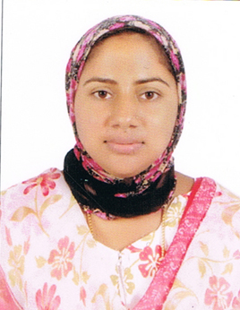
Shameena Rahman
Shameena Manzil
Thachnady
Puthucode,Palakkad
Phone – 04922 266844,9037696724
Email : shameena.rahman9@gmail.com

OBJECTIVE

To obtain responsible and career oriented position in a challenging environment where I can enhance my knowledge and utilize my potential effectively and diligently for the bank developing activity

EDUCATIONAL QUALIFICATION

COURSE | BOARD/UNIVERSITY | YEAR OF PASSING
M.com, ICWAI | Bharathiyar university | Doing
B.com | Calicut University | 2004
Plus Two | Board of Examination | 2001
S S L C | State Board of Kerala | 1999

COMPUTER LITERANCY

Packages
- Have knowledge on handling tally package.
- Have knowledge in Microsoft Office.
Working experience

1 year experience in danalaxmi bank as a sales officer – selling all the liability products in the bank

STRENGTHS

Proactive, Quick Learner, Hardworking, Goal Oriented, Well Organized & not easily discouraged. Often sees the whole picture and seeks practical solutions, spontaneous.

PERSONAL PROFILE

Name : shameena rahman
Address : Shameena Manzil
Thachnady
Puthucode, Palakkad
Gender : Female
Date of Birth : 15/05/1984
Nationality : Indian
Language Known : Malayalam, English & Tamil
Phone : 9037696724

DECLARATION

I here by declare that all the above information furnished about me is true to the best of my knowledge and belief.

Place :
Date : Yours Truly

shameena rahman

