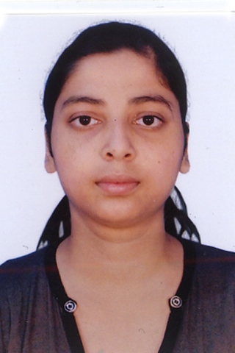
NAME : SAYANTI GHOSH
ADDRESS : 4/30 Tilok Road, B-Zone ,
Durgapur -713205, W.B.
DEPT : Electronics and Communication Engineering.
Mobile No. : 8172043602 / 9434538541
Passport No . : K8121638 (valid upto 04/03/2023)
E-mail : sayantighosh.1991@gmail.com
---------------------------------------------------------------------------------------------------------
Career Objective:-
Wish to build a career with leading corporate of hi-tech environment with committed & dedicated people, which will help me to explore myself fully & realize my potential.
Willing to work as a key player in challenging & creative environment.

Strengths:-
I am logical, ambitious, positive minded & disciplined. I know how to mould myself according to situation & environment. I am a good learner as well as good listener.

Academic Qualifications:
Degree / Certificate | Qualification | Institute | Board /  University | Year | Aggregate % / CGPA
Post Graduation | M-tech  (ECE-Telecommunication Engineering) | National Institute of Technology, Durgapur | N  NIT | 202014-2016 | 9.73 percentile
Graduation | B-tech  (ECE) | Bengal college of engineering and technology for women. | WBUT | 2009-2013 | 8.74 percentile
12th | Higher secondary examination | Ramkrishnapally Vivekananda vidyapith. | WBCHSE | 2009 | 78%
10th | Secondary examination | Akbar Road girl’s high school. | WBBSE | 2007 | 81%

Trainings / Projects Undertaken:
NAME OF ORGANIZATION | Project Title | Duration
WEST BENGAL STATE ELECTRICITYY DISTRIBUTION COMPANY LIMITED.  (A GOVERNMENT OF WEST BENGAL ENTERPRISE). | DATABASE NETWORKING SYSTEM. | 09/O6/2011 TO 23/06/2011
BHARAT SANCHAR NIGAM LTD.  (A GOVERNMENT OF INDIA ENTERPRISE) . | PROJECT ON BSNL | 11/06/2012 TO 03/07/2012
BENGAL COLLEGE OF ENGINEERING AND TECHNOLOGY FOR WOMEN. | DTMF SWITCHING | 08/09/2012 TO  05/01/2013
BENGAL COLLEGE OF ENGINEERING AND TECHNOLOGY | SPEECH ANALYSIS USING LPC(LINEAR PREDECTIVE CODING) METHOD | 18/07/2012 TO 28/04/2013
NATIONAL INSTITUTE OF TECHNOLOGY, DURGAPUR | WIRELESS COMMUNICATION (COGNITIVE RADIO NETWORK) | 06/06/2015 TO TILL DATE

Specialization:
Telecommunication Engineering

Additional Qualification / Achievements / Certifications:
1) ROBOJAGRAN (a workshop on Manual & autonomous Robotics)
2) NEN Eieaders (NATIONAL ENTERPRENEURSHIP NETWORK)
3) BITM (BIRLA INDUSTRIAL and TECHNICAL MUSIUAM).

Publication:
1)IEEE International conference on Microelectronics, Computing and Communication 2016 NIT DURGAPUR based on Performance of Weighted fusion spectrum sensing under double threshold in cognitive radio network.

Computer Proficiency:
Programming Language
1) C
2) C++
3) DATA STRUCTURE
4) JAVA(core)

Personal Details:
Date of Birth : 07/09/1991
Father`s Name : Manikeswar Ghosh
Gender : Female
Nationality : Indian
Religion : Hindu
Community : General
Languages Known : Bengali, Hindi, English
Hobbies : Listening to music, Making new friends & Mind management

Declaration:-
I am quite confident about myself & know how to lead my team from front. I vow to give my utmost to my organization. Always I think beyond the possibilities & like to go for extra miles.
I hereby declare that the information furnished above are true to the best of my knowledge.
Signature:

