RAMYASHREE S


ADDRESS #60,3rd cross, Maruthinagar, Bangalore. Contact Number: 8151850357 E-mail: ramyashrees1994@gmail.com

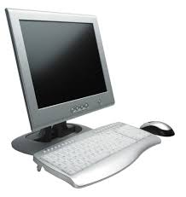
COMPUTER SKILL
- Basics like Ms World, Excel etc…
- Internet,DTP.
- Tally
- Typing


WORK EXPERIENCES

- Experienced in Andromeda as CSR for 6 months
- Experienced in Kruti Promotion & Event Pvt. Ltd. As a Receiptionist for a period of 2 year


EDUCATION QUALIFICATION

Qualification | Institute | Percentage
S. S. L. C. | Women’s peace league school | 62%
P.U.C | SSMRV PU College | 77.83%

- Persuing Final Year Bcom

PERSONAL DETAIL

- Name : Ramyashree S
- Father’s Name : Srirangashetty
- Date of Birth : 28th july 1994
- Nationality : Indian
- Marital status : Unmarried
- Sex : Female
- Language Known : English, Kannada,Telugu
- Hobbies : listen to music, Dancing.

DECLARATION

I here by declare that all the above mentioned details are true to the best of my knowledge. Kindly consider application and provide me an opportunity to serve in your Organization.

Thanking You,
Place: Bangalore Yours Faithfull

(Ramya shree S)

