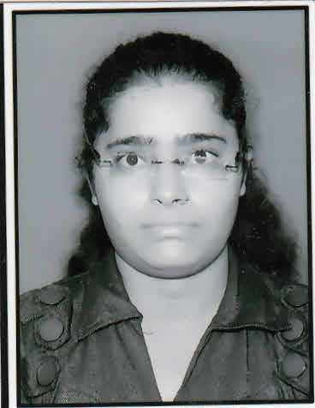
Arpita Vishnoi
467/2 Shastri Nagar, Kanpur
8707457480
Vishnoiarpita@gmail.com

CAREER OBJECTIVE
To acquire a demanding position in a environment where I can best developed my skills
And utilized my education.

PROFESSIONAL QUALIFICATIONS

- M.B.A. (2012-14)
(Masters of Business Administration)
2year full-time MBA program with dual specialization in Finance & marketing
From: Pranveer Singh Institute of Technology, Kanpur, and Uttar Pradesh.
Percentage: 66%

- B.B.A. (2009-12)
(Bachelor of Business Administration)
3 years full-time BBA Program with Finance
From: C.S.J.M. University, Kanpur
Percentage: 53%

ACADAMIC QUALIFICATIONS

- Intermediate (2009)
(Commerce stream)
From: Kanpur Vidya Mandir, Girls Inter Collage. (U.P. Board)
Aggregate: 64%

- High school (2007)
(Science Stream with Mathematics, Science, English, Hindi, ART, S.S.T)
From: City Model G College Kakadev, Kanpur (UP Board)
Aggregate: 58%
_________________________________________________________________
INDUSTRIAL TRAINING/ SUMMER INTERNSHIP

HINDUSTAN AERONATUIC Ltd., Lucknow
Duration: 6 weeks extensive training from 5th June 2013 to 8th July 2013
Methodology: study about capital budgeting of organization.
Highlights: Indulged with the study of strategic management process of company along with capital budgeting.
______________________________________________________________

WINTER PROJECT

- Opportunities and challenges of Development Financial Institution in India

WORKING EXPERIENCE:-

- I had worked in MY CAR PVT. LTD. Fazalganj, Kanpur as a Finance Deppt. Since 18 July 2014 to 02 august 2015.
- I had worked in UJJIVAN SMALL FINANCE BANK as a cashier.
- Currently work in pegaroid I/Q solution pvt.ltd. In Kanpur.

LINGUISTIC PROFICIENCY

- English
- Hindi

TECHNICAL SKILLS

- Windows XP
- MS-Office( MS-excel)
- MS-WORD
- MS-Power point
- Tally Erp 9 with gst
- MIS course
- “o” level course

KEY SKILLS AND ATTRIBUTES

- Strong Will Power
- Ability to work for long hours
- People oriented person
- Analytical and Reasoning skills
- Energetic and Enthusiastic Learner
- Good at relationship building.
- Committed team player with flexible approach to work

PERSONAL DETAILS

- Date of Birth : 2 Aug 1991
- Gender : Female
- Father’s Name : Mr. Rajiv Kumar Vishnoi
- Marital Status : Single
- Nationality : Indian

DECLARATION

I hereby declare that all the information given above is true to the best of my knowledge and credence.

Date:
(Arpita Vishnoi)

