AMRITA SADHU
+91- 09836340703/8777085485



Email: amrita_sadhu@yahoo.co.in
53/25, R.N. Guha Road

Professional Profile

PROFESSIONAL SUMMARY:



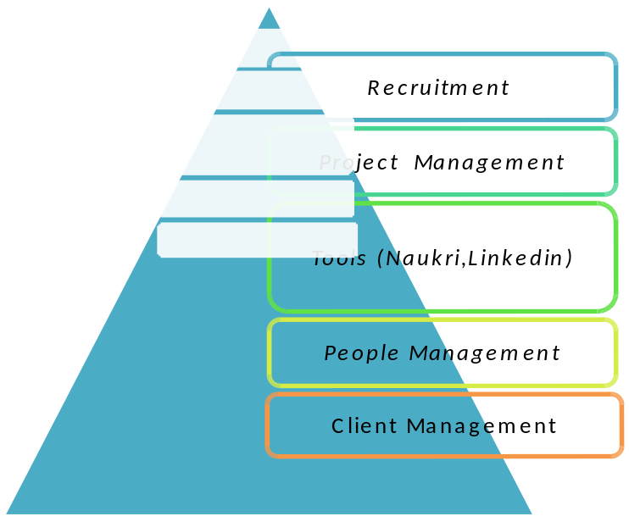
Core Competencies
Academic profile | - Bachelor of Computer Application  - PGDHR From symbiosis Pune
Technology Summary | - Attended Recruitment workshop.  - Systems:- Windows (all), Unix  - Software:- MS Office (Excel, Word, PowerPoint, Outlook),

Professional Experience

Experis IT (Manpower Group)
Sr.Talent Acquisition Executive April 2018 To Till date
- Responsible for End to End Recruitment for Domestic and International clients.
- Actively involved in Corporate hiring as well as internal hiring.
- Proficient in working on Niche skills.
Best Infosystem Pvt Ltd
Kolkata
Sr.IT Recruitment Consultant . April 2016 to March 2018.

- Manage existing and new Clients/Accounts and Handling SPOC from different deferent IT MNC clients
- Partnering closely with the Business Managers to ensure their hiring needs are met effectively and efficiently.
- Handling branch operation and manage service delivery.
- Supporting to the team members to understand job description and search better.
- Utilizes Consultative Selling techniques that apply integrated solutions across staffing, outsourcing and consulting service lines
- Engages directly with key clients to solidify, grow and expand Damco business opportunities
- Developed account plans and needs assessments for area(s) of responsibility
- Developed client relationships with key decision makers
- Managing the entire Talent Acquisition cycle right from understanding the manpower requirement, sourcing candidates, interviewing candidates, negotiating offers and closing the position.
- Working closely with IT MNC clients to ensure an in-depth understand of the Hiring Mandate and create impactful job descriptions.
- Depending on the desired candidate profile, effectively source candidates from varied sources, such as job portals, campus hiring, walk-ins, head hunting, internal referrals etc.
- Adhering to internal HR processes such as ensuring proper documentation of candidates' papers, monthly hiring MIS, Reports.
- Coordinate with clients for requirement, scheduling for an interview. salary negotiation, onboarding done.

Summary of Technology skill sets successfully recruited so far:

Handling recruitment processes right from sourcing to the placement of candidates specially at the middle & top level management for technologies as;

- Talent Acquisition into various modules like SAP technical (ABAP, HANA, FIORI, Mobility) and functional modules(SAP CO,FICO,BASIS,BASIS HANA,SAP MM,SAP SD)(having a profound knowledge in these modules).
- Talent Acquisition/Recruitment in automotive modules like ASPICE Quality Audit,L2 L3 Protocol Development
- Recruitment in modules like Microsoft Azure PAAS, IAAS Cloud architect, Oracle DBA, JAVA J2EE, DOT NET WPF/WCF ,JAVA Analytics Testing and Development, ETL Testing, Automation and Webservices Testing, Infrastructure Management Presales, etc.
- Recruitment experience in senior technical profiles like Project Manager, IT Delivery Manager, Datacenter Practice Head, Solution Architect with Presales, IMS(Infrastructure Management Solutions) Architect, ETL Architect, Oracle EBS Architect, Hyperion Planning Manager.

Yellow Box
Kolkata
Recruitment Executive March 2015 to Nov 2015.

- Manage existing and new Clients/Accounts and Handling SPOC from different deferent IT/ ITES MNC clients
- Supporting to the team members to understand job description and search better
- Managing the entire Talent Acquisition cycle right from understanding the manpower requirement, sourcing candidates, interviewing candidates, negotiating offers and closing the position
- Depending on the desired candidate profile, effectively source candidates from varied sources, such as job portals, campus hiring, walk-ins, head hunting, internal referrals etc.
- Adhering to internal HR processes such as ensuring proper documentation of candidates' papers, monthly hiring MIS, Reports.
- Coordinate with clients for requirement, scheduling for an interview. salary negotiation, onboarding done.

WIPRO LIMITED,Kolkata

Senior Tech Associate April 2010 – Jun -2014
- Worked as a wireless network support specialist
- Resolving issues with deadline.
- Diagnosis of fault either on hardware or software or operating system related.
- Providing support to customers on phone or via Mail
- Access network installation through remote access login
- Responsible in taking up escalation calls
- Keeping a track of the agents performance
- Providing quality updates to the team
- Providing feedback to the agent in respective of the calls taken
- Auditing agents calls

Additional Responsibility :

- Initial Screening candidates for interview
- Checking the communication of the candidates as per the project requirement .

Firstsource Solution Limited
Kolkata

Senior Associate Feb 2007 – April 2008

- Worked as a Customer support specialist.
- Trouble shooting Vodafone Postpaid customers issue
- Also worked as a team member for advanced issues
- Resolving issues with deadline.
- Diagnosis of fault either on hardware or software or Network related.
- Providing support to customers on phone.
- Responsible in taking up escalation calls
- Keeping a track of the agents performance
- Providing quality updates to the team
- Providing feedback to the agent in respective of the calls taken
- Auditing agents calls

