CURRICULUM VITAE
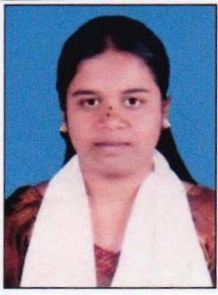
Ankita Ankush Vanne
Contact No. – 8605098195
Email ID : ankitavanne@gmail.com
Add. : Ambedkar Colony, Pachgani
Tal – Mahableshwar, Dist - Satara – 412805

OBJECTIVE :

To utilize my potential to full extent in terms of knowledge & hard work for helping the organization in achiving its goals.

EDUCATIONAL QUALIFICATION :

Exam | Board | Year of Passing | Percentage
S.S.C | Kolhapur | 2010 | 50.00%
H.S.C | Kolhapur | 2012 | 45.00%
B.C.A 1st | Karnataka University | 2013 | 72.00%

COMPUTER KNOWLEDGE :

MS-CIT Pass, Basic Computer knowledge

WORK EXPERIENCE :

Total Experience – 1 year experience in Litil Angle Tiny Tots School as a Teacher.

PERSONAL DETAILS :
Name : Ankita Ankush Vanne
Birth Date : 1st July 1995
Gender : Female
Marital Status : Single
Nationality : Indian
Religion : Hindu
Languages Known : Marathi, Hindi and English

DECLARATION :

I here by declare that the above written particulars are true to the best of my knowledge and believe.

Yours faithfully,
Date:
Place :
Ankita Ankush Vanne

